City of Boise
ADA Assessment

Appendix A – Boise Airport

05/21/2021
Report # TO21-B027 (Part 1)

Prepared by:

 | ID:  4322 | Facility:  Boise Airport

Location: 1st Floor Accessible Parking
Schedule: 2021
Estimated Cost: $100.00

Priority Score 9
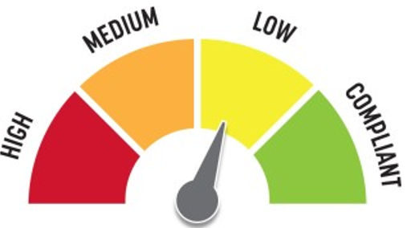
Quick Fix: Yes
Built before ADA: No

VIOLATIONS
2010 ADA Standards for Accessible Design Codes: §502.6
There is no signage present identifying the accessible parking spaces.

RECOMMENDATIONS
Install an accessible parking sign at each accessible space at a minimum height of 60" above the ground.

PHOTOGRAPH(S) OF THIS LOCATION

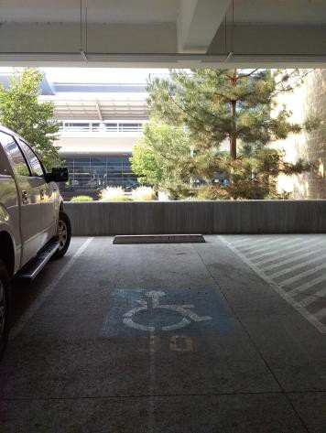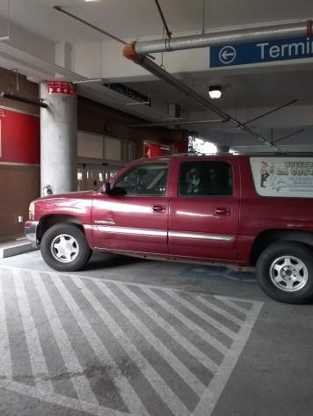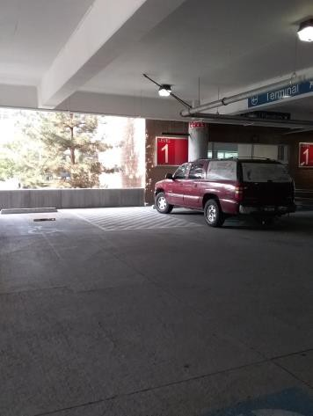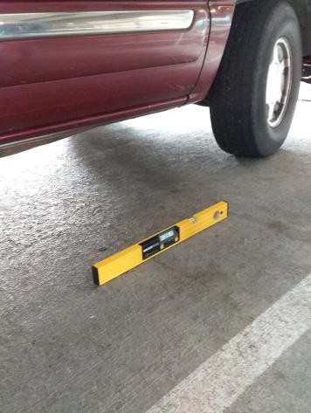

 | ID:  4157 | Facility:  Boise Airport

Location: 1st Floor Accessible Parking
Schedule: 2022
Estimated Cost: $1,000.00

Priority Score 6
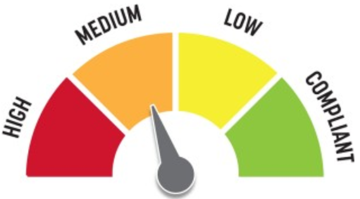
Quick Fix: No
Built before ADA: No

VIOLATIONS
2010 ADA Standards for Accessible Design Codes: §502.3
The access aisles are not of sufficient width due to concrete poles.

RECOMMENDATIONS
Move the parking bumpers forward so that the entire usable width of the parking space is 96" and the entire usable width of the access aisle is 60".
The accessible route must be maintained even when cars are parked and overhang the bumpers.

PHOTOGRAPH(S) OF THIS LOCATION

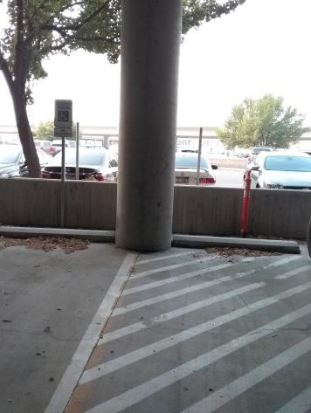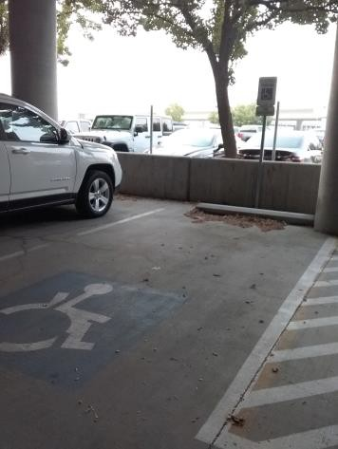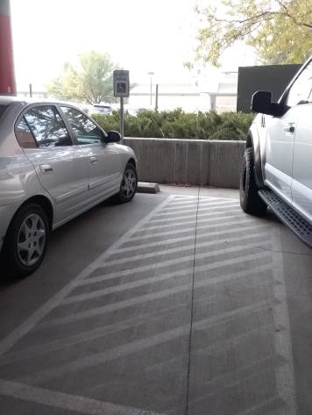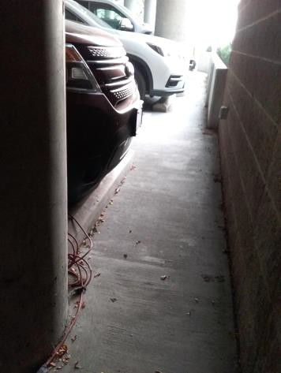

 | ID:  4153 | Facility:  Boise Airport

Location: 1st Floor Accessible Parking
Schedule: 2021
Estimated Cost: $1,000.00

Priority Score 0
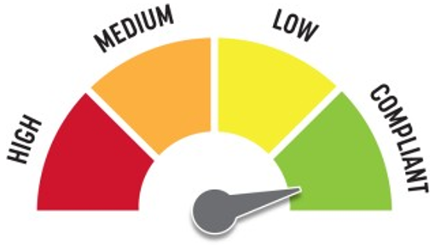
Quick Fix: No
Built before ADA: No

VIOLATIONS
2010 ADA Standards for Accessible Design Codes: §502.3
The accessible route passes behind parked vehicles.

RECOMMENDATIONS
For the purposes of achieving greater accessibility and Human Centric Design, move the parking bumpers forward to allow for the 36" wide accessible route to go in front of the vehicles rather than behind.
The accessible route must be maintained even when cars are parked and overhang the bumpers. This will require adjusting all the bumpers on this row to allow for a continuous route.

PHOTOGRAPH(S) OF THIS LOCATION

 | ID:  3800 | Facility:  Boise Airport

Location: 1st Floor Accessible Parking D10
Schedule: 2021
Estimated Cost: $5,000.00

Priority Score 3
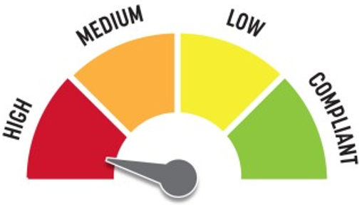
Quick Fix: No
Built before ADA: No

VIOLATIONS
2010 ADA Standards for Accessible Design Codes: §502.5
There are beams in the accessible parking space.
The closest space to the accessible route is not accessible.

RECOMMENDATIONS
Relocate the existing accessible parking space to be the space closest to the accessible route or move the parking bumpers forward so that the entire usable width of the parking space is 96" and the entire usable width of the access aisle is 60".

PHOTOGRAPH(S) OF THIS LOCATION

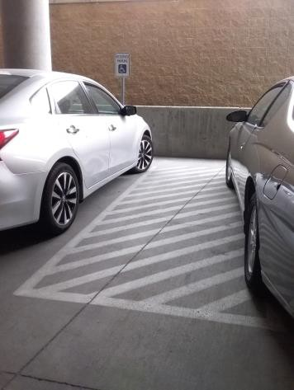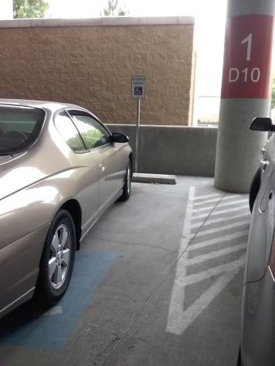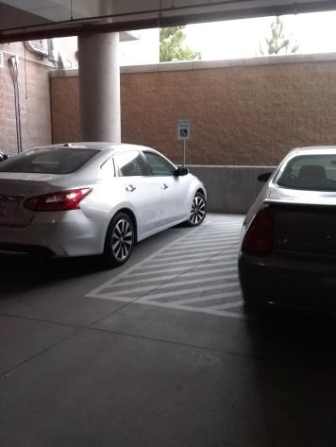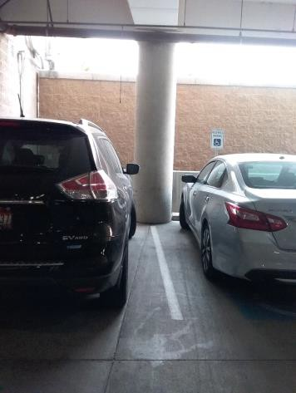

 | ID:  3994 | Facility:  Boise Airport

Location: 1st Floor Accessible Parking Ramp
Schedule: 2021
Estimated Cost: $100.00

Priority Score 5
Quick Fix: Yes
Built before ADA: No

VIOLATIONS
2010 ADA Standards for Accessible Design Codes: §307.2
The fire extinguisher protrudes 5" into the circulation space at 30" above the floor.

RECOMMENDATIONS
Recess the fire extinguisher so it protrudes a maximum of 4", lower it so the bottom edge is 27" maximum above the floor, or place a cane detectable object beneath it.

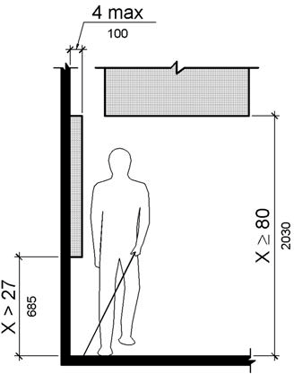

PHOTOGRAPH(S) OF THIS LOCATION

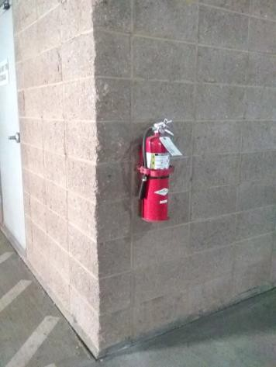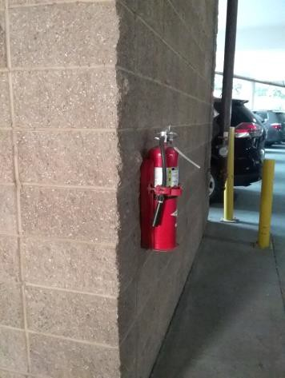

 | ID:  4180 | Facility:  Boise Airport

Location: 1st Floor Accessible Parking Ramp
Schedule: 2023
Estimated Cost: $1,000.00

Priority Score 9
Quick Fix: No
Built before ADA: No

VIOLATIONS
2010 ADA Standards for Accessible Design Codes: §502, §502.3
The accessible route goes behind parked vehicles and is not marked. The painted lines for the accessible parking spaces are faded.

RECOMMENDATIONS
For the purposes of achieving greater accessibility and Human Centric Design, mark the access aisle in front of the parked vehicles to enhance pedestrian safety.
It is safer to have the accessible route not go behind vehicles. Restripe and repaint the accessible parking spaces, access aisles, and ISA symbols.

PHOTOGRAPH(S) OF THIS LOCATION

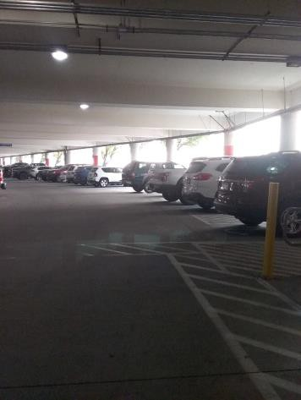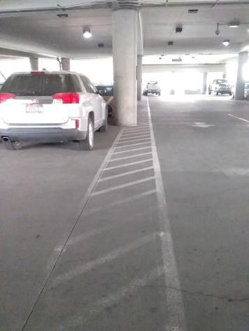

 | ID:  3504 | Facility:  Boise Airport

Location: 1st Floor New Parking Garage 1A5
Schedule: 2021
Estimated Cost: $100.00

Priority Score 9
Quick Fix: Yes
Built before ADA: No

VIOLATIONS
2010 ADA Standards for Accessible Design Codes: §502.6
There is no signage present identifying two of the accessible parking spaces.

RECOMMENDATIONS
Install an accessible parking sign at each accessible space at a minimum height of 60" above the ground.

PHOTOGRAPH(S) OF THIS LOCATION

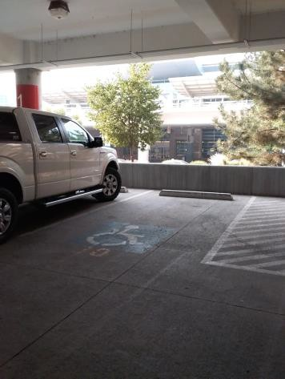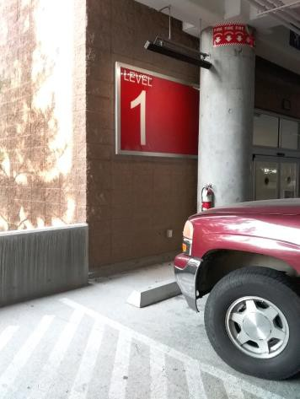

 | ID:  3696 | Facility:  Boise Airport

Location: 1st Floor New Parking Garage 1A5
Schedule: 2021
Estimated Cost: $100.00

Priority Score 6
Quick Fix: Yes
Built before ADA: No

VIOLATIONS
2010 ADA Standards for Accessible Design Codes: §703.4
The tactile sign identifying the room is not in the correct location at 60.75" above the floor.

RECOMMENDATIONS
Reinstall the sign on the latch side of the door at 48" minimum above the floor measured from the baseline of the lowest character and 60" maximum measured from the baseline of the highest character.

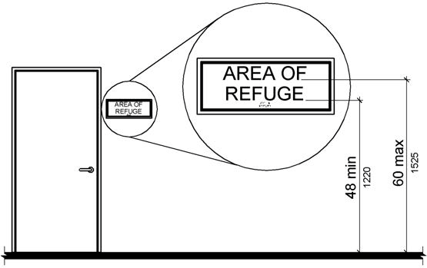

PHOTOGRAPH(S) OF THIS LOCATION

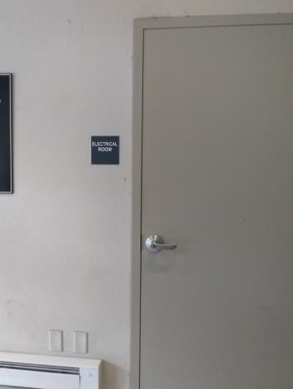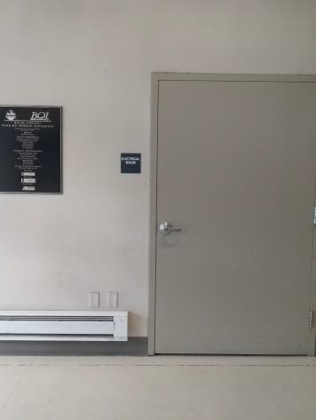

 | ID:  3315 | Facility:  Boise Airport

Location: 1st Floor New Parking Garage 1A5
Schedule: 2021
Estimated Cost: $400.00

Priority Score 9
Quick Fix: Yes
Built before ADA: No

VIOLATIONS
2010 ADA Standards for Accessible Design Codes: §502.6
The accessible parking signs are 52" above the ground.

RECOMMENDATIONS
Remount the accessible parking signs at each accessible space at a minimum height of 60" above the ground.

PHOTOGRAPH(S) OF THIS LOCATION

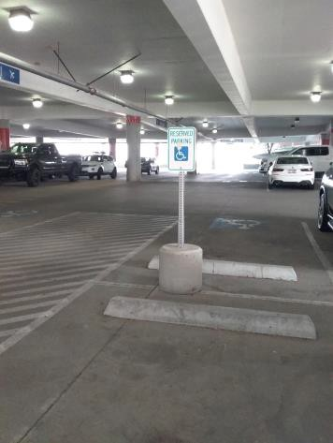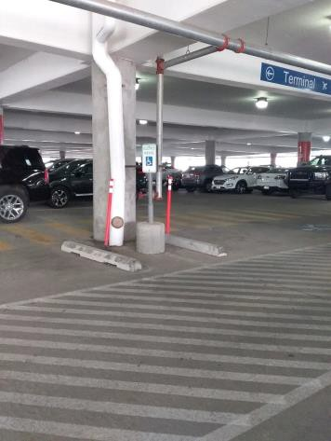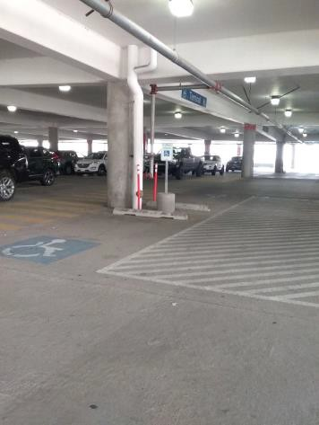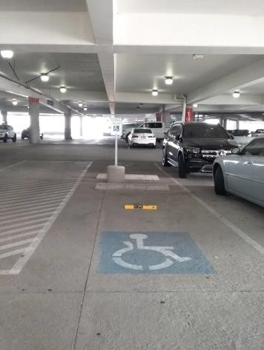

 | ID:  3196 | Facility:  Boise Airport

Location: 1st Floor New Parking Garage 1A5
Schedule: 2023
Estimated Cost: $1,000.00

Priority Score 9
Quick Fix: No
Built before ADA: No

VIOLATIONS
2010 ADA Standards for Accessible Design Codes: §206.8
A bollard and garbage can encroaches on the access aisle reducing its width.

RECOMMENDATIONS
Relocate the bollard and garbage can from the access aisle to ensure that the width of the access aisle is 60" for the entire length of the accessible parking space.

PHOTOGRAPH(S) OF THIS LOCATION

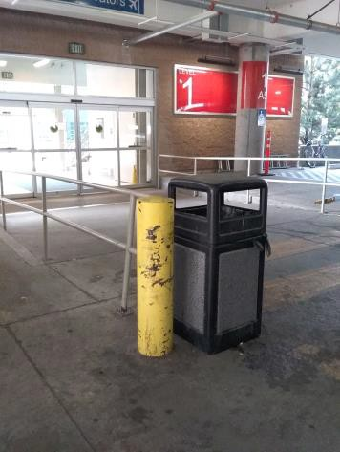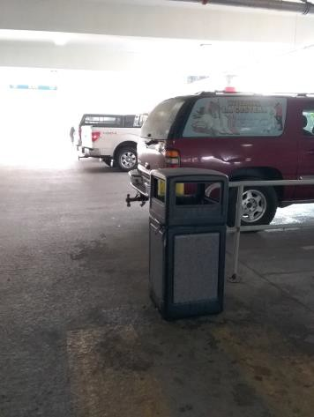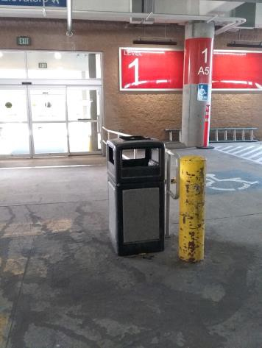

 | ID:  3026 | Facility:  Boise Airport

Location: 1st Floor New Parking Garage 1A5
Schedule: 2021
Estimated Cost: $1,000.00

Priority Score 2
Quick Fix: No
Built before ADA: No

VIOLATIONS
2010 ADA Standards for Accessible Design Codes: §208.2.4
There are no marked "Van accessible" spaces.

RECOMMENDATIONS
Add a 132" wide van accessible parking space for every six vehicle parking spaces. Add a “van accessible” parking sign at a minimum height of 60" above the ground.

PHOTOGRAPH(S) OF THIS LOCATION

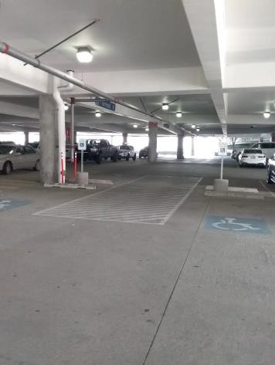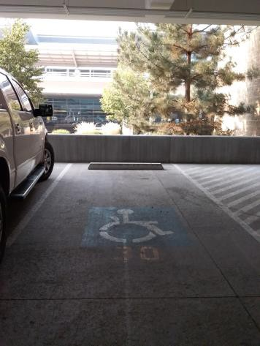

 | ID:  3598 | Facility:  Boise Airport

Location: 1st Floor New Parking Garage 1A5
Schedule: 2023
Estimated Cost: $2,000.00

Priority Score 9
Quick Fix: No
Built before ADA: No

VIOLATIONS
2010 ADA 2010 ADA Standards for Accessible Design Codes: §502
The painted lines for the accessible parking spaces are missing on one side of two spaces.

RECOMMENDATIONS
Paint the missing lines at the two accessible parking spaces.

PHOTOGRAPH(S) OF THIS LOCATION

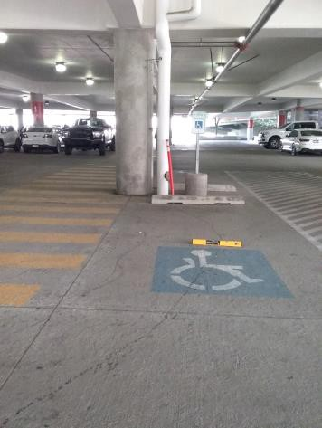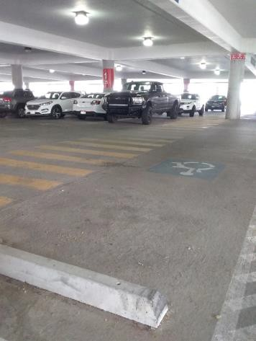

 | ID:  3949 | Facility:  Boise Airport

Location: 2nd Floor Women's Restroom
Schedule: 2021
Estimated Cost: $100.00

Priority Score 5
Quick Fix: Yes
Built before ADA: No

VIOLATIONS
2010 ADA Standards for Accessible Design Codes: §307.2, §308.2.1
The dispenser is outside of the unobstructed forward reach range at 48.25" above the floor. The dispenser protrudes 6.5" into the circulation space at 48.25" above the floor.

RECOMMENDATIONS
Lower the dispenser by 0.25" to meet the accessible reach range of 48" maximum above the floor.
Recess the dispenser so it protrudes a maximum of 4" or place a cane detectable object beneath it.

PHOTOGRAPH(S) OF THIS LOCATION

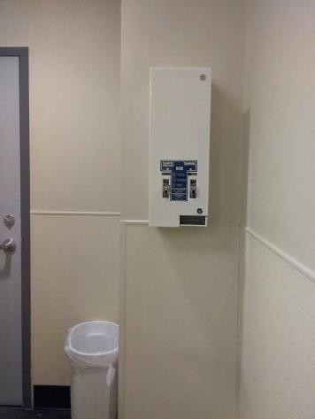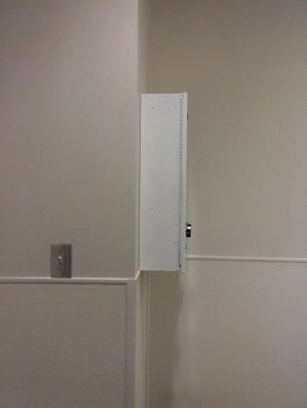
 | ID:  4167 | Facility:  Boise Airport

Location: 2nd Floor Parking Garage Restroom
Schedule: 2021
Estimated Cost: $100.00

Priority Score 5
Quick Fix: Yes
Built before ADA: No

VIOLATIONS
2010 ADA Standards for Accessible Design Codes: §307.2
The paper towel dispenser protrudes 8" into the circulation space at 45" above the floor.

RECOMMENDATIONS
Recess the paper towel dispenser so it protrudes a maximum of 4" or place a cane detectable object beneath it.

PHOTOGRAPH(S) OF THIS LOCATION

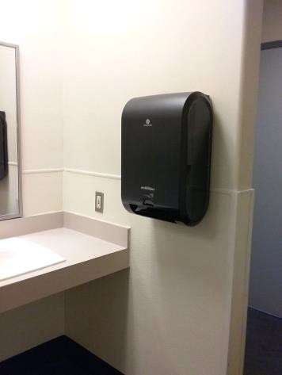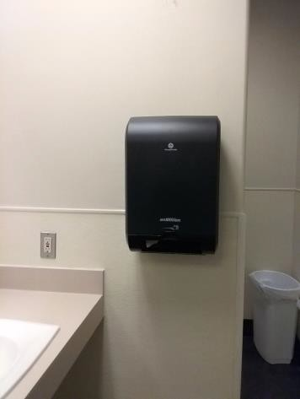

 | ID:  4280 | Facility:  Boise Airport

Location: 2nd Floor Parking Garage
Schedule: 2021
Estimated Cost: $100.00

Priority Score 5
Quick Fix: Yes
Built before ADA: No

VIOLATIONS
2010 ADA Standards for Accessible Design Codes: §307.2
The fire extinguisher protrudes 6.75" into the circulation space at 29.75" above the floor.

RECOMMENDATIONS
Recess the fire extinguisher so it protrudes a maximum of 4", lower it so the bottom edge is 27" maximum above the floor, or place a cane detectable object beneath it.

PHOTOGRAPH(S) OF THIS LOCATION

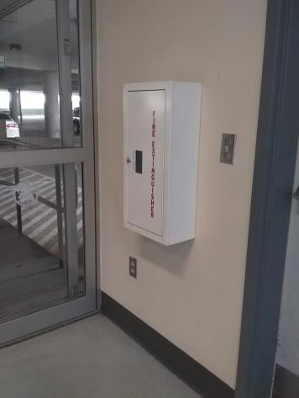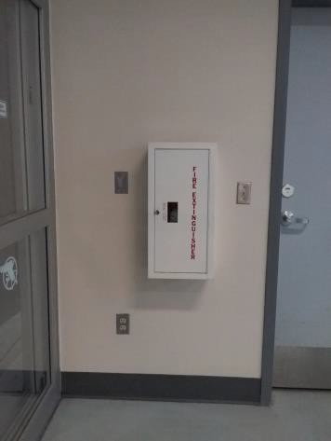

 | ID:  3834 | Facility:  Boise Airport

Location: 2nd Floor Parking Garage Restroom
Schedule: 2021
Estimated Cost: $200.00

Priority Score 6
Quick Fix: Yes
Built before ADA: No

VIOLATIONS
2010 ADA Standards for Accessible Design Codes: §703.4
The tactile sign identifying the room is not in the correct location.

RECOMMENDATIONS
Reinstall the sign on the latch side of the door at 48" minimum above the floor measured from the baseline of the lowest character and 60" maximum measured from the baseline of the highest character.

PHOTOGRAPH(S) OF THIS LOCATION

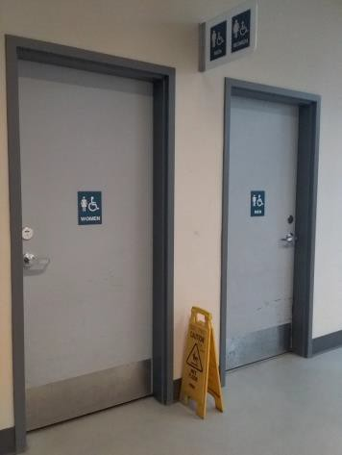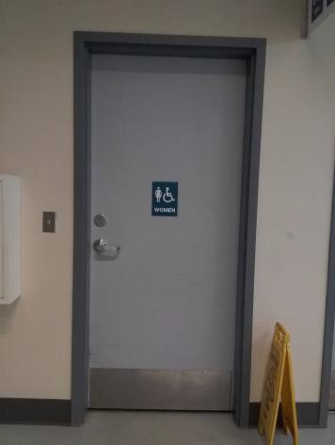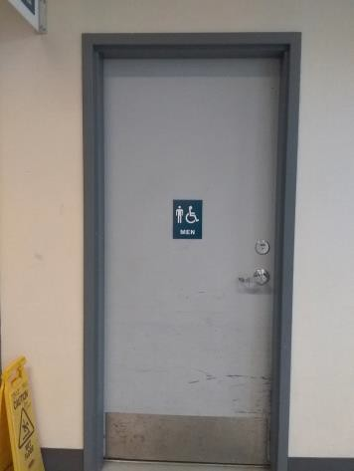

 | ID:  3886 | Facility:  Boise Airport

Location: 2nd Floor Accessible Parking Women's Restroom
Schedule: 2021
Estimated Cost: $100.00

Priority Score 5
Quick Fix: Yes
Built before ADA: No

VIOLATIONS
2010 ADA Standards for Accessible Design Codes: §604.7
The toilet paper dispenser is located out of the accessible reach range.

RECOMMENDATIONS
Remount the toilet paper dispenser to 7” minimum and 9” maximum in front of the water closet measured to the centerline of the dispenser.
The outlet of the dispenser shall be 15” minimum and 48” maximum above the floor and shall not be located behind the water closet.

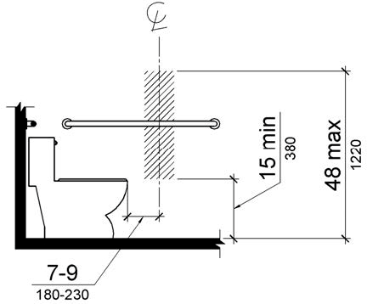

PHOTOGRAPH(S) OF THIS LOCATION

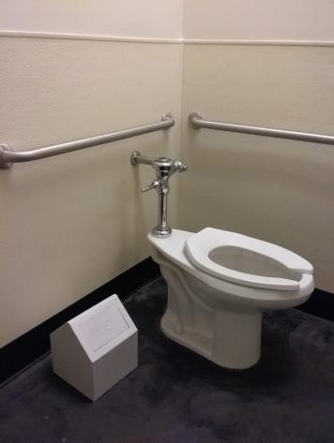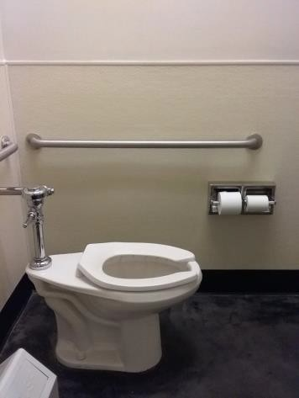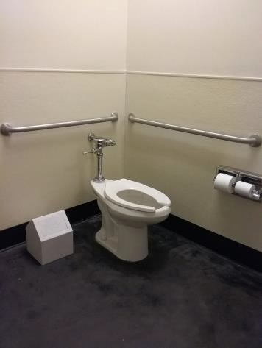

 | ID:  4085 | Facility:  Boise Airport

Location: 2nd Floor Accessible Parking Women's Restroom
Schedule: 2021
Estimated Cost: $100.00

Priority Score 8
Quick Fix: Yes
Built before ADA: No

VIOLATIONS
2010 ADA Standards for Accessible Design Codes: §308.2.1
The hook is outside of the unobstructed forward reach range at 66" above the floor.

RECOMMENDATIONS
Lower the hook by 18" to meet the accessible reach range of 48" maximum above the floor.

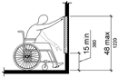

PHOTOGRAPH(S) OF THIS LOCATION

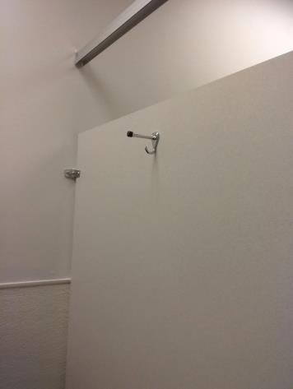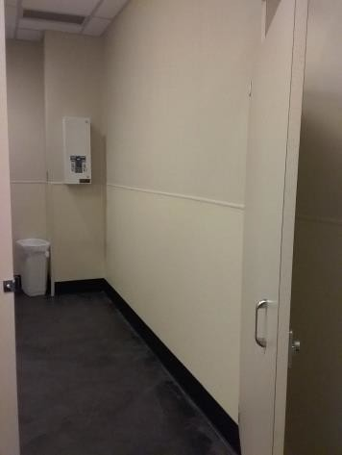

 | ID:  4086 | Facility:  Boise Airport

Location: 2nd Floor Accessible Parking Women's Restroom
Schedule: 2021
Estimated Cost: $100.00

Priority Score 5
Quick Fix: Yes
Built before ADA: No

VIOLATIONS
2010 ADA Standards for Accessible Design Codes: §604.8.1.2
The door to the accessible water closet is not self closing.
Either self-closing hinges are not installed on the door or if installed, they are defective.

RECOMMENDATIONS
Install or reinstall self-closing hinges on the door to ensure that the door is self-closing per the ADA requirements.

PHOTOGRAPH(S) OF THIS LOCATION

 | ID:  3883 | Facility:  Boise Airport

Location: 2nd Floor Accessible Parking Women's Restroom
Schedule: 2021
Estimated Cost: $500.00

Priority Score 5
Quick Fix: Yes
Built before ADA: No

VIOLATIONS
2010 ADA Standards for Accessible Design Codes: §604.5.1
The side grab bar is located 3.75" from the rear wall.

RECOMMENDATIONS
Remount the side grab bar 12" maximum from the rear wall and extending 54" minimum from the rear wall.

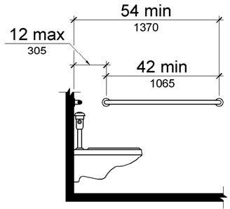

PHOTOGRAPH(S) OF THIS LOCATION

 | ID:  3885 | Facility:  Boise Airport

Location: 2nd Floor Accessible Parking Women's Restroom
Schedule: 2022
Estimated Cost: $1,000.00

Priority Score 5
Quick Fix: No
Built before ADA: No

VIOLATIONS
2010 ADA Standards for Accessible Design Codes: ICC A117.1 §604.5.1
There is no vertical grab bar

RECOMMENDATIONS
Install an 18" long (minimum) vertical grab bar on the side wall. The grab bar shall be mounted with the bottom located at 39" minimum and 41" maximum above the floor.
The centerline of the vertical grab bar shall be located 39" minimum and 41" maximum from the rear wall.

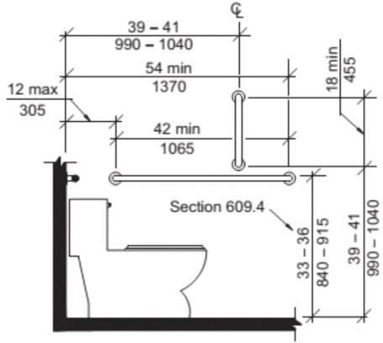

PHOTOGRAPH(S) OF THIS LOCATION

 | ID:  4506 | Facility:  Boise Airport

Location: 2nd Floor Accessible Parking Women's Restroom
Schedule: 2022
Estimated Cost: $1,000.00

Priority Score 5
Quick Fix: No
Built before ADA: No

VIOLATIONS
2010 ADA Standards for Accessible Design Codes: §604.2
The centerline of the toilet is located 19" from the sidewall.

RECOMMENDATIONS
Reposition the centerline of the toilet to be within 16" minimum and 18" maximum from the sidewall. Install vertical grab bars with a minimum length of 18".

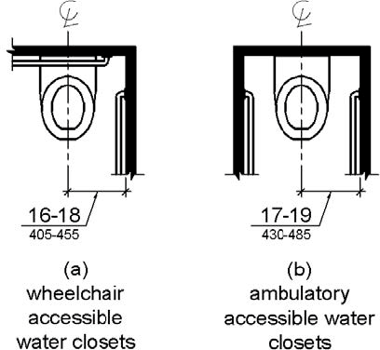

PHOTOGRAPH(S) OF THIS LOCATION

 | ID:  4246 | Facility:  Boise Airport

Location: 2nd Floor Departure Garage
Schedule: 2023
Estimated Cost: $0.00

Priority Score 8
Quick Fix: Yes
Built before ADA: No

VIOLATIONS
2010 ADA Standards for Accessible Design Codes: §707
The interactive touch screen does not have any sound or tactile components.
Therefore, a visually impaired person would not be able to access the information provided by the kiosk.

RECOMMENDATIONS
Audio instructions must be provided to guide the user through all the functions of the machine. This is to accommodate an individual sitting in the back seat who requires non-visual access to the equipment.
Tactile instructions must be provided informing the user on the method of activating the audio instructions.

PHOTOGRAPH(S) OF THIS LOCATION

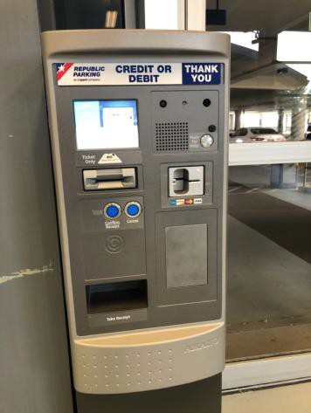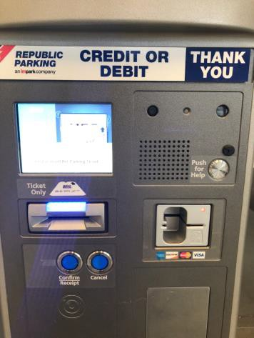

 | ID:  3854 | Facility:  Boise Airport

Location: 2nd Floor Departure Garage Men's Restroom
Schedule: 2021
Estimated Cost: $100.00

Priority Score 6
Quick Fix: Yes
Built before ADA: No

VIOLATIONS
2010 ADA Standards for Accessible Design Codes: §703.4
The tactile sign identifying the room is not in the correct location.

RECOMMENDATIONS
Reinstall the sign on the latch side of the door at 48" minimum above the floor measured from the baseline of the lowest character and 60" maximum measured from the baseline of the highest character.

PHOTOGRAPH(S) OF THIS LOCATION

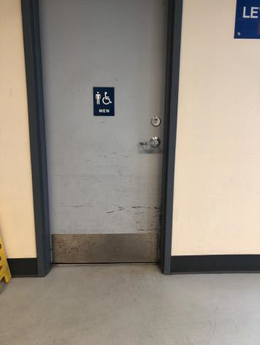

 | ID:  3889 | Facility:  Boise Airport

Location: 2nd Floor Departure Garage Men's Restroom
Schedule: 2021
Estimated Cost: $100.00

Priority Score 5
Quick Fix: Yes
Built before ADA: No

VIOLATIONS
2010 ADA Standards for Accessible Design Codes: §307.2
The paper towel dispenser protrudes 8" into the circulation space at 46" above the floor.

RECOMMENDATIONS
Recess the paper towel dispenser so it protrudes a maximum of 4" or place a cane detectable object beneath it.

PHOTOGRAPH(S) OF THIS LOCATION

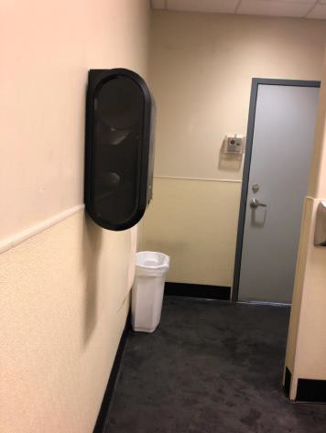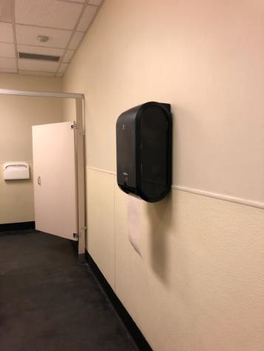

 | ID:  3904 | Facility:  Boise Airport

Location: 2nd Floor Departure Garage Men's Restroom
Schedule: 2021
Estimated Cost: $100.00

Priority Score 5
Quick Fix: Yes
Built before ADA: No

VIOLATIONS
2010 ADA Standards for Accessible Design Codes: §604.7
The toilet paper dispenser is located out of the accessible reach range.

RECOMMENDATIONS
Remount the toilet paper dispenser to 7” minimum and 9” maximum in front of the water closet measured to the centerline of the dispenser.
The outlet of the dispenser shall be 15” minimum and 48” maximum above the floor and shall not be located behind the water closet.

PHOTOGRAPH(S) OF THIS LOCATION

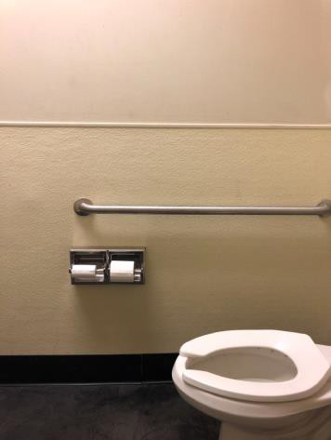

 | ID:  3948 | Facility:  Boise Airport

Location: 2nd Floor Departure Garage Men's Restroom
Schedule: 2021
Estimated Cost: $100.00

Priority Score 5
Quick Fix: Yes
Built before ADA: No

VIOLATIONS
2010 ADA Standards for Accessible Design Codes: §307.2, §308.2.1
The sharps dispenser is outside of the unobstructed forward reach range at 49" above the floor.
The sharps dispenser protrudes 5" into the circulation space at 49" above the floor.

RECOMMENDATIONS
Lower the sharps dispenser by 1" to meet the accessible reach range of 48" maximum above the floor.
Recess the sharps dispenser so it protrudes a maximum of 4" or place a cane detectable object beneath it.

PHOTOGRAPH(S) OF THIS LOCATION

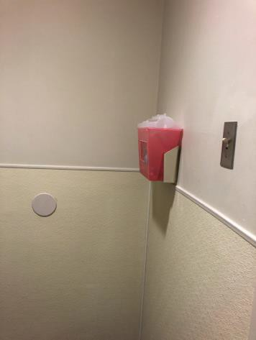

 | ID:  4012 | Facility:  Boise Airport

Location: 2nd Floor Departure Garage Men's Restroom
Schedule: 2021
Estimated Cost: $100.00

Priority Score 7
Quick Fix: Yes
Built before ADA: No

VIOLATIONS
2010 ADA Standards for Accessible Design Codes: §606.5
The pipes under the sink are not covered.

RECOMMENDATIONS
Wrap the pipes beneath the sink with soft protective wrap or plastic.

PHOTOGRAPH(S) OF THIS LOCATION

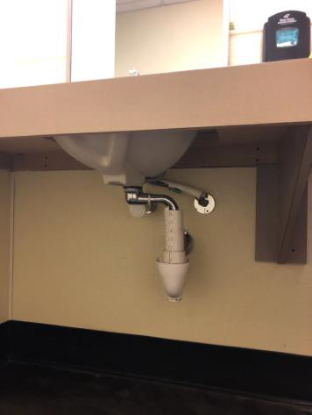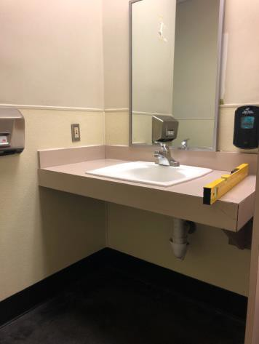

 | ID:  4102 | Facility:  Boise Airport

Location: 2nd Floor Departure Garage Men's Restroom
Schedule: 2021
Estimated Cost: $100.00

Priority Score 5
Quick Fix: Yes
Built before ADA: No

VIOLATIONS
2010 ADA Standards for Accessible Design Codes: §604.8.1.2
The door to the accessible water closet is not self closing. Either self-closing hinges are not installed on the door or if installed, they are defective.

RECOMMENDATIONS
Install or reinstall self-closing hinges on the door to ensure that the door is self-closing per the ADA requirements.

PHOTOGRAPH(S) OF THIS LOCATION

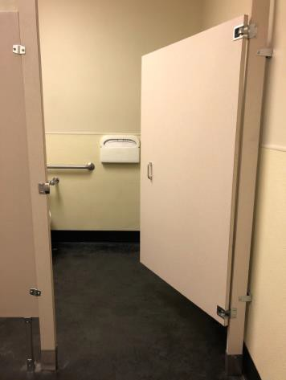

 | ID:  4144 | Facility:  Boise Airport

Location: 2nd Floor Departure Garage Men's Restroom
Schedule: 2021
Estimated Cost: $100.00

Priority Score 8
Quick Fix: Yes
Built before ADA: No

VIOLATIONS
2010 ADA Standards for Accessible Design Codes: §308.2.1
The coat hook is outside of the unobstructed forward reach range at 63" above the floor.

RECOMMENDATIONS
Lower the coat hook by 15" to meet the accessible reach range of 48" maximum above the floor.

PHOTOGRAPH(S) OF THIS LOCATION

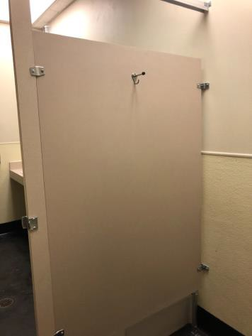

 | ID:  4078 | Facility:  Boise Airport

Location: 2nd Floor Departure Garage Men's Restroom
Schedule: 2022
Estimated Cost: $1,000.00

Priority Score 5
Quick Fix: No
Built before ADA: No

VIOLATIONS
2010 ADA Standards for Accessible Design Codes: §604.2
The centerline of the toilet is located 19.5" from the sidewall.

RECOMMENDATIONS
Reposition the centerline of the toilet to be within 16" minimum and 18" maximum from the sidewall.

PHOTOGRAPH(S) OF THIS LOCATION

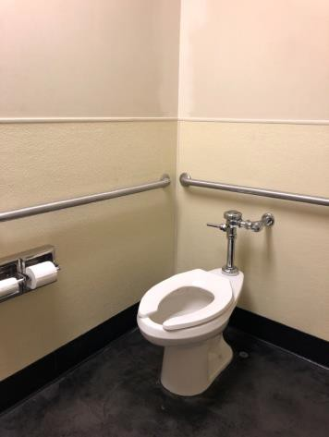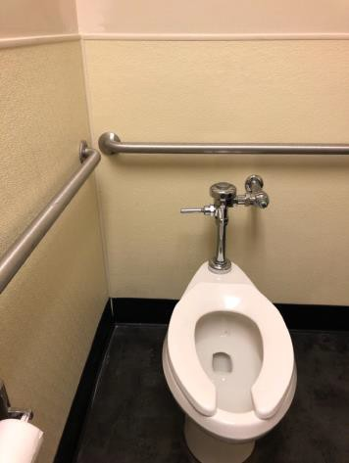

 | ID:  4079 | Facility:  Boise Airport

Location: 2nd Floor Departure Garage Men's Restroom
Schedule: 2022
Estimated Cost: $1,000.00

Priority Score 5
Quick Fix: No
Built before ADA: No

VIOLATIONS
2010 ADA Standards for Accessible Design Codes: §604.6
The flush control is located on the wall side of the toilet.

RECOMMENDATIONS
Either make the toilet flush automatically or relocate the flush control to be operated on the open side of the toilet.

PHOTOGRAPH(S) OF THIS LOCATION

 | ID:  4133 | Facility:  Boise Airport

Location: 2nd Floor Departure Garage Men's Restroom
Schedule: 2022
Estimated Cost: $1,000.00

Priority Score 5
Quick Fix: No
Built before ADA: No

VIOLATIONS
2010 ADA Standards for Accessible Design Codes: ICC A117.1 §604.5.1
The accessible water closet does not have a vertical grab bar.

RECOMMENDATIONS
Install an 18" long (minimum) vertical grab bar on the side wall. The grab bar shall be mounted with the bottom located at 39" minimum and 41" maximum above the floor.
The centerline of the vertical grab bar shall be located 39" minimum and 41" maximum from the real wall.

PHOTOGRAPH(S) OF THIS LOCATION

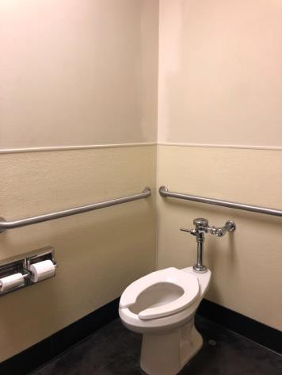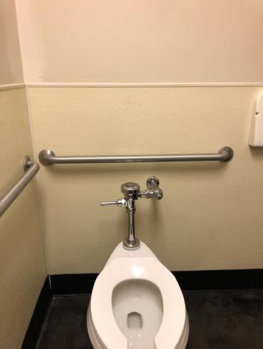

 | ID:  4134 | Facility:  Boise Airport

Location: 2nd Floor Departure Garage Men's Restroom
Schedule: 2022
Estimated Cost: $1,000.00

Priority Score 5
Quick Fix: No
Built before ADA: No

VIOLATIONS
2010 ADA Standards for Accessible Design Codes: §604.5.2
The rear grab bar is centered on the toilet.

RECOMMENDATIONS
Replace the rear grab bar with one that is a minimum of 36" long minimum and extends from the centerline of the water closet 12" minimum on one side and 24" minimum on the other.

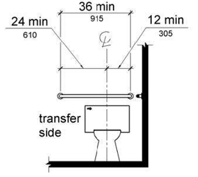

PHOTOGRAPH(S) OF THIS LOCATION

 | ID:  4352 | Facility:  Boise Airport

Location: 2nd Floor New Parking Garage
Schedule: 2021
Estimated Cost: $100.00

Priority Score 6
Quick Fix: Yes
Built before ADA: No

VIOLATIONS
2010 ADA Standards for Accessible Design Codes: §703.4
The tactile sign identifying the room is too high.

RECOMMENDATIONS
Reinstall the sign on the latch side of the door at 48" minimum above the floor measured from the baseline of the lowest character and 60" maximum measured from the baseline of the highest character.

PHOTOGRAPH(S) OF THIS LOCATION

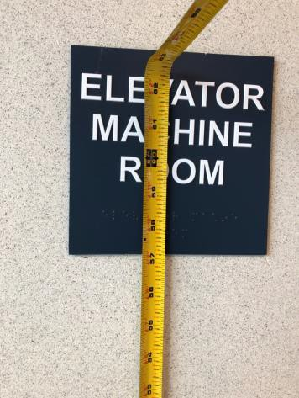

 | ID:  4443 | Facility:  Boise Airport

Location: 2nd Floor New Parking Garage
Schedule: 2021
Estimated Cost: $500.00

Priority Score 9
Quick Fix: Yes
Built before ADA: No

VIOLATIONS
2010 ADA Standards for Accessible Design Codes: §502.6
One accessible parking space sign is missing. The four existing accessible parking space signs are 52" above the ground.

RECOMMENDATIONS
Install/readjust the height of an accessible parking sign at each accessible space at a minimum height of 60" above the ground.

PHOTOGRAPH(S) OF THIS LOCATION

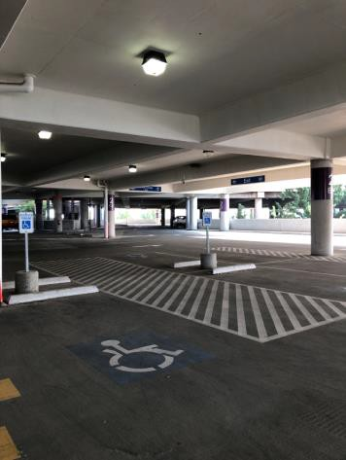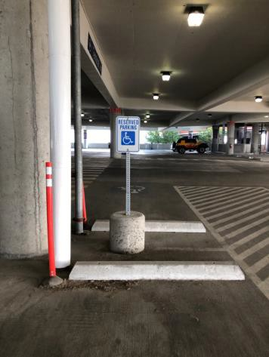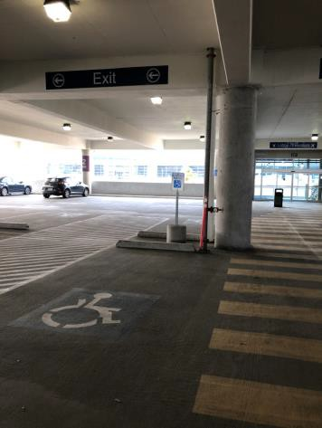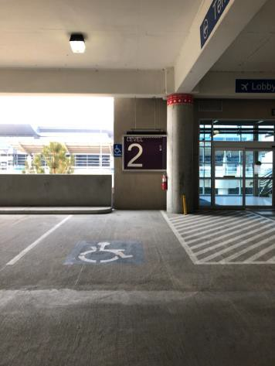

 | ID:  4445 | Facility:  Boise Airport

Location: 2nd Floor New Parking Garage
Schedule: 2021
Estimated Cost: $500.00

Priority Score 9
Quick Fix: Yes
Built before ADA: No

VIOLATIONS
2010 ADA Standards for Accessible Design Codes: §502
The painted lines for the accessible parking spaces are missing along the crosswalk.

RECOMMENDATIONS
Paint the boundary line for accessible parking space along the crosswalk.

PHOTOGRAPH(S) OF THIS LOCATION

 | ID:  4446 | Facility:  Boise Airport

Location: 2nd Floor New Parking Garage
Schedule: 2023
Estimated Cost: $1,000.00

Priority Score 9
Quick Fix: No
Built before ADA: No

VIOLATIONS
2010 ADA Standards for Accessible Design Codes: §206.8
A bollard encroaches on the yellow painted access aisle reducing its width.

RECOMMENDATIONS
Add a parking bumper to ensure that the column and bollard are not encroaching on the adjacent access aisle.

PHOTOGRAPH(S) OF THIS LOCATION

 | ID:  4444 | Facility:  Boise Airport

Location: 2nd Floor New Parking Garage
Schedule: 2021
Estimated Cost: $1,000.00

Priority Score 2
Quick Fix: No
Built before ADA: No

VIOLATIONS
2010 ADA Standards for Accessible Design Codes: §208.2.4
There are no marked "Van accessible" spaces.

RECOMMENDATIONS
Add a 132" wide van accessible parking space for every six vehicle parking spaces. Add a “van accessible” parking sign at a minimum height of 60" above the ground.

PHOTOGRAPH(S) OF THIS LOCATION

 | ID:  3087 | Facility:  Boise Airport

Location: 2nd Floor Parking Garage D10
Schedule: 2021
Estimated Cost: $100.00

Priority Score 5
Quick Fix: Yes
Built before ADA: No

VIOLATIONS
2010 ADA Standards for Accessible Design Codes: §307.2
The fire extinguisher protrudes 6.5" into the circulation space at 31" above the floor.

RECOMMENDATIONS
Recess the fire extinguisher so it protrudes a maximum of 4", lower it so the bottom edge is 27" maximum above the floor, or place a cane detectable object beneath it.

PHOTOGRAPH(S) OF THIS LOCATION

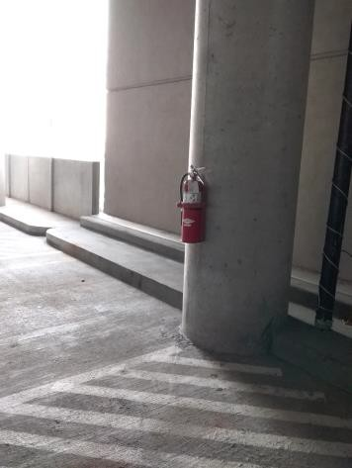

 | ID:  3169 | Facility:  Boise Airport

Location: 2nd Floor Parking Garage D10
Schedule: 2021
Estimated Cost: $100.00

Priority Score 3
Quick Fix: Yes
Built before ADA: No

VIOLATIONS
2010 ADA Standards for Accessible Design Codes: §502.3
The garbage can is obstructing the access route.

RECOMMENDATIONS
Relocate the garbage can so it is not located within the access aisle or blocking the ramp's handrails and accessible route.

PHOTOGRAPH(S) OF THIS LOCATION

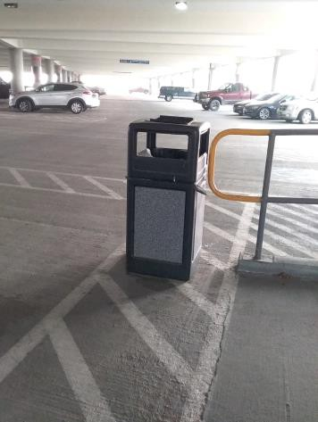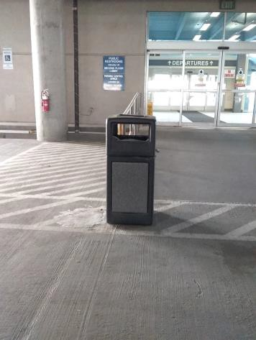

 | ID:  3687 | Facility:  Boise Airport

Location: 2nd Floor Parking Garage D10
Schedule: 2021
Estimated Cost: $500.00

Priority Score 3
Quick Fix: Yes
Built before ADA: No

VIOLATIONS
2010 ADA Standards for Accessible Design Codes: §502.5
There is a metal pole in the accessible route and interfering with the accessible parking space.

RECOMMENDATIONS
Remove the metal pole from access aisle.

PHOTOGRAPH(S) OF THIS LOCATION

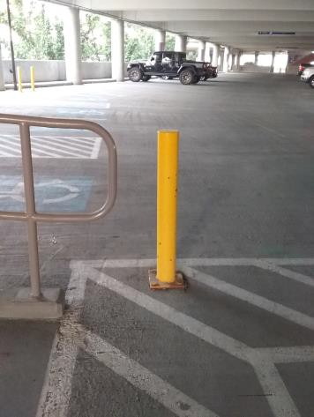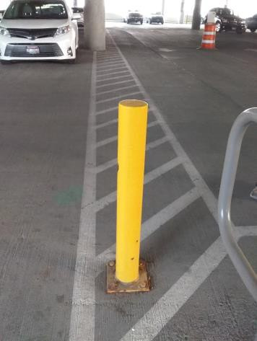

 | ID:  3156 | Facility:  Boise Airport

Location: 2nd Floor Parking Garage D10
Schedule: 2021
Estimated Cost: $5,000.00

Priority Score 3
Quick Fix: No
Built before ADA: No

VIOLATIONS
2010 ADA Standards for Accessible Design Codes: §502.4
The parking space has a 3% slope.

RECOMMENDATIONS
Resurface the parking space to reduce the slope to a maximum of 2% in all directions.

PHOTOGRAPH(S) OF THIS LOCATION

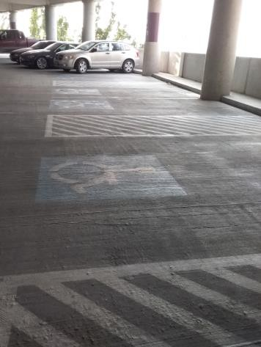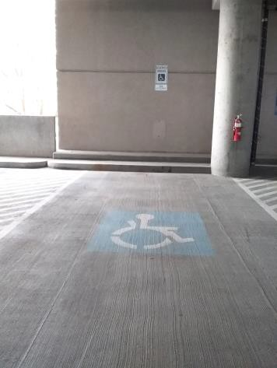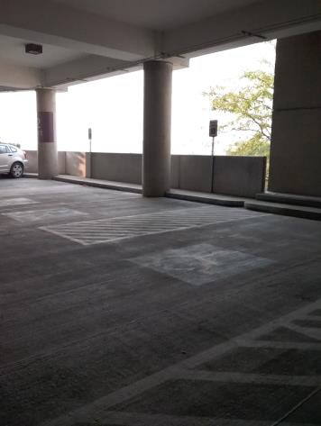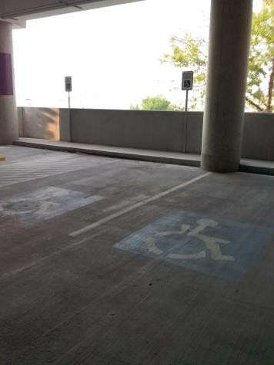

 | ID:  3773 | Facility:  Boise Airport

Location: 2nd Floor Parking Garage Ramp
Schedule: 2021
Estimated Cost: $5,000.00

Priority Score 3
Quick Fix: No
Built before ADA: No

VIOLATIONS
2010 ADA Standards for Accessible Design Codes: §405.2
The running slope of the ramp is between 8.7% and 8.9%.

RECOMMENDATIONS
Resurface the ramp to reduce the running slope to a maximum of 8.3%.

PHOTOGRAPH(S) OF THIS LOCATION

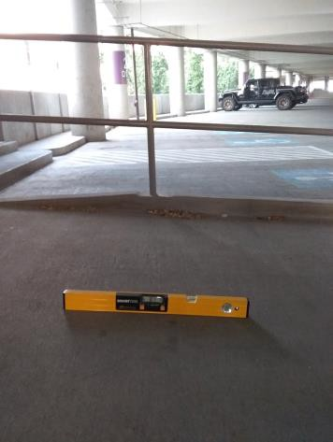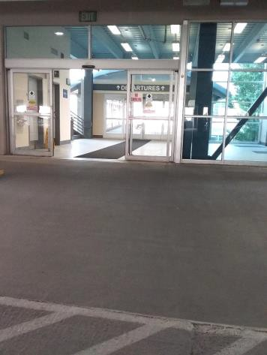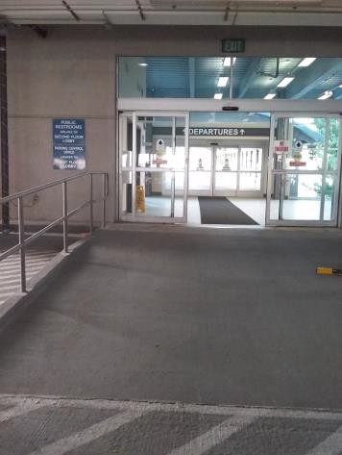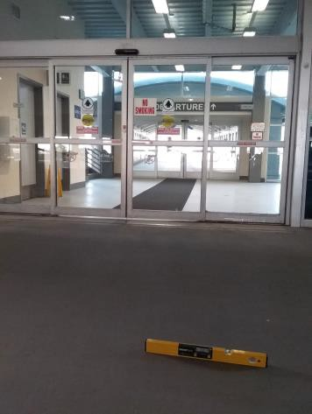

 | ID:  4027 | Facility:  Boise Airport

Location: 2nd Floor Parking Garage to Departure
Schedule: 2021
Estimated Cost: $2,000.00

Priority Score 3
Quick Fix: No
Built before ADA: No

VIOLATIONS
2010 ADA Standards for Accessible Design Codes: §406.3
The curb ramp flares have a 11.6% slope.

RECOMMENDATIONS
Resurface the curb ramp flares to ensure a maximum slope of 10%.

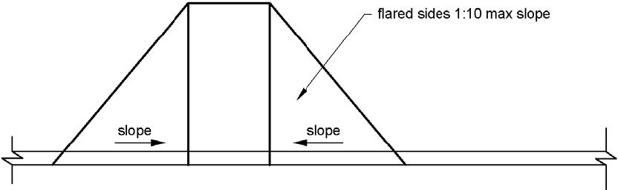

PHOTOGRAPH(S) OF THIS LOCATION

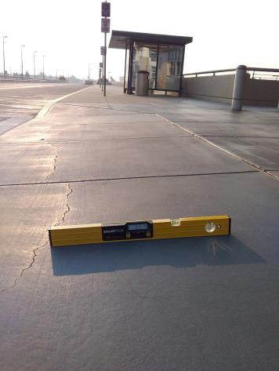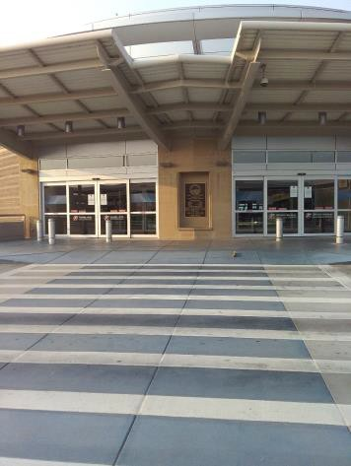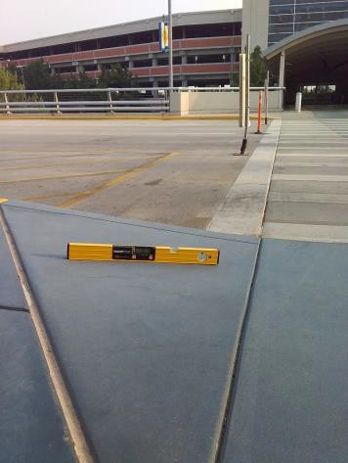

 | ID:  4026 | Facility:  Boise Airport

Location: 2nd Floor Parking Garage to Departure
Schedule: 2021
Estimated Cost: $3,000.00

Priority Score 3
Quick Fix: No
Built before ADA: No

VIOLATIONS
2010 ADA Standards for Accessible Design Codes: §405.2, §705
The curb ramp does not have a detectable warning.
The running slope of the curb ramp is 9.3%.

RECOMMENDATIONS
Install detectable warnings that contrast visually with the adjacent surface with either light-on-dark, or dark-on-light, are the width of the curb ramp, and have a depth of 24".
Reconstruct the curb ramp to reduce the running slope to a maximum of 8.3%.

PHOTOGRAPH(S) OF THIS LOCATION

 | ID:  3008 | Facility:  Boise Airport

Location: 2nd Floor Parking Garage to Departures Terminal
Schedule: 2022
Estimated Cost: $1,000.00

Priority Score 7
Quick Fix: No
Built before ADA: No

VIOLATIONS
2010 ADA Standards for Accessible Design Codes: §705
The curb ramps do not have detectable warnings.

RECOMMENDATIONS
Install detectable warnings that contrast visually with the adjacent surface with either light-on-dark, or dark-on-light, are the width of the curb ramp, and have a depth of 24".

PHOTOGRAPH(S) OF THIS LOCATION

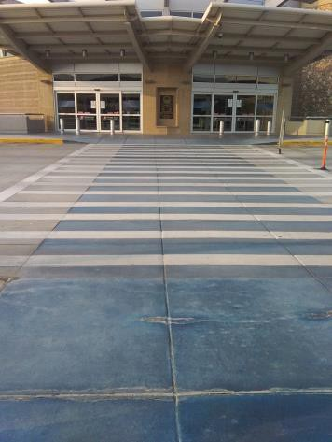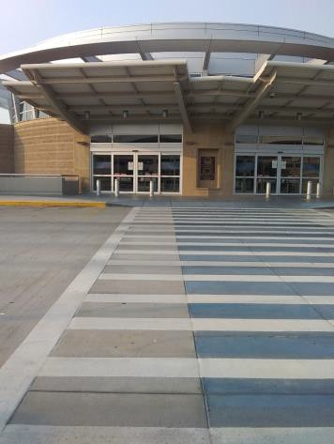

 | ID:  3107 | Facility:  Boise Airport

Location: 2nd Floor Parking Garage to Departures Terminal
Schedule: 2022
Estimated Cost: $1,000.00

Priority Score 7
Quick Fix: No
Built before ADA: No

VIOLATIONS
2010 ADA Standards for Accessible Design Codes: §705
The curb ramps do not have detectable warnings. This is located in the Departures Terminal for United.

RECOMMENDATIONS
Install detectable warnings that contrast visually with the adjacent surface with either light-on-dark, or dark-on-light, are the width of the curb ramp, and have a depth of 24".

PHOTOGRAPH(S) OF THIS LOCATION

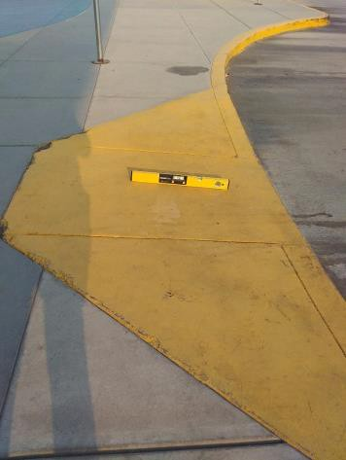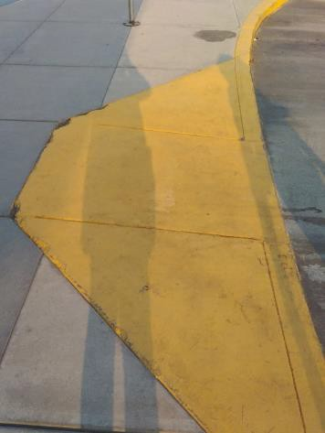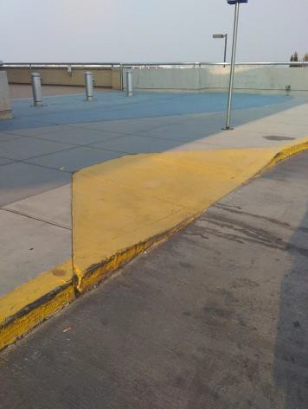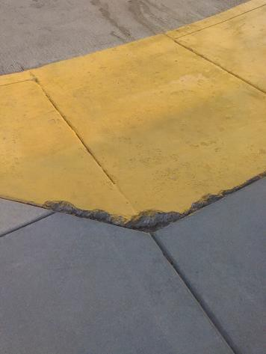

 | ID:  3109 | Facility:  Boise Airport

Location: 2nd Floor Parking Garage to Departures Terminal
Schedule: 2022
Estimated Cost: $1,000.00

Priority Score 7
Quick Fix: No
Built before ADA: No

VIOLATIONS
2010 ADA Standards for Accessible Design Codes: §406.2
There is an abrupt change in vertical elevation where the curb ramp meets the sidewalk. This is located in the Departures Terminal for Allegiant, Delta, and American.

RECOMMENDATIONS
Regrade the transition to ensure that the vertical change in elevation does not exceed 0.25".

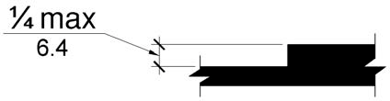

PHOTOGRAPH(S) OF THIS LOCATION

 | ID:  3132 | Facility:  Boise Airport

Location: 2nd Floor Parking Garage to Departures Terminal
Schedule: 2022
Estimated Cost: $1,000.00

Priority Score 5
Quick Fix: No
Built before ADA: No

VIOLATIONS
2010 ADA Standards for Accessible Design Codes: §303.2
There is a change in level greater than 0.25".

RECOMMENDATIONS
Resurface the pathway to reduce the change in level to less than 0.25" or 0.5" if beveled.

PHOTOGRAPH(S) OF THIS LOCATION

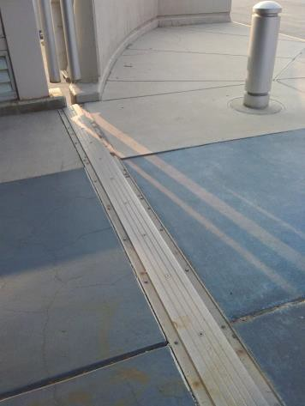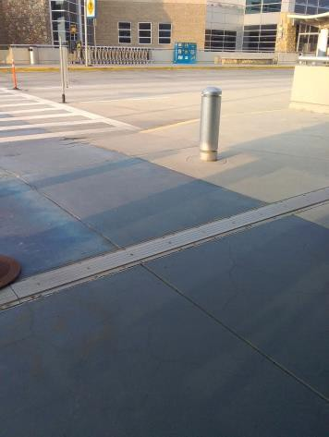

 | ID:  3691 | Facility:  Boise Airport

Location: 2nd Floor Parking Garage to Departures Terminal
Schedule: 2022
Estimated Cost: $1,000.00

Priority Score 5
Quick Fix: No
Built before ADA: No

VIOLATIONS
2010 ADA Standards for Accessible Design Codes: §303.2
There is a 1.5" step at the base of the curb ramp.
This is located in the Departures Terminal for Southwest.

RECOMMENDATIONS
Resurface the pathway to reduce the change in level to less than 0.25" or 0.5" if beveled.

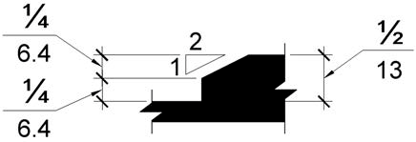

PHOTOGRAPH(S) OF THIS LOCATION

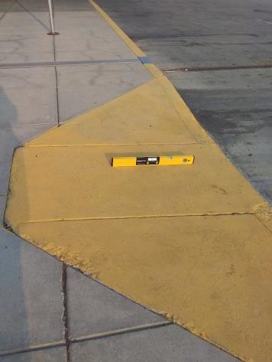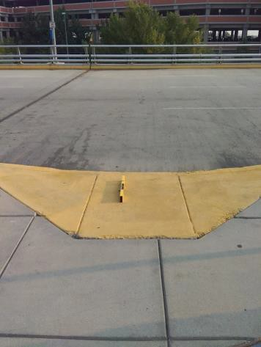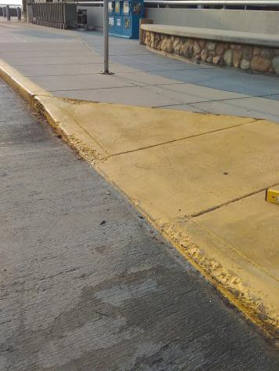

 | ID:  3110 | Facility:  Boise Airport

Location: 2nd Floor Parking Garage to Departures Terminal
Schedule: 2021
Estimated Cost: $1,000.00

Priority Score 3
Quick Fix: No
Built before ADA: No

VIOLATIONS
2010 ADA Standards for Accessible Design Codes: §302.1
There is a change in level at the top of the curb ramp due to a large crack. This is located in the Departures Terminal for Allegiant, Delta, and American.

RECOMMENDATIONS
Repave the top of the curb ramp to remove the crack.

PHOTOGRAPH(S) OF THIS LOCATION

 | ID:  3111 | Facility:  Boise Airport

Location: 2nd Floor Parking Garage to Departures Terminal
Schedule: 2021
Estimated Cost: $2,000.00

Priority Score 3
Quick Fix: No
Built before ADA: No

VIOLATIONS
2010 ADA Standards for Accessible Design Codes: §406.3
The curb ramp flares have slopes of 10.7% and 11.3%.
This is located in the Departures Terminal for Allegiant, Delta, and American.

RECOMMENDATIONS
Resurface the curb ramp flares to ensure a maximum slope of 10%.

PHOTOGRAPH(S) OF THIS LOCATION

 | ID:  3108 | Facility:  Boise Airport

Location: 2nd Floor Parking Garage to Departures Terminal
Schedule: 2022
Estimated Cost: $2,500.00

Priority Score 7
Quick Fix: No
Built before ADA: No

VIOLATIONS
2010 ADA Standards for Accessible Design Codes: §405.2
The running slope of the curb ramp is 9.8%.
This is located in the Departures Terminal for Allegiant, Delta, and American.

RECOMMENDATIONS
Reconstruct the curb ramp to reduce the running slope to a maximum of 8.3%.

PHOTOGRAPH(S) OF THIS LOCATION

 | ID:  3131 | Facility:  Boise Airport

Location: 2nd Floor Parking Garage to Departures Terminal
Schedule: 2021
Estimated Cost: $5,000.00

Priority Score 3
Quick Fix: No
Built before ADA: No

VIOLATIONS
2010 ADA Standards for Accessible Design Codes: §403.3
The route has a running slope of 10%.

RECOMMENDATIONS
Resurface the route to reduce the running slope to a maximum of 5%.

PHOTOGRAPH(S) OF THIS LOCATION

 | ID:  3096 | Facility:  Boise Airport

Location: 2nd Floor Parking Garage to Departures Terminal (Alaska Airlines)
Schedule: 2021
Estimated Cost: $100.00

Priority Score 8
Quick Fix: Yes
Built before ADA: No

VIOLATIONS
2010 ADA Standards for Accessible Design Codes: §308.2.1
The newspaper stand is outside of the unobstructed forward reach range at 53" above the floor.

RECOMMENDATIONS
Lower the newspaper stand by 5" to meet the accessible reach range of 48" maximum above the floor.

PHOTOGRAPH(S) OF THIS LOCATION

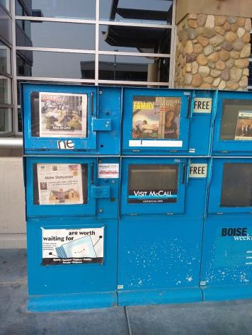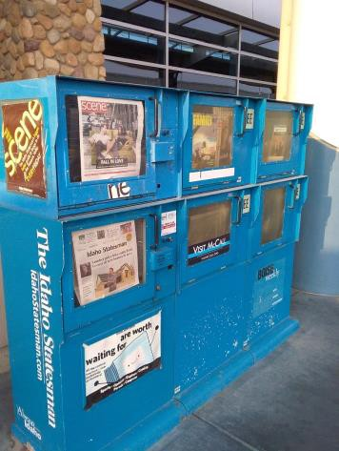

 | ID:  3485 | Facility:  Boise Airport

Location: 2nd Floor Parking Garage to Departures Terminal (Alaska Airlines)
Schedule: 2022
Estimated Cost: $500.00

Priority Score 7
Quick Fix: Yes
Built before ADA: No

VIOLATIONS
2010 ADA Standards for Accessible Design Codes: §705
The curb ramps do not have detectable warnings.

RECOMMENDATIONS
Install detectable warnings that contrast visually with the adjacent surface with either light-on-dark, or dark-on-light, are the width of the curb ramp, and have a depth of 24".

PHOTOGRAPH(S) OF THIS LOCATION

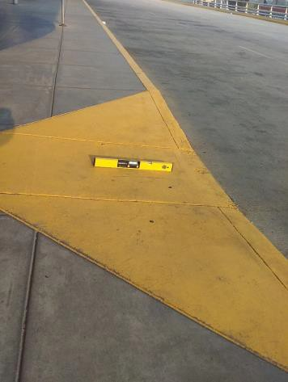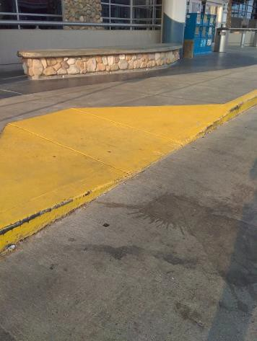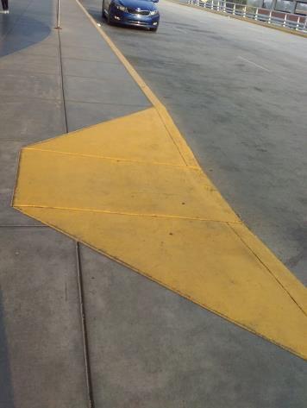

 | ID:  3486 | Facility:  Boise Airport

Location: 2nd Floor Parking Garage to Departures Terminal (Alaska Airlines)
Schedule: 2022
Estimated Cost: $1,000.00

Priority Score 5
Quick Fix: No
Built before ADA: No

VIOLATIONS
2010 ADA Standards for Accessible Design Codes: §303.2
There is an abrupt change in vertical elevation where the curb ramp meets the sidewalk resulting in a change in level greater than 0.25".

RECOMMENDATIONS
Resurface the pathway to reduce the change in level to less than 0.25" or 0.5" if beveled.

PHOTOGRAPH(S) OF THIS LOCATION

 | ID:  3484 | Facility:  Boise Airport

Location: 2nd Floor Parking Garage to Departures Terminal (Alaska Airlines)
Schedule: 2021
Estimated Cost: $1,000.00

Priority Score 3
Quick Fix: No
Built before ADA: No

VIOLATIONS
2010 ADA Standards for Accessible Design Codes: §406.3
The curb ramp flares have a 10.6% to 11.4% slope.

RECOMMENDATIONS
Resurface the curb ramp flares to ensure a maximum slope of 10%.

PHOTOGRAPH(S) OF THIS LOCATION

 | ID:  3482 | Facility:  Boise Airport

Location: 2nd Floor Parking Garage to Departures Terminal (Alaska Airlines)
Schedule: 2022
Estimated Cost: $2,500.00

Priority Score 7
Quick Fix: No
Built before ADA: No

VIOLATIONS
2010 ADA Standards for Accessible Design Codes: §405.2
The running slope of the curb ramp is 10.5%.

RECOMMENDATIONS
Reconstruct the curb ramp to reduce the running slope to a maximum of 8.3%.

PHOTOGRAPH(S) OF THIS LOCATION

 | ID:  3690 | Facility:  Boise Airport

Location: 2nd Floor Parking Garage to Departures Terminal (Southwest)
Schedule: 2022
Estimated Cost: $1,000.00

Priority Score 7
Quick Fix: No
Built before ADA: No

VIOLATIONS
2010 ADA Standards for Accessible Design Codes: §705
The curb ramps do not have detectable warnings.

RECOMMENDATIONS
Install detectable warnings that contrast visually with the adjacent surface with either light-on-dark, or dark-on-light, are the width of the curb ramp, and have a depth of 24".

PHOTOGRAPH(S) OF THIS LOCATION

 | ID:  3692 | Facility:  Boise Airport

Location: 2nd Floor Parking Garage to Departures Terminal (Southwest)
Schedule: 2022
Estimated Cost: $1,000.00

Priority Score 7
Quick Fix: No
Built before ADA: No

VIOLATIONS
2010 ADA Standards for Accessible Design Codes: §405.2
The running slope of the curb ramp is 9.3%.

RECOMMENDATIONS
Resurface the curb ramp to reduce the running slope to a maximum of 8.3%.

PHOTOGRAPH(S) OF THIS LOCATION

 | ID:  3693 | Facility:  Boise Airport

Location: 2nd Floor Parking Garage to Departures Terminal (Southwest)
Schedule: 2021
Estimated Cost: $2,000.00

Priority Score 3
Quick Fix: No
Built before ADA: No

VIOLATIONS
2010 ADA Standards for Accessible Design Codes: §406.3
The curb ramp flares have a 10.8% and 13.2% slope.

RECOMMENDATIONS
Resurface the curb ramp flares to ensure a maximum slope of 10%.

PHOTOGRAPH(S) OF THIS LOCATION

 | ID:  3694 | Facility:  Boise Airport

Location: 2nd Floor Parking Garage to Departures Terminal (Southwest)
Schedule: 2021
Estimated Cost: $2,500.00

Priority Score 3
Quick Fix: No
Built before ADA: No

VIOLATIONS
2010 ADA Standards for Accessible Design Codes: §405.5
The curb ramp is 34" wide.

RECOMMENDATIONS
Expand the curb ramp to be a minimum width of 36".

PHOTOGRAPH(S) OF THIS LOCATION

 | ID:  4324 | Facility:  Boise Airport

Location: 3rd Floor Accessible Parking
Schedule: 2021
Estimated Cost: $1,000.00

Priority Score 3
Quick Fix: No
Built before ADA: No

VIOLATIONS
2010 ADA Standards for Accessible Design Codes: §502.4
The parking space has a 2.3% slope.

RECOMMENDATIONS
Resurface the parking space to reduce the slope to a maximum of 2% in all directions.

PHOTOGRAPH(S) OF THIS LOCATION

 | ID:  3359 | Facility:  Boise Airport

Location: 3rd Floor New Parking Garage 3A5
Schedule: 2021
Estimated Cost: $100.00

Priority Score 6
Quick Fix: Yes
Built before ADA: No

VIOLATIONS
2010 ADA Standards for Accessible Design Codes: §703.4
The tactile sign identifying the room is not in the correct location at 60.5" above the floor.

RECOMMENDATIONS
Reinstall the sign on the latch side of the door at 48" minimum above the floor measured from the baseline of the lowest character and 60" maximum measured from the baseline of the highest character.

PHOTOGRAPH(S) OF THIS LOCATION

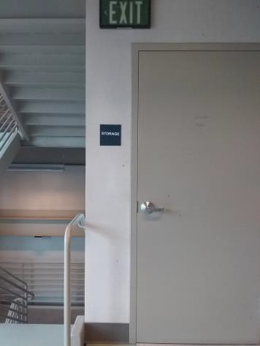

 | ID:  3392 | Facility:  Boise Airport

Location: 3rd Floor New Parking Garage 3A5
Schedule: 2021
Estimated Cost: $100.00

Priority Score 9
Quick Fix: Yes
Built before ADA: No

VIOLATIONS
2010 ADA Standards for Accessible Design Codes: §502.6
The accessible parking sign is 51" above the ground.

RECOMMENDATIONS
Remount the accessible parking sign at a minimum height of 60" above the ground.

PHOTOGRAPH(S) OF THIS LOCATION

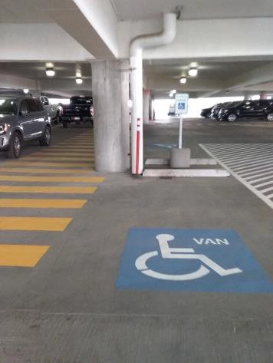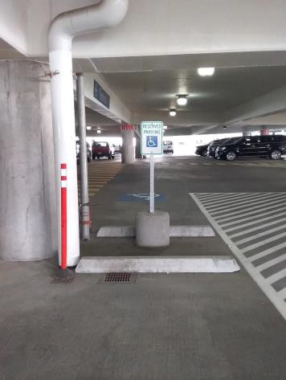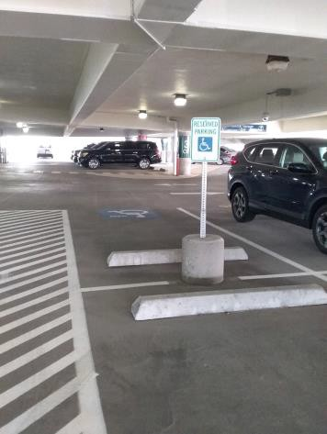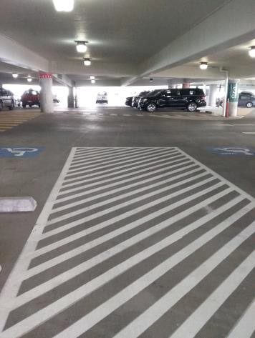

 | ID:  3668 | Facility:  Boise Airport

Location: 3rd Floor New Parking Garage 3A5
Schedule: 2021
Estimated Cost: $100.00

Priority Score 5
Quick Fix: Yes
Built before ADA: No

VIOLATIONS
2010 ADA Standards for Accessible Design Codes: §307.2
The fire extinguisher protrudes 6" into the circulation space at 29.5" above the floor.

RECOMMENDATIONS
Recess the fire extinguisher so it protrudes a maximum of 4", lower it or relocate so the bottom edge is 27" maximum above the floor, or place a cane detectable object beneath it.

PHOTOGRAPH(S) OF THIS LOCATION

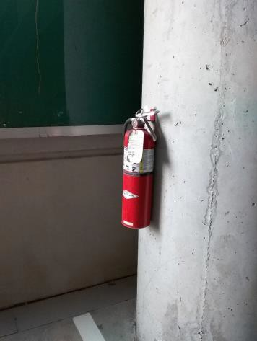

 | ID:  3391 | Facility:  Boise Airport

Location: 3rd Floor New Parking Garage 3A5
Schedule: 2021
Estimated Cost: $1,000.00

Priority Score 9
Quick Fix: No
Built before ADA: No

VIOLATIONS
2010 ADA Standards for Accessible Design Codes: §502
There are no markings on the side of the space closest to the yellow crosswalk.

RECOMMENDATIONS
Paint the accessible parking space to completion by adding a line along the yellow crosswalk.

PHOTOGRAPH(S) OF THIS LOCATION

 | ID:  3706 | Facility:  Boise Airport

Location: 3rd Floor New Parking Garage 3A5
Schedule: 2021
Estimated Cost: $2,000.00

Priority Score 3
Quick Fix: No
Built before ADA: No

VIOLATIONS
2010 ADA Standards for Accessible Design Codes: §502.4
The parking space has a 2.9% slope.

RECOMMENDATIONS
Resurface the parking space to reduce the slope to a maximum of 2% in all directions.

PHOTOGRAPH(S) OF THIS LOCATION

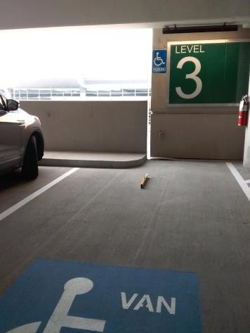

 | ID:  3338 | Facility:  Boise Airport

Location: 3rd Floor Parking Garage D11
Schedule: 2021
Estimated Cost: $100.00

Priority Score 5
Quick Fix: Yes
Built before ADA: No

VIOLATIONS
2010 ADA Standards for Accessible Design Codes: §307.2
The fire extinguisher protrudes 7" into the circulation space at 30.5" above the floor.

RECOMMENDATIONS
Recess the fire extinguisher so it protrudes a maximum of 4", lower it so the bottom edge is 27" maximum above the floor, or place a cane detectable object beneath it.
Or relocate it outside of the accessible route.

PHOTOGRAPH(S) OF THIS LOCATION

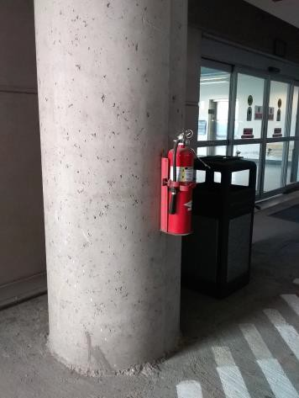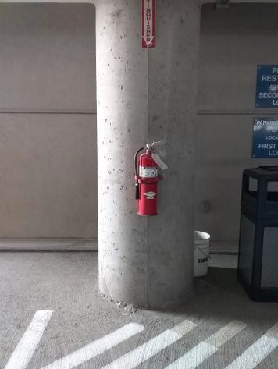

 | ID:  3433 | Facility:  Boise Airport

Location: 3rd Floor Parking Garage D11
Schedule: 2021
Estimated Cost: $100.00

Priority Score 9
Quick Fix: Yes
Built before ADA: No

VIOLATIONS
2010 ADA Standards for Accessible Design Codes: §502.6
The van accessible parking sign is 60.5" above the ground.

RECOMMENDATIONS
Remount the accessible parking sign at a minimum height of 60" above the ground.

PHOTOGRAPH(S) OF THIS LOCATION

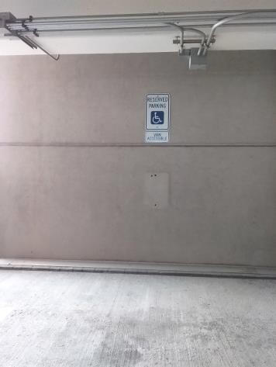

 | ID:  3767 | Facility:  Boise Airport

Location: 3rd Floor Parking Garage D11
Schedule: 2021
Estimated Cost: $100.00

Priority Score 5
Quick Fix: Yes
Built before ADA: No

VIOLATIONS
2010 ADA Standards for Accessible Design Codes: §307.2
The fire extinguisher protrudes 6.75" into the circulation space at 30" above the floor.

RECOMMENDATIONS
Recess the fire extinguisher so it protrudes a maximum of 4", lower it so the bottom edge is 27" maximum above the floor, or place a cane detectable object beneath it.

PHOTOGRAPH(S) OF THIS LOCATION

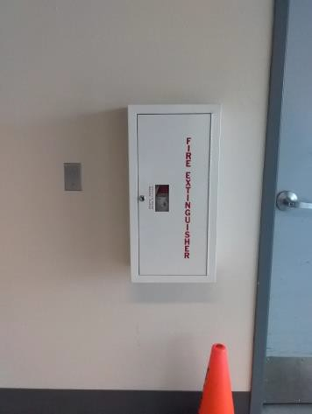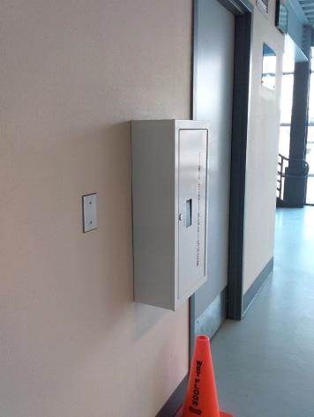

 | ID:  3067 | Facility:  Boise Airport

Location: 3rd Floor Parking Garage D11
Schedule: 2022
Estimated Cost: $1,000.00

Priority Score 6
Quick Fix: No
Built before ADA: No

VIOLATIONS
2010 ADA Standards for Accessible Design Codes: §505.2
The slope of the ramp is 6.5% and there are no handrails.

RECOMMENDATIONS
Install handrails at a minimum height of 34” and maximum of 38” above the ground. Make sure there are adequate handrail extensions both at the top and bottom of the handrail. OR reduce the running slope to a maximum of 5%.

PHOTOGRAPH(S) OF THIS LOCATION

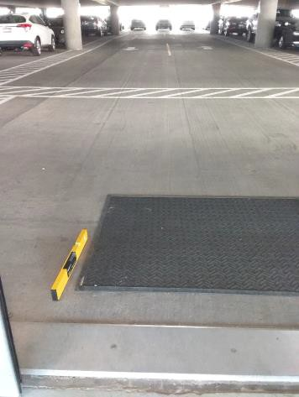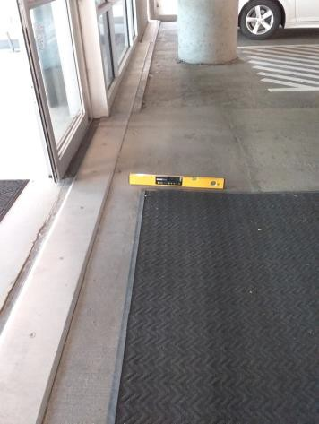

 | ID:  3119 | Facility:  Boise Airport

Location: 3rd Floor Parking Garage D11
Schedule: 2021
Estimated Cost: $1,000.00

Priority Score 3
Quick Fix: No
Built before ADA: No

VIOLATIONS
2010 ADA Standards for Accessible Design Codes: §502.5
The vertical clearance at the van accessible parking space is 95" above the ground. At the top of the space, the height is reduced to 90" above the ground.

RECOMMENDATIONS
Make sure the vertical clearance of the van accessible parking space and access aisle is 98” minimum. Accessible parking spaces shall be a minimum width of 144" with 60" wide access aisles.
This may require moving the spaces to another location that meets the minimum height requirement. Ensure that the entire route leading to the van accessible parking space is of sufficient height.

PHOTOGRAPH(S) OF THIS LOCATION

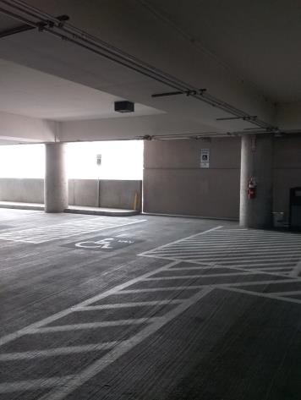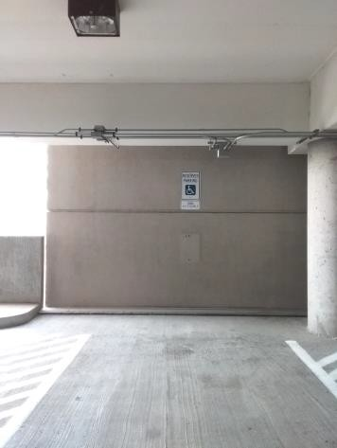

 | ID:  3423 | Facility:  Boise Airport

Location: 3rd Floor Parking Garage D11
Schedule: 2021
Estimated Cost: $1,000.00

Priority Score 3
Quick Fix: No
Built before ADA: No

VIOLATIONS
2010 ADA Standards for Accessible Design Codes: §502.3
The accessible parking spaces and access aisles are not of sufficient width due to concrete poles.

RECOMMENDATIONS
Install parking bumpers to ensure that accessible parking spaces are a minimum of 96" wide, van parking spaces are a minimum of 132" wide, and their adjacent access aisles are a minimum of 60” wide.
The accessible route must be continuous even when cars are parked and overhang the bumpers.

PHOTOGRAPH(S) OF THIS LOCATION

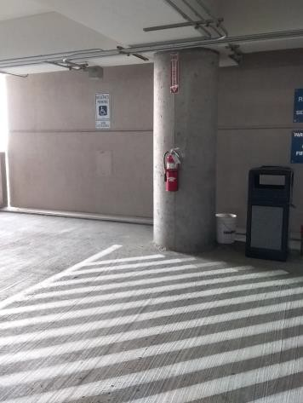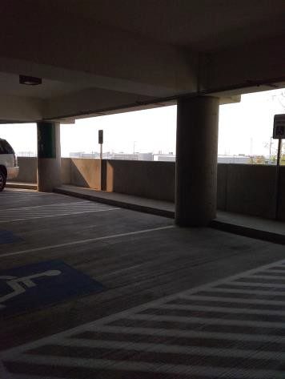

 | ID:  3601 | Facility:  Boise Airport

Location: 3rd Floor Parking Garage D11
Schedule: 2021
Estimated Cost: $1,000.00

Priority Score 3
Quick Fix: No
Built before ADA: No

VIOLATIONS
2010 ADA Standards for Accessible Design Codes: §502.2
The accessible parking space is 91" wide.

RECOMMENDATIONS
Install an accessible parking space that is a minimum of 96" wide with an adjacent aisle that is a minimum of 60" wide.
Ensure at least one accessible parking space is marked as "van" accessible.

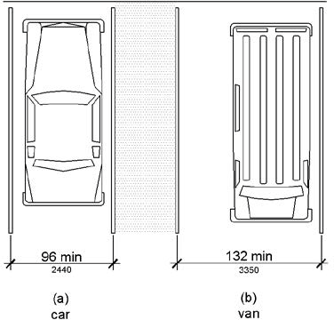

PHOTOGRAPH(S) OF THIS LOCATION

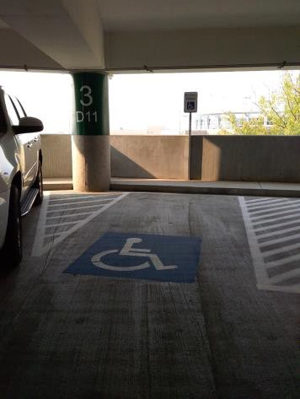

 | ID:  4033 | Facility:  Boise Airport

Location: 4th Floor New Parking Garage
Schedule: 2021
Estimated Cost: $200.00

Priority Score 6
Quick Fix: Yes
Built before ADA: No

VIOLATIONS
2010 ADA Standards for Accessible Design Codes: §703.4
The tactile signs identifying the rooms are not in the correct location as they are too high above the ground.

RECOMMENDATIONS
Reinstall the signs on the latch side of the door at 48" minimum above the floor measured from the baseline of the lowest character and 60" maximum measured from the baseline of the highest character.

PHOTOGRAPH(S) OF THIS LOCATION

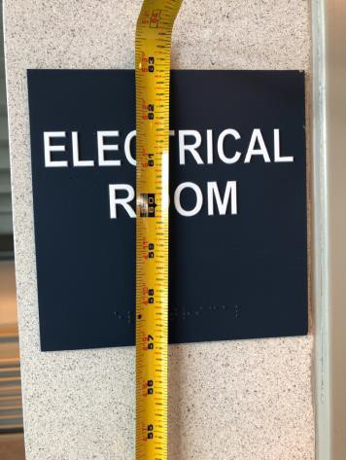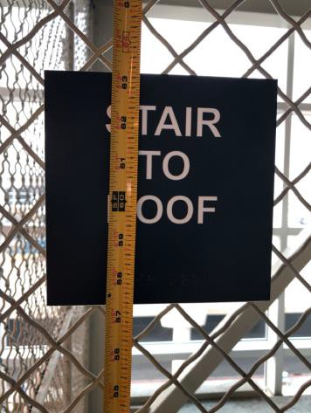

 | ID:  3411 | Facility:  Boise Airport

Location: 4th Floor New Parking Garage 4A5
Schedule: 2021
Estimated Cost: $400.00

Priority Score 9
Quick Fix: Yes
Built before ADA: No

VIOLATIONS
2010 ADA Standards for Accessible Design Codes: §502.6
The accessible parking signs are between 53" and 55" above the floor.

RECOMMENDATIONS
Remount the accessible parking signs at a minimum height of 60" above the ground.

PHOTOGRAPH(S) OF THIS LOCATION

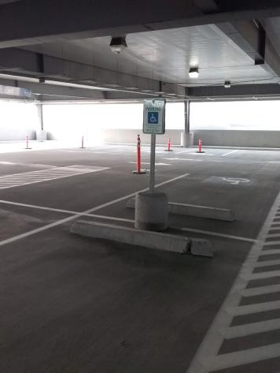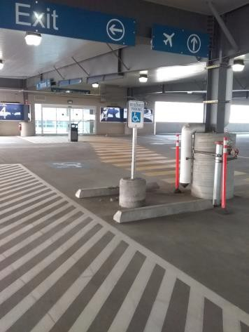

 | ID:  3200 | Facility:  Boise Airport

Location: 4th Floor New Parking Garage 4A5
Schedule: 2021
Estimated Cost: $4,000.00

Priority Score 3
Quick Fix: No
Built before ADA: No

VIOLATIONS
2010 ADA Standards for Accessible Design Codes: §502.3
The access aisles are not of sufficient width due to concrete poles.

RECOMMENDATIONS
Repaint the accessible parking spaces and access aisles so that all accessible car parking spaces are a minimum of 96" wide, van parking spaces are a minimum of 132" wide, and their adjacent access aisles are a minimum of 60” wide. This may require relocating the parking bumper.

PHOTOGRAPH(S) OF THIS LOCATION

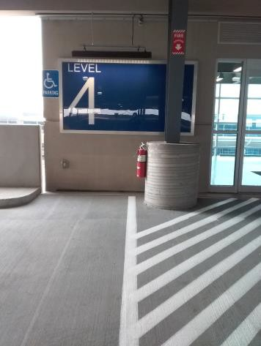

 | ID:  3013 | Facility:  Boise Airport

Location: 4th Floor Parking Garage
Schedule: 2021
Estimated Cost: $100.00

Priority Score 5
Quick Fix: Yes
Built before ADA: No

VIOLATIONS
2010 ADA Standards for Accessible Design Codes: §307.2
The fire extinguisher protrudes 6.75" into the circulation space at 29" above the floor.

RECOMMENDATIONS
Recess the fire extinguisher so it protrudes a maximum of 4", lower it so the bottom edge is 27" maximum above the floor, or place a cane detectable object beneath it.

PHOTOGRAPH(S) OF THIS LOCATION

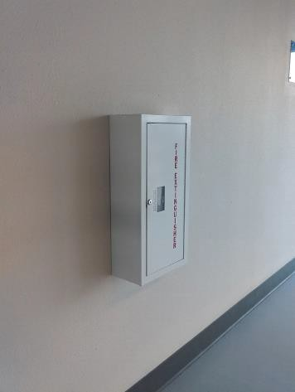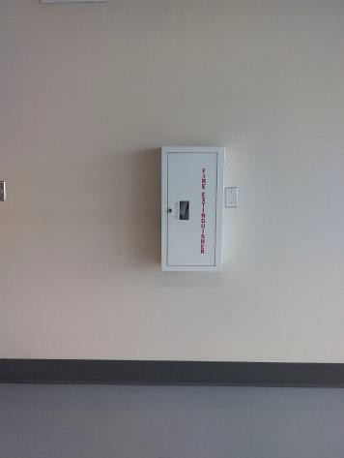

 | ID:  3581 | Facility:  Boise Airport

Location: 4th Floor Parking Garage
Schedule: 2021
Estimated Cost: $1,000.00

Priority Score 3
Quick Fix: No
Built before ADA: No

VIOLATIONS
2010 ADA Standards for Accessible Design Codes: §502.5
The vertical clearance at the van accessible parking space is 96".

RECOMMENDATIONS
Van accessible parking requires a minimum vertical clearance of 98". Relocate the van accessible parking to a location that meets this requirement.

PHOTOGRAPH(S) OF THIS LOCATION

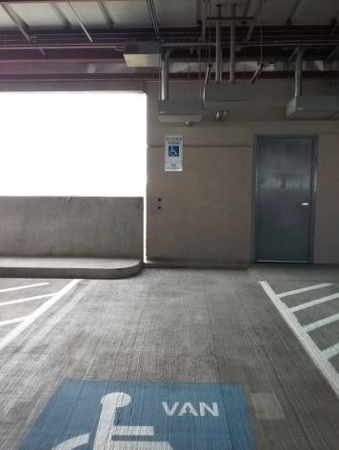

 | ID:  3340 | Facility:  Boise Airport

Location: 4th Floor Parking Garage
Schedule: 2021
Estimated Cost: $2,000.00

Priority Score 3
Quick Fix: No
Built before ADA: No

VIOLATIONS
2010 ADA Standards for Accessible Design Codes: §404.2.4.4, §703
The entrance has a 5.7% slope and no room signage.

RECOMMENDATIONS
Resurface the entryway to reduce the running slope to a maximum of 2% in all directions. Install tactile signage on the latch side of the doorway at a height of 48" minimum to 60" maximum above the floor. Signs shall be Braille with raised lettering and should be placed on the wall in the center of an 18"x18" clear floor space.

PHOTOGRAPH(S) OF THIS LOCATION

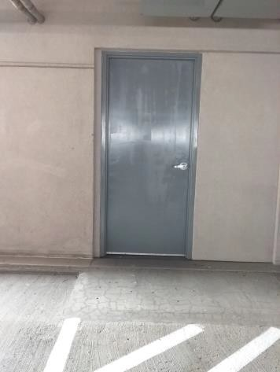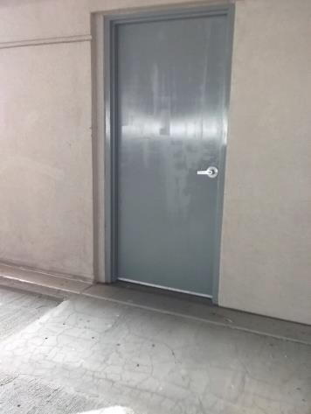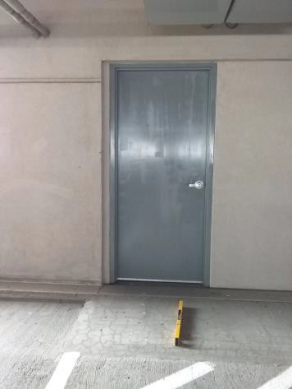

 | ID:  3141 | Facility:  Boise Airport

Location: 4th Floor Parking Garage
Schedule: 2021
Estimated Cost: $2,500.00

Priority Score 3
Quick Fix: No
Built before ADA: No

VIOLATIONS
2010 ADA Standards for Accessible Design Codes: §403.3
The running slope is 6.5%.

RECOMMENDATIONS
Reconstruct the route to reduce the running slope to a maximum of 5%. Or install handrails at a minimum height of 34” and maximum of 38” above the ground. Make sure there are adequate handrail extensions both at the top and bottom of the handrail.

PHOTOGRAPH(S) OF THIS LOCATION

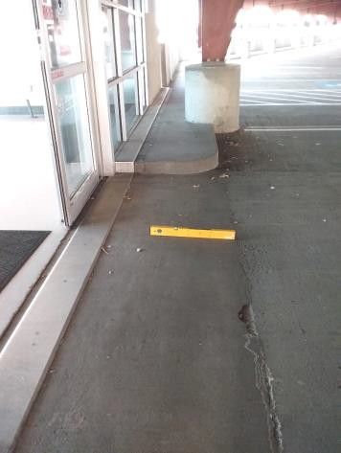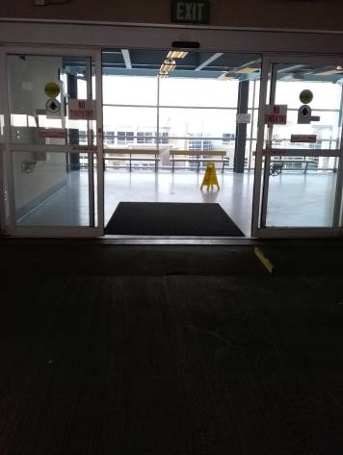

 | ID:  3944 | Facility:  Boise Airport

Location: Contractor Lot Accessible Parking Elevator
Schedule: 2021
Estimated Cost: $500.00

Priority Score 8
Quick Fix: Yes
Built before ADA: No

VIOLATIONS
2010 ADA Standards for Accessible Design Codes: §308.2.1
The button is outside of the unobstructed forward reach range at 56" above the floor.

RECOMMENDATIONS
Lower the button by 8" to meet the accessible reach range of 48" maximum above the floor.
Relocate the button to a location with a leveled clear floor space of 30"x48" with a maximum slope of 2%.

PHOTOGRAPH(S) OF THIS LOCATION

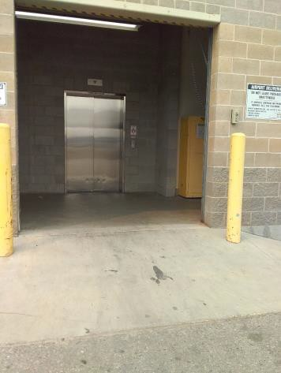

 | ID:  3942 | Facility:  Boise Airport

Location: Contractor Lot Accessible Parking Elevator
Schedule: 2021
Estimated Cost: $1,000.00

Priority Score 3
Quick Fix: No
Built before ADA: No

VIOLATIONS
2010 ADA Standards for Accessible Design Codes: §405.7.2, §405.7.3
The landing is 48" deep and 64" wide.

RECOMMENDATIONS
Expand the provided landing to ensure that the clear length is 60" long minimum perpendicular to the door allowing adequate turning space.

PHOTOGRAPH(S) OF THIS LOCATION

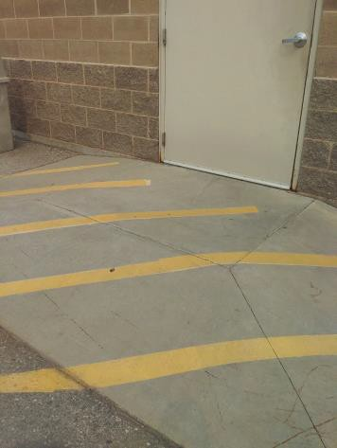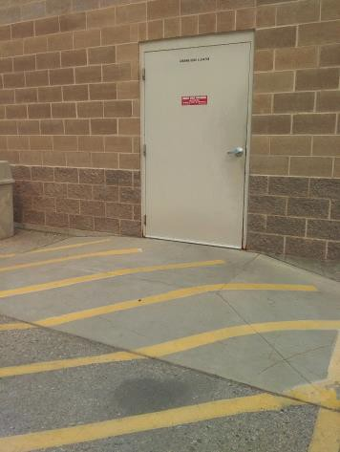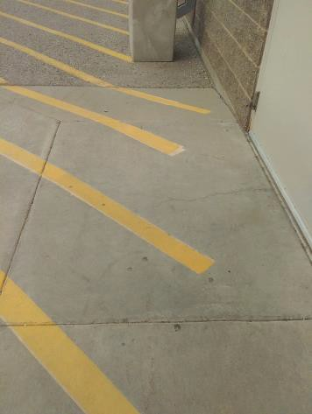

 | ID:  3941 | Facility:  Boise Airport

Location: Contractor Lot Accessible Parking Elevator
Schedule: 2022
Estimated Cost: $2,500.00

Priority Score 7
Quick Fix: No
Built before ADA: No

VIOLATIONS
2010 ADA Standards for Accessible Design Codes: §405.2
The running slope of the ramp is 20%.

RECOMMENDATIONS
Reconstruct the ramp to reduce the running slope to a maximum of 8.3%.

PHOTOGRAPH(S) OF THIS LOCATION

 | ID:  3943 | Facility:  Boise Airport

Location: Contractor Lot Accessible Parking Elevator
Schedule: 2022
Estimated Cost: $2,500.00

Priority Score 7
Quick Fix: No
Built before ADA: No

VIOLATIONS
2010 ADA Standards for Accessible Design Codes: §405.2
The running slope of the ramp is 14.6%.

RECOMMENDATIONS
Reconstruct the ramp to reduce the running slope to a maximum of 8.3%.

PHOTOGRAPH(S) OF THIS LOCATION

 | ID:  3932 | Facility:  Boise Airport

Location: Economy Lot Shuttle Stop C Parking
Schedule: 2021
Estimated Cost: $200.00

Priority Score 3
Quick Fix: Yes
Built before ADA: No

VIOLATIONS
2010 ADA Standards for Accessible Design Codes: §406.4
Due to the garbage cans, the landing clear width is less than 36".

RECOMMENDATIONS
Relocate the garbage cans outside of the landing area.

PHOTOGRAPH(S) OF THIS LOCATION

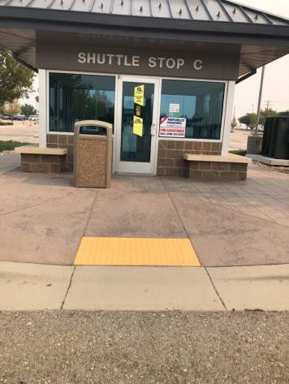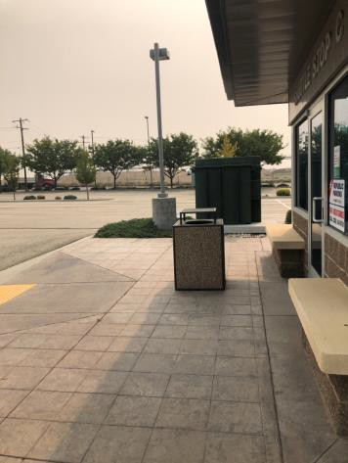

 | ID:  4358 | Facility:  Boise Airport

Location: Economy Lot Shuttle Stop C Parking
Schedule: 2021
Estimated Cost: $200.00

Priority Score 9
Quick Fix: Yes
Built before ADA: No

VIOLATIONS
2010 ADA Standards for Accessible Design Codes: §502.6
The accessible parking signage is 54" above the ground.

RECOMMENDATIONS
Remount the accessible parking sign at each accessible space at a minimum height of 60" above the ground.

PHOTOGRAPH(S) OF THIS LOCATION

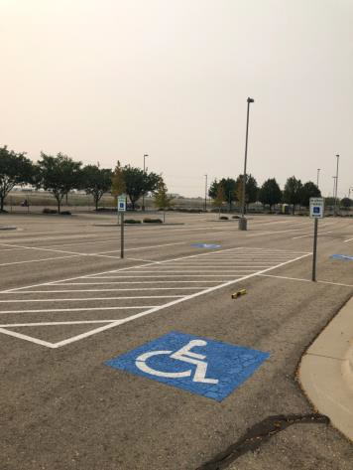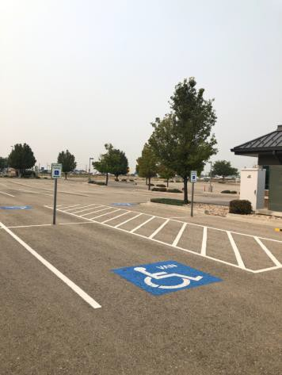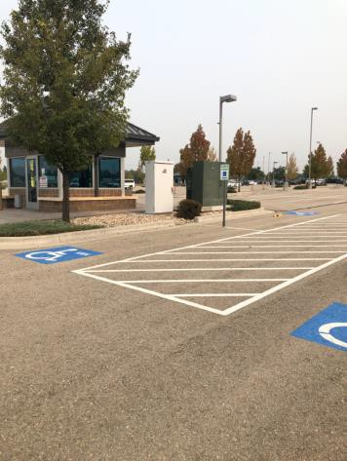

 | ID:  4360 | Facility:  Boise Airport

Location: Economy Lot Shuttle Stop C Parking
Schedule: 2021
Estimated Cost: $200.00

Priority Score 9
Quick Fix: Yes
Built before ADA: No

VIOLATIONS
2010 ADA Standards for Accessible Design Codes: §502.6
The accessible parking sign is 54" above the ground.

RECOMMENDATIONS
Remount the accessible parking sign at each accessible space at a minimum height of 60" above the ground.

PHOTOGRAPH(S) OF THIS LOCATION

 | ID:  4357 | Facility:  Boise Airport

Location: Economy Lot Shuttle Stop C Parking
Schedule: 2021
Estimated Cost: $1,000.00

Priority Score 3
Quick Fix: No
Built before ADA: No

VIOLATIONS
2010 ADA Standards for Accessible Design Codes: §502.4
The North West parking space has a 2.6% slope.

RECOMMENDATIONS
Resurface the parking space to reduce the slope to a maximum of 2% in all directions.

PHOTOGRAPH(S) OF THIS LOCATION

 | ID:  3897 | Facility:  Boise Airport

Location: Economy Parking Lot for Concessions and Airlines
Schedule: 2021
Estimated Cost: $300.00

Priority Score 9
Quick Fix: Yes
Built before ADA: No

VIOLATIONS
2010 ADA Standards for Accessible Design Codes: §502.6
The accessible parking signs are 53.5" to 54.5" above the ground.

RECOMMENDATIONS
Install an accessible parking sign at each accessible space at a minimum height of 60" above the ground.

PHOTOGRAPH(S) OF THIS LOCATION

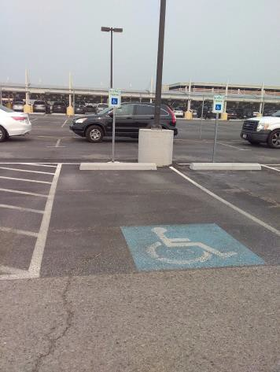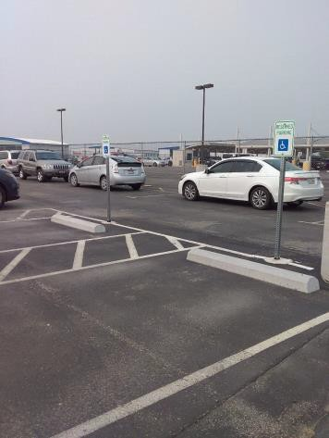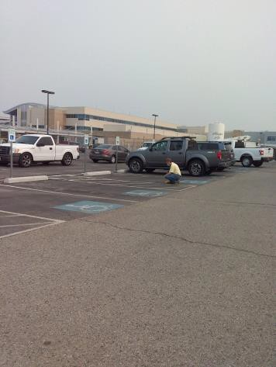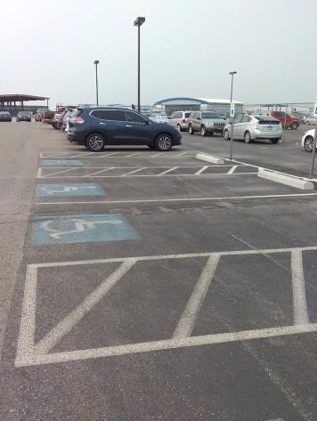

 | ID:  3896 | Facility:  Boise Airport

Location: Economy Parking Lot for Concessions and Airlines
Schedule: 2021
Estimated Cost: $2,500.00

Priority Score 3
Quick Fix: No
Built before ADA: No

VIOLATIONS
2010 ADA Standards for Accessible Design Codes: §502.4
The parking space closest to the entrance has a 3.5% running slope and 2.5% cross slope.

RECOMMENDATIONS
Reconstruct the parking space to reduce the slope to a maximum of 2% in all directions.

PHOTOGRAPH(S) OF THIS LOCATION

 | ID:  3895 | Facility:  Boise Airport

Location: Economy Parking Lot for Concessions and Airlines
Schedule: 2021
Estimated Cost: $4,000.00

Priority Score 3
Quick Fix: No
Built before ADA: No

VIOLATIONS
2010 ADA Standards for Accessible Design Codes: §502.4
The four parking spaces closest to the old fire station have a 3% slope.

RECOMMENDATIONS
Resurface the parking spaces to reduce the slope to a maximum of 2% in all directions.

PHOTOGRAPH(S) OF THIS LOCATION

 | ID:  3914 | Facility:  Boise Airport

Location: Economy Parking Lot for Concessions and Airlines
Schedule: 2021
Estimated Cost: $5,000.00

Priority Score 3
Quick Fix: No
Built before ADA: No

VIOLATIONS
2010 ADA Standards for Accessible Design Codes: §403.3
The cross slope is 3%.

RECOMMENDATIONS
Resurface the route to reduce the cross slope to a maximum of 2%.

PHOTOGRAPH(S) OF THIS LOCATION

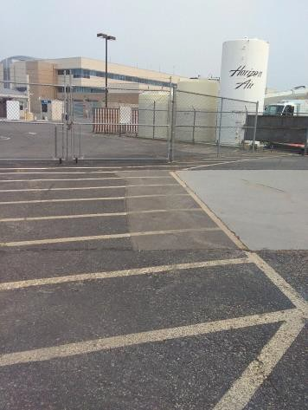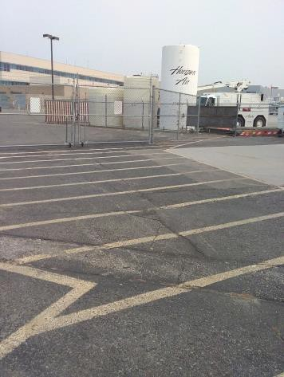

 | ID:  4030 | Facility:  Boise Airport

Location: Economy Parking Lot Restroom Spaces
Schedule: 2021
Estimated Cost: $200.00

Priority Score 9
Quick Fix: Yes
Built before ADA: No

VIOLATIONS
2010 ADA Standards for Accessible Design Codes: §502.6
The accessible parking space signs are 53" and 54" above the ground.

RECOMMENDATIONS
Remount the accessible parking signs at each accessible space at a minimum height of 60" above the ground.

PHOTOGRAPH(S) OF THIS LOCATION

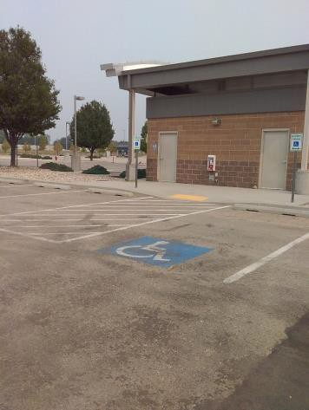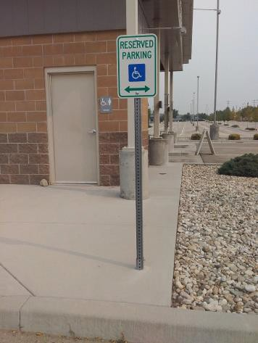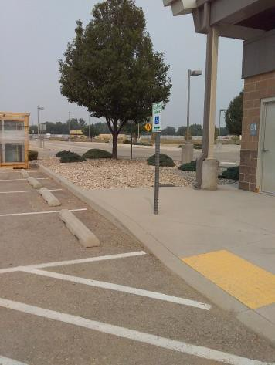

 | ID:  4314 | Facility:  Boise Airport

Location: Economy Parking Lot Shuttle Stop A
Schedule: 2021
Estimated Cost: $100.00

Priority Score 4
Quick Fix: Yes
Built before ADA: No

VIOLATIONS
2010 ADA Standards for Accessible Design Codes: §404.2.4.1
There is not adequate maneuvering clearance to operate the door due to the presence of a garbage can.

RECOMMENDATIONS
Relocate the garbage can.

PHOTOGRAPH(S) OF THIS LOCATION

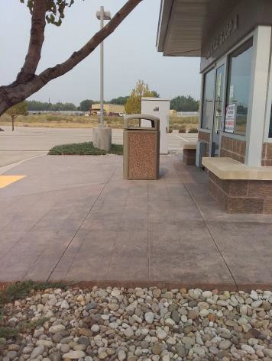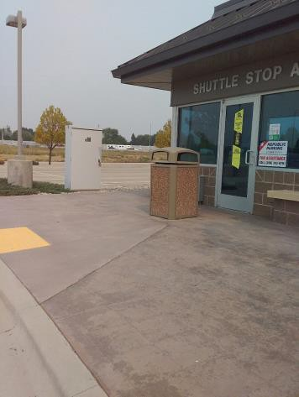

 | ID:  4111 | Facility:  Boise Airport

Location: Economy Parking Lot Shuttle Stop A
Schedule: 2021
Estimated Cost: $400.00

Priority Score 9
Quick Fix: Yes
Built before ADA: No

VIOLATIONS
2010 ADA Standards for Accessible Design Codes: §502.6
The four accessible parking space signs are 54.5" above the ground.

RECOMMENDATIONS
Remount the four accessible parking signs at a minimum height of 60" above the ground.

PHOTOGRAPH(S) OF THIS LOCATION

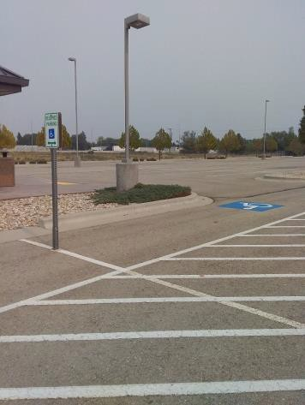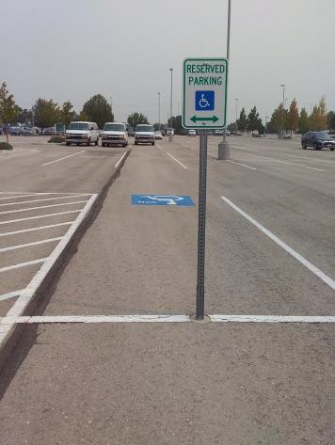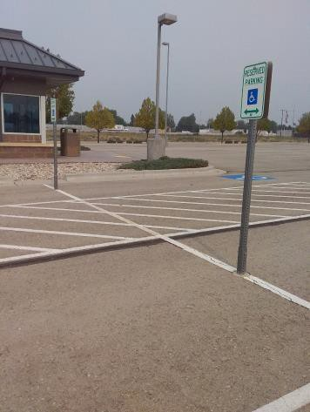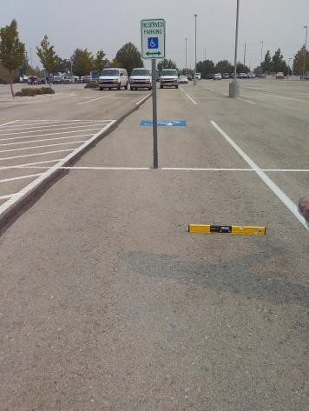

 | ID:  4114 | Facility:  Boise Airport

Location: Economy Parking Lot Shuttle Stop A
Schedule: 2021
Estimated Cost: $1,000.00

Priority Score 2
Quick Fix: No
Built before ADA: No

VIOLATIONS
2010 ADA Standards for Accessible Design Codes: §208.2.4
Of the four spaces, there are no marked "Van accessible" spaces.

RECOMMENDATIONS
Expand one of the existing 108.5" wide spaces to be a 132" wide van accessible parking space. Add a “van accessible” parking sign at a minimum height of 60" above the ground.
Ensure that there is a 60" wide access aisle connecting to an accessible route.

PHOTOGRAPH(S) OF THIS LOCATION

 | ID:  4112 | Facility:  Boise Airport

Location: Economy Parking Lot Shuttle Stop A
Schedule: 2021
Estimated Cost: $2,000.00

Priority Score 3
Quick Fix: No
Built before ADA: No

VIOLATIONS
2010 ADA Standards for Accessible Design Codes: §502.2
Two of the accessible parking spaces are not of sufficient width at 90.5" wide.

RECOMMENDATIONS
Expand the accessible parking spaces to a minimum of 96" wide. Ensure at least one accessible parking space is marked as "van" accessible.

PHOTOGRAPH(S) OF THIS LOCATION

 | ID:  4115 | Facility:  Boise Airport

Location: Economy Parking Lot Shuttle Stop A
Schedule: 2021
Estimated Cost: $2,000.00

Priority Score 3
Quick Fix: No
Built before ADA: No

VIOLATIONS
2010 ADA Standards for Accessible Design Codes: §502.4
The parking spaces have a 2.9% slope.

RECOMMENDATIONS
Resurface the parking space to reduce the slope to a maximum of 2% in all directions.

PHOTOGRAPH(S) OF THIS LOCATION

 | ID:  4091 | Facility:  Boise Airport

Location: Economy Parking Lot Shuttle Stop D
Schedule: 2021
Estimated Cost: $1,000.00

Priority Score 3
Quick Fix: No
Built before ADA: No

VIOLATIONS
2010 ADA Standards for Accessible Design Codes: §305.2
The clear floor space has a 2.6% slope.

RECOMMENDATIONS
Resurface the 30"x48" clear floor space to have a maximum slope of 2% in all directions.

PHOTOGRAPH(S) OF THIS LOCATION

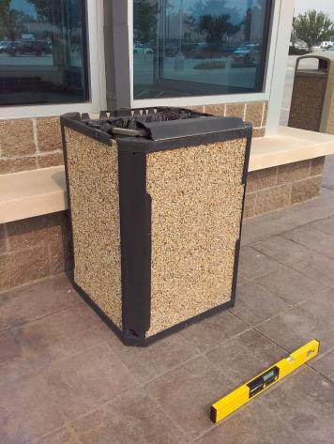

 | ID:  4243 | Facility:  Boise Airport

Location: Economy Parking Lot Shuttle Stop D
Schedule: 2021
Estimated Cost: $1,000.00

Priority Score 3
Quick Fix: No
Built before ADA: No

VIOLATIONS
2010 ADA Standards for Accessible Design Codes: §405.7.2, §405.7.3
The landing is not 60" long.

RECOMMENDATIONS
Expand the provided landing to ensure that the clear length is 60" long minimum to allow adequate turning space.

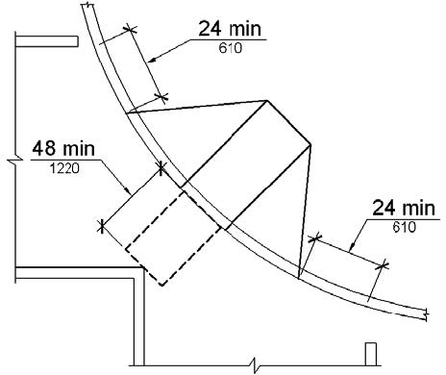

PHOTOGRAPH(S) OF THIS LOCATION

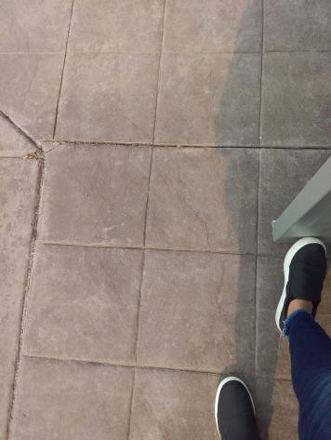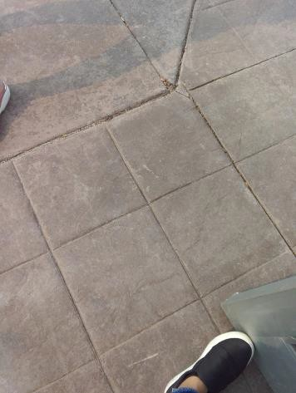

 | ID:  4447 | Facility:  Boise Airport

Location: Economy Parking Lot Shuttle Stop D
Schedule: 2021
Estimated Cost: $2,000.00

Priority Score 3
Quick Fix: No
Built before ADA: No

VIOLATIONS
2010 ADA Standards for Accessible Design Codes: §405.2, §406.3
The curb ramp flares have a 11.3% slope.
The running slope of the curb ramp is 8.6%.

RECOMMENDATIONS
Resurface the curb ramp flares to ensure a maximum slope of 10%. Resurface the curb ramp to reduce the running slope to a maximum of 8.3%.

PHOTOGRAPH(S) OF THIS LOCATION

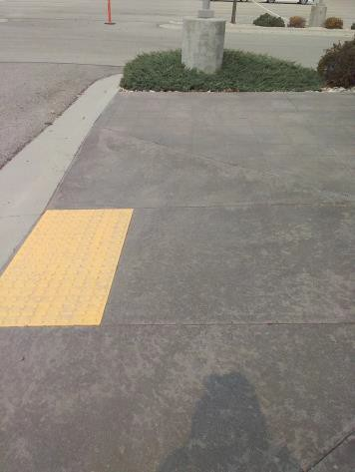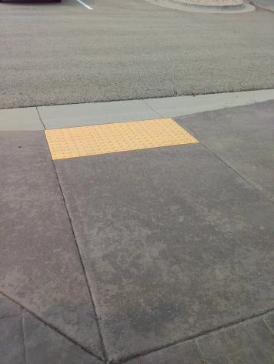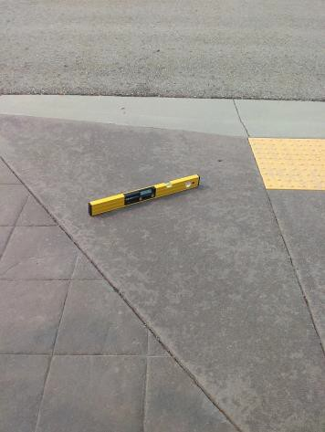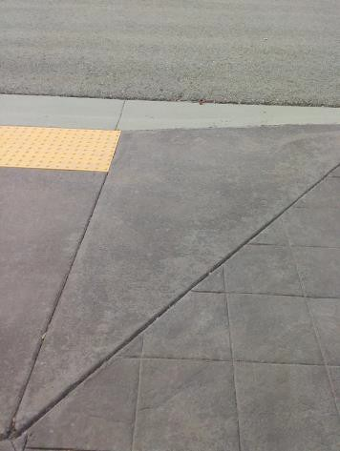

 | ID:  3894 | Facility:  Boise Airport

Location: Economy Parking Lot Women's Restroom
Schedule: 2021
Estimated Cost: $100.00

Priority Score 8
Quick Fix: Yes
Built before ADA: No

VIOLATIONS
2010 ADA Standards for Accessible Design Codes: §308.2.1
The soap dispenser is outside of the unobstructed forward reach range at 52" above the floor.

RECOMMENDATIONS
Lower the soap dispenser by 4" to meet the accessible reach range of 48" maximum above the floor.

PHOTOGRAPH(S) OF THIS LOCATION

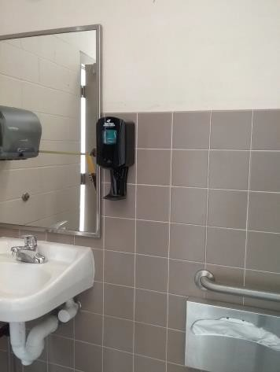

 | ID:  4122 | Facility:  Boise Airport

Location: Economy Parking Lot Women's Restroom
Schedule: 2022
Estimated Cost: $1,000.00

Priority Score 5
Quick Fix: No
Built before ADA: No

VIOLATIONS
2010 ADA Standards for Accessible Design Codes: §604.5.2
The rear grab bar is located 6" from the side wall.

RECOMMENDATIONS
Replace the rear grab bar with one that is a minimum of 36" long minimum and extends from the centerline of the water closet 12" minimum on one side and 24" minimum on the other.

PHOTOGRAPH(S) OF THIS LOCATION

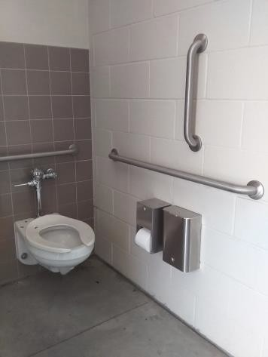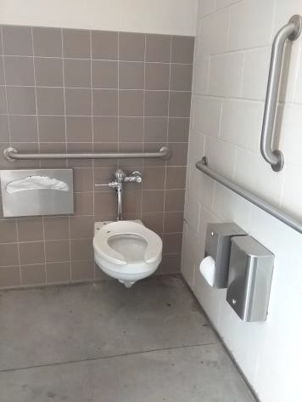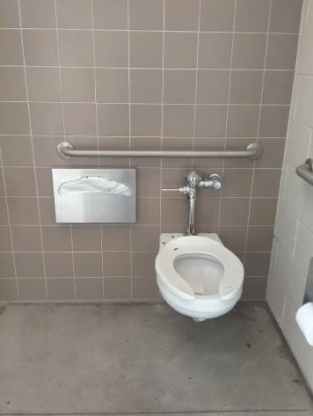

 | ID:  4120 | Facility:  Boise Airport

Location: Economy Parking Lot Women's Restroom
Schedule: 2021
Estimated Cost: $1,000.00

Priority Score 5
Quick Fix: No
Built before ADA: No

VIOLATIONS
2010 ADA Standards for Accessible Design Codes: §604.7
The toilet paper dispenser is located out of the accessible reach range.

RECOMMENDATIONS
Remount the toilet paper dispenser to 7” minimum and 9” maximum in front of the water closet measured to the centerline of the dispenser.
The outlet of the dispenser shall be 15” minimum and 48” maximum above the floor and shall not be located behind the water closet.

PHOTOGRAPH(S) OF THIS LOCATION

 | ID:  4263 | Facility:  Boise Airport

Location: Economy Parking Lot, Middle of Parking lot, New Area
Schedule: 2021
Estimated Cost: $2,500.00

Priority Score 3
Quick Fix: No
Built before ADA: No

VIOLATIONS
2010 ADA Standards for Accessible Design Codes: §502.4
The parking space has a 3.3-5.3% slope.

RECOMMENDATIONS
Resurface the parking space to reduce the slope to a maximum of 2% in all directions.

PHOTOGRAPH(S) OF THIS LOCATION

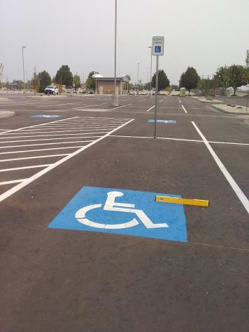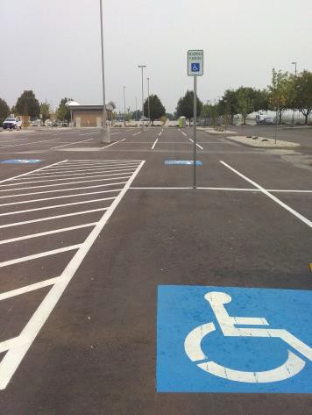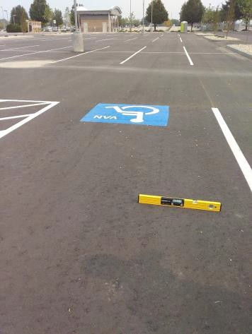

 | ID:  4055 | Facility:  Boise Airport

Location: Employee Accessible Parking
Schedule: 2021
Estimated Cost: $300.00

Priority Score 9
Quick Fix: Yes
Built before ADA: No

VIOLATIONS
2010 ADA Standards for Accessible Design Codes: §502.6
The accessible parking signs are 54.25" above the ground.

RECOMMENDATIONS
Remount the accessible parking signs at each accessible space at a minimum height of 60" above the ground.

PHOTOGRAPH(S) OF THIS LOCATION

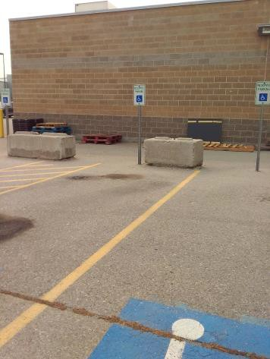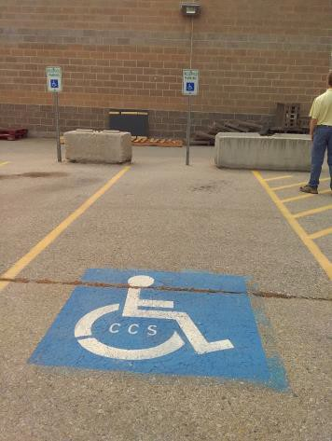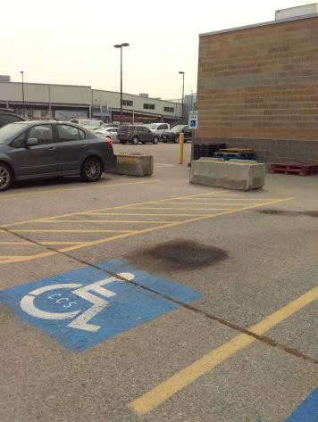

 | ID:  4210 | Facility:  Boise Airport

Location: Employee Accessible Parking
Schedule: 2021
Estimated Cost: $500.00

Priority Score 3
Quick Fix: Yes
Built before ADA: No

VIOLATIONS
2010 ADA Standards for Accessible Design Codes: §302.3
The gap in the parking space is 1" wide and 0.75" deep.

RECOMMENDATIONS
Fill in the gap.

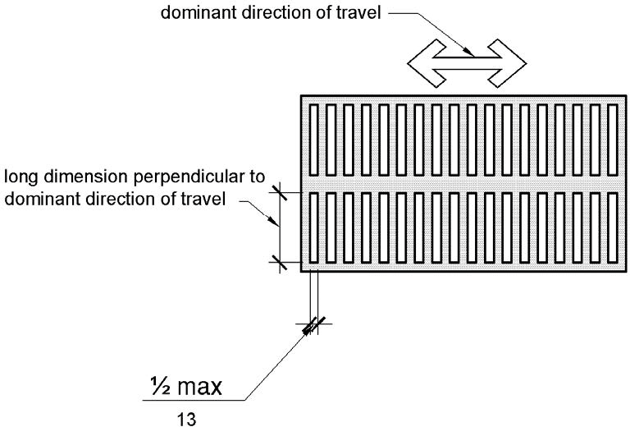

PHOTOGRAPH(S) OF THIS LOCATION

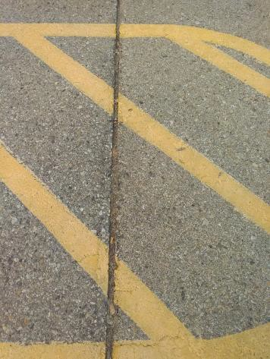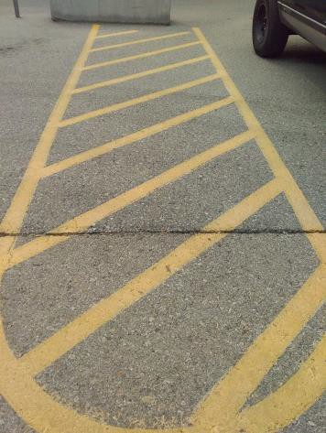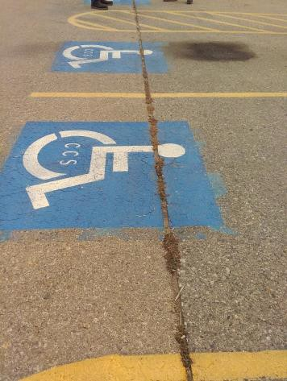
 | ID:  4388 | Facility:  Boise Airport

Location: Employee Accessible Parking
Schedule: 2021
Estimated Cost: $1,000.00

Priority Score 2
Quick Fix: No
Built before ADA: No

VIOLATIONS
2010 ADA Standards for Accessible Design Codes: §502.3
The access aisles are not of sufficient width due to cement blocks.

RECOMMENDATIONS
Move the blocks to ensure that all accessible car parking spaces are a minimum of 96" wide and their adjacent access aisles are a minimum of 60” wide.

PHOTOGRAPH(S) OF THIS LOCATION

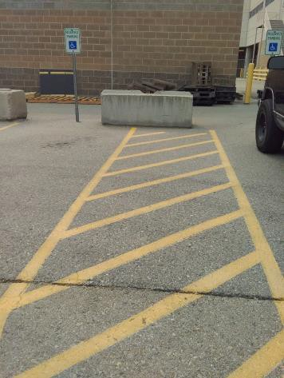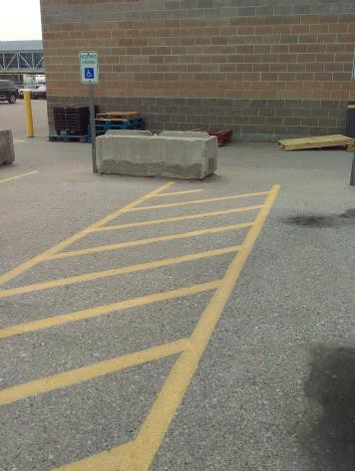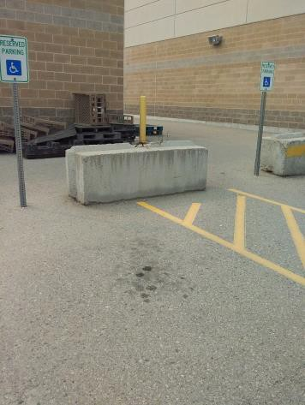

 | ID:  4389 | Facility:  Boise Airport

Location: Employee Accessible Parking
Schedule: 2021
Estimated Cost: $1,000.00

Priority Score 2
Quick Fix: No
Built before ADA: No

VIOLATIONS
2010 ADA Standards for Accessible Design Codes: §208.2.4
There are no marked "Van accessible" spaces.

RECOMMENDATIONS
Add a 132" wide van accessible parking space for every six vehicle parking spaces.
Add a “van accessible” parking sign at a minimum height of 60" above the ground. Ensure that there is a 60" wide access aisle connecting to an accessible route.

PHOTOGRAPH(S) OF THIS LOCATION

 | ID:  4341 | Facility:  Boise Airport

Location: Employee Accessible Parking
Schedule: 2021
Estimated Cost: $2,000.00

Priority Score 3
Quick Fix: No
Built before ADA: No

VIOLATIONS
2010 ADA Standards for Accessible Design Codes: §502.4
The parking space has a 3% slope at the bottom.

RECOMMENDATIONS
Resurface the parking spaces to reduce the slope to a maximum of 2% in all directions.

PHOTOGRAPH(S) OF THIS LOCATION

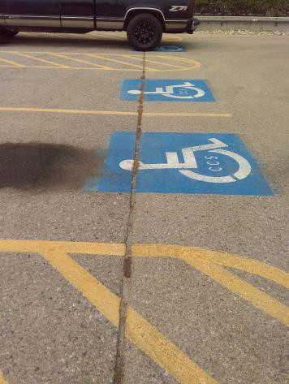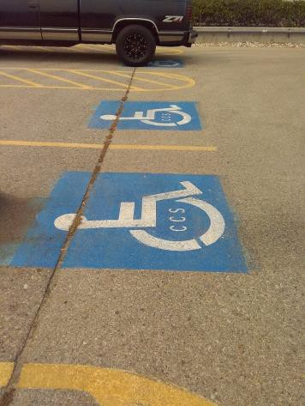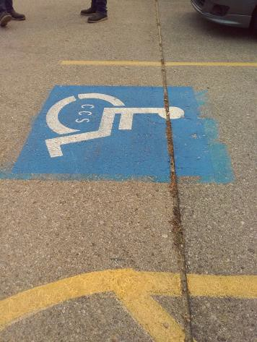

 | ID:  3838 | Facility:  Boise Airport

Location: Employee Accessible Parking
Schedule: 2021
Estimated Cost: $2,500.00

Priority Score 3
Quick Fix: No
Built before ADA: No

VIOLATIONS
2010 ADA Standards for Accessible Design Codes: §502.4
The access aisle has a 5% slope.

RECOMMENDATIONS
Resurface the access aisle to reduce the slope to a maximum of 2% in all directions.

PHOTOGRAPH(S) OF THIS LOCATION

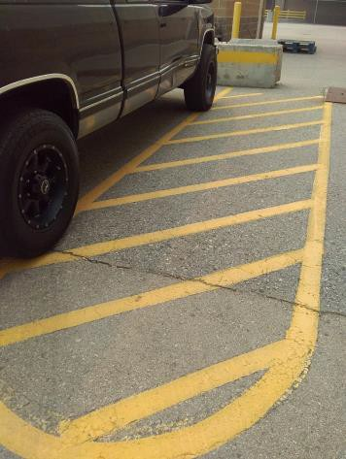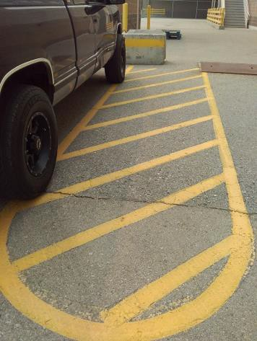

 | ID:  4056 | Facility:  Boise Airport

Location: Employee Accessible Parking
Schedule: 2021
Estimated Cost: $3,000.00

Priority Score 3
Quick Fix: No
Built before ADA: No

VIOLATIONS
2010 ADA Standards for Accessible Design Codes: §208.2, §502.4
The Economy Employee parking lot has a total of 567 spaces, and four spaces are marked as accessible.

RECOMMENDATIONS
Install seven additional accessible parking spaces that are a minimum of 96" wide. Ensure at least two of the accessible parking spaces are marked as "van" accessible.
Install a 60" wide access aisle connecting to an accessible route. Install a sign 60" above the ground. Ensure that the maximum slope is 2% for accessible spaces and access aisle.

PHOTOGRAPH(S) OF THIS LOCATION

 | ID:  4178 | Facility:  Boise Airport

Location: Long Term Lot Adjacent to Garage
Schedule: 2021
Estimated Cost: $1,000.00

Priority Score 2
Quick Fix: No
Built before ADA: No

VIOLATIONS
2010 ADA Standards for Accessible Design Codes: §502.3
There are no access aisles.

RECOMMENDATIONS
Install access aisles connecting the accessible parking spaces to an accessible route. Two parking spaces shall be permitted to share a common access aisle. Each access aisle shall be 60” wide.

PHOTOGRAPH(S) OF THIS LOCATION

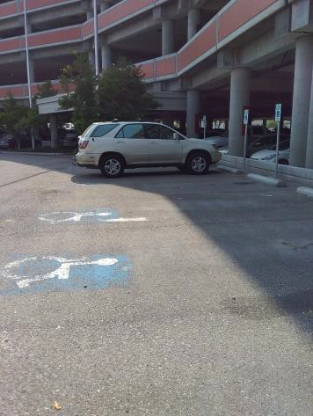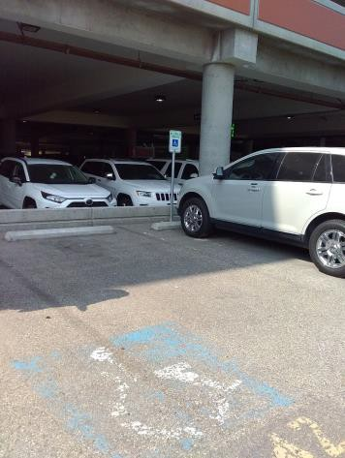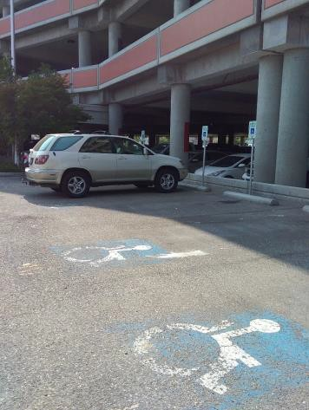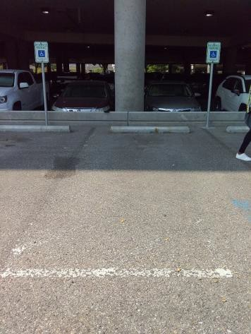

 | ID:  4177 | Facility:  Boise Airport

Location: Long Term Lot Adjacent to Garage
Schedule: 2023
Estimated Cost: $2,000.00

Priority Score 9
Quick Fix: No
Built before ADA: No

VIOLATIONS
2010 ADA Standards for Accessible Design Codes: §502
The painted lines for the accessible parking spaces are faded.

RECOMMENDATIONS
Restripe and repaint the accessible parking spaces, access aisles, and ISA symbols.

PHOTOGRAPH(S) OF THIS LOCATION

 | ID:  4146 | Facility:  Boise Airport

Location: New Parking Garage Crosswalk by Ramps
Schedule: 2022
Estimated Cost: $2,000.00

Priority Score 7
Quick Fix: No
Built before ADA: No

VIOLATIONS
2010 ADA Standards for Accessible Design Codes: §705
The curb ramps do not have detectable warnings.

RECOMMENDATIONS
Install detectable warnings that contrast visually with the adjacent surface with either light-on-dark, or dark-on-light, are the width of the curb ramp, and have a depth of 24".

PHOTOGRAPH(S) OF THIS LOCATION

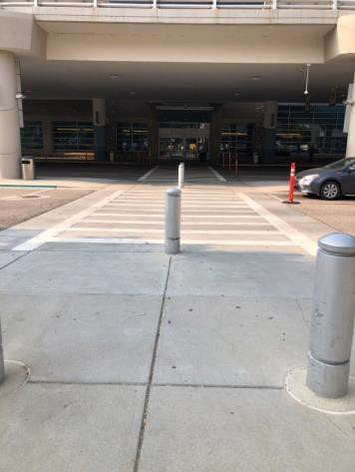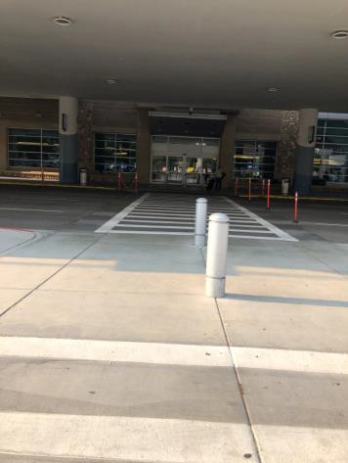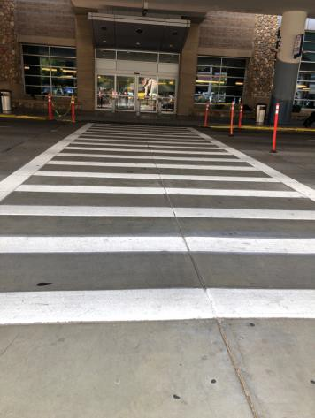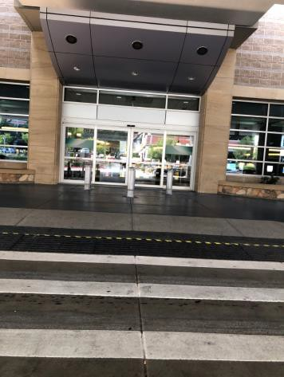

 | ID:  4253 | Facility:  Boise Airport

Location: New Parking Garage Crosswalk by Stairs
Schedule: 2021
Estimated Cost: $1,000.00

Priority Score 4
Quick Fix: No
Built before ADA: No

VIOLATIONS
2010 ADA Standards for Accessible Design Codes: §405.2-§405.5, §406
No curb ramps are provided where the accessible route crosses a curb.

RECOMMENDATIONS
Install a curb ramp that is compliant with §406. The running slope shall not exceed 8.3% and the flare slope shall not exceed 10%.

PHOTOGRAPH(S) OF THIS LOCATION

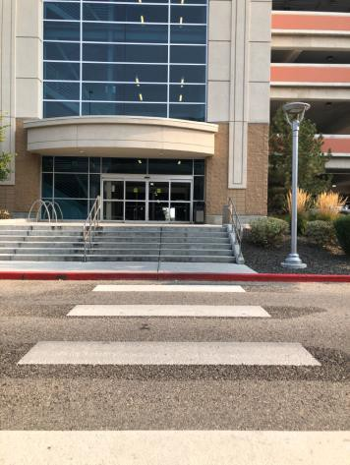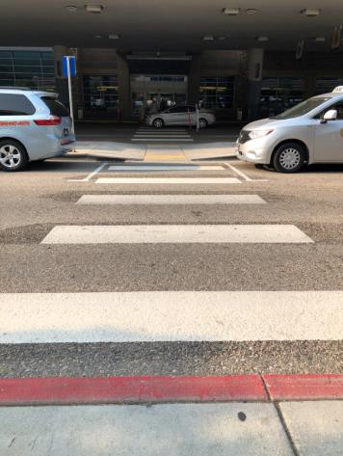

 | ID:  3240 | Facility:  Boise Airport

Location: Parking Garage
Schedule: 2021
Estimated Cost: $10,000.00

Priority Score 3
Quick Fix: No
Built before ADA: No

VIOLATIONS
2010 ADA Sandards for Accessible Design Codes: §208.2
The parking garage has a total of 2,097 spaces and 43 accessible parking spaces.

RECOMMENDATIONS
Install 68 additional accessible parking spaces that are a minimum of 96" wide. Ensure at least 19 of the accessible parking spaces are marked as "van" accessible.
Install a 60" wide access aisle connecting to an accessible route. Install a sign 60" above the ground. Ensure that the maximum slope is 2% for accessible spaces and access aisle.

PHOTOGRAPH(S) OF THIS LOCATION

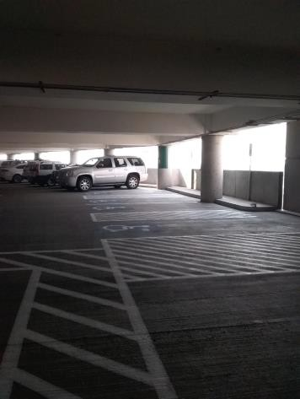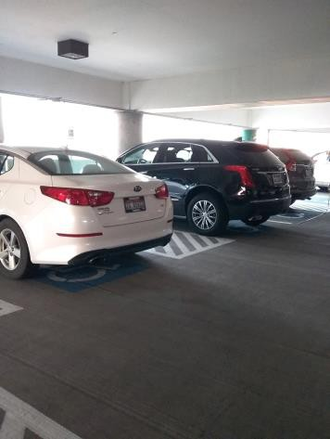

 | ID:  3103 | Facility:  Boise Airport

Location: Parking Garage Benches
Schedule: 2022
Estimated Cost: $1,000.00

Priority Score 5
Quick Fix: No
Built before ADA: No

VIOLATIONS
2010 ADA Standards for Accessible Design Codes: §903.4
The benches do not have sufficient back support.

RECOMMENDATIONS
Although the ADA regulations do not cover convenience benches, having benches with higher backs would provide a greater level of accessibility.
The back support must be 42" long minimum and extends from a point 2" maximum above the seat surface to a point 18" minimum above the seat surface.

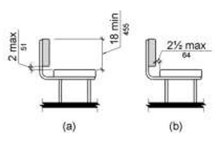

PHOTOGRAPH(S) OF THIS LOCATION

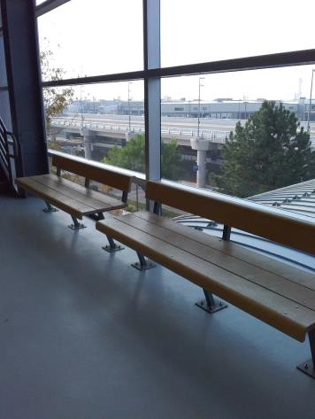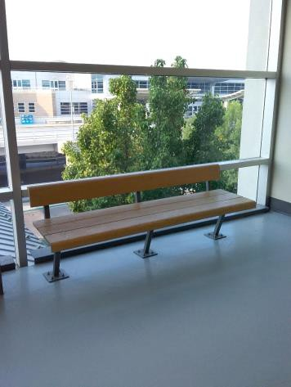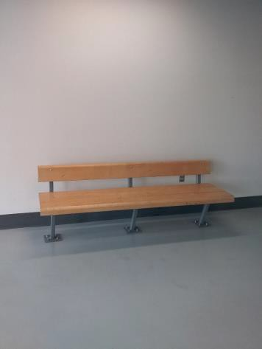

 | ID:  3952 | Facility:  Boise Airport

Location: Parking near 1A5
Schedule: 2021
Estimated Cost: $100.00

Priority Score 9
Quick Fix: Yes
Built before ADA: No

VIOLATIONS
2010 ADA Standards for Accessible Design Codes: §502.6
The accessible parking sign is mounted 53" above the ground.

RECOMMENDATIONS
Remount the accessible parking sign at a minimum height of 60" above the ground.

PHOTOGRAPH(S) OF THIS LOCATION

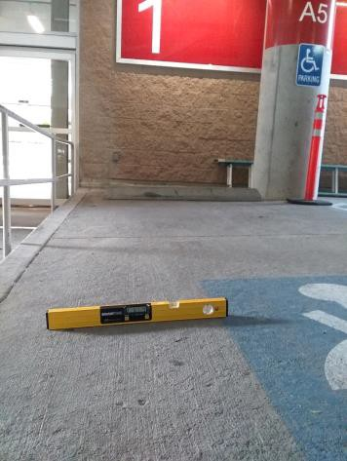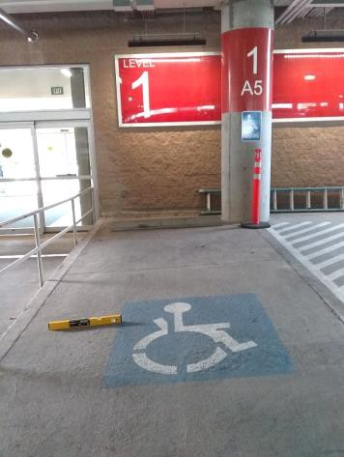

 | ID:  4505 | Facility:  Boise Airport

Location: Parking near 1A5
Schedule: 2021
Estimated Cost: $2,500.00

Priority Score 3
Quick Fix: No
Built before ADA: No

VIOLATIONS
2010 ADA Standards for Accessible Design Codes: §502.4
The parking space has a 6.7% slope.

RECOMMENDATIONS
Reconstruct the parking space to reduce the slope to a maximum of 2% in all directions.

PHOTOGRAPH(S) OF THIS LOCATION

