City of Boise ADA Assessment

Appendix A –Fairmont Pool House

12/4/2020
Report #TO20-B007

Prepared by:
 | ID:  2087 | Facility:  Fairmont Pool House

Location: Accessible Seat
Schedule: 2021
Estimated Cost: $1,000.00

Priority Score 3
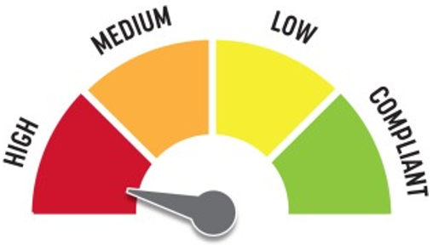
Quick Fix: No
Built before ADA: Yes

VIOLATIONS
2010 ADA Standards for Accessible Design Codes: §305.2
The clear floor space for the pool lift has a 3.1% slope.

RECOMMENDATIONS
Resurface the 30"x48" clear floor space to have a maximum slope of 2% slope.

PHOTOGRAPH(S) OF THIS LOCATION

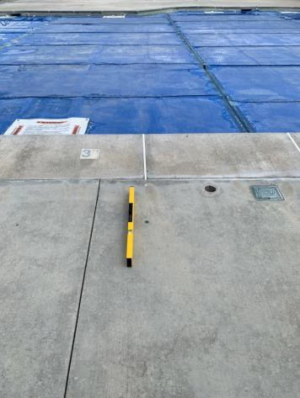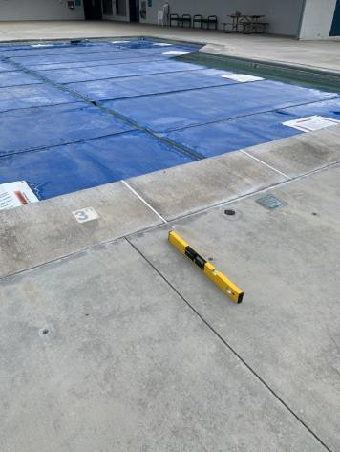

 | ID:  2048 | Facility:  Fairmont Pool House

Location: Bleachers
Schedule: 2021
Estimated Cost: $5,000.00

Priority Score 3
Quick Fix: No
Built before ADA: Yes

VIOLATIONS
2010 ADA Standards for Accessible Design Codes: §302.1, §305
There is not a firm, stable, and slip resistant route to the bleachers.

RECOMMENDATIONS
Construct a firm, stable, and slip resistant accessible route with a maximum cross slope of 2% and maximum running slope of 5%.

PHOTOGRAPH(S) OF THIS LOCATION

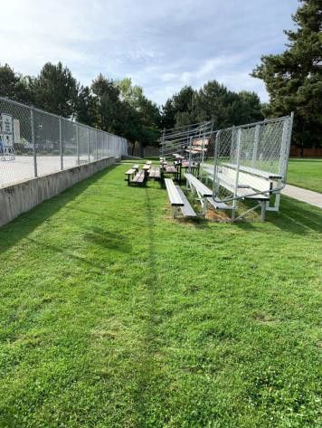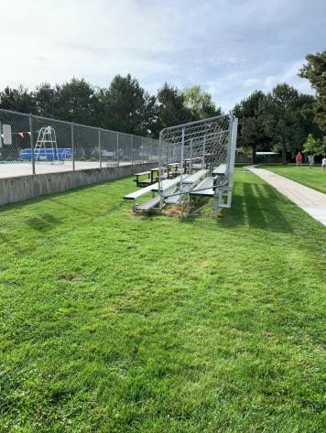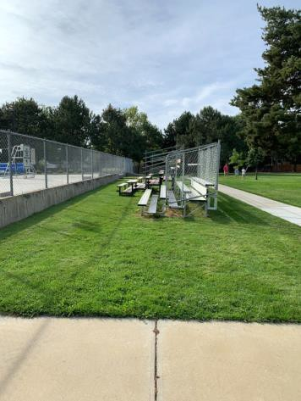

 | ID:  2068 | Facility:  Fairmont Pool House

Location: Entrance
Schedule: 2021
Estimated Cost: $1,000.00

Priority Score 4
Quick Fix: No
Built before ADA: Yes

VIOLATIONS
2010 ADA Standards for Accessible Design Codes: §904.4.1
The check-in counter is 37.75" above the floor.

RECOMMENDATIONS
A 36" wide portion of the service counter must be no higher than 36” above the floor.

PHOTOGRAPH(S) OF THIS LOCATION

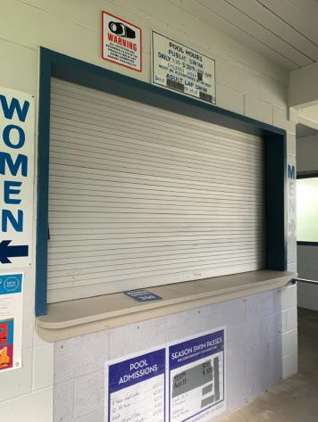

 | ID:  2395 | Facility:  Fairmont Pool House

Location: Entrance Ramp
Schedule: 2022
Estimated Cost: $2,000.00

Priority Score 5
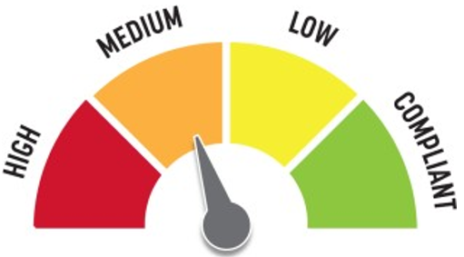
Quick Fix: No
Built before ADA: Yes

VIOLATIONS
2010 ADA Standards for Accessible Design Codes: §505.4
Handrails are not at a compliant height at 32" above the floor.

RECOMMENDATIONS
Raise the handrails to a minimum height of 34" and a maximum of 38" above the ground. Ensure that the handrails are at a consistent height along the walking surface.

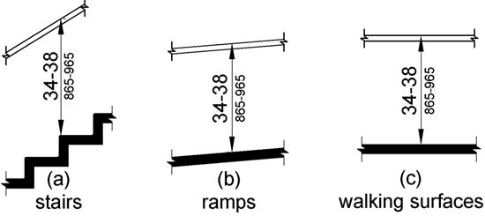

PHOTOGRAPH(S) OF THIS LOCATION

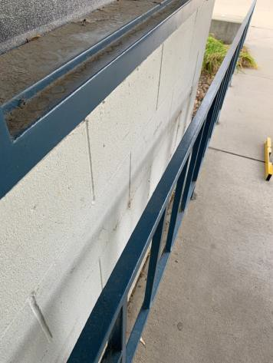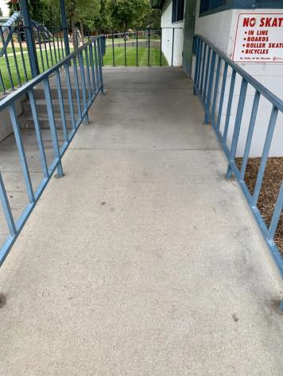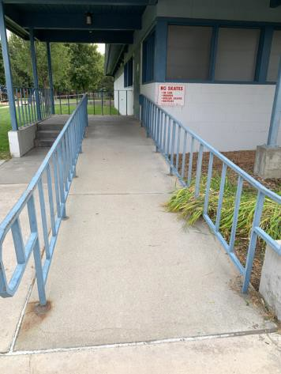

 | ID:  2393 | Facility:  Fairmont Pool House

Location: Entrance Stairs
Schedule: 2022
Estimated Cost: $500.00

Priority Score 6
Quick Fix: Yes
Built before ADA: Yes

VIOLATIONS
2010 ADA Standards for Accessible Design Codes: §505.2
There are no handrails on one side of the stairwell.

RECOMMENDATIONS
Install handrails at a minimum height of 34” and maximum of 38” above the ground. Make sure there are adequate handrail extensions both at the top and bottom of the handrail.

PHOTOGRAPH(S) OF THIS LOCATION

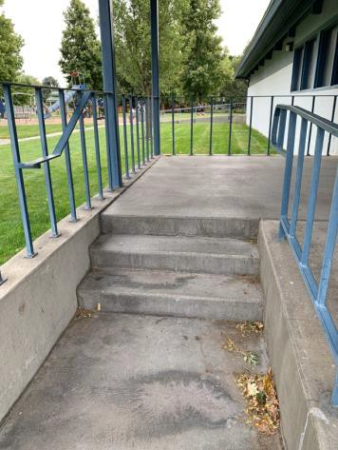

 | ID:  2056 | Facility:  Fairmont Pool House

Location: Exterior Park Restrooms
Schedule: 2022
Estimated Cost: $200.00

Priority Score 6
Quick Fix: Yes
Built before ADA: Yes

VIOLATIONS
2010 ADA Standards for Accessible Design Codes: §703.4
The tactile signs identifying the restrooms are not in the correct location.

RECOMMENDATIONS
Reinstall the signs on the latch side of the doors at 48" minimum above the floor measured from the baseline of the lowest character and 60" maximum measured from the baseline of the highest character.

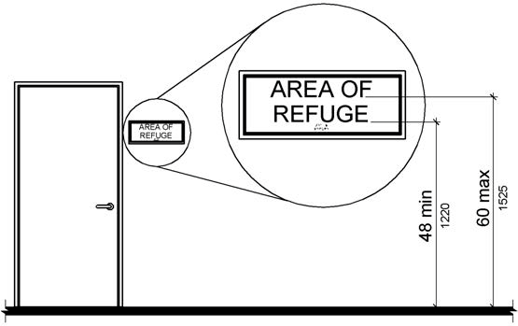

PHOTOGRAPH(S) OF THIS LOCATION

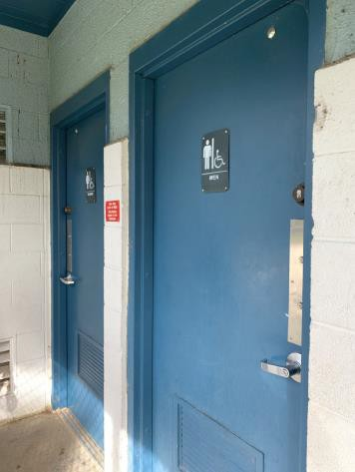

 | ID:  2396 | Facility:  Fairmont Pool House

Location: Garbage Can
Schedule: 2021
Estimated Cost: $500.00

Priority Score 7
Quick Fix: Yes
Built before ADA: Yes

VIOLATIONS
2010 ADA Standards for Accessible Design Codes: §302.3
There is a 1.25" gap causing a tripping hazard and uneven surface.

RECOMMENDATIONS
Fill in the gap to ensure that openings in the accessible route does not exceed 1/2".

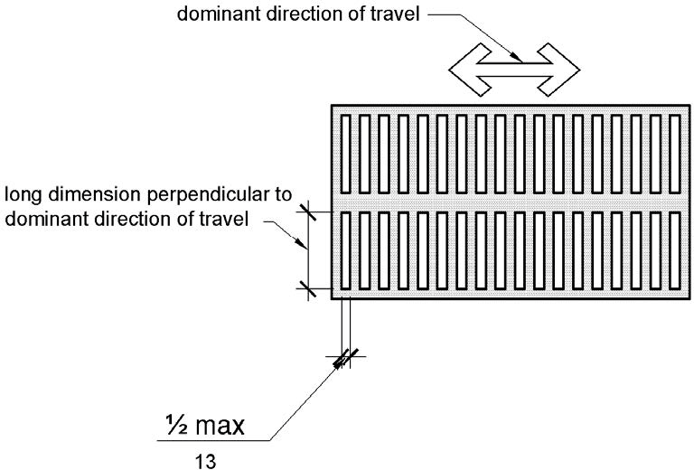

PHOTOGRAPH(S) OF THIS LOCATION

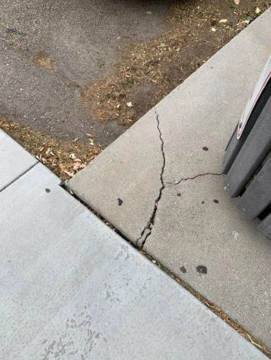

 | ID:  2065 | Facility:  Fairmont Pool House

Location: Grass Area
Schedule: 2022
Estimated Cost: $1,000.00

Priority Score 6
Quick Fix: No
Built before ADA: Yes

VIOLATIONS
2010 ADA Standards for Accessible Design Codes: §505.2
The ramp leading to the grass area has no handrails.

RECOMMENDATIONS
Install handrails at a minimum height of 34” and maximum of 38” above the ground. Make sure there are adequate handrail extensions both at the top and bottom of the handrail.

PHOTOGRAPH(S) OF THIS LOCATION

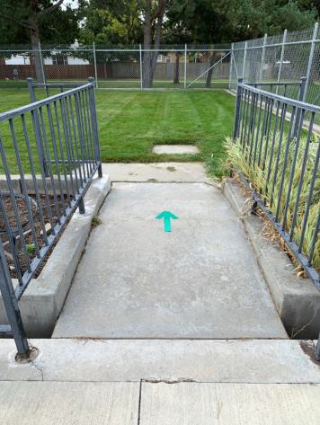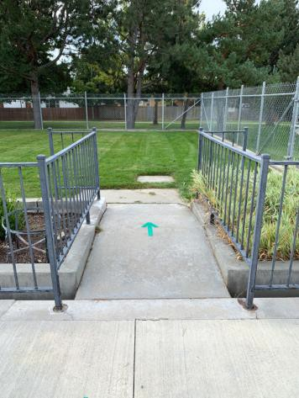

 | ID:  2089 | Facility:  Fairmont Pool House

Location: Grass Area
Schedule: 2022
Estimated Cost: $1,000.00

Priority Score 6
Quick Fix: No
Built before ADA: Yes

VIOLATIONS
2010 ADA Standards for Accessible Design Codes: §505.2
The ramp leading to the grass area has no handrails.

RECOMMENDATIONS
Install handrails at a minimum height of 34” and maximum of 38” above the ground. Make sure there are adequate handrail extensions both at the top and bottom of the handrail.

PHOTOGRAPH(S) OF THIS LOCATION

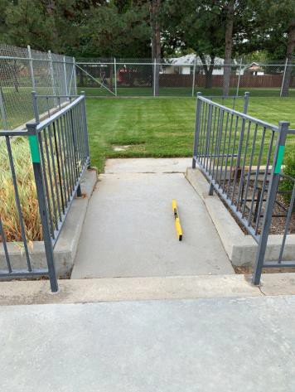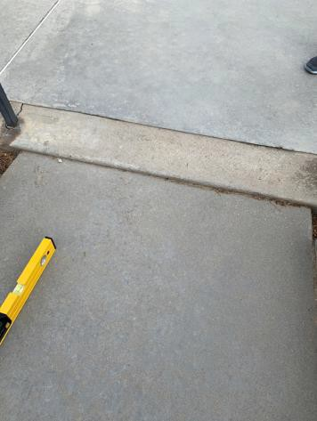

 | ID:  2088 | Facility:  Fairmont Pool House

Location: Grass Area
Schedule: 2022
Estimated Cost: $2,500.00

Priority Score 7
Quick Fix: No
Built before ADA: Yes

VIOLATIONS
2010 ADA Standards for Accessible Design Codes: §405.2
The running slope of the ramp is 11.4%.

RECOMMENDATIONS
Reconstruct the ramp to reduce the running slope to a maximum of 8.3%.

PHOTOGRAPH(S) OF THIS LOCATION

 | ID:  2057 | Facility:  Fairmont Pool House

Location: Men’s Exterior Park Restroom
Schedule: 2022
Estimated Cost: $100.00

Priority Score 7
Quick Fix: Yes
Built before ADA: Yes

VIOLATIONS
2010 ADA Standards for Accessible Design Codes: §606.5
The pipes under the sink are not covered.

RECOMMENDATIONS
Wrap the pipes beneath the sink with soft protective wrap or plastic.

PHOTOGRAPH(S) OF THIS LOCATION

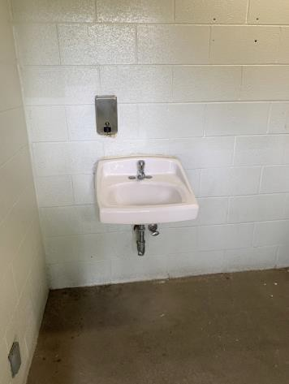

 | ID:  2059 | Facility:  Fairmont Pool House

Location: Men’s Exterior Park Restroom
Schedule: 2022
Estimated Cost: $1,000.00

Priority Score 5
Quick Fix: No
Built before ADA: Yes

VIOLATIONS
2010 ADA Standards for Accessible Design Codes: §605.2
The urinal is 25" above the floor.

RECOMMENDATIONS
Lower the urinal to a maximum height of 17"above the floor.

PHOTOGRAPH(S) OF THIS LOCATION

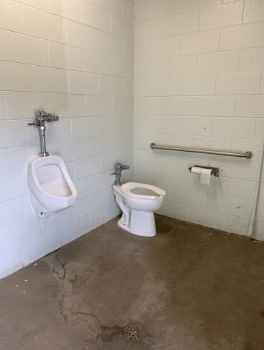

 | ID:  2060 | Facility:  Fairmont Pool House

Location: Men’s Exterior Park Restroom
Schedule: 2022
Estimated Cost: $1,000.00

Priority Score 5
Quick Fix: No
Built before ADA: Yes

VIOLATIONS
2010 ADA Standards for Accessible Design Codes: §604.5
There is no rear grab bar.

RECOMMENDATIONS
Install a rear grab bar at a minimum height of 33” and maximum height of 36” above the finish floor.

PHOTOGRAPH(S) OF THIS LOCATION

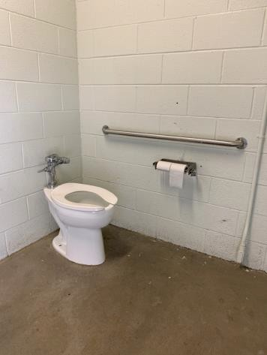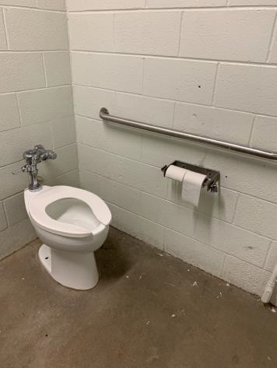

 | ID:  2061 | Facility:  Fairmont Pool House

Location: Men’s Exterior Park Restroom
Schedule: 2022
Estimated Cost: $1,000.00

Priority Score 5
Quick Fix: No
Built before ADA: Yes

VIOLATIONS
2010 ADA Standards for Accessible Design Codes: ICC A117.1 §604.5.1
The accessible water closet does not have a vertical grab bar.

RECOMMENDATIONS
Install an 18" long (minimum) vertical grab bar, mounted with the bottom located at 39" minimum and 41" maximum above the floor.
The centerline of the vertical grab bar shall be located 39" minimum and 41" maximum from the rear wall.

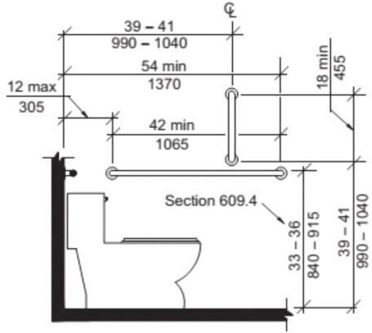

PHOTOGRAPH(S) OF THIS LOCATION

 | ID:  2062 | Facility:  Fairmont Pool House

Location: Men’s Exterior Park Restroom
Schedule: 2022
Estimated Cost: $1,000.00

Priority Score 5
Quick Fix: No
Built before ADA: Yes

VIOLATIONS
2010 ADA Standards for Accessible Design Codes: §604.2
The toilet is located 20" from the sidewall.

RECOMMENDATIONS
Reposition the toilet to be within 16" minimum and 18" maximum from the sidewall.

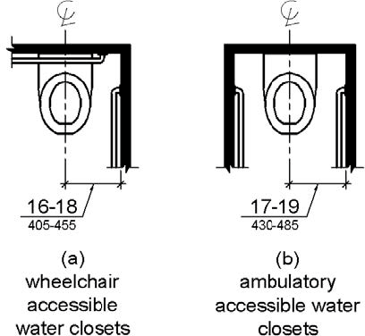

PHOTOGRAPH(S) OF THIS LOCATION

 | ID:  2110 | Facility:  Fairmont Pool House

Location: Men’s Locker Room
Schedule: 2023
Estimated Cost: $100.00

Priority Score 8
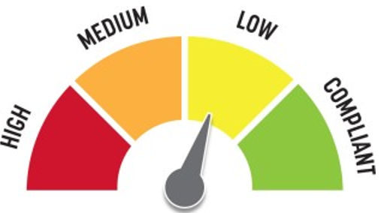
Quick Fix: Yes
Built before ADA: Yes

VIOLATIONS
2010 ADA Standards for Accessible Design Codes: §308.2.1
The hooks are outside of the unobstructed forward reach range at 65" above the floor.

RECOMMENDATIONS
Lower at least one hook by 17" to meet the accessible reach range of 15" minimum and 48" maximum above the floor.

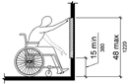

PHOTOGRAPH(S) OF THIS LOCATION

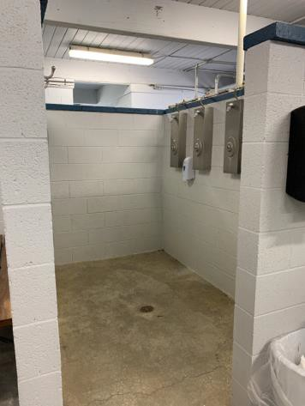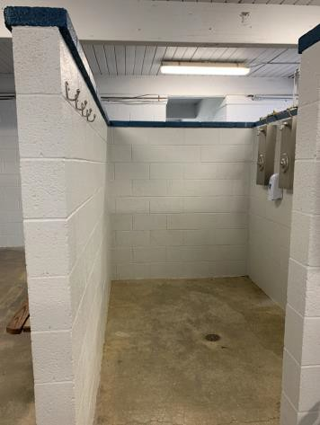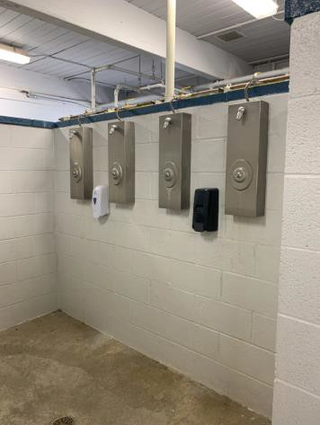

 | ID:  2100 | Facility:  Fairmont Pool House

Location: Men’s Locker Room
Schedule: 2022
Estimated Cost: $100.00

Priority Score 5
Quick Fix: Yes
Built before ADA: Yes

VIOLATIONS
2010 ADA Standards for Accessible Design Codes: §604.7
The toilet paper dispenser is not located in an accessible position.

RECOMMENDATIONS
Remount the toilet paper dispenser so that it is located 7" minimum to 9" maximum in front of the toilet. Ensure that the height is within the accessible reach range of 15" minimum to 48" maximum above the floor.

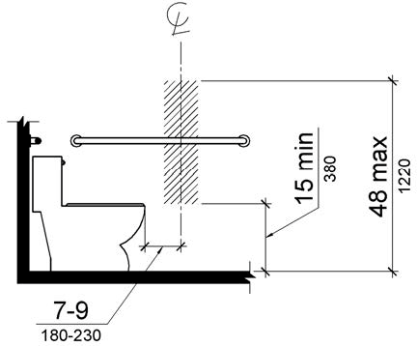

PHOTOGRAPH(S) OF THIS LOCATION

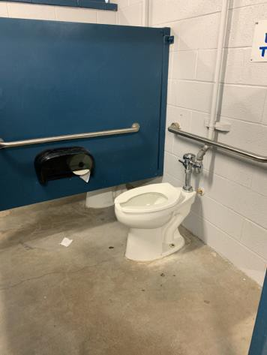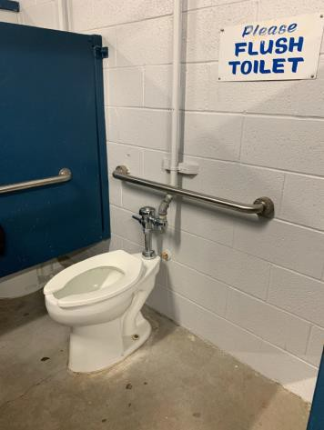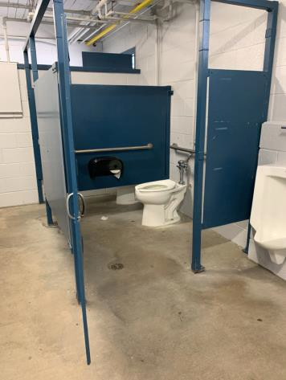

 | ID:  2101 | Facility:  Fairmont Pool House

Location: Men’s Locker Room
Schedule: 2022
Estimated Cost: $100.00

Priority Score 5
Quick Fix: Yes
Built before ADA: Yes

VIOLATIONS
2010 ADA Standards for Accessible Design Codes: §604.8.1.2
The door to the accessible water closet is not self closing. Either self-closing hinges are not installed on the door or if installed, they are defective.

RECOMMENDATIONS
Install or reinstall self-closing hinges on the door to ensure that the door is self-closing per the ADA requirements.

PHOTOGRAPH(S) OF THIS LOCATION

 | ID:  2112 | Facility:  Fairmont Pool House

Location: Men’s Locker Room
Schedule: 2022
Estimated Cost: $100.00

Priority Score 7
Quick Fix: Yes
Built before ADA: Yes

VIOLATIONS
2010 ADA Standards for Accessible Design Codes: §603.3
The mirror is too high to be accessible at 43.5" above the floor.

RECOMMENDATIONS
Lower the mirror its bottom edge is a maximum height of 40" above the floor.

PHOTOGRAPH(S) OF THIS LOCATION

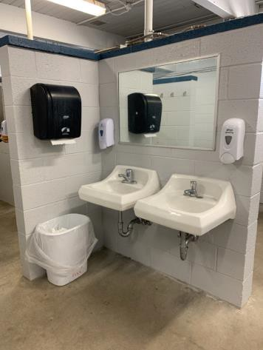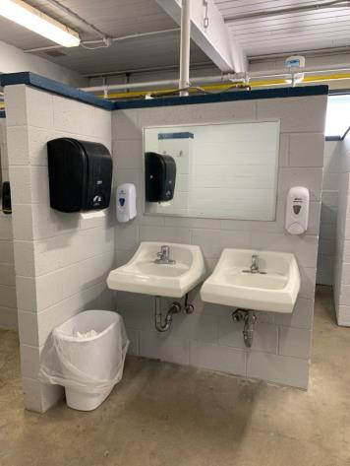

 | ID:  2094 | Facility:  Fairmont Pool House

Location: Men’s Locker Room
Schedule: 2021
Estimated Cost: $100.00

Priority Score 3
Quick Fix: Yes
Built before ADA: Yes

VIOLATIONS
2010 ADA Standards for Accessible Design Codes: §216.2, §703
There is no tactile sign identifying the permanent room.

RECOMMENDATIONS
Install tactile signage on the latch side of the doorway at a height of 48” minimum to 60” maximum above the floor, identifying room by name or room number.
Signs shall be Braille with raised lettering and should be placed on the wall in the center of an 18"x18" clear floor space.

PHOTOGRAPH(S) OF THIS LOCATION

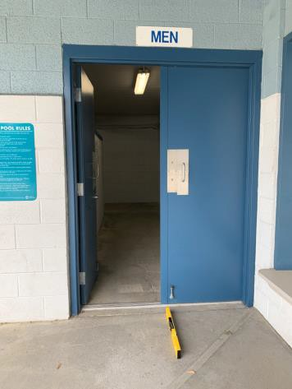

 | ID:  2111 | Facility:  Fairmont Pool House

Location: Men’s Locker Room
Schedule: 2022
Estimated Cost: $200.00

Priority Score 7
Quick Fix: Yes
Built before ADA: Yes

VIOLATIONS
22010 ADA Standards for Accessible Design Codes: §606.5
The pipes under the sink are not covered.

RECOMMENDATIONS
Wrap the pipes beneath the sink with soft protective wrap or plastic.

PHOTOGRAPH(S) OF THIS LOCATION

 | ID:  2114 | Facility:  Fairmont Pool House

Location: Men’s Locker Room
Schedule: 2022
Estimated Cost: $500.00

Priority Score 5
Quick Fix: Yes
Built before ADA: Yes

VIOLATIONS
2010 ADA Standards for Accessible Design Codes: §903.3
The benches in the men's locker room are 13" deep.

RECOMMENDATIONS
Install one new bench that is at least 42" long and 20" to 24" inches deep. The accessible bench shall have a back support or be affixed to a wall.

PHOTOGRAPH(S) OF THIS LOCATION

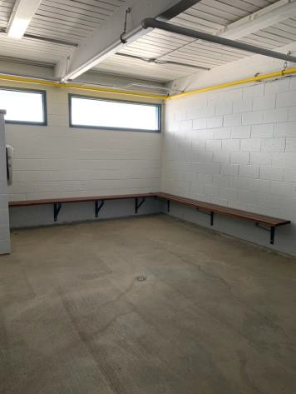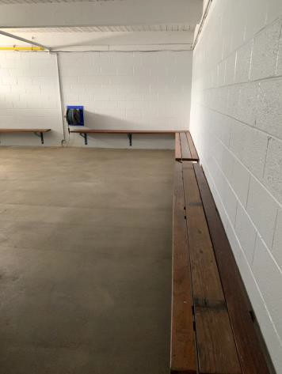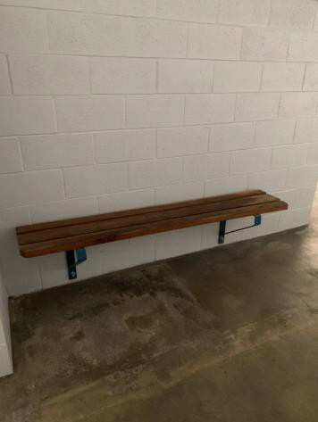

 | ID:  2098 | Facility:  Fairmont Pool House

Location: Men’s Locker Room
Schedule: 2022
Estimated Cost: $1,000.00

Priority Score 5
Quick Fix: No
Built before ADA: Yes

VIOLATIONS
2010 ADA Standards for Accessible Design Codes: §604.6
The flush control is located on the wall side of the toilet.

RECOMMENDATIONS
Either make the toilet flush automatically or relocate the flush control to be operated on the open side of the toilet.

PHOTOGRAPH(S) OF THIS LOCATION

 | ID:  2102 | Facility:  Fairmont Pool House

Location: Men’s Locker Room
Schedule: 2022
Estimated Cost: $1,000.00

Priority Score 5
Quick Fix: No
Built before ADA: Yes

VIOLATIONS
2010 ADA Standards for Accessible Design Codes: §605.2
The urinal is 18.5" above the floor.

RECOMMENDATIONS
Lower at least one of the urinals to a maximum height of 17"above the floor.

PHOTOGRAPH(S) OF THIS LOCATION

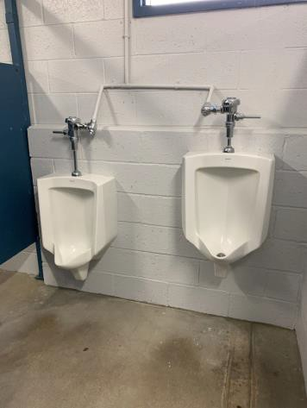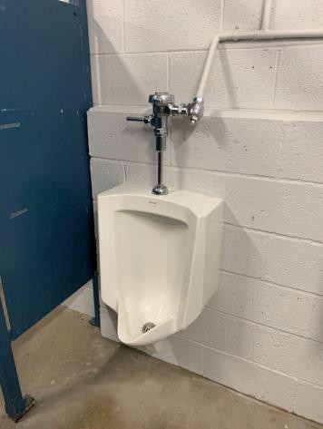

 | ID:  2093 | Facility:  Fairmont Pool House

Location: Men’s Locker Room
Schedule: 2021
Estimated Cost: $1,000.00

Priority Score 3
Quick Fix: No
Built before ADA: Yes

VIOLATIONS
2010 ADA Standards for Accessible Design Codes: §404.2.4.4, §404.2.4.1
The maneuvering clearance at the entrance has a 2.8% slope.

RECOMMENDATIONS
Resurface the maneuvering clearance to reduce the slope to a maximum of 2% in all directions for 60" perpendicular to the doorway.

PHOTOGRAPH(S) OF THIS LOCATION

 | ID:  2097 | Facility:  Fairmont Pool House

Location: Men’s Locker Room
Schedule: 2022
Estimated Cost: $2,000.00

Priority Score 5
Quick Fix: No
Built before ADA: Yes

VIOLATIONS
2010 ADA Standards for Accessible Design Codes: §604.5.1, ICC A117.1 §604.5.1
The accessible water closet does not have a vertical grab bar.
The side grab bar is located 12" from the real wall and extends 53.5".

RECOMMENDATIONS
Install an 18" long (minimum) vertical grab bar, mounted with the bottom located at 39" minimum and 41" maximum above the floor. The centerline of the vertical grab bar shall be located 39" minimum and 41" maximum from the re Replace the side grab bar with one that is a minimum of 42" long minimum, located 12" maximum from the rear wall and extending 54" minimum from the rear wall.

PHOTOGRAPH(S) OF THIS LOCATION

 | ID:  2106 | Facility:  Fairmont Pool House

Location: Men’s Locker Room
Schedule: 2022
Estimated Cost: $10,000.00

Priority Score 6
Quick Fix: No
Built before ADA: Yes

VIOLATIONS
2010 ADA Standards for Accessible Design Codes: §213.3.6, §608.5.1
The shower is not accessible and controls are 56" above the floor.

RECOMMENDATIONS
Install at least one accessible transfer or roll-in shower, complying with § 608 as shown in the Locker Room Showers section of this report.
Adjust the height of shower controls to a minimum height of 38" and a maximum of 48" above the floor. Ensure appropriate seating, handrails, and shower hardware are provided.

PHOTOGRAPH(S) OF THIS LOCATION

 | ID:  2116 | Facility:  Fairmont Pool House

Location: Office
Schedule: 2023
Estimated Cost: $100.00

Priority Score 8
Quick Fix: Yes
Built before ADA: Yes

VIOLATIONS
2010 ADA Standards for Accessible Design Codes: §308.2.1
The hooks are outside of the unobstructed forward reach range at 78" above the floor.

RECOMMENDATIONS
Lower at least one hook by 30" to meet the accessible reach range of 15" minimum and 48" maximum above the floor.

PHOTOGRAPH(S) OF THIS LOCATION

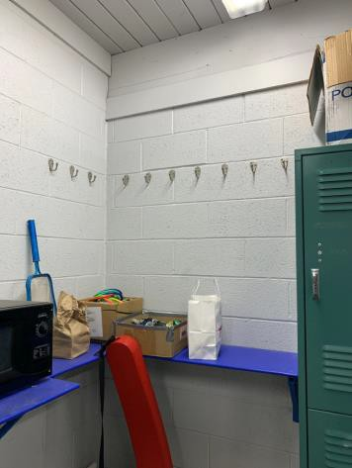

 | ID:  2117 | Facility:  Fairmont Pool House

Location: Office
Schedule: 2023
Estimated Cost: $100.00

Priority Score 8
Quick Fix: Yes
Built before ADA: Yes

VIOLATIONS
2010 ADA Standards for Accessible Design Codes: §308.2.1
The microwave is outside of the unobstructed forward reach range at 52" above the floor.

RECOMMENDATIONS
Lower the microwave by 4" to meet the accessible reach range of 15" minimum and 48" maximum above the floor.

PHOTOGRAPH(S) OF THIS LOCATION

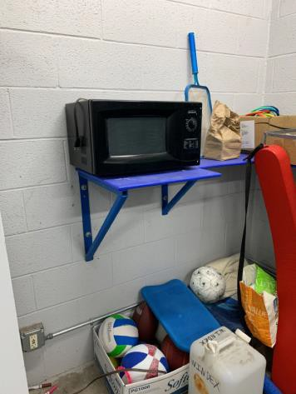

 | ID:  2119 | Facility:  Fairmont Pool House

Location: Office
Schedule: 2023
Estimated Cost: $100.00

Priority Score 8
Quick Fix: Yes
Built before ADA: Yes

VIOLATIONS
2010 ADA Standards for Accessible Design Codes: §308.2.1
The paper towel dispenser is outside of the unobstructed forward reach range at 58" above the floor.

RECOMMENDATIONS
Lower the paper towel dispenser by 10" to meet the accessible reach range of 15" minimum and 48" maximum above the floor.

PHOTOGRAPH(S) OF THIS LOCATION

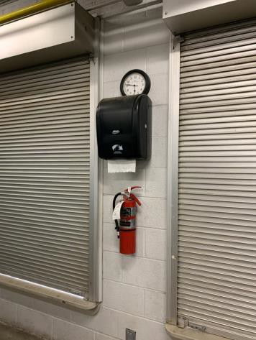

 | ID:  2118 | Facility:  Fairmont Pool House

Location: Office
Schedule: 2022
Estimated Cost: $100.00

Priority Score 5
Quick Fix: Yes
Built before ADA: Yes

VIOLATIONS
2010 ADA Standards for Accessible Design Codes: §307.2
The fire extinguisher protrudes 4.5" into the circulation space at 34" above the floor.

RECOMMENDATIONS
Recess the fire extinguisher so it protrudes a maximum of 4", lower it so the bottom edge is 27" maximum above the floor, or place a cane detectable object beneath it.

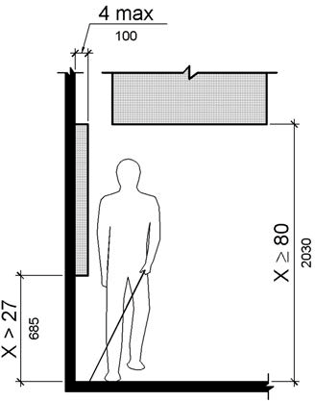

PHOTOGRAPH(S) OF THIS LOCATION

 | ID:  2402 | Facility:  Fairmont Pool House

Location: Parking
Schedule: 2023
Estimated Cost: $1,000.00

Priority Score 9
Quick Fix: No
Built before ADA: Yes

VIOLATIONS
2010 ADA Standards for Accessible Design Codes: §208.2, §502.6
There is a total of 53 parking spaces, and only 2 are designated as accessible. The accessible parking sign is 54.5" above the ground.

RECOMMENDATIONS
Paint at least one more accessible parking space with a 96" minimum width. The accessible space and the adjoining access aisle shall have a maximum slope of 2% in all directions.
Remount the existing accessible parking sign and install a new sign for the additional accessible space at a minimum height of 60" above the ground.

PHOTOGRAPH(S) OF THIS LOCATION

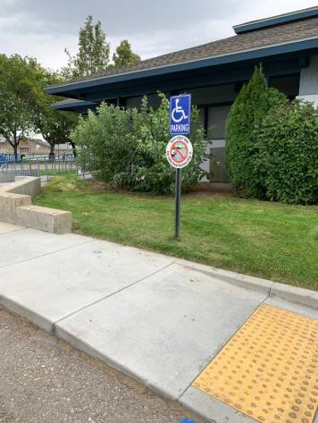

 | ID:  2398 | Facility:  Fairmont Pool House

Location: Parking
Schedule: 2021
Estimated Cost: $100.00

Priority Score 3
Quick Fix: Yes
Built before ADA: Yes

VIOLATIONS
2010 ADA Standards for Accessible Design Codes: §406.4
The landing clear width is less than 36".

RECOMMENDATIONS
The landing clear width is required to be as wide as the curb ramp. Is that the same for detectable warnings? What is the applicable code?

PHOTOGRAPH(S) OF THIS LOCATION

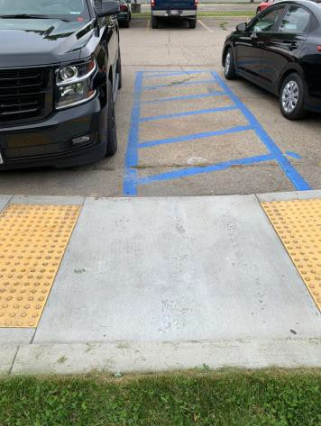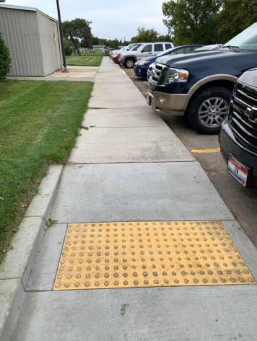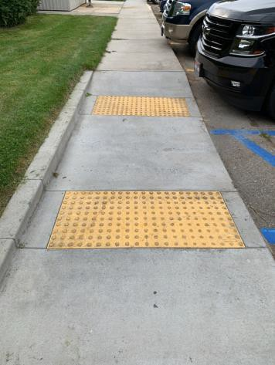

 | ID:  2400 | Facility:  Fairmont Pool House

Location: Parking
Schedule: 2021
Estimated Cost: $1,000.00

Priority Score 3
Quick Fix: No
Built before ADA: Yes

VIOLATIONS
2010 ADA Standards for Accessible Design Codes: §208.2.4, §208.2
There is a total of 53 parking spaces but only two accessible parking spaces, neither of which are marked as "van accessible".

RECOMMENDATIONS
Restripe an accessible parking space as a 132" wide van accessible parking space with an adjacent 60" access aisle. Add a “van accessible” parking sign at a minimum height of 60" above the ground.

PHOTOGRAPH(S) OF THIS LOCATION

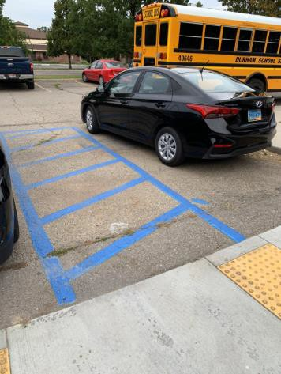

 | ID:  2067 | Facility:  Fairmont Pool House

Location: Parking by Tennis Courts
Schedule: 2023
Estimated Cost: $100.00

Priority Score 9
Quick Fix: Yes
Built before ADA: Yes

VIOLATIONS
2010 ADA Standards for Accessible Design Codes: §502.6
The accessible parking sign is 50" high and not centered on the space.

RECOMMENDATIONS
Remount the accessible parking sign at a minimum height of 60" above the ground.

PHOTOGRAPH(S) OF THIS LOCATION

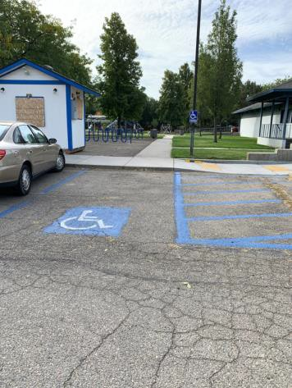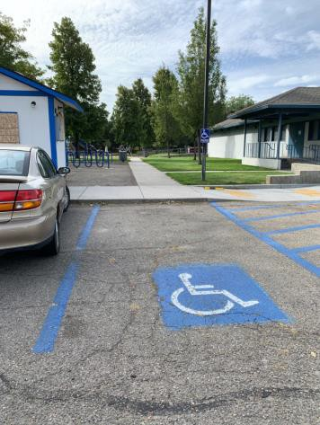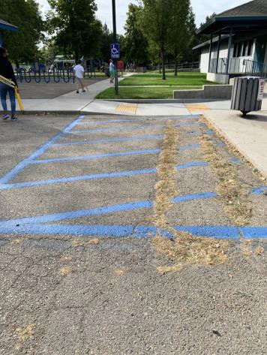

 | ID:  2066 | Facility:  Fairmont Pool House

Location: Parking by Tennis Courts
Schedule: 2021
Estimated Cost: $1,500.00

Priority Score 3
Quick Fix: No
Built before ADA: Yes

VIOLATIONS
2010 ADA Standards for Accessible Design Codes: §502.4
The parking space has a 5% running slope and 2.3% cross slope. The access aisle has a 2.5% slope.

RECOMMENDATIONS
Resurface the parking space and access aisle to reduce the slope to a maximum of 2% in all directions.

PHOTOGRAPH(S) OF THIS LOCATION

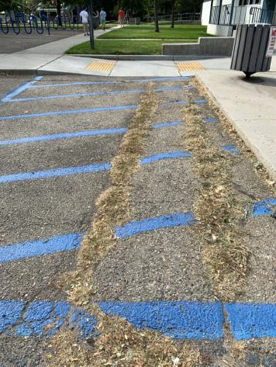

 | ID:  2095 | Facility:  Fairmont Pool House

Location: Pool Deck
Schedule: 2023
Estimated Cost: $100.00

Priority Score 10
Quick Fix: Yes
Built before ADA: Yes

VIOLATIONS
2010 ADA Standards for Accessible Design Codes: §602, §307.2
The tall drinking fountain protrudes 17.75" into the circulation path.

RECOMMENDATIONS
Place a drinking fountain skirt at this location to provide cane detectability.

PHOTOGRAPH(S) OF THIS LOCATION

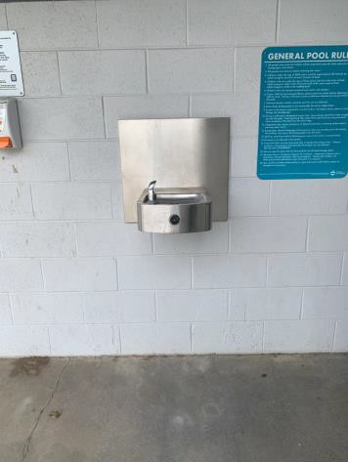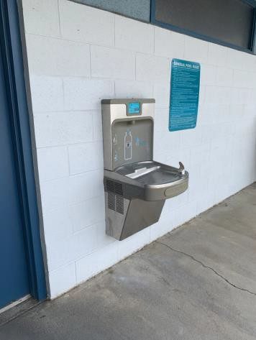

 | ID:  2086 | Facility:  Fairmont Pool House

Location: Pool Deck
Schedule: 2021
Estimated Cost: $400.00

Priority Score 3
Quick Fix: Yes
Built before ADA: Yes

VIOLATIONS
2010 ADA Standards for Accessible Design Codes: §216.2, §703
There is no tactile sign identifying the permanent room.

RECOMMENDATIONS
Install tactile signage on the latch side of the doorway at a height of 48” minimum to 60” maximum above the floor, identifying room by name or room number.
Signs shall be Braille with raised lettering and should be placed on the wall in the center of an 18"x18" clear floor space.

PHOTOGRAPH(S) OF THIS LOCATION

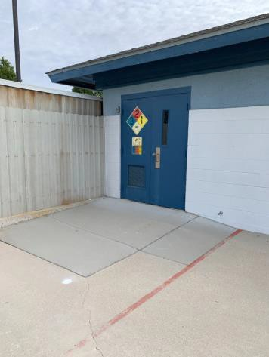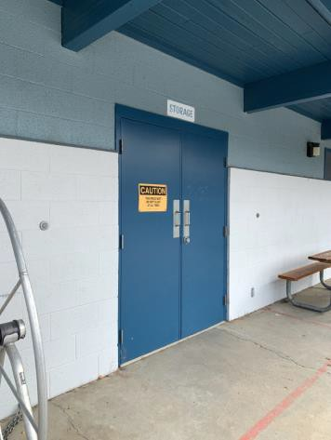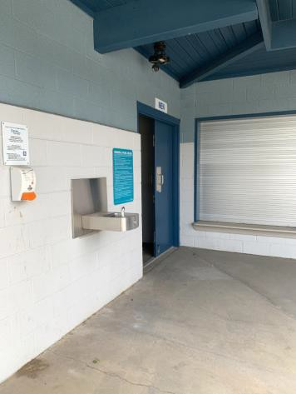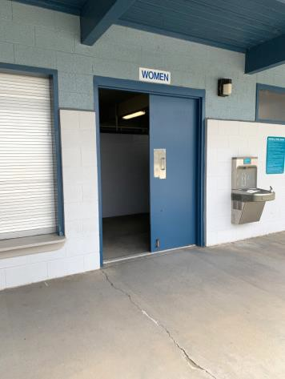

 | ID:  2092 | Facility:  Fairmont Pool House

Location: Pool Deck
Schedule: 2021
Estimated Cost: $1,000.00

Priority Score 3
Quick Fix: No
Built before ADA: Yes

VIOLATIONS
2010 ADA Standards for Accessible Design Codes: §305.2
The clear floor space has a 3.2% slope.

RECOMMENDATIONS
Resurface the 30"x48" clear floor space to have a maximum slope of 2% slope.

PHOTOGRAPH(S) OF THIS LOCATION

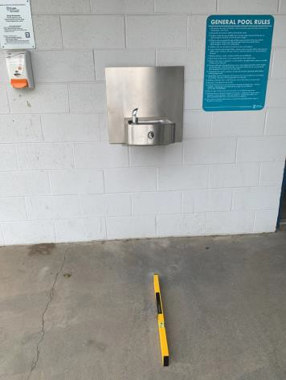

 | ID:  2091 | Facility:  Fairmont Pool House

Location: Pool Deck
Schedule: 2021
Estimated Cost: $2,000.00

Priority Score 3
Quick Fix: No
Built before ADA: Yes

VIOLATIONS
2010 ADA Standards for Accessible Design Codes: §226.1, §902, §305, §306
The provided picnic table does not have an accessible clear space for a wheelchair user.

RECOMMENDATIONS
Add/replace picnic tables so that at least 5% of the seating is wheelchair accessible.
Ensure that the wheelchair accessible seating has a clear floor space of 30" x 48" with a slope not steeper than 2% and that the tables have sufficient knee and toe clearance.

PHOTOGRAPH(S) OF THIS LOCATION

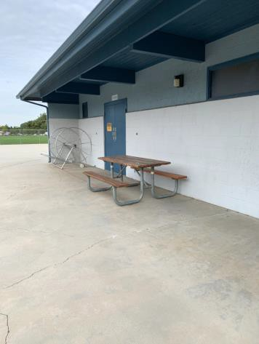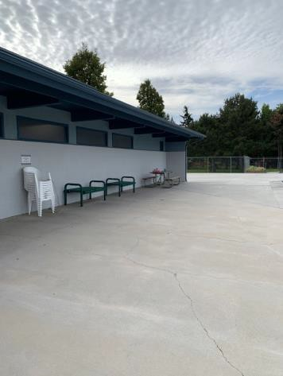

 | ID:  2090 | Facility:  Fairmont Pool House

Location: Pool Deck Sunscreen Dispenser
Schedule: 2021
Estimated Cost: $1,000.00

Priority Score 3
Quick Fix: No
Built before ADA: Yes

VIOLATIONS
2010 ADA Standards for Accessible Design Codes: §305.2
The clear floor space has a 2.8% slope.

RECOMMENDATIONS
Resurface the 30"x48" clear floor space to have a maximum slope of 2% slope.

PHOTOGRAPH(S) OF THIS LOCATION

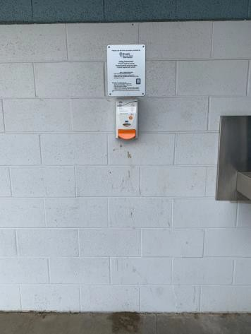

 | ID:  2064 | Facility:  Fairmont Pool House

Location: Ramp to Exterior Park Restrooms
Schedule: 2022
Estimated Cost: $1,000.00

Priority Score 7
Quick Fix: No
Built before ADA: Yes

VIOLATIONS
2010 ADA Standards for Accessible Design Codes: §405.2
The running slope of the ramp is 9.1% and 9.6% at the top.

RECOMMENDATIONS
Resurface the ramp to reduce the running slope to a maximum of 8.3%.

PHOTOGRAPH(S) OF THIS LOCATION

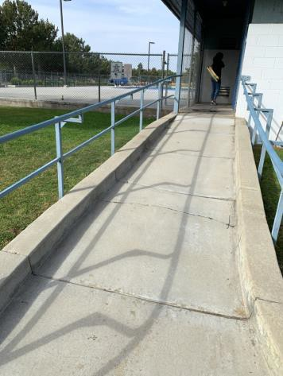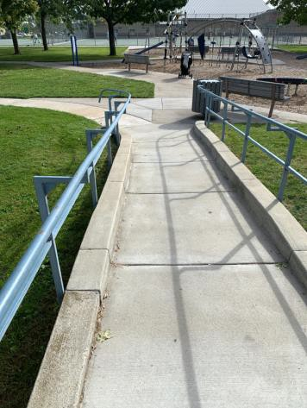

 | ID:  2050 | Facility:  Fairmont Pool House

Location: Women’s Exterior Park Restroom
Schedule: 2022
Estimated Cost: $100.00

Priority Score 7
Quick Fix: Yes
Built before ADA: Yes

VIOLATIONS
2010 ADA Standards for Accessible Design Codes: §606.5
The pipes under the sink are not covered.

RECOMMENDATIONS
Wrap the pipes beneath the sink with soft protective wrap or plastic.

PHOTOGRAPH(S) OF THIS LOCATION

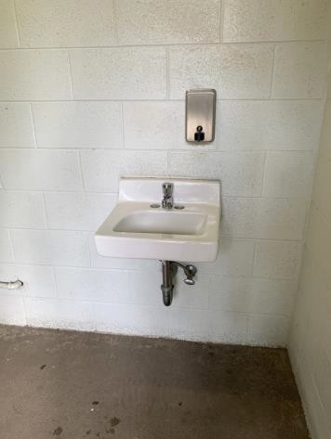

 | ID:  2054 | Facility:  Fairmont Pool House

Location: Women’s Exterior Park Restroom
Schedule: 2022
Estimated Cost: $100.00

Priority Score 5
Quick Fix: Yes
Built before ADA: Yes

VIOLATIONS
2010 ADA Standards for Accessible Design Codes: §604.7
The toilet paper dispenser is not located in an accessible position at 12" in front of the toilet.

RECOMMENDATIONS
Remount the toilet paper dispenser so that it is located 7" minimum to 9" maximum in front of the toilet. Ensure that the height is within the accessible reach range of 15" minimum to 48" maximum above the floor.

PHOTOGRAPH(S) OF THIS LOCATION

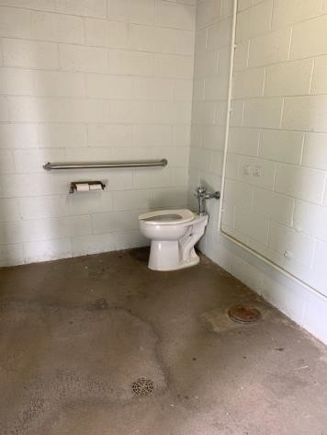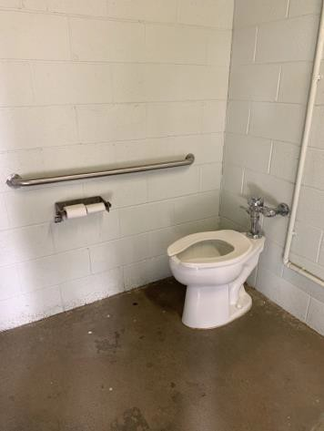

 | ID:  2049 | Facility:  Fairmont Pool House

Location: Women’s Exterior Park Restroom
Schedule: 2022
Estimated Cost: $1,000.00

Priority Score 5
Quick Fix: No
Built before ADA: Yes

VIOLATIONS
2010 ADA Standards for Accessible Design Codes: §604.5
There is no rear grab bar.

RECOMMENDATIONS
Install a rear grab bar at a minimum height of 33” and maximum height of 36” above the finish floor.

PHOTOGRAPH(S) OF THIS LOCATION

 | ID:  2053 | Facility:  Fairmont Pool House

Location: Women’s Exterior Park Restroom
Schedule: 2022
Estimated Cost: $1,000.00

Priority Score 5
Quick Fix: No
Built before ADA: Yes

VIOLATIONS
2010 ADA Standards for Accessible Design Codes: §604.6
The flush control is located on the wall side of the toilet.

RECOMMENDATIONS
Either make the toilet flush automatically or relocate the flush control to be operated on the open side of the toilet.

PHOTOGRAPH(S) OF THIS LOCATION

 | ID:  2055 | Facility:  Fairmont Pool House

Location: Women’s Exterior Park Restroom
Schedule: 2022
Estimated Cost: $1,000.00

Priority Score 5
Quick Fix: No
Built before ADA: Yes

VIOLATIONS
2010 ADA Standards for Accessible Design Codes: ICC A117.1 §604.5.1
The accessible water closet does not have a vertical grab bar.

RECOMMENDATIONS
Install an 18" long (minimum) vertical grab bar, mounted with the bottom located at 39" minimum and 41" maximum above the floor.
The centerline of the vertical grab bar shall be located 39" minimum and 41" maximum from the rear wall

PHOTOGRAPH(S) OF THIS LOCATION

 | ID:  2076 | Facility:  Fairmont Pool House

Location: Women’s Locker Room
Schedule: 2023
Estimated Cost: $100.00

Priority Score 8
Quick Fix: Yes
Built before ADA: Yes

VIOLATIONS
2010 ADA Standards for Accessible Design Codes: §308.2.1
The hooks are outside of the unobstructed forward reach range at 67.5" above the floor.

RECOMMENDATIONS
Lower at least one hook by 19.5" to meet the accessible reach range of 15" minimum and 48" maximum above the floor.

PHOTOGRAPH(S) OF THIS LOCATION

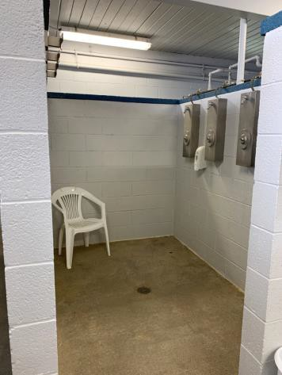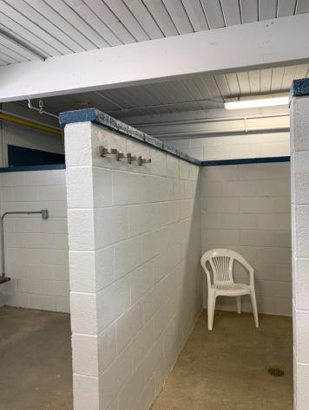

 | ID:  2069 | Facility:  Fairmont Pool House

Location: Women’s Locker Room
Schedule: 2022
Estimated Cost: $100.00

Priority Score 5
Quick Fix: Yes
Built before ADA: Yes

VIOLATIONS
2010 ADA Standards for Accessible Design Codes: §604.8.1.2
The door to the accessible water closet is not self closing. Either self-closing hinges are not installed on the door or if installed, they are defective.

RECOMMENDATIONS
Install or reinstall self-closing hinges on the door to ensure that the door is self-closing per the ADA requirements.

PHOTOGRAPH(S) OF THIS LOCATION

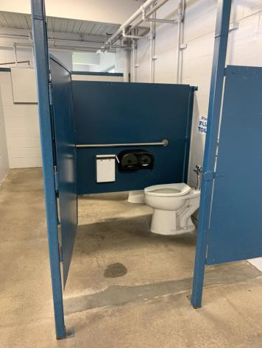

 | ID:  2075 | Facility:  Fairmont Pool House

Location: Women’s Locker Room
Schedule: 2022
Estimated Cost: $100.00

Priority Score 5
Quick Fix: Yes
Built before ADA: Yes

VIOLATIONS
2010 ADA Standards for Accessible Design Codes: §604.7
The toilet paper dispenser is not located in an accessible position.

RECOMMENDATIONS
Remount the toilet paper dispenser so that it is located 7" minimum to 9" maximum in front of the toilet.
Ensure that the height is within the accessible reach range of 15" minimum to 48" maximum above the floor.

PHOTOGRAPH(S) OF THIS LOCATION

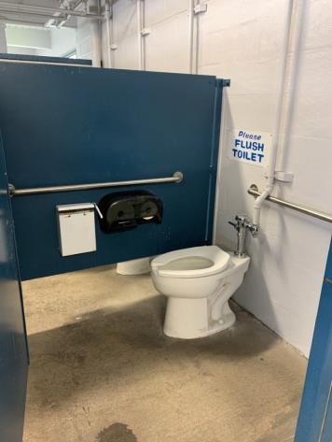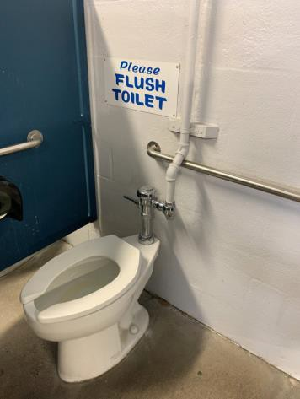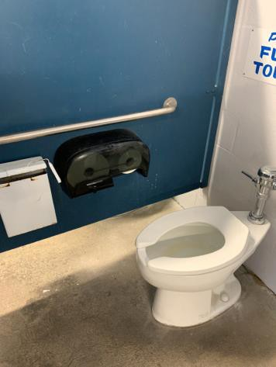

 | ID:  2082 | Facility:  Fairmont Pool House

Location: Women’s Locker Room
Schedule: 2022
Estimated Cost: $100.00

Priority Score 7
Quick Fix: Yes
Built before ADA: Yes

VIOLATIONS
2010 ADA Standards for Accessible Design Codes: §603.3
The mirror is too high to be accessible at 43" above the floor.

RECOMMENDATIONS
Lower the mirror its bottom edge is a maximum height of 40" above the floor.

PHOTOGRAPH(S) OF THIS LOCATION

 | ID:  2083 | Facility:  Fairmont Pool House

Location: Women’s Locker Room
Schedule: 2022
Estimated Cost: $200.00

Priority Score 7
Quick Fix: Yes
Built before ADA: Yes

VIOLATIONS
2010 ADA Standards for Accessible Design Codes: §606.5
The pipes under the sinks are not covered.

RECOMMENDATIONS
Wrap the pipes beneath the sinks with soft protective wrap or plastic.

PHOTOGRAPH(S) OF THIS LOCATION

 | ID:  2085 | Facility:  Fairmont Pool House

Location: Women’s Locker Room
Schedule: 2022
Estimated Cost: $500.00

Priority Score 5
Quick Fix: Yes
Built before ADA: Yes

VIOLATIONS
2010 ADA Standards for Accessible Design Codes: §903.3
The benches in the women's locker room are 15" deep.

RECOMMENDATIONS
Install one new bench that is at least 42" long and 20" to 24" inches deep. The accessible bench shall have a back support or be affixed to a wall.

PHOTOGRAPH(S) OF THIS LOCATION

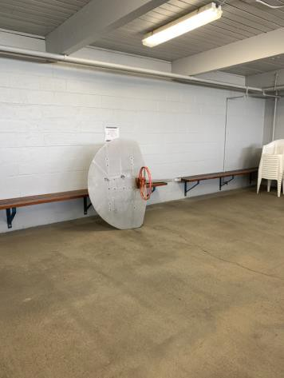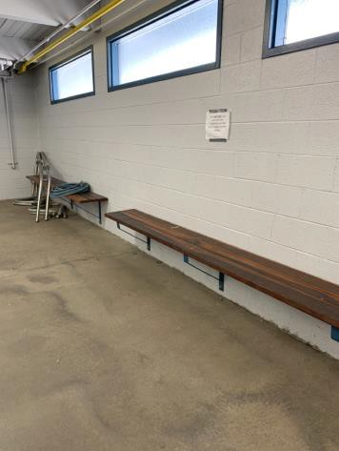

 | ID:  2070 | Facility:  Fairmont Pool House

Location: Women’s Locker Room
Schedule: 2022
Estimated Cost: $1,000.00

Priority Score 5
Quick Fix: No
Built before ADA: Yes

VIOLATIONS
2010 ADA Standards for Accessible Design Codes: §604.6
The flush control is located on the wall side of the toilet.

RECOMMENDATIONS
Either make the toilet flush automatically or relocate the flush control to be operated on the open side of the toilet.

PHOTOGRAPH(S) OF THIS LOCATION

 | ID:  2071 | Facility:  Fairmont Pool House

Location: Women’s Locker Room
Schedule: 2022
Estimated Cost: $1,000.00

Priority Score 5
Quick Fix: No
Built before ADA: Yes

VIOLATIONS
2010 ADA Standards for Accessible Design Codes: §604.5.2
A pipe covers the rear grab bar.

RECOMMENDATIONS
Either split the rear grab bar or shift it to the open side of the toilet area per exception 2 in the 2010 ADA Standards.
Where an administrative authority requires flush controls for flush valves to be located in a position that conflicts with the location of the rear grab bar, the rear grab bar shall be permitted to be split or shifted to the open side of the toilet area

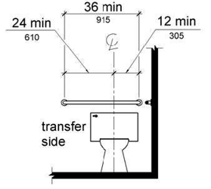

PHOTOGRAPH(S) OF THIS LOCATION

 | ID:  2072 | Facility:  Fairmont Pool House

Location: Women’s Locker Room
Schedule: 2022
Estimated Cost: $2,000.00

Priority Score 5
Quick Fix: No
Built before ADA: Yes

VIOLATIONS
2010 ADA Standards for Accessible Design Codes: §604.5.2, ICC A117.1 §604.5.1
There is no vertical grab bar, and the rear grab bar is 31" long.

RECOMMENDATIONS
Install an 18" long (minimum) vertical grab bar, mounted with the bottom located at 39" minimum and 41" maximum above the floor. The centerline of the vertical grab bar shall be located 39" minimum and 41" maximum from the re Replace the rear grab bar with one that is a minimum of 36" long minimum and extends from the centerline of the water closet 12" minimum on one side and 24" minimum on the other.

PHOTOGRAPH(S) OF THIS LOCATION

 | ID:  2077 | Facility:  Fairmont Pool House

Location: Women’s Locker Room
Schedule: 2022
Estimated Cost: $10,000.00

Priority Score 6
Quick Fix: No
Built before ADA: Yes

VIOLATIONS
2010 ADA Standards for Accessible Design Codes: §213.3.6
There is not an accessible shower provided.

RECOMMENDATIONS
Install at least one accessible transfer or roll-in shower, complying with § 608 as shown in the Locker Room Showers section of this report.
Ensure appropriate seating, handrails, and shower hardware are provided.

PHOTOGRAPH(S) OF THIS LOCATION

