City of Boise
ADA Assessment

AppendixA-
Library! At Cole & Ustick

01/27/2021
Report #TO21-B016

Prepared by:

 | ID:  2523 | Facility:  Ustick Library

Location: Adult Audiobooks, New Books, and Fiction
Schedule: 2021
Estimated Cost: $300.00

Priority Score 5
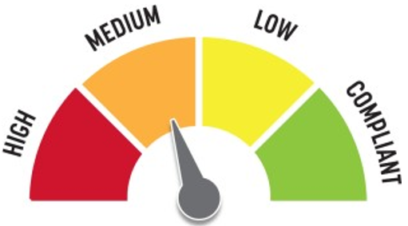
Quick Fix: Yes
Built before ADA: No

VIOLATIONS
2010 ADA Standards for Accessible Design Codes §307.2
The desks protrude 14.75" into the circulation space at 35.5" above the floor.

RECOMMENDATIONS
Extend the sides of the desks down so the bottom edge is 27" maximum above the floor.

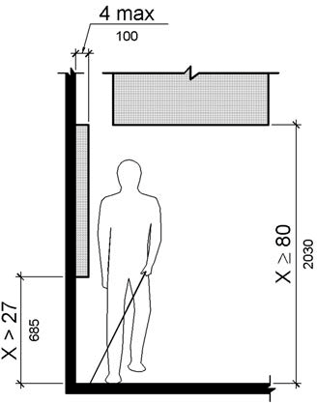

PHOTOGRAPH(S) OF THIS LOCATION

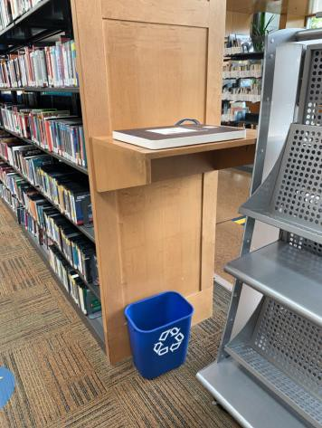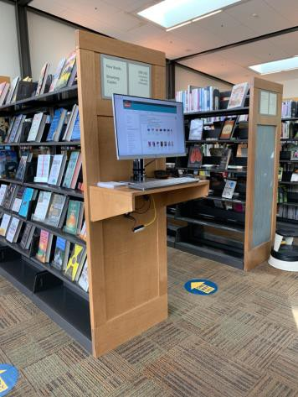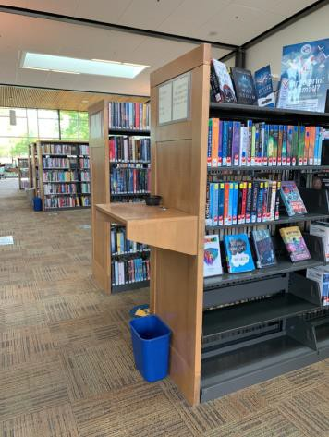

 | ID:  2414 | Facility:  Ustick Library

Location: Back Accessible Parking Space
Schedule: 2021
Estimated Cost: $100.00

Priority Score 6
Quick Fix: Yes
Built before ADA: No

VIOLATIONS
2010 ADA Standards for Accessible Design Codes §216.5
The parking sign identifying the accessible parking space does not meet the 60" minimum height from the ground at 54".

RECOMMENDATIONS
Remount the accessible parking signs to ensure 60" minimum height from the ground.

PHOTOGRAPH(S) OF THIS LOCATION

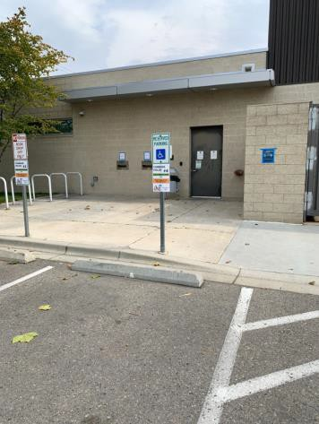

 | ID:  2416 | Facility:  Ustick Library

Location: Back Accessible Parking Space
Schedule: 2021
Estimated Cost: $1,000.00

Priority Score 3
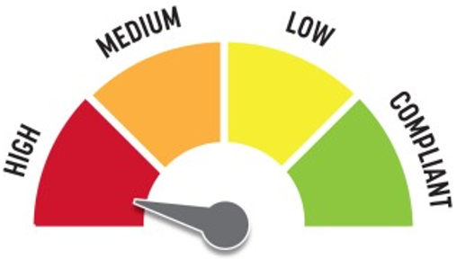
Quick Fix: No
Built before ADA: No

VIOLATIONS
2010 ADA Standards for Accessible Design Codes §406.4
There is no landing provided at the top of the curb ramp.

RECOMMENDATIONS
For the purposes of achieving greater accessibility and Human Centric Design, relocate the access aisle and curb ramp away from the dumpster.
Ensure that the curb has a maximum running slope of 8.3% and a maximum cross slope of 2%. Additionally, install a landing at the top of the curb ramp with a minimum clear length of 36".

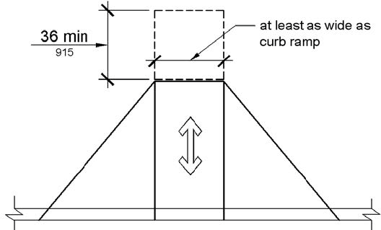

PHOTOGRAPH(S) OF THIS LOCATION

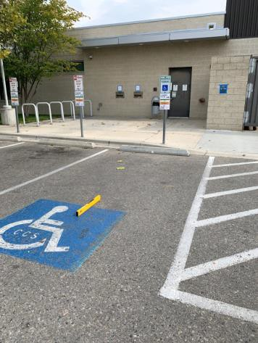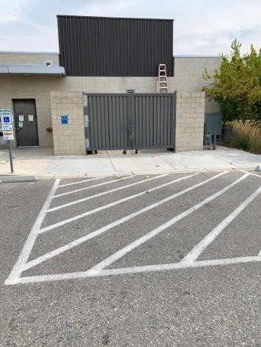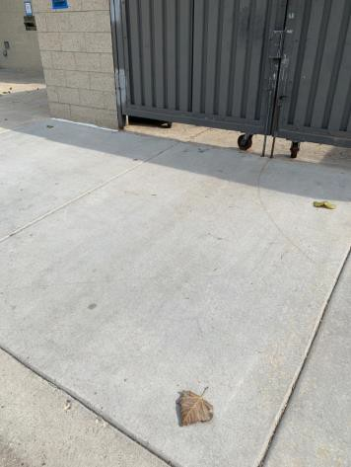

 | ID:  2440 | Facility:  Ustick Library

Location: Back Door
Schedule: 2021
Estimated Cost: $100.00

Priority Score 3
Quick Fix: Yes
Built before ADA: No

VIOLATIONS
2010 ADA Standards for Accessible Design Codes §216.2, §703
There is no tactile sign identifying the permanent room.

RECOMMENDATIONS
Install tactile signage on the latch side of the doorway at a height of 48” minimum to 60” maximum above the floor, identifying room by name or room number.
Signs shall be Braille with raised lettering and should be placed on the wall in the center of an 18"x18" clear floor space.

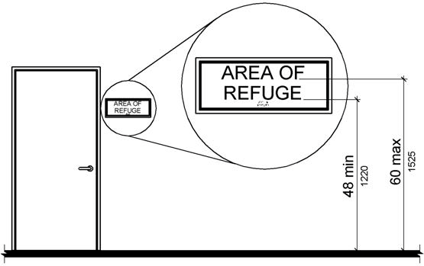

PHOTOGRAPH(S) OF THIS LOCATION

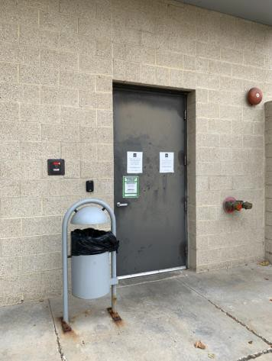

 | ID:  2438 | Facility:  Ustick Library

Location: Back Fire Riser Room
Schedule: 2021
Estimated Cost: $100.00

Priority Score 6
Quick Fix: Yes
Built before ADA: No

VIOLATIONS
2010 ADA Standards for Accessible Design Codes §703.4
The tactile sign identifying the room is not in the correct location.

RECOMMENDATIONS
Reinstall the sign on the latch side of the door at 48" minimum above the floor measured from the baseline of the lowest character and 60" maximum measured from the baseline of the highest character.

PHOTOGRAPH(S) OF THIS LOCATION

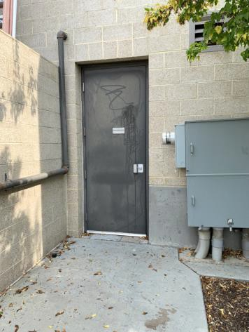

 | ID:  2503 | Facility:  Ustick Library

Location: Bitterbrush Room
Schedule: 2021
Estimated Cost: $100.00

Priority Score 6
Quick Fix: Yes
Built before ADA: No

VIOLATIONS
2010 ADA Standards for Accessible Design Codes §703.4
The tactile sign identifying the room is not in the correct location.

RECOMMENDATIONS
Reinstall the sign on the latch side of the door at 48" minimum above the floor measured from the baseline of the lowest character and 60" maximum measured from the baseline of the highest character.

PHOTOGRAPH(S) OF THIS LOCATION

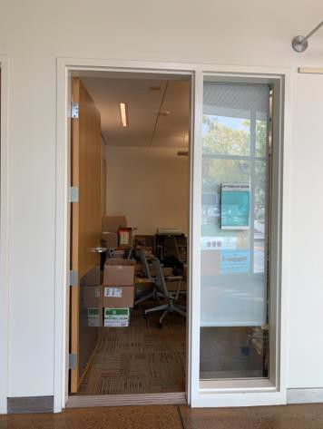

 | ID:  2439 | Facility:  Ustick Library

Location: Book Returns
Schedule: 2021
Estimated Cost: $500.00

Priority Score 3
Quick Fix: Yes
Built before ADA: No

VIOLATIONS
2010 ADA Standards for Accessible Design Codes §302.1
There are tripping hazards in the accessible route.

RECOMMENDATIONS
Repave the area of the sidewalk to remove the cracks.

PHOTOGRAPH(S) OF THIS LOCATION

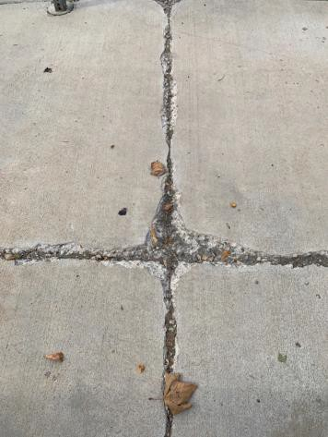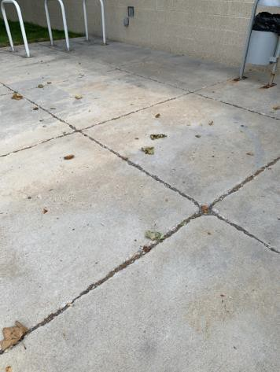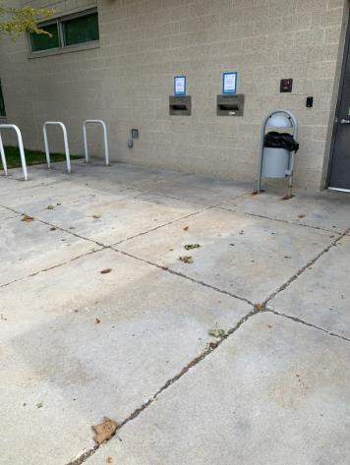

 | ID:  2493 | Facility:  Ustick Library

Location: Children's Area
Schedule: 2021
Estimated Cost: $100.00

Priority Score 3
Quick Fix: Yes
Built before ADA: No

VIOLATIONS
2010 ADA Standards for Accessible Design Codes §216.4, §703
Doors serving as exits are not marked by tactile signage.

RECOMMENDATIONS
Place a tactile exit sign on the right side of the right hand door, that complies with §703.1, §703.2 and §703.5, identifying the exit doors. Install missing signage at 48" minimum above the floor measured from the baseline of the lowest character and 60" maximum measured from the baseline of the highest character.

PHOTOGRAPH(S) OF THIS LOCATION

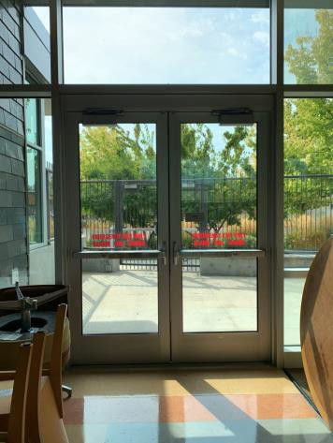

 | ID:  2491 | Facility:  Ustick Library

Location: Children's Area
Schedule: 2022
Estimated Cost: $1,000.00

Priority Score 5
Quick Fix: No
Built before ADA: No

VIOLATIONS
2010 ADA Standards for Accessible Design Codes §306.3.3
There is no knee clearance underneath the counter.

RECOMMENDATIONS
Provide knee clearance underneath the counter at the sink that is a minimum of 11" deep at 9" above the floor and 8" deep at 27" above the floor.

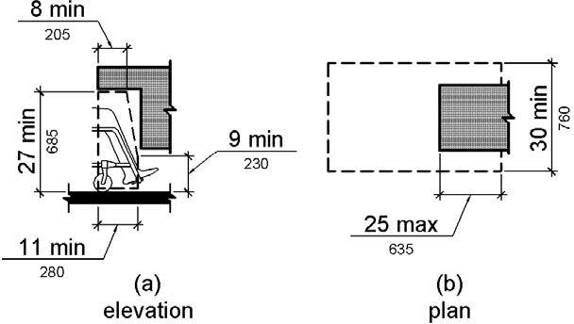

PHOTOGRAPH(S) OF THIS LOCATION

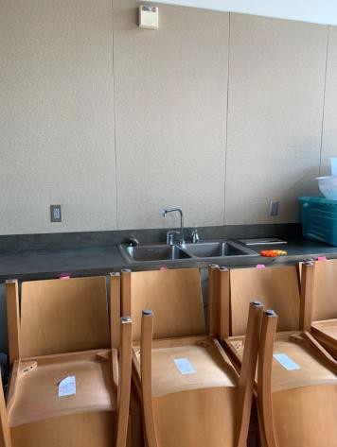

 | ID:  2492 | Facility:  Ustick Library

Location: Children's Area
Schedule: 2023
Estimated Cost: $2,000.00

Priority Score 8
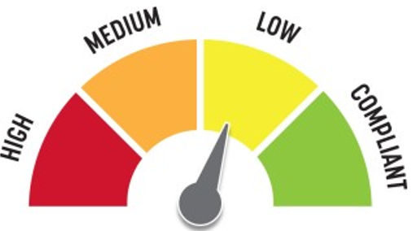
Quick Fix: No
Built before ADA: No

VIOLATIONS
2010 ADA Standards for Accessible Design Codes §902.3, §606.3
The sink is 34.25" above the floor.
The dining and work surface counter is 34.25" above the floor.

RECOMMENDATIONS
Lower the sink to the maximum height of 34" above the floor.
A 30" portion of the dining and work surface must be no higher than 34” above the floor.

PHOTOGRAPH(S) OF THIS LOCATION

 | ID:  2442 | Facility:  Ustick Library

Location: Computer Lab Exterior Doors
Schedule: 2021
Estimated Cost: $500.00

Priority Score 4
Quick Fix: Yes
Built before ADA: No

VIOLATIONS
2010 ADA Standards for Accessible Design Codes §404.2.9
The opening and closing force of the doors is 13 pounds.

RECOMMENDATIONS
Adjust the resistance on the door so that it allows the doors to be continuously opened at a maximum force of 5 pounds.

PHOTOGRAPH(S) OF THIS LOCATION

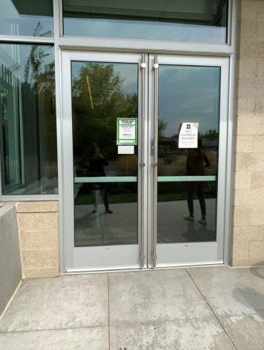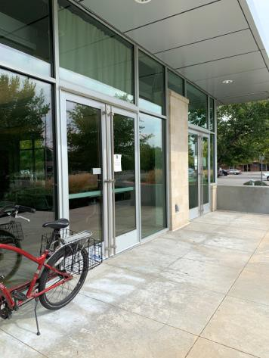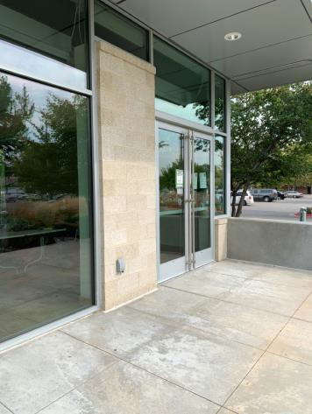

 | ID:  2441 | Facility:  Ustick Library

Location: Crosswalk
Schedule: 2022
Estimated Cost: $1,000.00

Priority Score 5
Quick Fix: No
Built before ADA: No

VIOLATIONS
2010 ADA Standards for Accessible Design Codes §303.2
There is a change in level greater than 0.25".

RECOMMENDATIONS
Resurface the pathway to reduce the change in level to less than 0.25" or 0.5" if beveled.

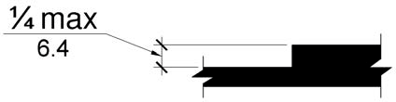

PHOTOGRAPH(S) OF THIS LOCATION

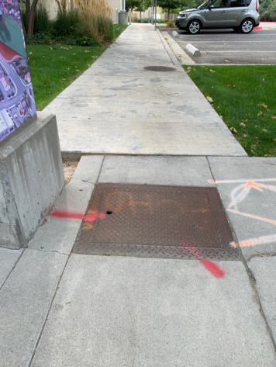

 | ID:  2498 | Facility:  Ustick Library

Location: Electrical Room
Schedule: 2021
Estimated Cost: $100.00

Priority Score 6
Quick Fix: Yes
Built before ADA: No

VIOLATIONS
2010 ADA Standards for Accessible Design Codes §703.4
The tactile sign identifying the room is not in the correct location.

RECOMMENDATIONS
Reinstall the sign on the inactive leaf at 48" minimum above the floor measured from the baseline of the lowest character and 60" maximum measured from the baseline of the highest character.

PHOTOGRAPH(S) OF THIS LOCATION

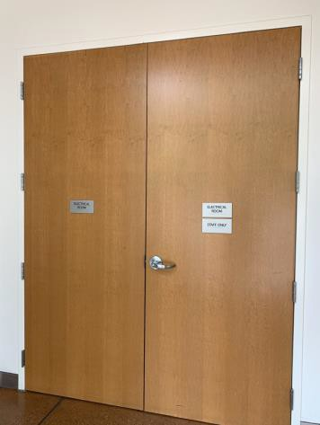

 | ID:  2450 | Facility:  Ustick Library

Location: Electrical Room Exit
Schedule: 2021
Estimated Cost: $100.00

Priority Score 3
Quick Fix: Yes
Built before ADA: No

VIOLATIONS
2010 ADA Standards for Accessible Design Codes §216.4, §703
Doors serving as exits are not marked by tactile signage.

RECOMMENDATIONS
Place a tactile exit sign, that complies with §703.1, §703.2 and §703.5, identifying the exit doors.
Install missing signage at 48" minimum above the floor measured from the baseline of the lowest character and 60" maximum measured from the baseline of the highest character.

PHOTOGRAPH(S) OF THIS LOCATION

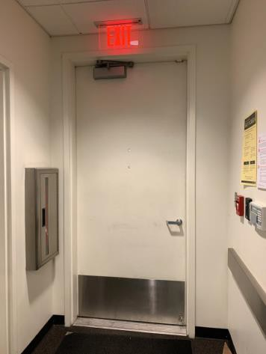

 | ID:  2483 | Facility:  Ustick Library

Location: Family Restroom
Schedule: 2021
Estimated Cost: $100.00

Priority Score 6
Quick Fix: Yes
Built before ADA: No

VIOLATIONS
2010 ADA Standards for Accessible Design Codes §703.4
The tactile sign identifying the room is not in the correct location.

RECOMMENDATIONS
Reinstall the sign on the latch side of the door at 48" minimum above the floor measured from the baseline of the lowest character and 60" maximum measured from the baseline of the highest character.

PHOTOGRAPH(S) OF THIS LOCATION

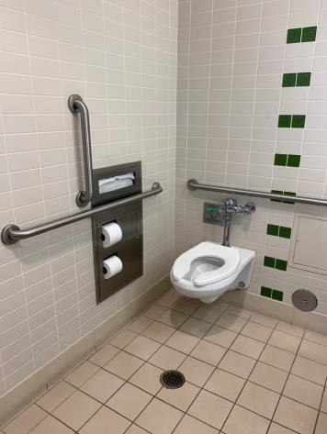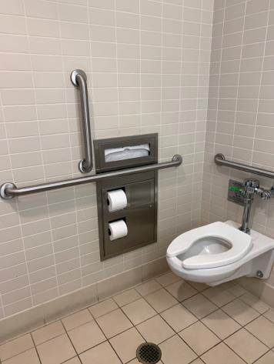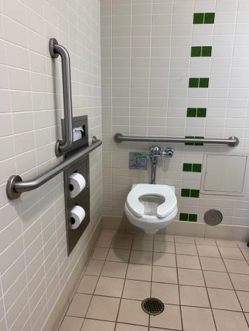

 | ID:  2489 | Facility:  Ustick Library

Location: Family Restroom
Schedule: 2021
Estimated Cost: $100.00

Priority Score 5
Quick Fix: Yes
Built before ADA: No

VIOLATIONS
2010 ADA Standards for Accessible Design Codes §604.7
The toilet paper dispenser is located out of the accessible reach range.

RECOMMENDATIONS
Remount the toilet paper dispenser to 7” minimum and 9” maximum in front of the water closet measured to the centerline of the dispenser.
The outlet of the dispenser shall be 15” minimum and 48” maximum above the floor and shall not be located behind.

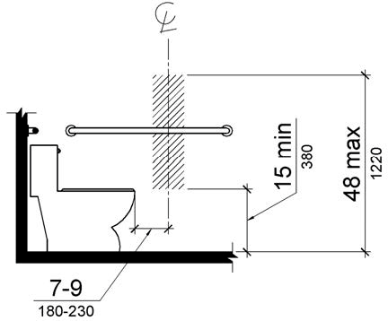

PHOTOGRAPH(S) OF THIS LOCATION

 | ID:  2486 | Facility:  Ustick Library

Location: Family Restroom
Schedule: 2021
Estimated Cost: $500.00

Priority Score 5
Quick Fix: Yes
Built before ADA: No

VIOLATIONS
2010 ADA Standards for Accessible Design Codes §604.5.1
The side grab bar extends 53" from the rear wall.

RECOMMENDATIONS
Remount the side grab bar 12" maximum from the rear wall and extending 54" minimum from the rear wall.

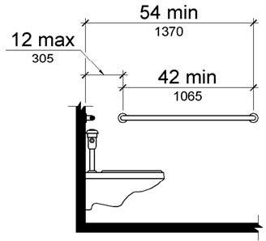

PHOTOGRAPH(S) OF THIS LOCATION

…

 | ID:  2488 | Facility:  Ustick Library

Location: Family Restroom
Schedule: 2022
Estimated Cost: $1,000.00

Priority Score 5
Quick Fix: No
Built before ADA: No

VIOLATIONS
2010 ADA Standards for Accessible Design Codes §604.4
The toilet is 20" above the floor.

RECOMMENDATIONS
Lower the toilet seat to comply with the maximum height of 19” above the floor measured to the top of the seat.

PHOTOGRAPH(S) OF THIS LOCATION

 | ID:  2451 | Facility:  Ustick Library

Location: Fire Riser Room
Schedule: 2021
Estimated Cost: $100.00

Priority Score 6
Quick Fix: Yes
Built before ADA: No

VIOLATIONS
2010 ADA Standards for Accessible Design Codes §703.4
The tactile sign identifying the room is not in the correct location.

RECOMMENDATIONS
Reinstall the sign on the latch side of the door at 48" minimum above the floor measured from the baseline of the lowest character and 60" maximum measured from the baseline of the highest character.

PHOTOGRAPH(S) OF THIS LOCATION

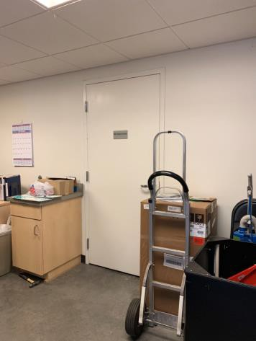

 | ID:  2499 | Facility:  Ustick Library

Location: Kitchen
Schedule: 2021
Estimated Cost: $100.00

Priority Score 3
Quick Fix: Yes
Built before ADA: No

VIOLATIONS
2010 ADA Standards for Accessible Design Codes §216.2, §703
There is no tactile sign identifying the permanent room.

RECOMMENDATIONS
Install tactile signage on the latch side of the doorway at a height of 48” minimum to 60” maximum
above the floor, identifying room by name or room number.
Signs shall be Braille with raised lettering and should be placed on the wall in the center of an 18"x18" clear floor space.

PHOTOGRAPH(S) OF THIS LOCATION

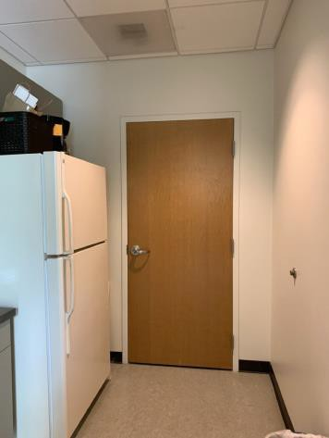

 | ID:  2502 | Facility:  Ustick Library

Location: Kitchen
Schedule: 2021
Estimated Cost: $100.00

Priority Score 6
Quick Fix: Yes
Built before ADA: No

VIOLATIONS
2010 ADA Standards for Accessible Design Codes §703.4
The tactile sign identifying the room is not in the correct location.

RECOMMENDATIONS
Reinstall the sign on the latch side of the door at 48" minimum above the floor measured from the baseline of the lowest character and 60" maximum measured from the baseline of the highest character.

PHOTOGRAPH(S) OF THIS LOCATION

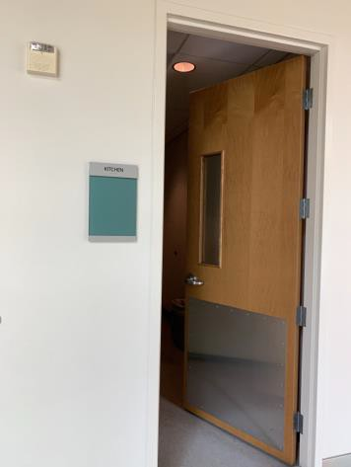

 | ID:  2500 | Facility:  Ustick Library

Location: Kitchen
Schedule: 2022
Estimated Cost: $1,000.00

Priority Score 5
Quick Fix: No
Built before ADA: No

VIOLATIONS
2010 ADA Standards for Accessible Design Codes §306.3.3
There is no knee clearance underneath the counter.

RECOMMENDATIONS
Provide knee clearance underneath the counter at the sink that is a minimum of 11" deep at 9" above the floor and 8" deep at 27" above the floor.

PHOTOGRAPH(S) OF THIS LOCATION

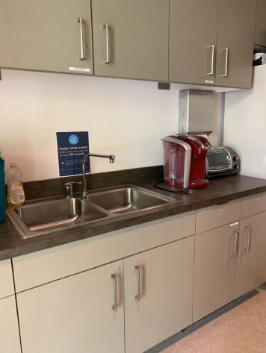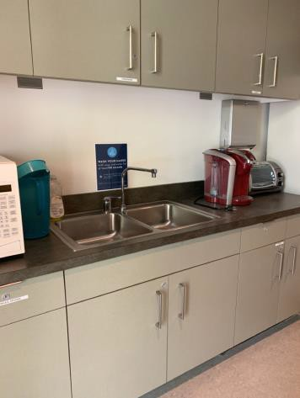

 | ID: | Facility:  Ustick Library

Location:
Schedule:
Estimated Cost:

Priority Score 8
Quick Fix: No
Built before ADA: No

VIOLATIONS
2010 ADA Standards for Accessible Design Codes §902.3, §606.3
The sink is 34.25" above the floor.
The dining and work surface counter is 34.25" above the floor.

RECOMMENDATIONS
Lower the sink to the maximum height of 34" above the floor.
A 30" portion of the dining and work surface must be no higher than 34” above the floor.

PHOTOGRAPH(S) OF THIS LOCATION

 | ID:  2458 | Facility:  Ustick Library

Location: Library Staff Restroom
Schedule: 2021
Estimated Cost: $0.00

Priority Score 0
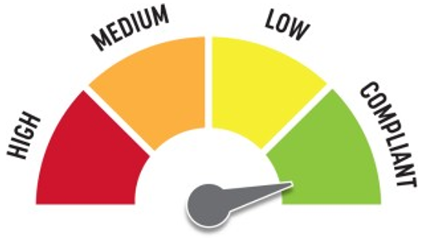
Quick Fix: Yes
Built before ADA: No

VIOLATIONS
2010 ADA Standards for Accessible Design Codes §607.6
The adjustable shower head is 64" above the floor.

RECOMMENDATIONS
For the purposes of achieving greater accessibility and Human Centric Design, consider installing a shorter vertical grab bar that ends at a maximum height of 48" above the floor.

PHOTOGRAPH(S) OF THIS LOCATION

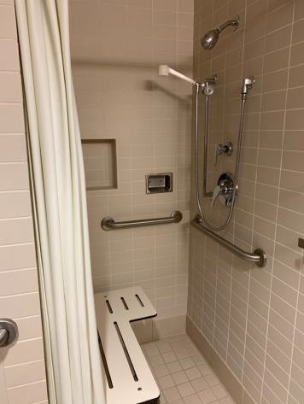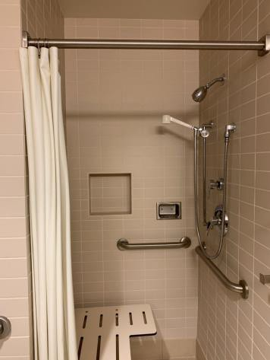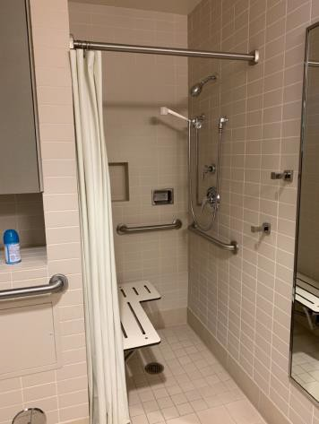

 | ID:  2471 | Facility:  Ustick Library

Location: Library Staff Restroom
Schedule: 2021
Estimated Cost: $0.00

Priority Score 0
Quick Fix: Yes
Built before ADA: No

VIOLATIONS
2010 ADA Standards for Accessible Design Codes §607.6
The adjustable shower head is 65" above the floor.

RECOMMENDATIONS
For the purposes of achieving greater accessibility and Human Centric Design, consider installing a shorter vertical grab bar that ends at a maximum height of 48" above the floor.

PHOTOGRAPH(S) OF THIS LOCATION

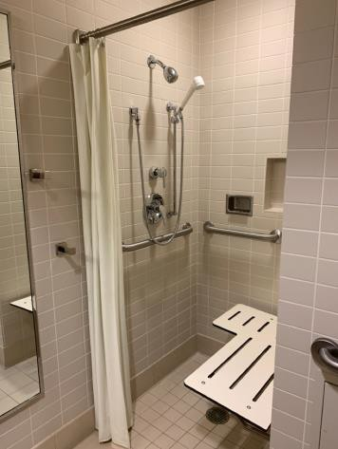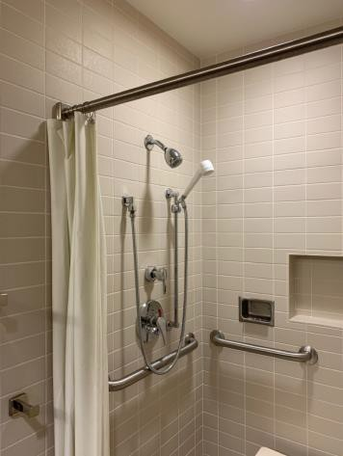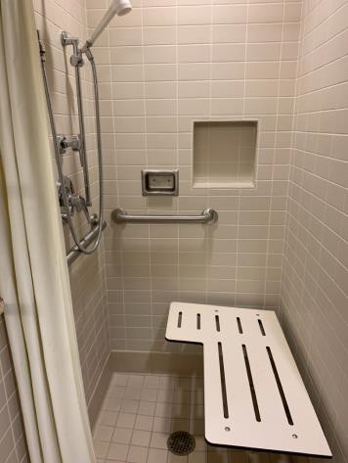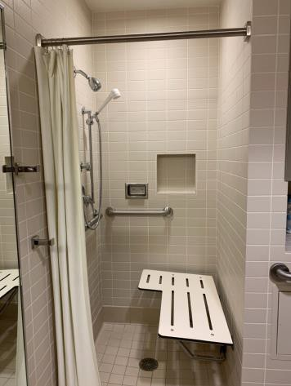

 | ID:  2459 | Facility:  Ustick Library

Location: Library Staff Restroom
Schedule: 2021
Estimated Cost: $100.00

Priority Score 5
Quick Fix: Yes
Built before ADA: No

VIOLATIONS
2010 ADA Standards for Accessible Design Codes §307.2
The shower curtain rod is 76" above the floor.

RECOMMENDATIONS
Raise the shower curtain rod to a minimum of 80" above the floor.

PHOTOGRAPH(S) OF THIS LOCATION

 | ID:  2461 | Facility:  Ustick Library

Location: Library Staff Restroom
Schedule: 2021
Estimated Cost: $100.00

Priority Score 5
Quick Fix: Yes
Built before ADA: No

VIOLATIONS
2010 ADA Standards for Accessible Design Codes §604.7
The toilet paper dispenser is located out of the accessible reach range at 12" in front of the toilet.

RECOMMENDATIONS
Remount the toilet paper dispenser to 7” minimum and 9” maximum in front of the water closet measured to the centerline of the dispenser.
The outlet of the dispenser shall be 15” minimum and 48” maximum above the floor and shall not be located behind.

PHOTOGRAPH(S) OF THIS LOCATION

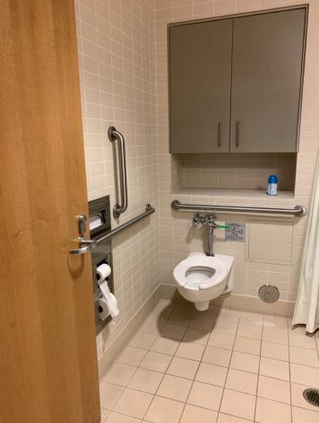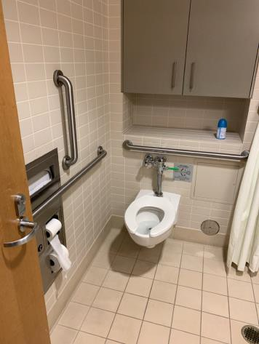

 | ID:  2464 | Facility:  Ustick Library

Location: Library Staff Restroom
Schedule: 2021
Estimated Cost: $100.00

Priority Score 5
Quick Fix: Yes
Built before ADA: No

VIOLATIONS
2010 ADA Standards for Accessible Design Codes §604.8.1.2
The door to the accessible water closet is not self closing. Either self-closing hinges are not installed on the door or if installed, they are defective.

RECOMMENDATIONS
Install or reinstall self-closing hinges on the door to ensure that the door is self-closing per the ADA requirements.

PHOTOGRAPH(S) OF THIS LOCATION

 | ID:  2466 | Facility:  Ustick Library

Location: Library Staff Restroom
Schedule: 2021
Estimated Cost: $100.00

Priority Score 7
Quick Fix: Yes
Built before ADA: No

VIOLATIONS
2010 ADA Standards for Accessible Design Codes §603.3
The mirror is too high to be accessible at 41" above the floor.

RECOMMENDATIONS
Lower the mirror its bottom edge is a maximum height of 40" above the floor.

PHOTOGRAPH(S) OF THIS LOCATION

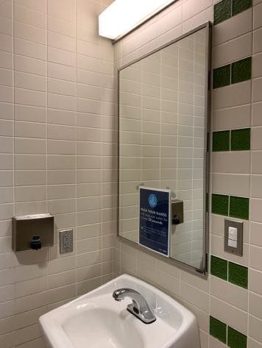

 | ID:  2473 | Facility:  Ustick Library

Location: Library Staff Restroom
Schedule: 2021
Estimated Cost: $100.00

Priority Score 5
Quick Fix: Yes
Built before ADA: No

VIOLATIONS
2010 ADA Standards for Accessible Design Codes §307.2
The shower curtain rod is 76" above the floor.

RECOMMENDATIONS
Raise the shower curtain rod to a minimum of 80" above the floor.

PHOTOGRAPH(S) OF THIS LOCATION

 | ID:  2478 | Facility:  Ustick Library

Location: Library Staff Restroom
Schedule: 2021
Estimated Cost: $100.00

Priority Score 5
Quick Fix: Yes
Built before ADA: No

VIOLATIONS
2010 ADA Standards for Accessible Design Codes §604.7
The toilet paper dispenser is located out of the accessible reach range.

RECOMMENDATIONS
Remount the toilet paper dispenser to 7” minimum and 9” maximum in front of the water closet measured to the centerline of the dispenser.
The outlet of the dispenser shall be 15” minimum and 48” maximum above the floor and shall not be located behind.

PHOTOGRAPH(S) OF THIS LOCATION

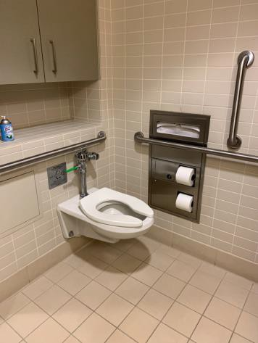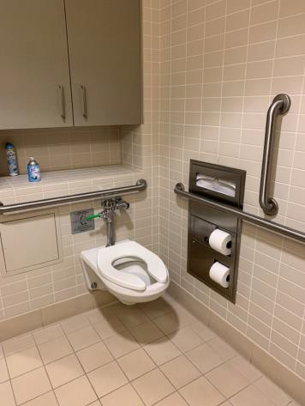

 | ID:  2479 | Facility:  Ustick Library

Location: Library Staff Restroom
Schedule: 2021
Estimated Cost: $100.00

Priority Score 5
Quick Fix: Yes
Built before ADA: No

VIOLATIONS
2010 ADA Standards for Accessible Design Codes §604.8.1.2
The door to the accessible water closet is not self closing. Either self-closing hinges are not installed on the door or if installed, they are defective.

RECOMMENDATIONS
Install or reinstall self-closing hinges on the door to ensure that the door is self-closing per the ADA requirements.

PHOTOGRAPH(S) OF THIS LOCATION

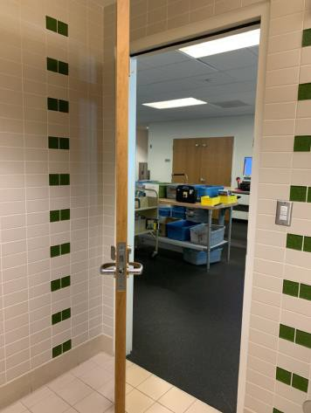

 | ID:  2480 | Facility:  Ustick Library

Location: Library Staff Restroom
Schedule: 2021
Estimated Cost: $100.00

Priority Score 7
Quick Fix: Yes
Built before ADA: No

VIOLATIONS
2010 ADA Standards for Accessible Design Codes §603.3
The mirror is too high to be accessible at 41" above the floor.

RECOMMENDATIONS
Lower the mirror its bottom edge is a maximum height of 40" above the floor.

PHOTOGRAPH(S) OF THIS LOCATION

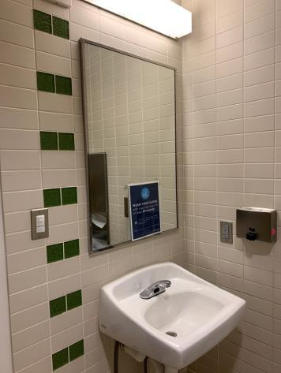

 | ID:  2463 | Facility:  Ustick Library

Location: Library Staff Restroom
Schedule: 2021
Estimated Cost: $500.00

Priority Score 5
Quick Fix: Yes
Built before ADA: No

VIOLATIONS
2010 ADA Standards for Accessible Design Codes §604.5.1
The side grab bar extends 53" from the rear wall.

RECOMMENDATIONS
Remount the side grab bar 12" maximum from the rear wall and extending 54" minimum from the rear wall.

PHOTOGRAPH(S) OF THIS LOCATION

 | ID:  2475 | Facility:  Ustick Library

Location: Library Staff Restroom
Schedule: 2021
Estimated Cost: $500.00

Priority Score 5
Quick Fix: Yes
Built before ADA: No

VIOLATIONS
2010 ADA Standards for Accessible Design Codes §604.5.1
The side grab bar extends 53" from the rear wall.

RECOMMENDATIONS
Remount the side grab bar 12" maximum from the rear wall and extending 54" minimum from the rear wall.

PHOTOGRAPH(S) OF THIS LOCATION

 | ID:  2455 | Facility:  Ustick Library

Location: Library Staff Restroom
Schedule: 2022
Estimated Cost: $1,000.00

Priority Score 6
Quick Fix: No
Built before ADA: No

VIOLATIONS
2010 ADA Standards for Accessible Design Codes §608.3, §609
The back wall grab bar is 5" from the control wall.

RECOMMENDATIONS
Install a grab bar across the back wall to a point 18" from the control wall at a maximum height of 36" above the bathroom floor.

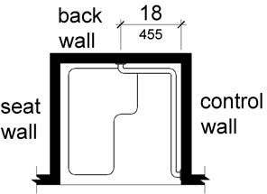

PHOTOGRAPH(S) OF THIS LOCATION

…

 | ID:  2460 | Facility:  Ustick Library

Location: Library Staff Restroom
Schedule: 2022
Estimated Cost: $1,000.00

Priority Score 5
Quick Fix: No
Built before ADA: No

VIOLATIONS
2010 ADA Standards for Accessible Design Codes §604.4
The toilet is 19.5" above the floor.

RECOMMENDATIONS
Lower the toilet seat to comply with the maximum height of 19” above the floor measured to the top of the seat.

PHOTOGRAPH(S) OF THIS LOCATION

 | ID:  2468 | Facility:  Ustick Library

Location: Library Staff Restroom
Schedule: 2022
Estimated Cost: $1,000.00

Priority Score 6
Quick Fix: No
Built before ADA: No

VIOLATIONS
2010 ADA Standards for Accessible Design Codes §608.3, §609
The back wall grab bar is 5" from the control wall.

RECOMMENDATIONS
Install a grab bar across the back wall to a point 18" from the control wall at a maximum height of 36" above the bathroom floor.

PHOTOGRAPH(S) OF THIS LOCATION

 | ID:  2477 | Facility:  Ustick Library

Location: Library Staff Restroom
Schedule: 2022
Estimated Cost: $1,000.00

Priority Score 5
Quick Fix: No
Built before ADA: No

VIOLATIONS
2010 ADA Standards for Accessible Design Codes §604.4
The toilet is 20" above the floor.

RECOMMENDATIONS
Lower the toilet seat to comply with the maximum height of 19” above the floor measured to the top of the seat.

PHOTOGRAPH(S) OF THIS LOCATION

 | ID:  2481 | Facility:  Ustick Library

Location: Library Staff Room 125
Schedule: 2021
Estimated Cost: $100.00

Priority Score 6
Quick Fix: Yes
Built before ADA: No

VIOLATIONS
2010 ADA Standards for Accessible Design Codes §703.4
The tactile sign identifying the room is not in the correct location.

RECOMMENDATIONS
Reinstall the sign on the latch side of the door at 48" minimum above the floor measured from the baseline of the lowest character and 60" maximum measured from the baseline of the highest character.

PHOTOGRAPH(S) OF THIS LOCATION

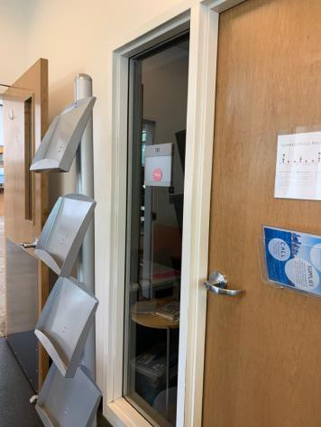

 | ID:  2443 | Facility:  Ustick Library

Location: Lounge
Schedule: 2021
Estimated Cost: $100.00

Priority Score 8
Built before ADA: No

VIOLATIONS
2010 ADA Standards for Accessible Design Codes §308.2.2
The microwave outside of the obstructed forward reach range at 65" above the floor.

RECOMMENDATIONS
Lower the microwave by 17" to meet the accessible reach range of 48" maximum above the floor or install a secondary microwave.

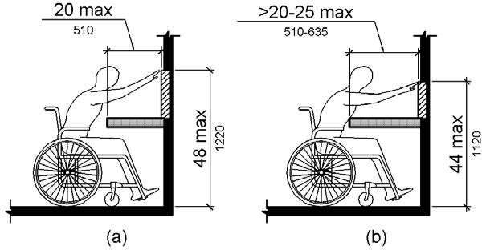

PHOTOGRAPH(S) OF THIS LOCATION

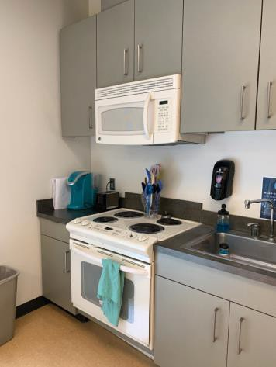

 | ID:  2446 | Facility:  Ustick Library

Location: Lounge
Schedule: 2021
Estimated Cost: $100.00

Priority Score 8
Quick Fix: Yes
Built before ADA: No

VIOLATIONS
2010 ADA Standards for Accessible Design Codes §308.2.1
The closet rod is outside of the unobstructed forward reach range at 61" above the floor.

RECOMMENDATIONS
Lower the closet rod by 13" to meet the accessible reach range of 48" maximum above the floor or install a secondary lower closet rod.

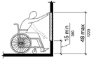

PHOTOGRAPH(S) OF THIS LOCATION

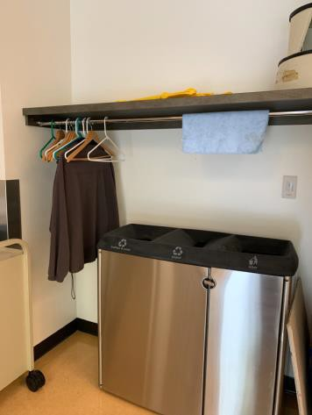

 | ID:  2447 | Facility:  Ustick Library

Location: Lounge
Schedule: 2021
Estimated Cost: $100.00

Priority Score 5
Quick Fix: Yes
Built before ADA: No

VIOLATIONS
2010 ADA Standards for Accessible Design Codes §307.2
The biohazard container protrudes 5" into the circulation space at 29" above the floor.

RECOMMENDATIONS
Recess the biohazard container so it protrudes a maximum of 4", lower it so the bottom edge is 27" maximum above the floor, or place a cane detectable object beneath it.

PHOTOGRAPH(S) OF THIS LOCATION

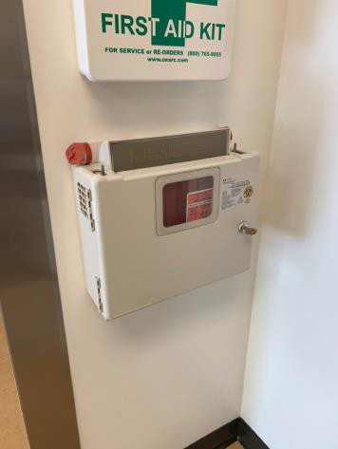

 | ID:  2448 | Facility:  Ustick Library

Location: Lounge
Schedule: 2021
Estimated Cost: $100.00

Priority Score 3
Quick Fix: Yes
Built before ADA: No

VIOLATIONS
2010 ADA Standards for Accessible Design Codes §216.4, §703
Doors serving as exits are not marked by tactile signage.

RECOMMENDATIONS
Place a tactile exit sign, that complies with §703.1, §703.2 and §703.5, identifying the exit doors.
Install missing signage at 48" minimum above the floor measured from the baseline of the lowest character and 60" maximum measured from the baseline of the highest character.

PHOTOGRAPH(S) OF THIS LOCATION

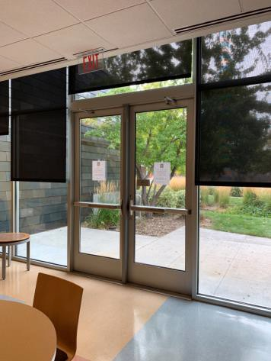

 | ID:  2445 | Facility:  Ustick Library

Location: Lounge
Schedule: 2022
Estimated Cost: $1,000.00

Priority Score 5
Quick Fix: No
Built before ADA: No

VIOLATIONS
2010 ADA Standards for Accessible Design Codes §306.3.3
There is no knee clearance underneath the counter.

RECOMMENDATIONS
Provide knee clearance underneath the counter at the sink that is a minimum of 11" deep at 9" above the floor and 8" deep at 27" above the floor.

PHOTOGRAPH(S) OF THIS LOCATION

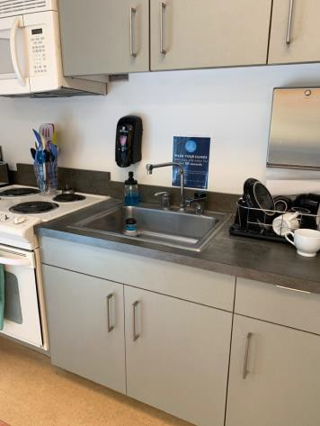

 | ID:  2449 | Facility:  Ustick Library

Location: Lounge
Schedule: 2022
Estimated Cost: $1,000.00

Priority Score 6
Quick Fix: No
Built before ADA: No

VIOLATIONS
2010 ADA Standards for Accessible Design Codes §211.2, §602.7
There is only one drinking fountain provided and the spout is 31" above the floor.

RECOMMENDATIONS
Install an additional drinking fountain at a minimum spout height of 38" and maximum of 43" above the floor.

PHOTOGRAPH(S) OF THIS LOCATION

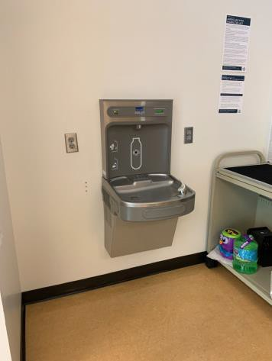

 | ID:  2520 | Facility:  Ustick Library

Location: Main Entrance
Schedule: 2022
Estimated Cost: $1,000.00

Priority Score 5
Quick Fix: No
Built before ADA: No

VIOLATIONS
2010 ADA Standards for Accessible Design Codes §307.2
The cabinets protrude 11" into the circulation space at 27.5" above the floor.

RECOMMENDATIONS
Recess the cabinets so they protrude a maximum of 4", lower them so the bottom edge is 27" maximum above the floor, or place a cane detectable object beneath them.

PHOTOGRAPH(S) OF THIS LOCATION

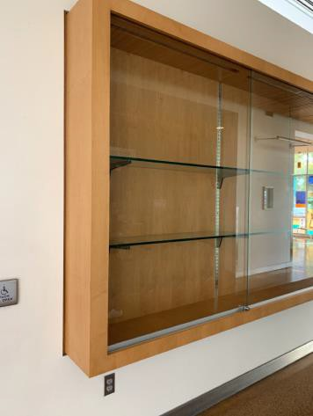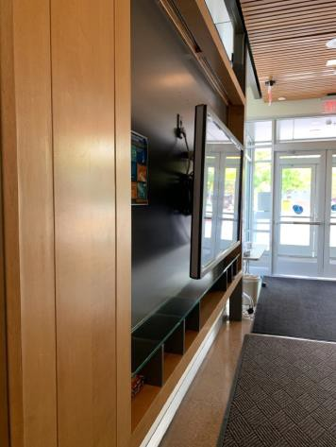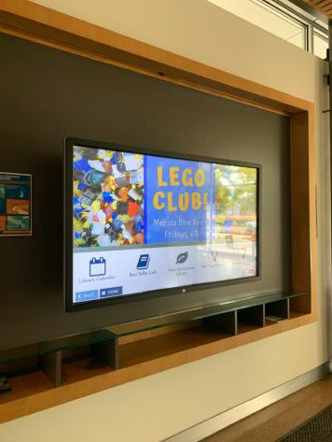

 | ID:  2504 | Facility:  Ustick Library

Location: Main Entrance Men's Restroom
Schedule: 2021
Estimated Cost: $100.00

Priority Score 5
Quick Fix: Yes
Built before ADA: No

VIOLATIONS
2010 ADA Standards for Accessible Design Codes §604.8.1.2
The door to the accessible water closet is not self closing. Either self-closing hinges are not installed on the door or if installed, they are defective.

RECOMMENDATIONS
Install or reinstall self-closing hinges on the door to ensure that the door is self-closing per the ADA requirements.

PHOTOGRAPH(S) OF THIS LOCATION

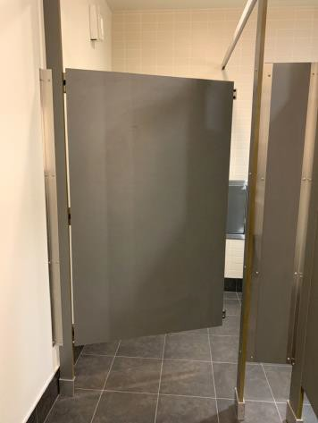

 | ID:  2509 | Facility:  Ustick Library

Location: Main Entrance Men's Restroom
Schedule: 2021
Estimated Cost: $100.00

Priority Score 5
Quick Fix: Yes
Built before ADA: No

VIOLATIONS
2010 ADA Standards for Accessible Design Codes §604.7
The toilet paper dispenser is located out of the accessible reach range at 10" in front of the toilet.

RECOMMENDATIONS
Remount the toilet paper dispenser to 7” minimum and 9” maximum in front of the water closet measured to the centerline of the dispenser.
The outlet of the dispenser shall be 15” minimum and 48” maximum above the floor and shall not be located behind.

PHOTOGRAPH(S) OF THIS LOCATION

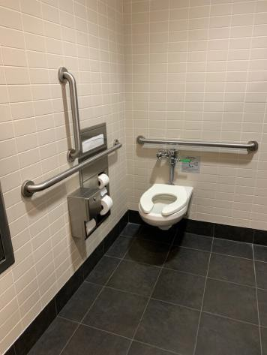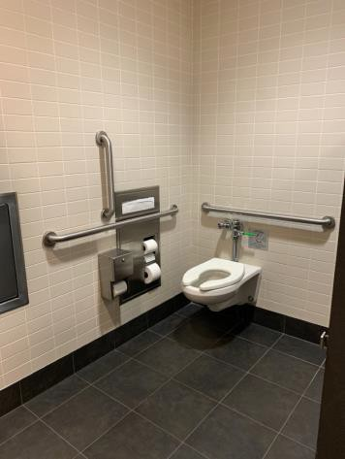

 | ID:  2511 | Facility:  Ustick Library

Location: Main Entrance Men's Restroom
Schedule: 2021
Estimated Cost: $100.00

Priority Score 5
Quick Fix: Yes
Built before ADA: No

VIOLATIONS
2010 ADA Standards for Accessible Design Codes §307.2
The sharps container protrudes 4.75" into the circulation space at 40" above the floor.

RECOMMENDATIONS
Recess the sharps container so it protrudes a maximum of 4", lower it so the bottom edge is 27" maximum above the floor, or place a cane detectable object beneath it.

PHOTOGRAPH(S) OF THIS LOCATION

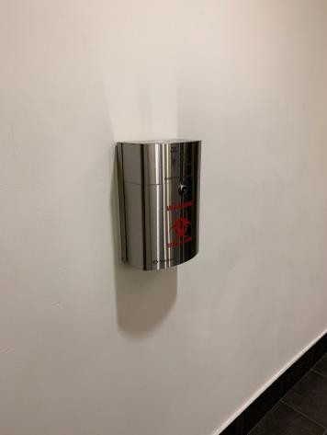

 | ID:  2506 | Facility:  Ustick Library

Location: Main Entrance Men's Restroom
Schedule: 2021
Estimated Cost: $500.00

Priority Score 5
Quick Fix: Yes
Built before ADA: No

VIOLATIONS
2010 ADA Standards for Accessible Design Codes §604.5.1
The side grab bar extends 52.5" from the rear wall.

RECOMMENDATIONS
Remount the side grab bar 12" maximum from the rear wall and extending 54" minimum from the rear wall.

PHOTOGRAPH(S) OF THIS LOCATION

 | ID:  2510 | Facility:  Ustick Library

Location: Main Entrance Men's Restroom
Schedule: 2022
Estimated Cost: $1,000.00

Priority Score 5
Quick Fix: No
Built before ADA: No

VIOLATIONS
2010 ADA Standards for Accessible Design Codes §605.2
The urinal is 17.75" above the floor.

RECOMMENDATIONS
Lower the urinal to a maximum height of 17" above the floor.

PHOTOGRAPH(S) OF THIS LOCATION

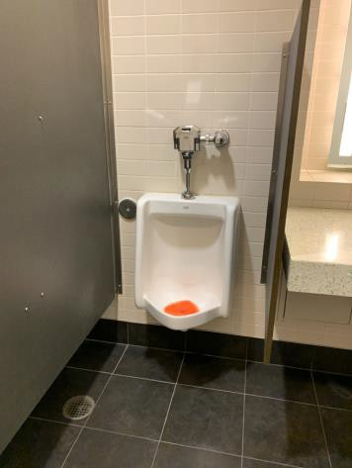

 | ID:  2508 | Facility:  Ustick Library

Location: Main Entrance Men's Restroom
Schedule: 2021
Estimated Cost: $1,000.00

Priority Score 3
Quick Fix: No
Built before ADA: No

VIOLATIONS
2010 ADA Standards for Accessible Design Codes §604.4
The toilet is 19.5" above the floor.

RECOMMENDATIONS
Lower the toilet seat to comply with the maximum height of 19” above the floor measured to the top of the seat.

PHOTOGRAPH(S) OF THIS LOCATION

 | ID:  2525 | Facility:  Ustick Library

Location: Main Entrance Parking
Schedule: 2021
Estimated Cost: $2,000.00

Priority Score 3
Quick Fix: No
Built before ADA: No

VIOLATIONS
2010 ADA Standards for Accessible Design Codes §502.2, §502.4
The access aisle has a 2.7% slope.
The accessible parking space is not of sufficient width at 90" wide.

RECOMMENDATIONS
Resurface the access aisle to reduce the slope to a maximum of 2% in all directions.
Restripe the van accessible parking spaces to a minimum of 132" wide and the car accessible parking spaces to a minimum of 96" wide.

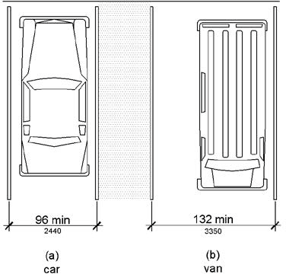

PHOTOGRAPH(S) OF THIS LOCATION

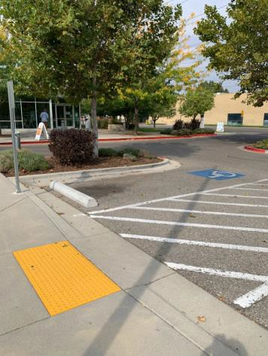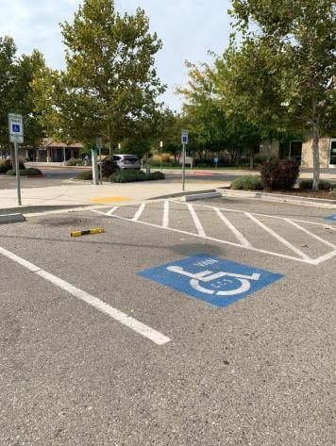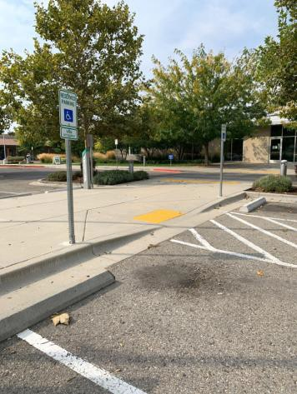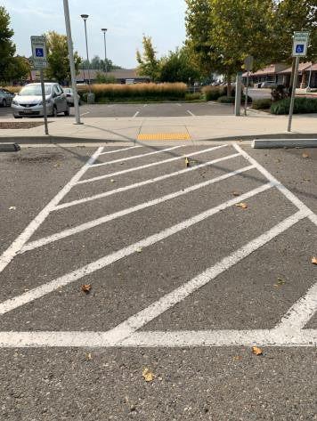

 | ID:  2512 | Facility:  Ustick Library

Location: Main Entrance Women's Restroom
Schedule: 2021
Estimated Cost: $100.00

Priority Score 5
Quick Fix: Yes
Built before ADA: No

VIOLATIONS
2010 ADA Standards for Accessible Design Codes §604.8.1.2
The door to the accessible water closet is not self closing. Either self-closing hinges are not installed on the door or if installed, they are defective.

RECOMMENDATIONS
Install or reinstall self-closing hinges on the door to ensure that the door is self-closing per the ADA requirements.

PHOTOGRAPH(S) OF THIS LOCATION

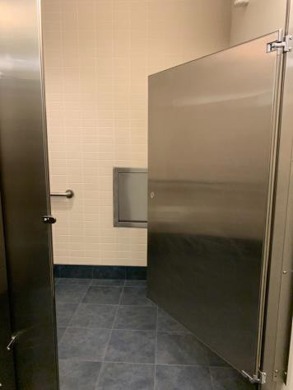
 | ID:  2517 | Facility:  Ustick Library

Location: Main Entrance Women's Restroom
Schedule: 2021
Estimated Cost: $100.00

Priority Score 5
Quick Fix: Yes
Built before ADA: No

VIOLATIONS
2010 ADA Standards for Accessible Design Codes §307.2
The sharps container protrudes 4.75" into the circulation space at 40" above the floor.

RECOMMENDATIONS
Recess the sharps container so it protrudes a maximum of 4", lower it so the bottom edge is 27" maximum above the floor, or place a cane detectable object beneath it.

PHOTOGRAPH(S) OF THIS LOCATION

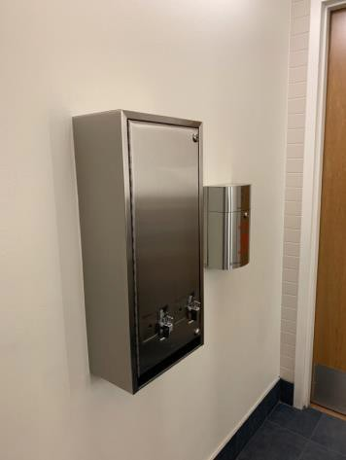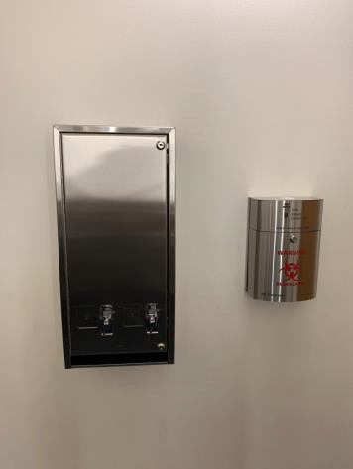

 | ID:  2518 | Facility:  Ustick Library

Location: Main Entrance Women's Restroom
Schedule: 2021
Estimated Cost: $100.00

Priority Score 5
Quick Fix: Yes
Built before ADA: No

VIOLATIONS
2010 ADA Standards for Accessible Design Codes §307.2
The dispenser protrudes 6.5" into the circulation space at 34" above the floor.

RECOMMENDATIONS
Recess the dispenser so it protrudes a maximum of 4", lower it so the bottom edge is 27" maximum above the floor, or place a cane detectable object beneath it.

PHOTOGRAPH(S) OF THIS LOCATION

 | ID:  2514 | Facility:  Ustick Library

Location: Main Entrance Women’s Restroom
Schedule: 2021
Estimated Cost: $100.00

Priority Score 5
Quick Fix: Yes
Built before ADA: No

VIOLATIONS
2010 ADA Standards for Accessible Design Codes §604.5.1
The side grab bar extends 52" from the rear wall.

RECOMMENDATIONS
Remount the side grab bar 11" from the rear wall.

PHOTOGRAPH(S) OF THIS LOCATION

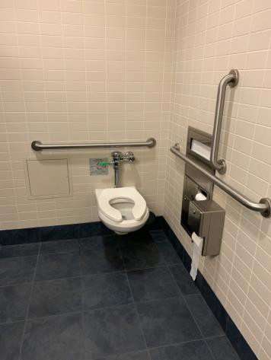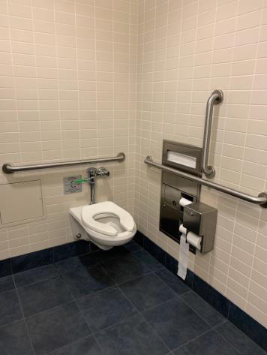

 | ID:  2516 | Facility:  Ustick Library

Location: Main Entrance Women’s Restroom
Schedule: 2021
Estimated Cost: $1,000.00

Priority Score 3
Quick Fix: No
Built before ADA: No

VIOLATIONS
2010 ADA Standards for Accessible Design Codes §604.4
The toilet is 19.5" above the floor.

RECOMMENDATIONS
Lower the toilet seat to comply with the maximum height of 19” above the floor measured to the top of the seat.

PHOTOGRAPH(S) OF THIS LOCATION

 | ID:  2496 | Facility:  Ustick Library

Location: Multipurpose Room
Schedule: 2021
Estimated Cost: $100.00

Priority Score 3
Quick Fix: Yes
Built before ADA: No

VIOLATIONS
2010 ADA Standards for Accessible Design Codes §216.4, §703
Doors serving as exits are not marked by tactile signage

RECOMMENDATIONS
Place a tactile exit sign, that complies with §703.1, §703.2 and §703.5, identifying the exit doors.
Install missing signage at 48" minimum above the floor measured from the baseline of the lowest character and 60" maximum measured from the baseline of the highest character.

PHOTOGRAPH(S) OF THIS LOCATION

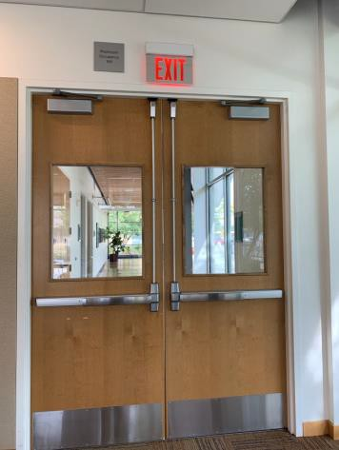

 | ID:  2497 | Facility:  Ustick Library

Location: Multipurpose Room
Schedule: 2021
Estimated Cost: $100.00

Priority Score 6
Quick Fix: Yes
Built before ADA: No

VIOLATIONS
2010 ADA Standards for Accessible Design Codes §703.4
The tactile sign identifying the room is not in the correct location.

RECOMMENDATIONS
Reinstall the sign on the inactive leaf of the door at 48" minimum above the floor measured from the baseline of the lowest character and 60" maximum measured from the baseline of the highest character.

PHOTOGRAPH(S) OF THIS LOCATION

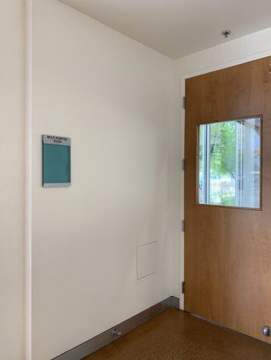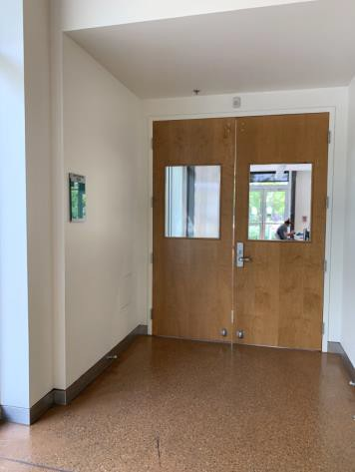

 | ID:  2495 | Facility:  Ustick Library

Location: Multipurpose Room
Schedule: 2021
Estimated Cost: $100.00

Priority Score 6
Quick Fix: Yes
Built before ADA: No

VIOLATIONS
2010 ADA Standards for Accessible Design Codes §703.4
The tactile signs identifying the exits are not in the correct location.

RECOMMENDATIONS
Reinstall the signs to the right side of the right hand doors at 48" minimum above the floor measured from the baseline of the lowest character and 60" maximum measured from the baseline of the highest character.

PHOTOGRAPH(S) OF THIS LOCATION

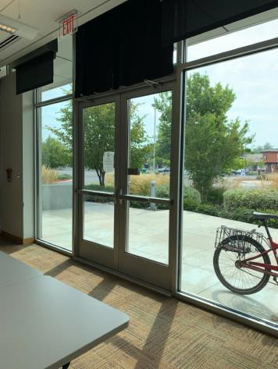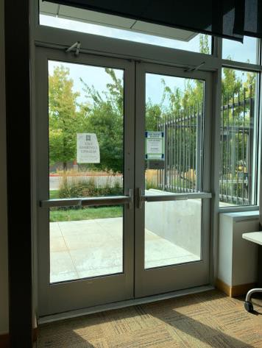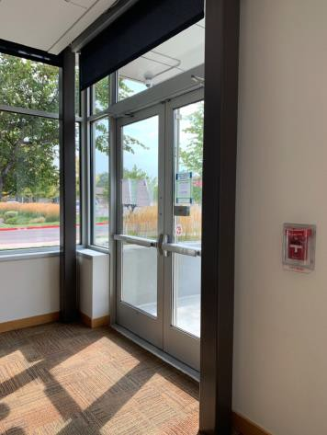

 | ID:  2494 | Facility:  Ustick Library

Location: Multipurpose Room
Schedule: 2023
Estimated Cost: $3,000.00

Priority Score 8
Quick Fix: No
Built before ADA: No

VIOLATIONS
2010 ADA Standards for Accessible Design Codes §707
The interactive touch screen does not have any sound or tactile components. Therefore, a visually impaired person would not be able to access the information provided by the kiosk

RECOMMENDATIONS
Audio instructions must be provided that guide the user through all the functions of the machine. Tactile instructions must be provided informing the user on the method of activating the audio instructions.
Controls to operate the kiosk must meet the requirements of §707.

PHOTOGRAPH(S) OF THIS LOCATION

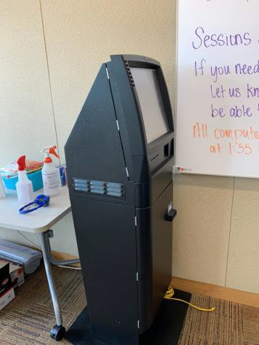

 | ID:  2490 | Facility:  Ustick Library

Location: Sagebrush Room
Schedule: 2021
Estimated Cost: $100

Priority Score 6
Quick Fix: Yes
Built before ADA: No

VIOLATIONS
2010 ADA Standards for Accessible Design Codes §703.4
The tactile sign identifying the room is not in the correct location.

RECOMMENDATIONS
Reinstall the sign on the latch side of the door at 48" minimum above the floor measured from the baseline of the lowest character and 60" maximum measured from the baseline of the highest character.

PHOTOGRAPH(S) OF THIS LOCATION

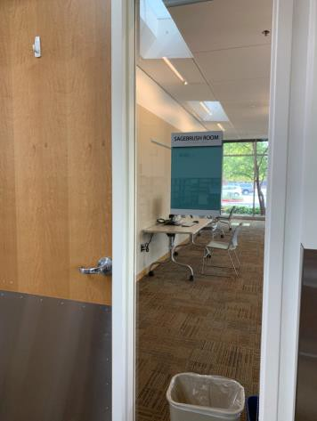

 | ID:  2522 | Facility:  Ustick Library

Location: Shelves (Top Only)
Schedule: 2021
Estimated Cost: $100.00

Priority Score 8
Quick Fix: Yes
Built before ADA: No

VIOLATIONS
2010 ADA Standards for Accessible Design Codes §308.2.1
The top shelves are outside of the unobstructed forward reach range at 58" above the floor.

RECOMMENDATIONS
Ensure that the library has a policy that states that employees and volunteers shall provide assistance to patrons in retrieving items from the shelves that are located beyond 48” above the floor.

PHOTOGRAPH(S) OF THIS LOCATION

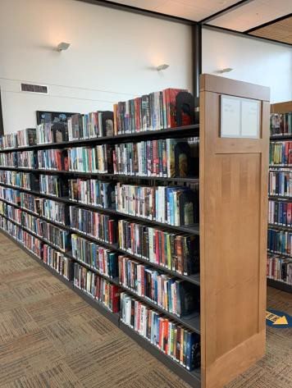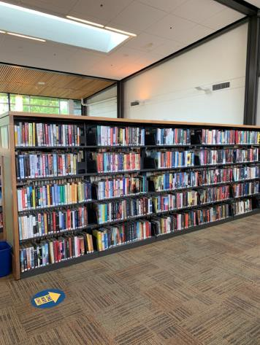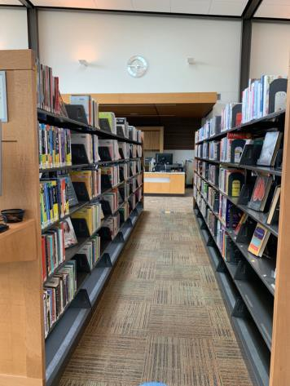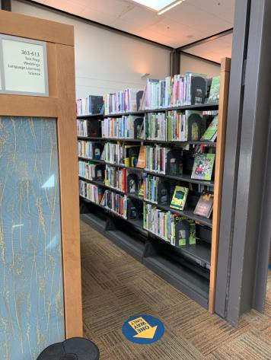

 | ID:  2482 | Facility:  Ustick Library

Location: Study Room 105
Schedule: 2021
Estimated Cost: $100.00

Priority Score 5
Quick Fix: Yes
Built before ADA: No

VIOLATIONS
2010 ADA Standards for Accessible Design Codes §307.2
The TV protrudes 7" into the circulation space at 46.5" above the floor.

RECOMMENDATIONS
Recess the TV so it protrudes a maximum of 4", raise it so the bottom edge is 80" maximum above the floor, or place a cane detectable object beneath it.

PHOTOGRAPH(S) OF THIS LOCATION

