City of Boise
ADA Assessment

Appendix A – Library! At Collister

01/27/2021
Report # TO21-B015

Prepared by:

 | ID:  2722 | Facility:  Collister Library

Location: Adult Mystery and Romance
Schedule: 2021
Estimated Cost: $100.00

Priority Score 8
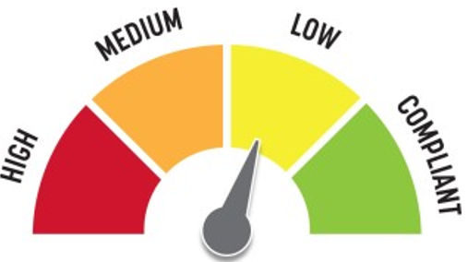
Quick Fix: Yes
Built before ADA: No

VIOLATIONS
2010 ADA Standards for Accessible Design Codes §307.2, §308.2.1
The paper towel dispenser protrudes 9" into the circulation space at 49" above the floor.
The paper towel dispenser is outside of the unobstructed forward reach range at 49" above the floor.

RECOMMENDATIONS
Recess the paper towel dispenser so it protrudes a maximum of 4" or place a cane detectable object beneath it.
Lower the paper towel dispenser by 1" to meet the accessible reach range of 48" maximum above the floor.

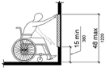

PHOTOGRAPH(S) OF THIS LOCATION

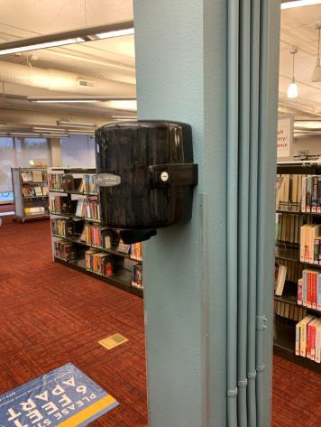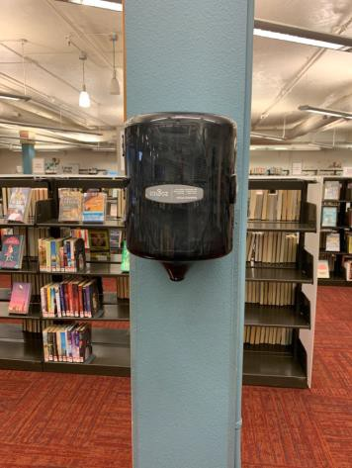

 | ID:  3628 | Facility:  Collister Library

Location: Book Drop
Schedule: 2021
Estimated Cost: $2,000.00

Priority Score 8
Quick Fix: No
Built before ADA: No

VIOLATIONS
2010 ADA Standards for Accessible Design Codes §308.2.1
The book drop is outside of the unobstructed forward reach range at 51" above the floor.

RECOMMENDATIONS
Lower the book drop by 3" to meet the accessible reach range of 48" maximum above the floor or install a secondary book drop within the accessible reach range.

PHOTOGRAPH(S) OF THIS LOCATION

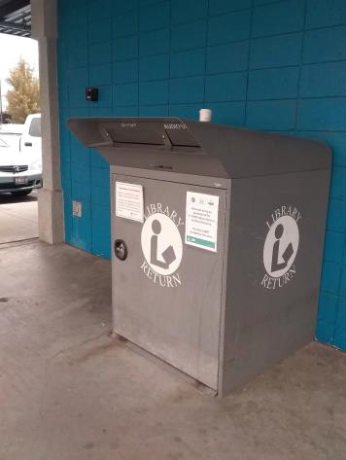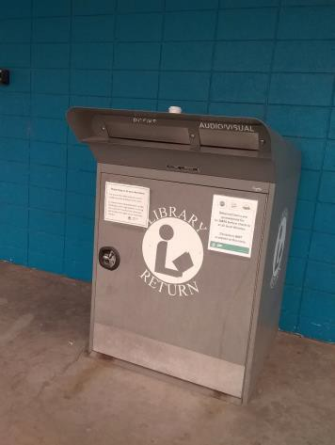

 | ID:  2723 | Facility:  Collister Library

Location: Catalpa Conference Room
Schedule: 2021
Estimated Cost: $0.00

Priority Score 0
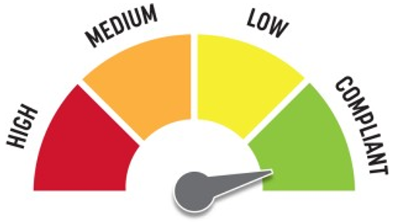
Quick Fix: Yes
Built before ADA: No

VIOLATIONS
2010 ADA Standards for Accessible Design Codes §307.2
The TVs protrude 11" into the circulation space at 53" above the floor.

RECOMMENDATIONS
Ensure that the tables remain underneath the TVs to provide cane detectability.
Recess the TVs so they protrude a maximum of 4" or raise them so their bottom edges are 80" maximum above the floor.

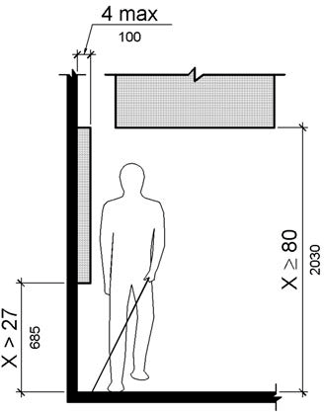

PHOTOGRAPH(S) OF THIS LOCATION

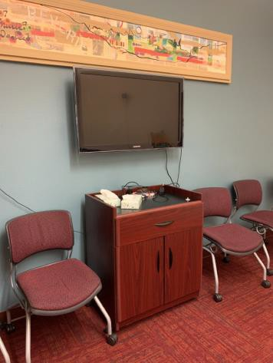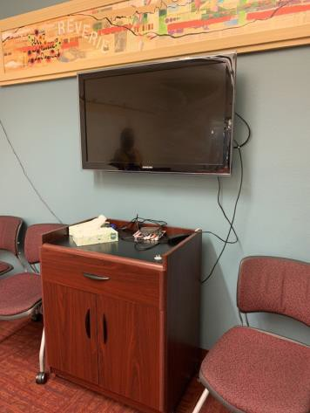

 | ID:  2724 | Facility:  Collister Library

Location: Computer Lab
Schedule: 2021
Estimated Cost: $0.00

Priority Score 0
Quick Fix: Yes
Built before ADA: No

VIOLATIONS
2010 ADA Standards for Accessible Design Codes §307.2
The TVs protrude 6" into the circulation space at 48.5" above the floor.

RECOMMENDATIONS
Ensure that the tables remain underneath the TVs to provide cane detectability.
Recess the TVs so they protrude a maximum of 4" or raise them so their bottom edges are 80" maximum above the floor.

PHOTOGRAPH(S) OF THIS LOCATION

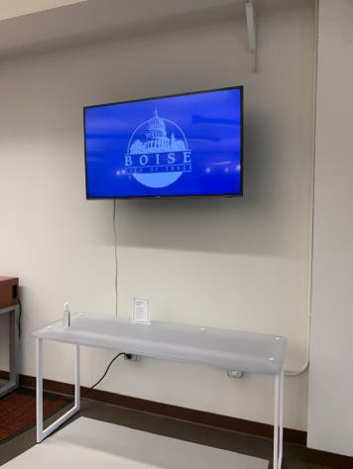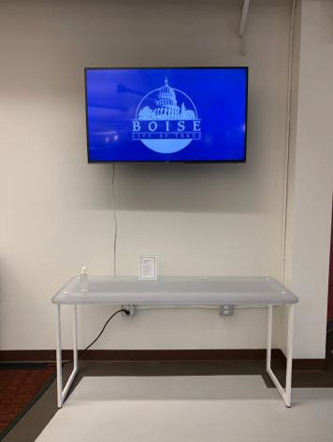

 | ID:  2717 | Facility:  Collister Library

Location: Entire Facility
Schedule: 2021
Estimated Cost: $700.00

Priority Score 3
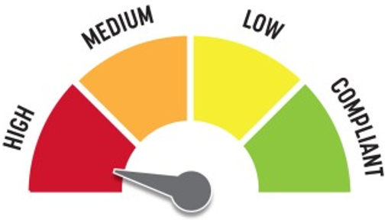
Quick Fix: No
Built before ADA: No

VIOLATIONS
2010 ADA Standards for Accessible Design Codes §216.2, §703
There are no tactile signs identifying seven permanent rooms.

RECOMMENDATIONS
Install tactile signage on the latch side of the doorway at a height of 48” minimum to 60” maximum above the floor, identifying room by name or room number.
Signs shall be Braille with raised lettering and should be placed on the wall in the center of an 18"x18" clear floor space

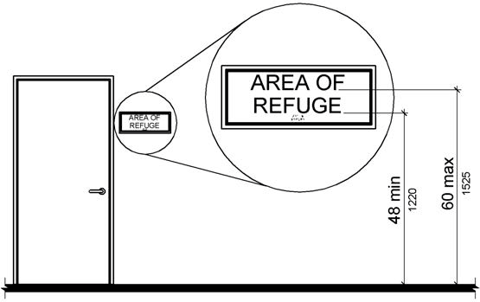

PHOTOGRAPH(S) OF THIS LOCATION

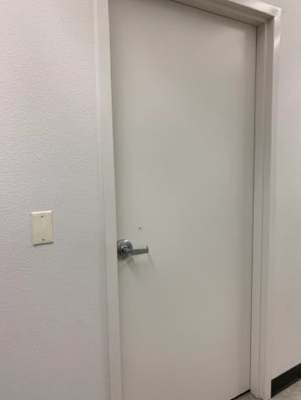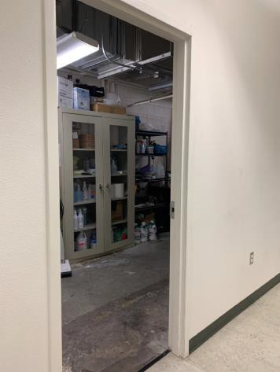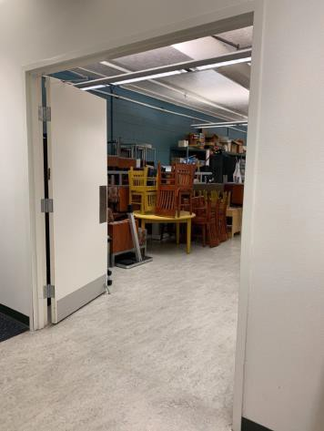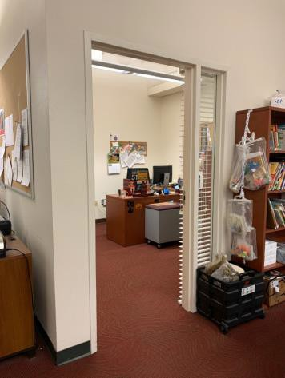

 | ID:  2725 | Facility:  Collister Library

Location: Entrance Area
Schedule: 2021
Estimated Cost: $100.00

Priority Score 5
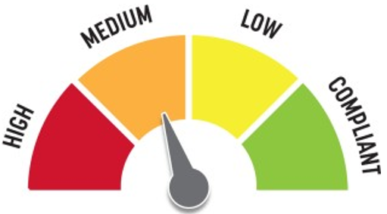
Quick Fix: Yes
Built before ADA: No

VIOLATIONS
2010 ADA Standards for Accessible Design Codes §307.2
The fire extinguisher protrudes 4.25" into the circulation space at 33" above the floor.

RECOMMENDATIONS
Recess the fire extinguisher so it protrudes a maximum of 4", lower it so the bottom edge is 27" maximum above the floor, or place a cane detectable object beneath it.

PHOTOGRAPH(S) OF THIS LOCATION

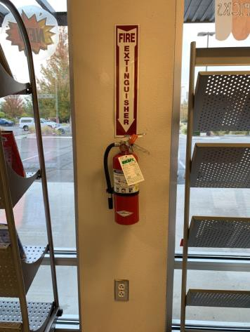

 | ID:  2720 | Facility:  Collister Library

Location: Front Desk
Schedule: 2021
Estimated Cost: $100.00

Priority Score 5
Quick Fix: Yes
Built before ADA: No

VIOLATIONS
2010 ADA Standards for Accessible Design Codes §307.2
The AED protrudes 6" into the circulation space at 36" above the floor.

RECOMMENDATIONS
Recess the AED so it protrudes a maximum of 4", lower it so the bottom edge is 27" maximum above the floor, or place a cane detectable object beneath it.

PHOTOGRAPH(S) OF THIS LOCATION

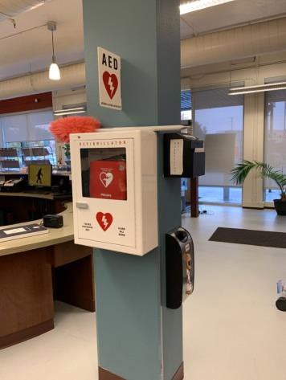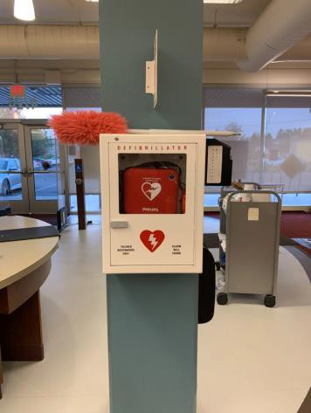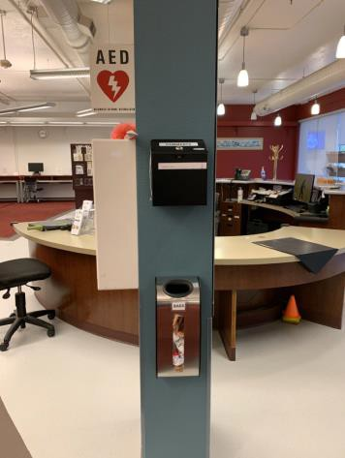

 | ID:  2721 | Facility:  Collister Library

Location: Front Desk
Schedule: 2021
Estimated Cost: $100.00

Priority Score 8
Quick Fix: Yes
Built before ADA: No

VIOLATIONS
2010 ADA Standards for Accessible Design Codes §307.2, §308.2.1
The suggestion box is outside of the unobstructed forward reach range at 49" above the floor. The suggestion box protrudes 6" into the circulation space at 49" above the floor.

RECOMMENDATIONS
Lower the suggestion box by 1" to meet the accessible reach range of 48" maximum above the floor.
Recess the suggestion box so it protrudes a maximum of 4" or place a cane detectable object beneath it.

PHOTOGRAPH(S) OF THIS LOCATION

 | ID:  2689 | Facility:  Collister Library

Location: Men’s Restroom
Schedule: 2021
Estimated Cost: $0.00

Priority Score 0
Quick Fix: Yes
Built before ADA: No

VIOLATIONS
2010 ADA Standards for Accessible Design Codes §307.2
The paper towel dispensers protrude 8.5" into the circulation space at 48" above the floor.

RECOMMENDATIONS
Ensure the garbage can remains underneath the paper towel dispensers or recess the paper towel dispensers so they protrude a maximum of 4".

PHOTOGRAPH(S) OF THIS LOCATION

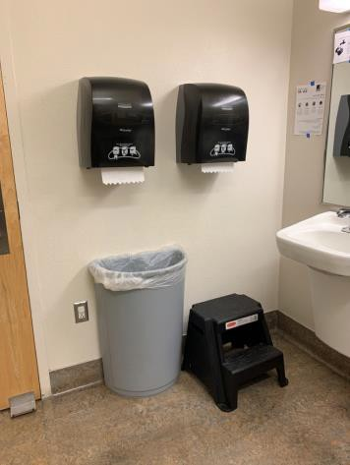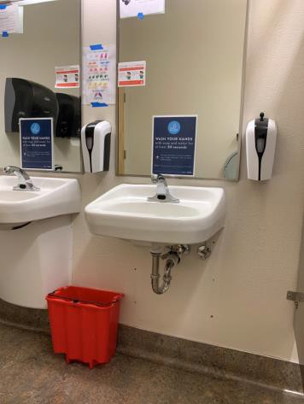

 | ID:  2680 | Facility:  Collister Library

Location: Men’s Restroom
Schedule: 2021
Estimated Cost: $100.00

Priority Score 5
Quick Fix: Yes
Built before ADA: No

VIOLATIONS
2010 ADA Standards for Accessible Design Codes §604.8.1.2
The door to the accessible water closet is not self closing. Either self-closing hinges are not installed on the door or if installed, they are defective.

RECOMMENDATIONS
Install or reinstall self-closing hinges on the door to ensure that the door is self-closing per the ADA requirements.

PHOTOGRAPH(S) OF THIS LOCATION

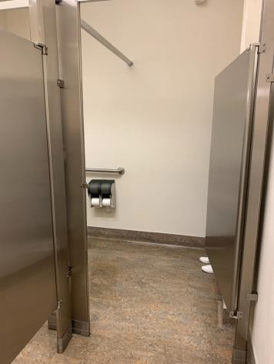

 | ID:  2685 | Facility:  Collister Library

Location: Men's Restroom
Schedule: 2021
Estimated Cost: $100.00

Priority Score 5
Quick Fix: Yes
Built before ADA: No

VIOLATIONS
2010 ADA Standards for Accessible Design Codes §604.7
The toilet paper dispenser is located out of the accessible reach range.

RECOMMENDATIONS
Remount the toilet paper dispenser to 7” minimum and 9” maximum in front of the water closet measured to the centerline of the dispenser.
The outlet of the dispenser shall be 15” minimum and 48” maximum above the floor and shall not be located behind.

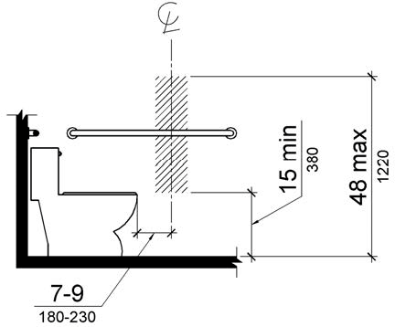

PHOTOGRAPH(S) OF THIS LOCATION

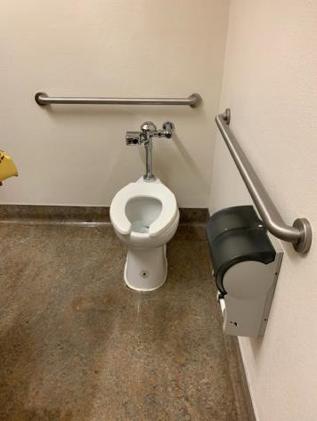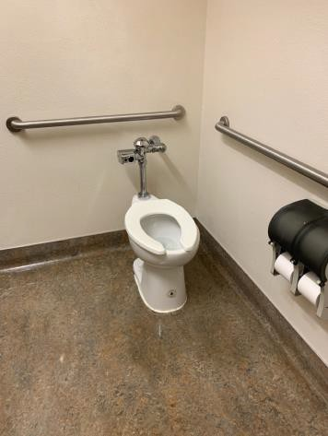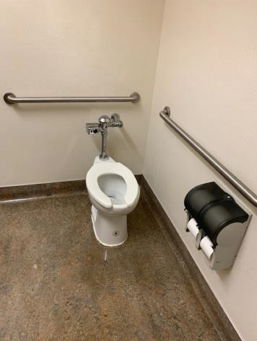

 | ID:  2687 | Facility:  Collister Library

Location: Men's Restroom
Schedule: 2021
Estimated Cost: $100.00

Priority Score 5
Quick Fix: Yes
Built before ADA: No

VIOLATIONS
2010 ADA Standards for Accessible Design Codes §307.2
The sharps container protrudes 4.75" into the circulation space at 40" above the floor.

RECOMMENDATIONS
Recess the sharps container so it protrudes a maximum of 4", lower it so the bottom edge is 27" maximum above the floor, or place a cane detectable object beneath it.

PHOTOGRAPH(S) OF THIS LOCATION

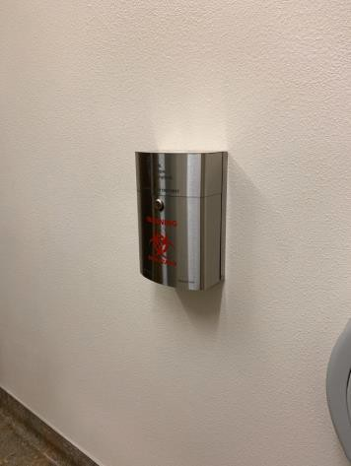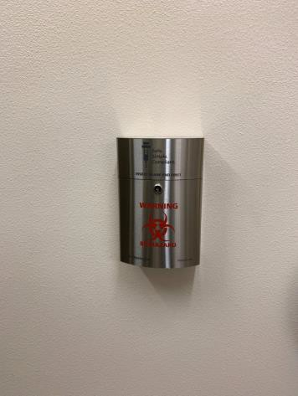

 | ID:  2688 | Facility:  Collister Library

Location: Men’s Restroom
Schedule: 2021
Estimated Cost: $100.00

Priority Score 7
Quick Fix: Yes
Built before ADA: No

VIOLATIONS
2010 ADA Standards for Accessible Design Codes §606.5
The pipes under the sink are not covered.

RECOMMENDATIONS
Wrap the pipes beneath the sink with soft protective wrap or plastic.

PHOTOGRAPH(S) OF THIS LOCATION

 | ID:  2681 | Facility:  Collister Library

Location: Men’s Restroom
Schedule: 2022
Estimated Cost: $1,000.00

Priority Score 5
Quick Fix: No
Built before ADA: No

VIOLATIONS
2010 ADA Standards for Accessible Design Codes ICC A117.1 §604.5.1
The accessible water closet does not have a vertical grab bar.

RECOMMENDATIONS
Install an 18" long (minimum) vertical grab bar on the side wall. The grab bar shall be mounted with the bottom located at 39" minimum and 41" maximum above the floor.
The centerline of the vertical grab bar shall be located 39" minimum and 41" maximum from the real wall.

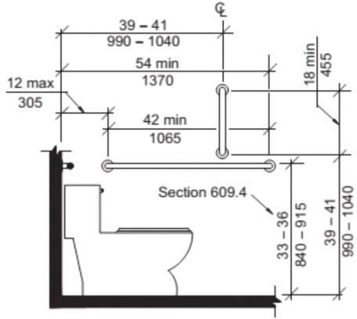

PHOTOGRAPH(S) OF THIS LOCATION

 | ID:  2677 | Facility:  Collister Library

Location: New Books, Children’s Nonfiction, and Fiction
Schedule: 2021
Estimated Cost: $100.00

Priority Score 8
Quick Fix: Yes
Built before ADA: No

VIOLATIONS
2010 ADA Standards for Accessible Design Codes §308.2.1
The top shelves are outside of the unobstructed forward reach range between 54" to 63" above the floor.

RECOMMENDATIONS
Ensure that the library has a policy requiring employees and volunteers to assist patrons by obtaining books on inaccessible shelves.

PHOTOGRAPH(S) OF THIS LOCATION

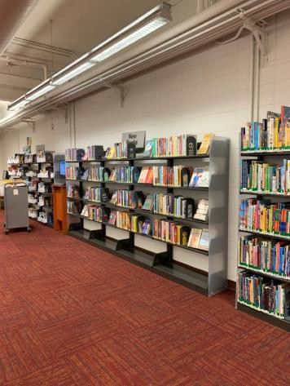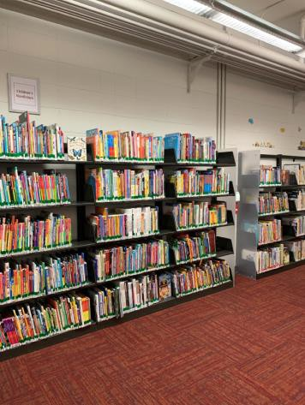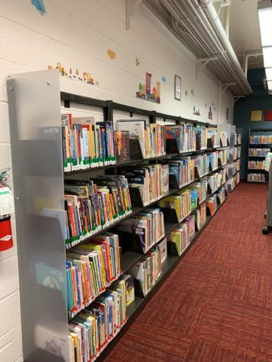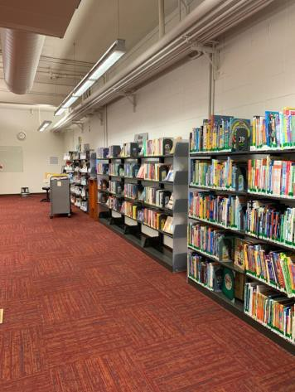

 | ID:  2675 | Facility:  Collister Library

Location: Paper Holder
Schedule: 2021
Estimated Cost: $100.00

Priority Score 8
Quick Fix: Yes
Built before ADA: No

VIOLATIONS
2010 ADA Standards for Accessible Design Codes §308.2.1
The top paper holder is outside of the unobstructed forward reach range at 50" above the floor.

RECOMMENDATIONS
Lower the top paper holder by 2" to meet the accessible reach range of 15" minimum and 48" maximum above the floor.

PHOTOGRAPH(S) OF THIS LOCATION

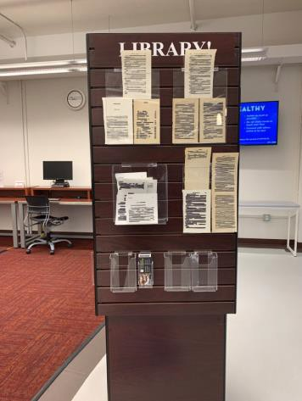

 | ID:  3016 | Facility:  Collister Library

Location: Parking
Schedule: 2021
Estimated Cost: $100.00

Priority Score 9
Quick Fix: Yes
Built before ADA: No

VIOLATIONS
2010 ADA Standards for Accessible Design Codes §502.6
The accessible parking sign is 36" above the ground.

RECOMMENDATIONS
Remount the accessible parking sign at a minimum height of 60" above the ground.

PHOTOGRAPH(S) OF THIS LOCATION

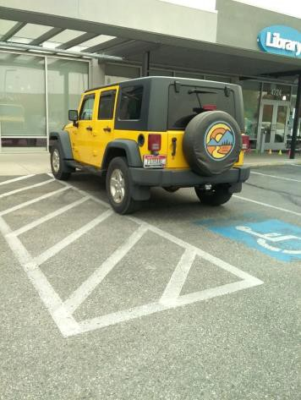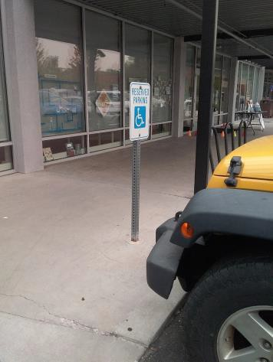

 | ID:  3346 | Facility:  Collister Library

Location: Parking
Schedule: 2021
Estimated Cost: $1,000.00

Priority Score 3
Quick Fix: No
Built before ADA: No

VIOLATIONS
2010 ADA Standards for Accessible Design Codes §405.3
The curb ramp has a 3% cross slope.

RECOMMENDATIONS
Resurface the curb ramp to have a cross slope of 2% or less, unless the accessible space and curb are relocated per ID #3495.

PHOTOGRAPH(S) OF THIS LOCATION

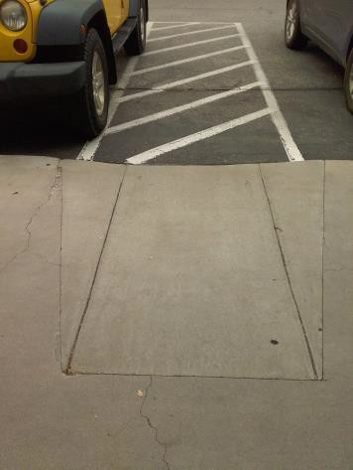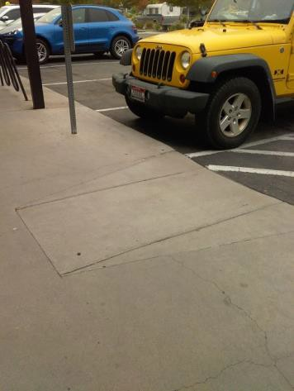

 | ID:  3495 | Facility:  Collister Library

Location: Parking
Schedule: 2021
Estimated Cost: $1,000.00

Priority Score 3
Quick Fix: No
Built before ADA: No

VIOLATIONS
2010 ADA Standards for Accessible Design Codes §208.3.1
The accessible parking space can be located closer to the library's entrance.

RECOMMENDATIONS
Consider relocating the accessible parking space, access aisle, and curb ramp directly in front of the library's entrance. This will reduce the distance a person using the space will have to travel.

PHOTOGRAPH(S) OF THIS LOCATION

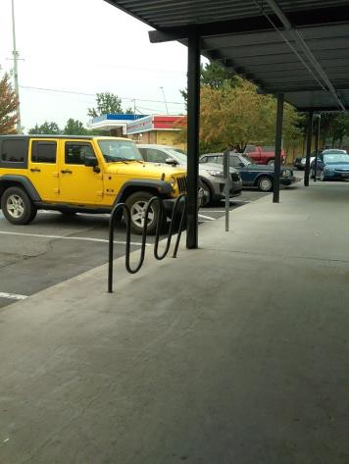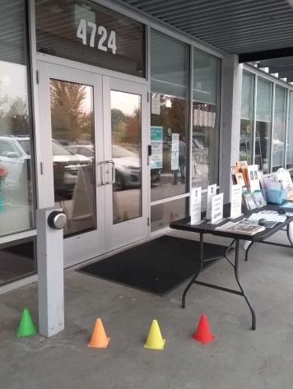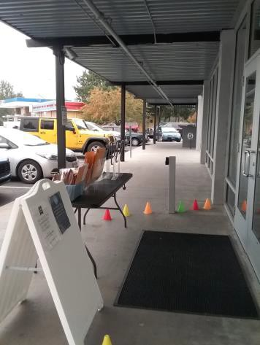

 | ID:  2691 | Facility:  Collister Library

Location: Restrooms
Schedule: 2022
Estimated Cost: $1,000.00

Priority Score 6
Quick Fix: No
Built before ADA: No

VIOLATIONS
2010 ADA Standards for Accessible Design Codes §602.4, §602.7
The heights of the drinking fountains are not compliant with spout heights at 32" and 34.75" above the floor.

RECOMMENDATIONS
Raise the existing tall drinking fountain in order to comply with the 38" minimum to 43" maximum spout height about the floor.

PHOTOGRAPH(S) OF THIS LOCATION

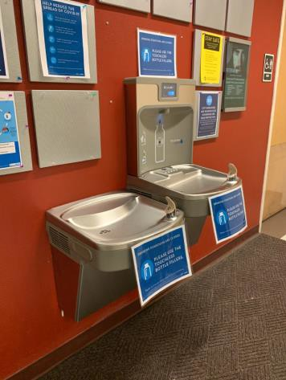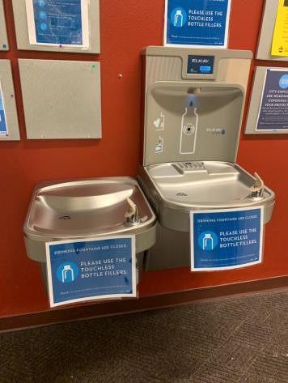

 | ID:  2679 | Facility:  Collister Library

Location: Scanner
Schedule: 2023
Estimated Cost: $1,000.00

Priority Score 8
Quick Fix: No
Built before ADA: No

VIOLATIONS
2010 ADA Standards for Accessible Design Codes §902.3
The two work surface counters are 39" and 45" above the floor

RECOMMENDATIONS
A 30" portion of the work surface counter must be no higher than 34” above the floor.

PHOTOGRAPH(S) OF THIS LOCATION

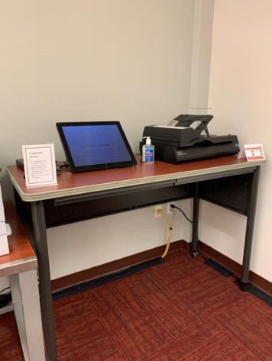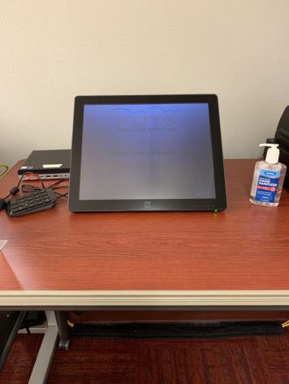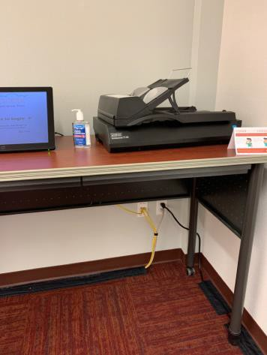

 | ID:  2712 | Facility:  Collister Library

Location: Staff Area
Schedule: 2021
Estimated Cost: $100.00

Priority Score 8
Quick Fix: Yes
Built before ADA: No

VIOLATIONS
2010 ADA Standards for Accessible Design Codes §308.2.2
The paper towel dispenser is outside of the obstructed forward reach range at 53" above the floor.

RECOMMENDATIONS
Lower the paper towel dispenser by 5" to meet the accessible reach range of 48" maximum above the floor.

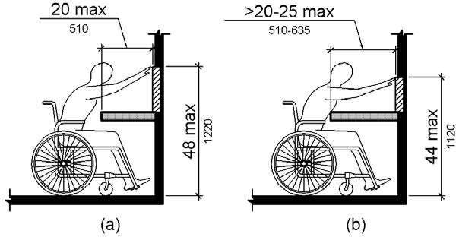

PHOTOGRAPH(S) OF THIS LOCATION

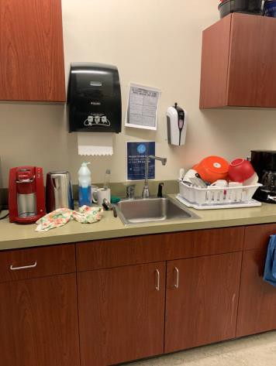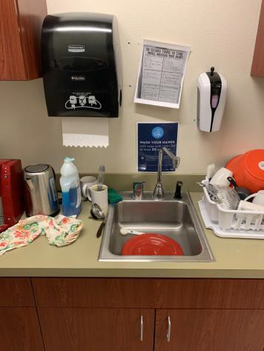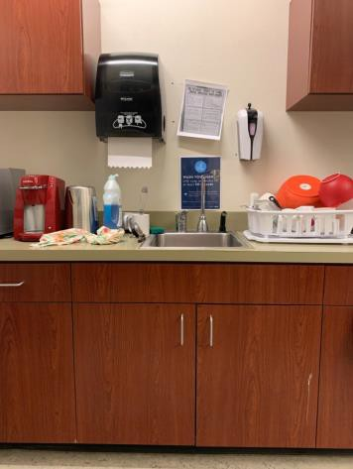

 | ID:  2713 | Facility:  Collister Library

Location: Staff Area
Schedule: 2021
Estimated Cost: $100.00

Priority Score 3
Quick Fix: Yes
Built before ADA: No

VIOLATIONS
2010 ADA Standards for Accessible Design Codes §307.2, §308.2.1
The coat hooks are outside of the unobstructed forward reach range at 65" above the floor.
The coat hooks protrude 12.25" into the circulation space at 65" above the floor.

RECOMMENDATIONS
Lower at least one of the coat hooks by 17" to meet the accessible reach range of 48" maximum above the floor.
Recess the coat hooks so they protrude a maximum of 4" or place a cane detectable object beneath them.

PHOTOGRAPH(S) OF THIS LOCATION

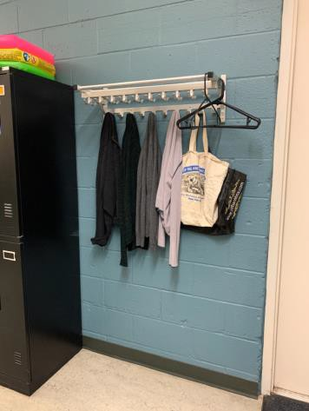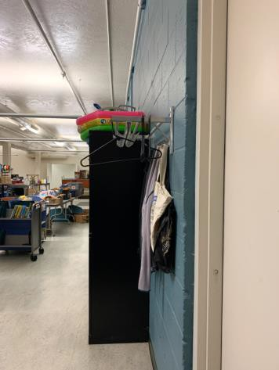

 | ID:  2713 | Facility:  Collister Library

Location: Staff Area
Schedule: 2021
Estimated Cost: $100.00

Priority Score 8
Quick Fix: No
Built before ADA: No

VIOLATIONS
2010 ADA Standards for Accessible Design Codes §307.2
The fire extinguisher protrudes 4.5" into the circulation space at 35.5" above the floor.

RECOMMENDATIONS
Recess the fire extinguisher so it protrudes a maximum of 4", lower it so the bottom edge is 27" maximum above the floor, or place a cane detectable object beneath it.

PHOTOGRAPH(S) OF THIS LOCATION

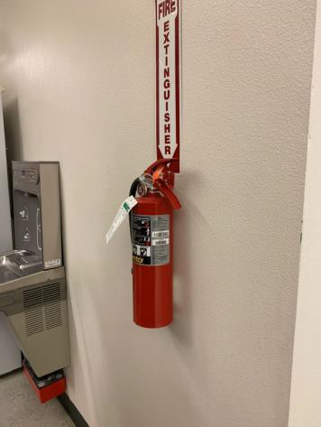

 | ID:  2617 | Facility:  Collister Library

Location: Staff Area
Schedule: 2021
Estimated Cost: $100.00

Priority Score 8
Quick Fix: Yes
Built before ADA: No

VIOLATIONS
2010 ADA Standards for Accessible Design Codes §307.2, §308.2.2
The first aid box is outside of the obstructed forward reach range at 56.75" above the floor. The first aid box protrudes 5.5" into the circulation space at 56.75" above the floor.

RECOMMENDATIONS
Lower the first aid box by 8.75" to 48" maximum if the reach depth is 20" and 44" if the reach depth exceeds 20" but does not exceed 25".
Recess the first aid box so it protrudes a maximum of 4", lower it so the bottom edge is 27" maximum above the floor, or place a cane detectable object beneath it.

PHOTOGRAPH(S) OF THIS LOCATION

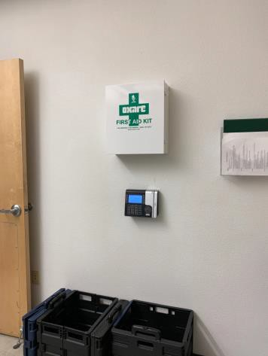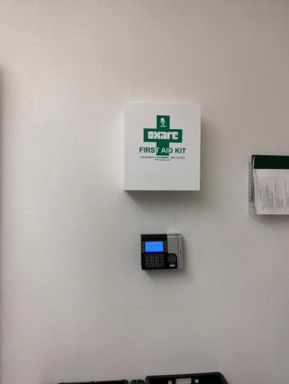

 | ID:  2718 | Facility:  Collister Library

Location: Staff Area
Schedule: 2021
Estimated Cost: $100.00

Priority Score 6
Quick Fix: Yes
Built before ADA: No

VIOLATIONS
2010 ADA Standards for Accessible Design Codes §703.4
The tactile sign identifying the room is not in the correct location at 61" above the floor.

RECOMMENDATIONS
Reinstall the sign on the latch side of the door at 48" minimum above the floor measured from the baseline of the lowest character and 60" maximum measured from the baseline of the highest character.

PHOTOGRAPH(S) OF THIS LOCATION

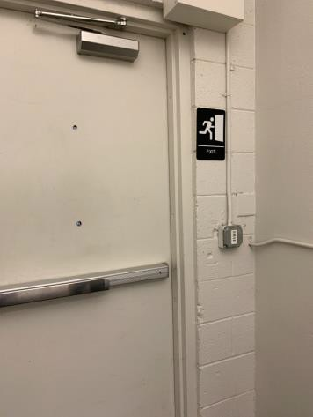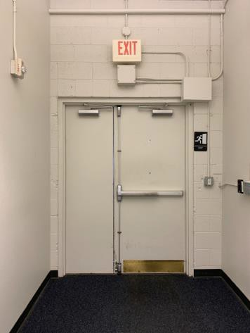

 | ID:  2719 | Facility:  Collister Library

Location: Staff Area
Schedule: 2021
Estimated Cost: $100.00

Priority Score 5
Quick Fix: Yes
Built before ADA: No

VIOLATIONS
2010 ADA Standards for Accessible Design Codes §307.2
The fire extinguisher protrudes 4.5" into the circulation space at 35" above the floor.

RECOMMENDATIONS
Recess the fire extinguisher so it protrudes a maximum of 4", lower it so the bottom edge is 27" maximum above the floor, or place a cane detectable object beneath it.

PHOTOGRAPH(S) OF THIS LOCATION

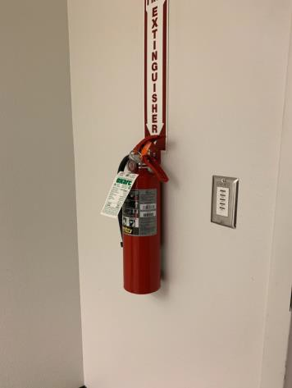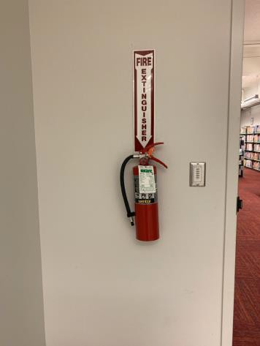

 | ID:  2714 | Facility:  Collister Library

Location: Staff Area
Schedule: 2021
Estimated Cost: $100.00

Priority Score 6
Quick Fix: No
Built before ADA: No

VIOLATIONS
2010 ADA Standards for Accessible Design Codes §211.2, §602.7
There is only one drinking fountain provided and the spout is 31.5" above the floor.

RECOMMENDATIONS
Install an additional drinking fountain at a minimum spout height of 38" and maximum of 43" above the floor.

PHOTOGRAPH(S) OF THIS LOCATION

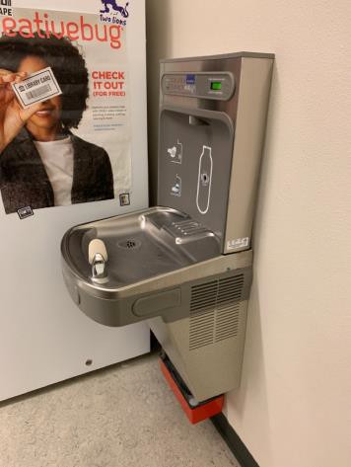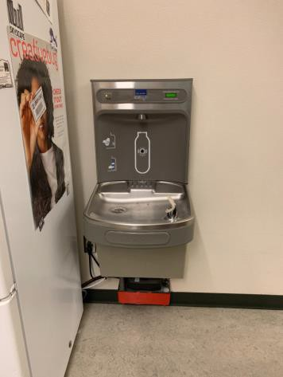

 | ID:  4480 | Facility:  Collister Library

Location: Staff Area
Schedule: 2022
Estimated Cost: $1,000.00

Priority Score 5
Quick Fix: No
Built before ADA: No

VIOLATIONS
2010 ADA Standards for Accessible Design Codes §306.3.3
There is no knee clearance underneath the sink.

RECOMMENDATIONS
Provide knee clearance underneath the counter at the sink that is a minimum of 11" deep at 9" above the floor and 8" deep at 27" above the floor.

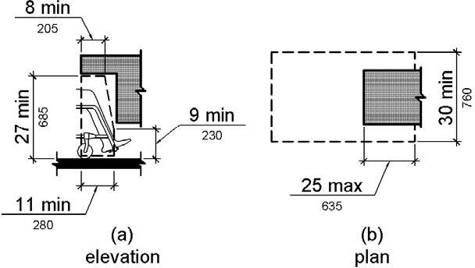

PHOTOGRAPH(S) OF THIS LOCATION

 | ID:  2676 | Facility:  Collister Library

Location: Staff Area
Schedule: 2022
Estimated Cost: $1,000.00

Priority Score 3
Quick Fix: Yes
Built before ADA: No

VIOLATIONS
2010 ADA Standards for Accessible Design Codes §216.2, §703
There is no tactile sign identifying the permanent room.

RECOMMENDATIONS
Install tactile signage on the latch side of the doorway at a height of 48” minimum to 60” maximum above the floor, identifying room by name or room number. Signs shall be Braille with raised lettering and should be placed on the wall in the center of an Signs shall be Braille with raised lettering and should be placed on the wall in the center of an 18"x18" clear floor space.

PHOTOGRAPH(S) OF THIS LOCATION

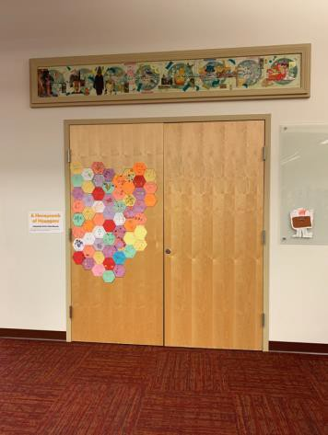

 | ID:  4481 | Facility:  Collister Library

Location: Storage Closet
Schedule: 2021
Estimated Cost: $100.00

Priority Score 7
Quick Fix: Yes
Built before ADA: No

VIOLATIONS
2010 ADA Standards for Accessible Design Codes §309.4
The door knob requires twisting of the wrist.

RECOMMENDATIONS
Replace the door knob with a lever handle that can be operated with a closed fist and without twisting the wrist.

PHOTOGRAPH(S) OF THIS LOCATION

 | ID:  2690 | Facility:  Collister Library

Location: Study Rooms A and B
Schedule: 2021
Estimated Cost: $200.00

Priority Score 6
Quick Fix: Yes
Built before ADA: No

VIOLATIONS
2010 ADA Standards for Accessible Design Codes §703.4
The tactile sign identifying the room is not in the correct location.

RECOMMENDATIONS
Reinstall the sign on the latch side of the door at 48" minimum above the floor measured from the baseline of the lowest character and 60" maximum measured from the baseline of the highest character.

PHOTOGRAPH(S) OF THIS LOCATION

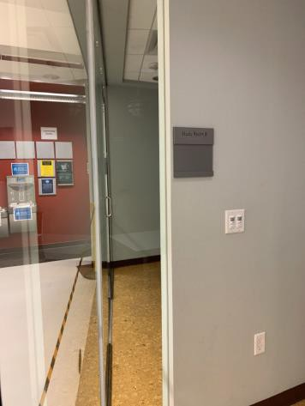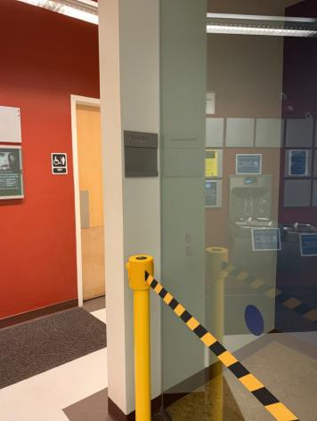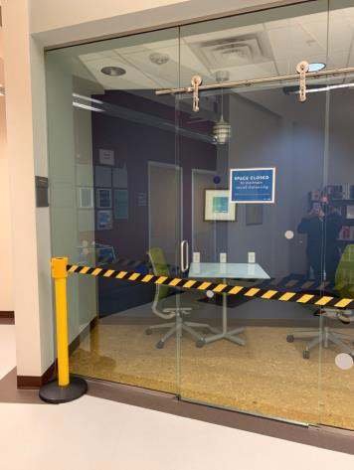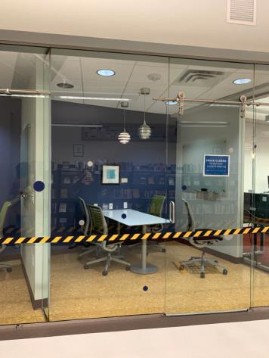

 | ID:  2727 | Facility:  Collister Library

Location: Sycamore Conference Room
Schedule: 2021
Estimated Cost: $100.00

Priority Score 5
Quick Fix: Yes
Built before ADA: No

VIOLATIONS
2010 ADA Standards for Accessible Design Codes §307.2
The TV protrudes 8" into the circulation space at 62.5" above the floor.

RECOMMENDATIONS
Recess the TV so it protrudes a maximum of 4", raise it so the bottom edge is 80" maximum above the floor, or place a cane detectable object beneath it.

PHOTOGRAPH(S) OF THIS LOCATION

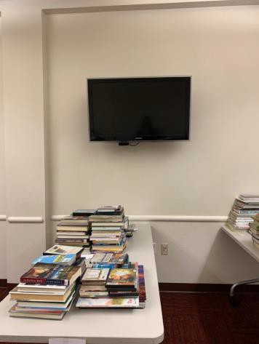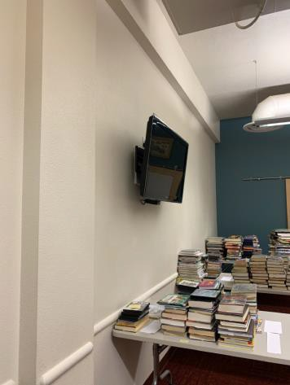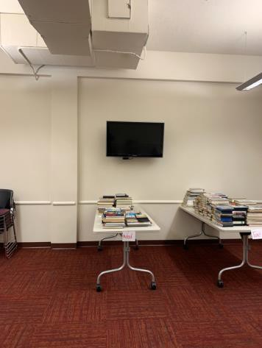

 | ID:  2702 | Facility:  Collister Library

Location: Unisex Restrooms
Schedule: 2021
Estimated Cost: $100.00

Priority Score 5
Quick Fix: Yes
Built before ADA: No

VIOLATIONS
2010 ADA Standards for Accessible Design Codes §307.2
The sharps container protrudes 4.5" into the circulation space at 41" above the floor.

RECOMMENDATIONS
Recess the sharps container so it protrudes a maximum of 4", lower it so the bottom edge is 27" maximum above the floor, or place a cane detectable object beneath it.

PHOTOGRAPH(S) OF THIS LOCATION

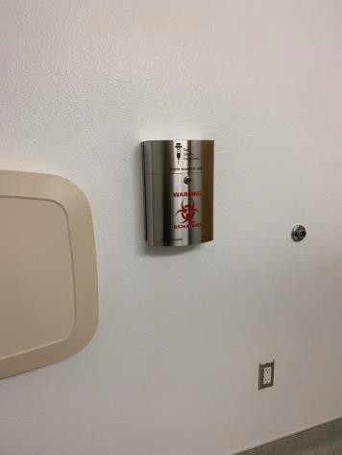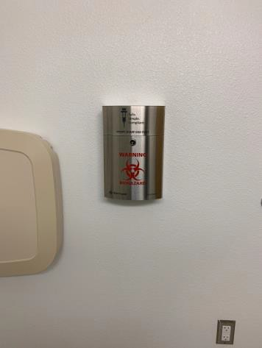

 | ID:  2703 | Facility:  Collister Library

Location: Unisex Restroom
Schedule: 2021
Estimated Cost: $100.00

Priority Score 5
Quick Fix: Yes
Built before ADA: No

VIOLATIONS
2010 ADA Standards for Accessible Design Codes §307.2
The shelf protrudes 5" into the circulation space at 47.25" above the floor.

RECOMMENDATIONS
Recess the shelf so it protrudes a maximum of 4" or place a cane detectable object beneath it.

PHOTOGRAPH(S) OF THIS LOCATION

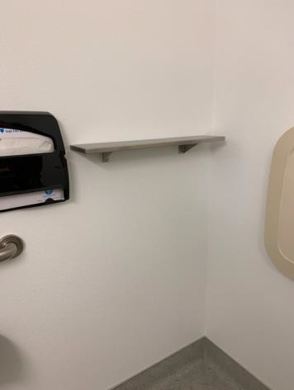

 | ID: | Facility:  Collister Library

Location: Unisex Restrooms
Schedule: 2021
Estimated Cost: $100.00

Priority Score 5
Quick Fix: Yes
Built before ADA: No

VIOLATIONS
2010 ADA Standards for Accessible Design Codes §609.3
The space between the grab bar and the toilet seat covers is 4.75".

RECOMMENDATIONS
Relocate the toilet seat covers to a location that is at least a distance of 12" or greater away from the grab bar.

PHOTOGRAPH(S) OF THIS LOCATION

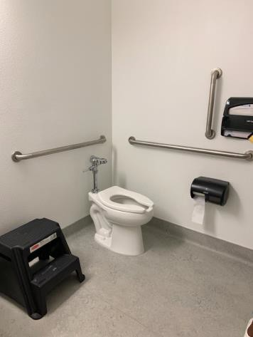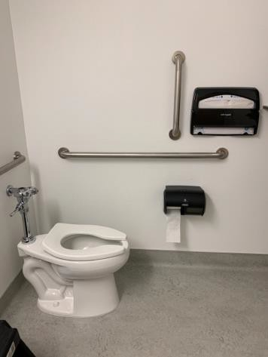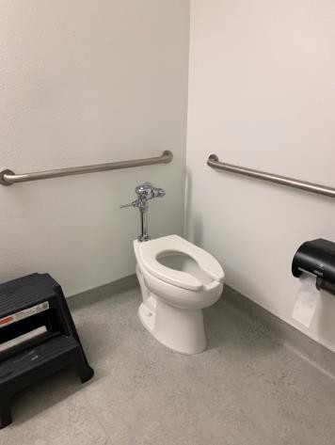

 | ID:  2709 | Facility:  Collister Library

Location: Unisex Restrooms
Schedule: 2021
Estimated Cost: $100.00

Priority Score 5
Quick Fix: Yes
Built before ADA: No

VIOLATIONS
2010 ADA Standards for Accessible Design Codes §604.7
The toilet paper dispenser is located out of the accessible reach range.

RECOMMENDATIONS
Remount the toilet paper dispenser to 7” minimum and 9” maximum in front of the water closet measured to the centerline of the dispenser.
The outlet of the dispenser shall be 15” minimum and 48” maximum above the floor and shall not be located behind.

PHOTOGRAPH(S) OF THIS LOCATION

 | ID:  2710 | Facility:  Collister Library

Location: Unisex Restrooms
Schedule: 2021
Estimated Cost: $100.00

Priority Score 5
Quick Fix: Yes
Built before ADA: No

VIOLATIONS
2010 ADA Standards for Accessible Design Codes §307.2
The paper towel dispenser protrudes 4.5" into the circulation space at 41" above the floor.

RECOMMENDATIONS
Recess the paper towel dispenser so it protrudes a maximum of 4" or place a cane detectable object beneath it.

PHOTOGRAPH(S) OF THIS LOCATION

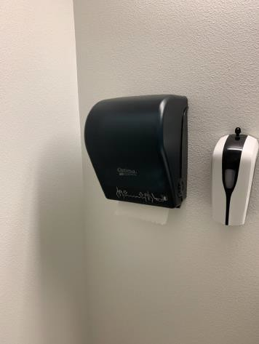

 | ID:  2705 | Facility:  Collister Library

Location: Unisex Restrooms
Schedule: 2021
Estimated Cost: $100.00

Priority Score 5
Quick Fix: Yes
Built before ADA: No

VIOLATIONS
2010 ADA Standards for Accessible Design Codes §604.5.1
The side grab bar is located 10" from the rear wall.

RECOMMENDATIONS
Remount the side grab bar 12" maximum from the rear wall and extending 54" minimum from the rear wall.

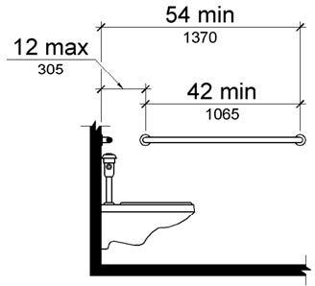

PHOTOGRAPH(S) OF THIS LOCATION

 | ID:  2701 | Facility:  Collister Library

Location: Women's Restrooms
Schedule: 2021
Estimated Cost: $0.00

Priority Score 0
Quick Fix: Yes
Built before ADA: No

VIOLATIONS
2010 ADA Standards for Accessible Design Codes §307.2
The dispenser protrudes 5.5" into the circulation space at 36" above the floor.

RECOMMENDATIONS
Ensure the garbage can remains underneath the paper towel dispensers or recess the paper towel dispensers so they protrude a maximum of 4".

PHOTOGRAPH(S) OF THIS LOCATION

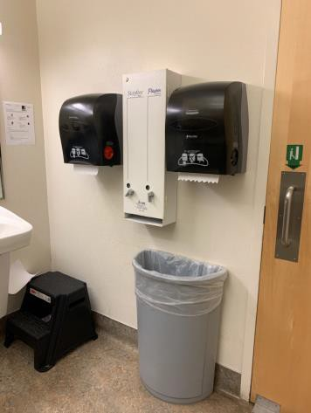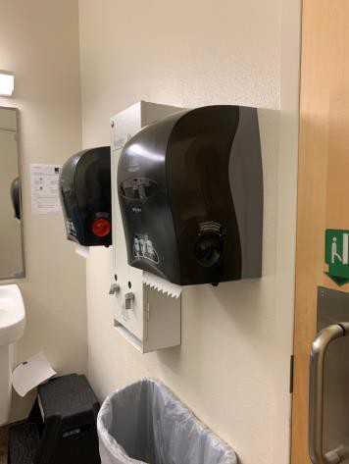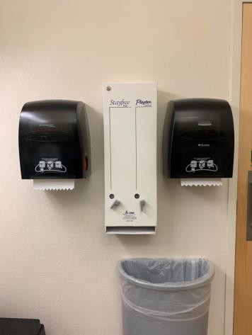

 | ID:  2692 | Facility:  Collister Library

Location: Women's Restrooms
Schedule: 2021
Estimated Cost: $100.00

Priority Score 5
Quick Fix: Yes
Built before ADA: No

VIOLATIONS
2010 ADA Standards for Accessible Design Codes §604.8.1.2
The door to the accessible water closet is not self closing. Either self-closing hinges are not installed on the door or if installed, they are defective.

RECOMMENDATIONS
Install or reinstall self-closing hinges on the door to ensure that the door is self-closing per the ADA requirements.

PHOTOGRAPH(S) OF THIS LOCATION

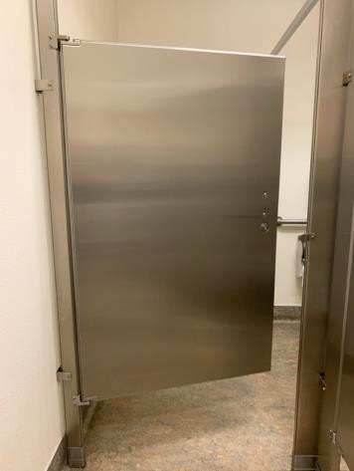

 | ID:  2696 | Facility:  Collister Library

Location: Women's Restroom
Schedule: 2021
Estimated Cost: $100.00

Priority Score 5
Quick Fix:Yes
Built before ADA: No

VIOLATIONS
2010 ADA Standards for Accessible Design Codes §609.3
The space between the grab bar and garbage can is 3".

RECOMMENDATIONS
Relocate the garbage can to a location that is at least a distance of 12" or greater away from the grab bar.

PHOTOGRAPH(S) OF THIS LOCATION

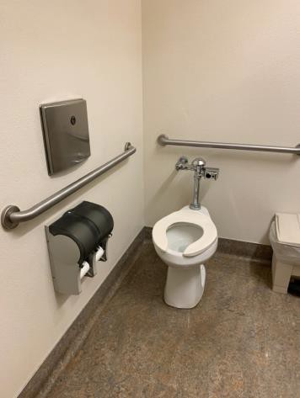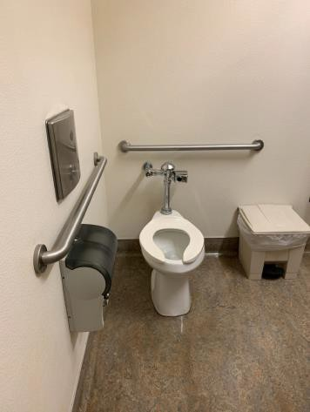

 | ID:  2698 | Facility:  Collister Library

Location: Women's Restrooms
Schedule: 2021
Estimated Cost: $100.00

Priority Score 8
Quick Fix: Yes
Built before ADA: No

VIOLATIONS
2010 ADA Standards for Accessible Design Codes §308.2.1
The hook is outside of the unobstructed forward reach range at 67.5" above the floor.

RECOMMENDATIONS
Lower the hook by 19.5" to meet the accessible reach range of 48" maximum above the floor.

PHOTOGRAPH(S) OF THIS LOCATION

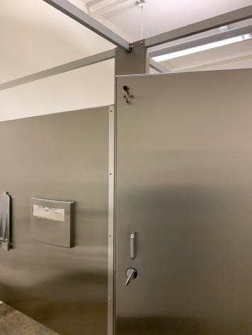

 | ID:  2699 | Facility:  Collister Library

Location: Women's Restrooms
Schedule: 2021
Estimated Cost: $100.00

Priority Score 5
Quick Fix: Yes
Built before ADA: No

VIOLATIONS
2010 ADA Standards for Accessible Design Codes §307.2
The sharps container protrudes 4.75" into the circulation space.

RECOMMENDATIONS
Recess the sharps container so it protrudes a maximum of 4" or place a cane detectable object beneath it.

PHOTOGRAPH(S) OF THIS LOCATION

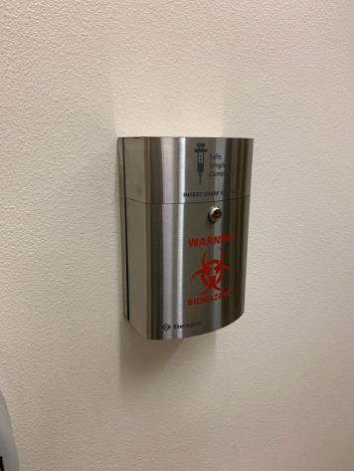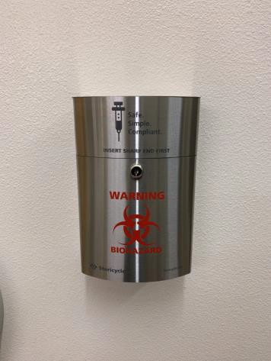

 | ID:  2700 | Facility:  Collister Library

Location: Women's Restrooms
Schedule: 2021
Estimated Cost: $100.00

Priority Score 5
Quick Fix: Yes
Built before ADA: No

VIOLATIONS
2010 ADA Standards for Accessible Design Codes §307.2
The paper towel dispensers protrude 8.5" into the circulation space at 48" above the floor.

RECOMMENDATIONS
Recess the paper towel dispensers so they protrude a maximum of 4", lower them so the bottom edge is 27" maximum above the floor, or place a cane detectable object beneath them.

PHOTOGRAPH(S) OF THIS LOCATION

 | ID:  2693 | Facility:  Collister Library

Location: Women's Restrooms
Schedule: 2022
Estimated Cost: $1,000.00

Priority Score 5
Quick Fix: No
Built before ADA: No

VIOLATIONS
2010 ADA Standards for Accessible Design Codes ICC A117.1 §604.5.1
The accessible water closet does not have a vertical grab bar.

RECOMMENDATIONS
Install an 18" long (minimum) vertical grab bar on the side wall. The grab bar shall be mounted with the bottom located at 39" minimum and 41" maximum above the floor.
The centerline of the vertical grab bar shall be located 39" minimum and 41" maximum from the real wall.

PHOTOGRAPH(S) OF THIS LOCATION

