City of Boise ADA Assessment

Appendix A –Quail Hollow Golf Course

2/19/2021
Report #TO21-B018

Prepared by:
 | ID:  1430 | Facility:  Quail Hollow Golf Course

Location: Banquet Room
Schedule: 2021
Estimated Cost: $100.00

Priority Score 5
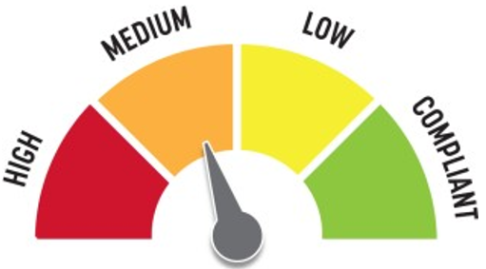
Quick Fix: Yes
Built before ADA: Yes

VIOLATIONS
2010 ADA Standards for Accessible Design Codes §307.2, §308.2.1
The hand sanitizer dispenser is outside of the unobstructed forward reach range at 55" above the floor. The hand sanitizer dispenser protrudes 8" into the circulation space at 55" above the floor.

RECOMMENDATIONS
Lower the hand sanitizer dispenser by 7" to meet the accessible reach range of 48" maximum above the floor.
Recess or replace the hand sanitizer dispenser so it protrudes a maximum of 4" or place a cane detectable object beneath it.

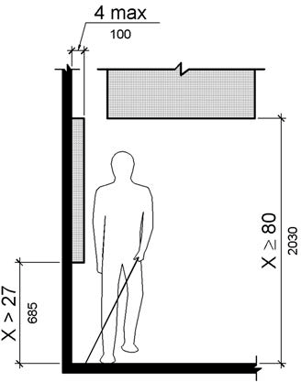

PHOTOGRAPH(S) OF THIS LOCATION

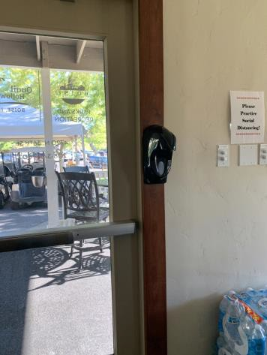

 | ID:  2 | Facility:  Quail Hollow Golf Course

Location: Banquet Room
Schedule: 2021
Estimated Cost: $400.00

Priority Score 3
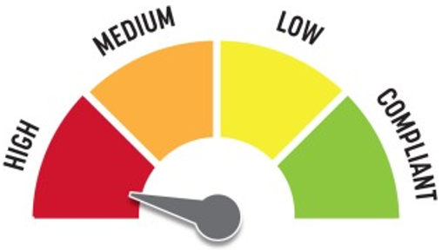
Quick Fix: Yes
Built before ADA: Yes

VIOLATIONS
2010 ADA Standards for Accessible Design Codes §216.2, §703
There are no tactile signs identifying four permanent rooms.

RECOMMENDATIONS
Install tactile signage on the latch side of the doorway at a height of 48” minimum to 60” maximum above the floor, identifying room by name or room number.
Signs shall be Braille with raised lettering and should be placed on the wall in the center of an 18"x18" clear floor space.

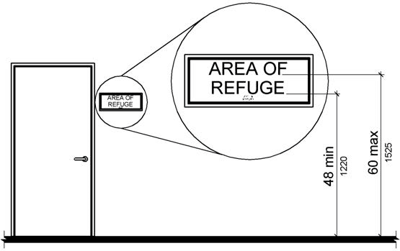

PHOTOGRAPH(S) OF THIS LOCATION

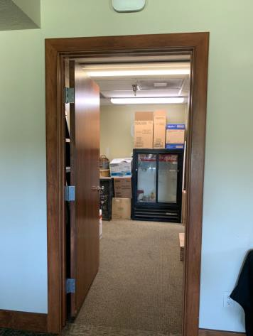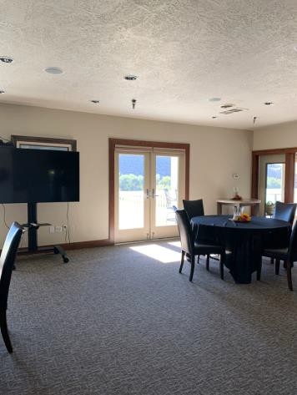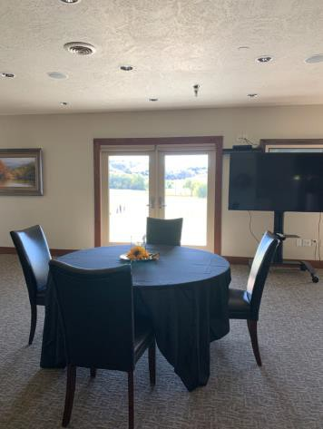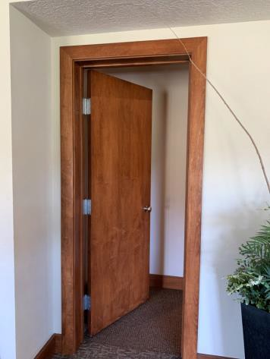

 | ID:  1446 | Facility:  Quail Hollow Golf Course

Location: Banquet Room
Schedule: 2022
Estimated Cost: $1,000.00

Priority Score 5
Quick Fix: No
Built before ADA: Yes

VIOLATIONS
2010 ADA Standards for Accessible Design Codes §505.4
The handrails are 32" above stair nosings.

RECOMMENDATIONS
Raise the handrails to a minimum height of 34" and a maximum of 38" above the stair nosings. Ensure that the handrails are at a consistent height along the stair treads.

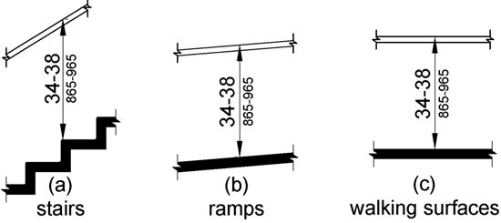

PHOTOGRAPH(S) OF THIS LOCATION

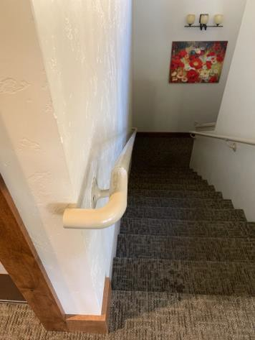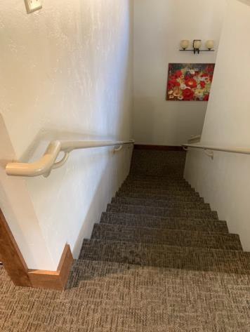

 | ID:  1448 | Facility:  Quail Hollow Golf Course

Location: Banquet Room
Schedule: 2022
Estimated Cost: $2,000.00

Priority Score 5
Quick Fix: No
Built before ADA: Yes

VIOLATIONS
2010 ADA Standards for Accessible Design Codes §505.10.2
The handrail extensions are 6".

RECOMMENDATIONS
Install new handrails with extensions that extend at least 12" horizontally above the landing beginning directly above the first stair riser nosing.

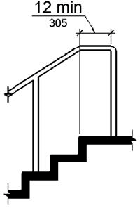

PHOTOGRAPH(S) OF THIS LOCATION

 | ID:  1417 | Facility:  Quail Hollow Golf Course

Location: Banquet Room
Schedule: 2021
Estimated Cost: $5,000.00

Priority Score 3
Quick Fix: No
Built before ADA: Yes

VIOLATIONS
2010 ADA Standards for Accessible Design Codes §208.2
There are no marked accessible parking spaces to access the banquet room.
The only way to access the banquet room is by using one of two stairways, navigating a 5" step, or utilizing the vehicular travel lane with a 12.1% to 12.3% cross slope.

RECOMMENDATIONS
Install an accessible parking space that is a minimum of 132" wide and a 60" wide access aisle connecting to an accessible route. Relocate the golf cart pick up area to another location. Add vertical access to the banquet room by installing a ramp. Ensure that the ramp slope does not exceed 8.3%, handrails are provided, and there is sufficient room for a level landing at the top and bottom of the ramp. Enact a policy that addresses assisting persons with disabilities in getting golf carts.

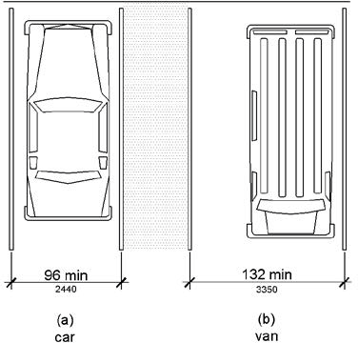

PHOTOGRAPH(S) OF THIS LOCATION

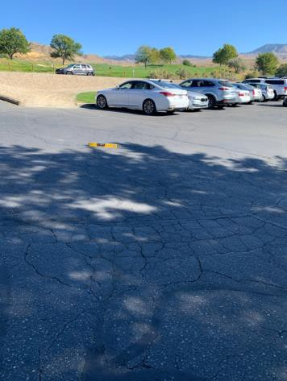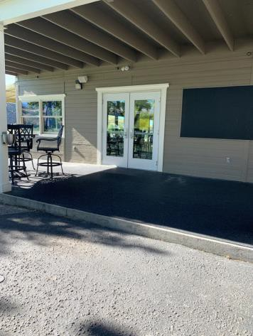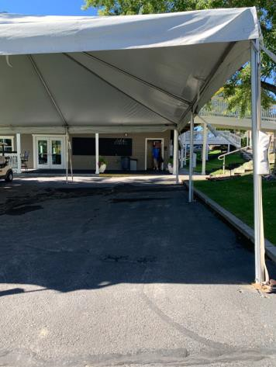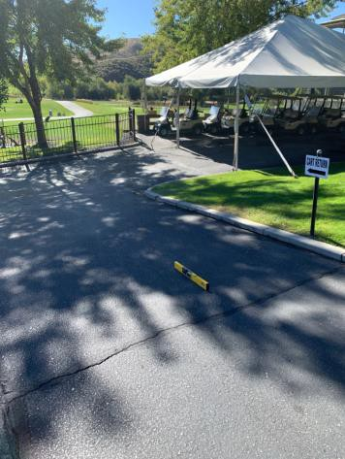

 | ID:  1483 | Facility:  Quail Hollow Golf Course

Location: Banquet Room Men’s Restroom
Schedule: 2022
Estimated Cost: $100.00

Priority Score 5
Quick Fix: Yes
Built before ADA: Yes

VIOLATIONS
2010 ADA Standards for Accessible Design Codes §307.2, §308.2.1
The paper towel dispenser is outside of the unobstructed forward reach range at 53" above the floor. The paper towel dispenser protrudes 7" into the circulation space at 53" above the floor.

RECOMMENDATIONS
Lower the paper towel dispenser by 5" to meet the accessible reach range of 48" maximum above the floor.
Recess the paper towel dispenser so it protrudes a maximum of 4" or place a cane detectable object beneath it.

PHOTOGRAPH(S) OF THIS LOCATION

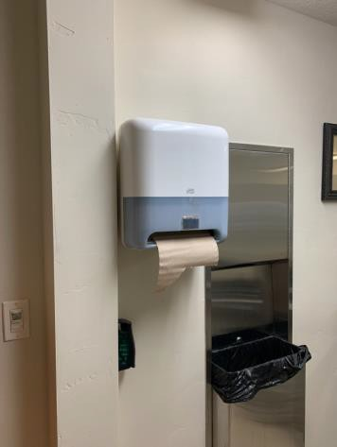

 | ID:  1436 | Facility:  Quail Hollow Golf Course

Location: Banquet Room Men’s Restroom
Schedule: 2021
Estimated Cost: $100.00

Priority Score 5
Quick Fix: Yes
Built before ADA: Yes

VIOLATIONS
2010 ADA Standards for Accessible Design Codes §604.8.1.2
The door to the accessible water closet is not self closing. Either self-closing hinges are not installed on the door or if installed, they are defective.

RECOMMENDATIONS
Install or reinstall self-closing hinges on the door to ensure that the door is self-closing per the ADA requirements.

PHOTOGRAPH(S) OF THIS LOCATION

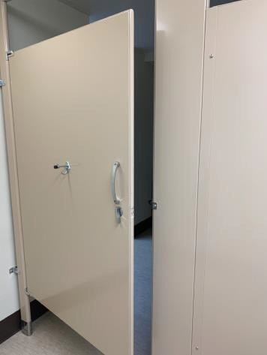

 | ID:  1437 | Facility:  Quail Hollow Golf Course

Location: Banquet Room Men’s Restroom
Schedule: 2021
Estimated Cost: $100.00

Priority Score 8
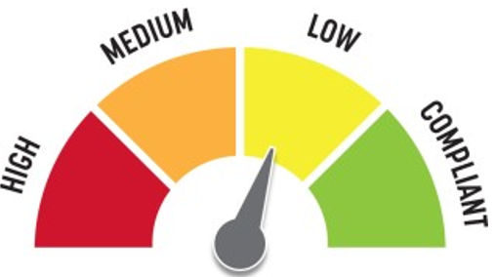
Quick Fix: Yes
Built before ADA: Yes

VIOLATIONS
2010 ADA Standards for Accessible Design Codes §305.2
The clear floor space at the low urinal is 29" wide.

RECOMMENDATIONS
Relocate the table.

PHOTOGRAPH(S) OF THIS LOCATION

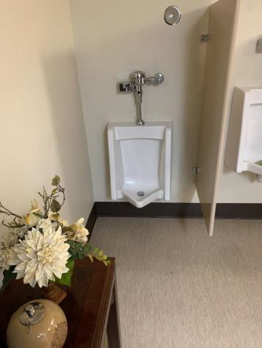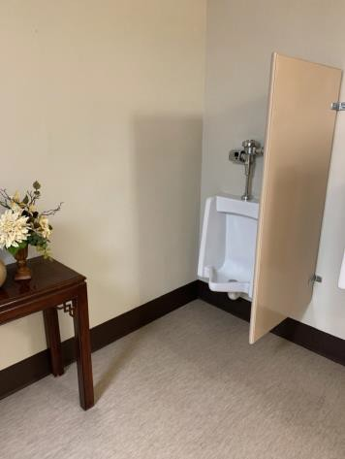

 | ID:  1445 | Facility:  Quail Hollow Golf Course

Location: Banquet Room Women’s Restroom
Schedule: 2021
Estimated Cost: $100.00

Priority Score 5
Quick Fix: Yes
Built before ADA: Yes

VIOLATIONS
2010 ADA Standards for Accessible Design Codes §307.2, §308.2.1
The paper towel dispenser protrudes 7" into the circulation space at 54" above the floor.
The paper towel dispenser is outside of the unobstructed forward reach range at 54" above the floor.

RECOMMENDATIONS
Recess the paper towel dispenser so it protrudes a maximum of 4" or place a cane detectable object beneath it.
Lower the paper towel dispenser by 6" to meet the accessible reach range of 48" maximum above the floor.

PHOTOGRAPH(S) OF THIS LOCATION

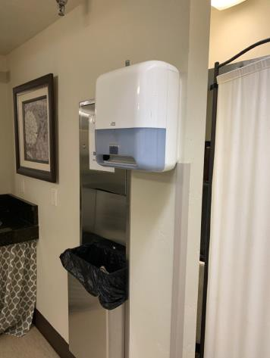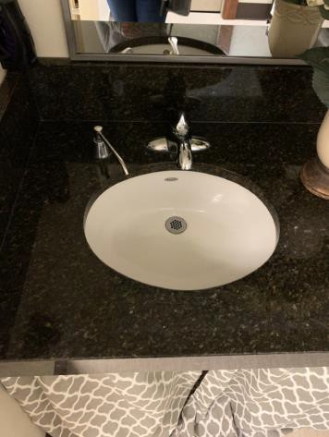

 | ID:  1443 | Facility:  Quail Hollow Golf Course

Location: Banquet Room Women’s Restroom
Schedule: 2022
Estimated Cost: $1,000.00

Priority Score 5
Quick Fix: No
Built before ADA: Yes

VIOLATIONS
2010 ADA Standards for Accessible Design Codes §604.2
The centerline of the toilet is located 19" from the sidewall.

RECOMMENDATIONS
Reposition the centerline of the toilet to be within 16" minimum and 18" maximum from the sidewall.

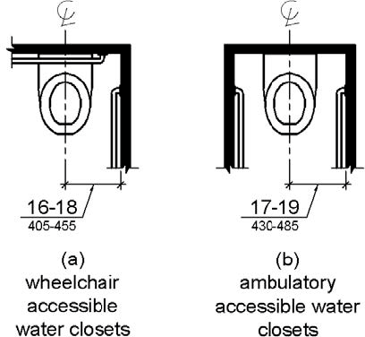

PHOTOGRAPH(S) OF THIS LOCATION

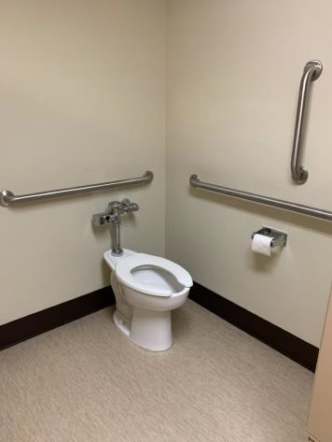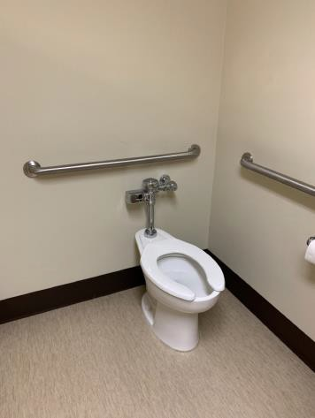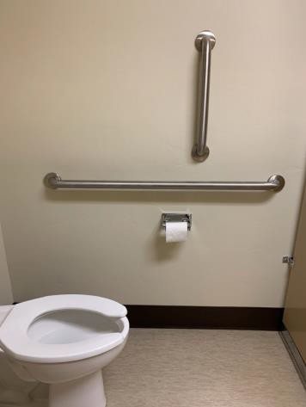

 | ID:  3722 | Facility:  Quail Hollow Golf Course

Location: Bottom Ramp
Schedule: 2022
Estimated Cost: $1,000.00

Priority Score 6
Quick Fix: No
Built before ADA: Yes

VIOLATIONS
2010 ADA Standards for Accessible Design Codes §505.2
There is one handrail.

RECOMMENDATIONS
Install an additional handrail at a minimum height of 34” and maximum of 38” above the ground. Make sure there are adequate handrail extensions both at the top and bottom of the handrail.

PHOTOGRAPH(S) OF THIS LOCATION

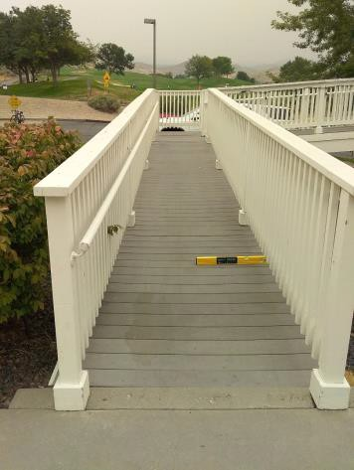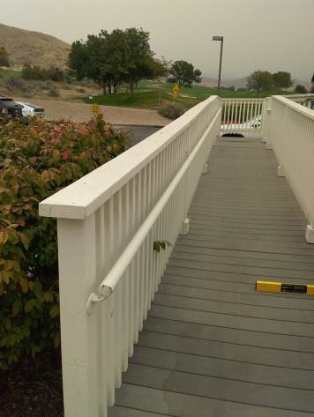

 | ID:  3723 | Facility:  Quail Hollow Golf Course

Location: Bottom Ramp
Schedule: 2022
Estimated Cost: $1,000.00

Priority Score 5
Quick Fix: No
Built before ADA: Yes

VIOLATIONS
2010 ADA Standards for Accessible Design Codes §505.10
There are no handrail extensions for the ramp.

RECOMMENDATIONS
Extend the ramp handrails 12” horizontally beyond the top and bottom of ramp runs.

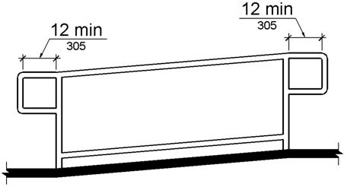

PHOTOGRAPH(S) OF THIS LOCATION

 | ID:  3720 | Facility:  Quail Hollow Golf Course

Location: Bottom Ramp
Schedule: 2021
Estimated Cost: $5,000.00

Priority Score 3
Quick Fix: No
Built before ADA: Yes

VIOLATIONS
2010 ADA Standards for Accessible Design Codes §405.3
The ramp is bowed causing the right side of the ramp to have a 4.2% cross slope.

RECOMMENDATIONS
Reconstruct the ramp to have a cross slope of 2% or less.

PHOTOGRAPH(S) OF THIS LOCATION

 | ID:  1453 | Facility:  Quail Hollow Golf Course

Location: Clubhouse
Schedule: 2022
Estimated Cost: $1,000.00

Priority Score 6
Quick Fix: No
Built before ADA: Yes

VIOLATIONS
2010 ADA Standards for Accessible Design Codes §602.7
The spout heights of the drinking fountains are not compliant at 31" and 37" above the floor.

RECOMMENDATIONS
Raise the existing tall drinking fountain to a minimum spout height of 38" and maximum spout height of 43" above the floor.

PHOTOGRAPH(S) OF THIS LOCATION

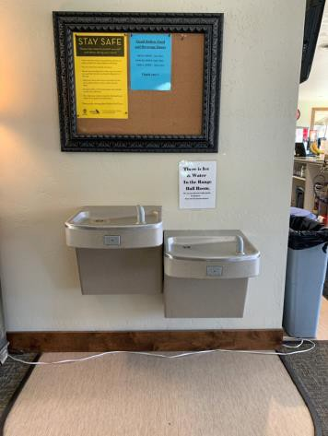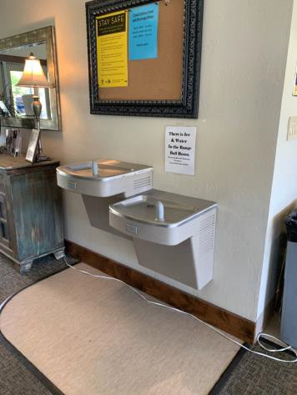

 | ID:  1451 | Facility:  Quail Hollow Golf Course

Location: Clubhouse Coffee Area
Schedule: 2021
Estimated Cost: $100.00

Priority Score 8
Quick Fix: Yes
Built before ADA: Yes

VIOLATIONS
2010 ADA Standards for Accessible Design Codes §308.2.1
The coffee maker is outside of the unobstructed forward reach range at 50" above the floor.

RECOMMENDATIONS
Lower the coffee maker by 2" to meet the accessible reach range of 15" minimum and 48" maximum above the floor.

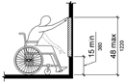

PHOTOGRAPH(S) OF THIS LOCATION

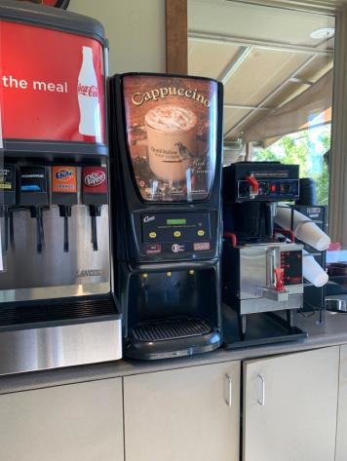

 | ID: | Facility:  Quail Hollow Golf Course

Location: Clubhouse Golf Association Computer
Schedule: 2021
Estimated Cost: $500.00

Priority Score 4
Quick Fix: Yes
Built before ADA: Yes

VIOLATIONS
2010 ADA Standards for Accessible Design Codes §904.4.1
The counter is 38.5" above the floor.

RECOMMENDATIONS
A portion of the service counter must be no higher than 36" above the floor for a horizontal distance of 36".

PHOTOGRAPH(S) OF THIS LOCATION

1452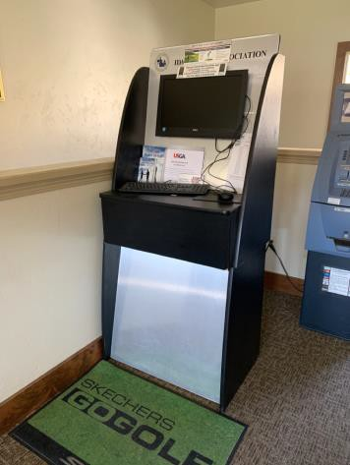 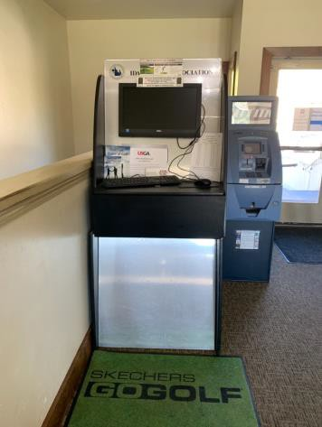

 | ID:  1465 | Facility:  Quail Hollow Golf Course

Location: Clubhouse Men’s Restroom
Schedule: 2021
Estimated Cost: $100.00

Priority Score 6
Quick Fix: Yes
Built before ADA: Yes

VIOLATIONS
2010 ADA Standards for Accessible Design Codes §307.2, §308.2.1
The paper towel dispenser is outside of the unobstructed forward reach range at 50.5" above the floor. The paper towel dispenser protrudes 7" into the circulation space at 50.5" above the floor.

RECOMMENDATIONS
Lower the paper towel dispenser by 2.5" to meet the accessible reach range of 48" maximum above the floor.
Recess the paper towel dispenser so it protrudes a maximum of 4" or place a cane detectable object beneath it.

PHOTOGRAPH(S) OF THIS LOCATION

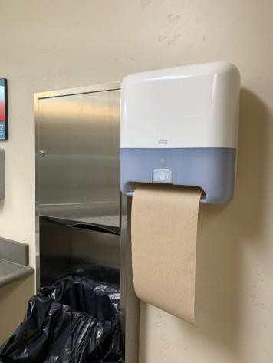

 | ID:  1470 | Facility:  Quail Hollow Golf Course

Location: Clubhouse Men’s Restroom
Schedule: 2021
Estimated Cost: $100.00

Priority Score 5
Quick Fix: Yes
Built before ADA: Yes

VIOLATIONS
2010 ADA Standards for Accessible Design Codes §604.8.1.2
The door to the accessible water closet is not self closing. Either self-closing hinges are not installed on the door or if installed, they are defective.

RECOMMENDATIONS
Install or reinstall self-closing hinges on the door to ensure that the door is self-closing per the ADA requirements.

PHOTOGRAPH(S) OF THIS LOCATION

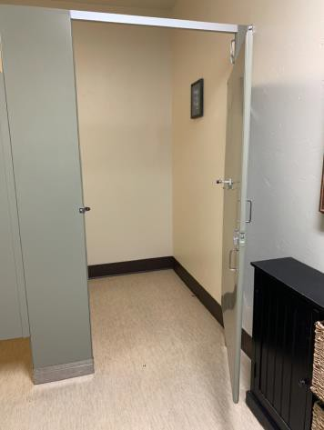

 | ID:  1466 | Facility:  Quail Hollow Golf Course

Location: Clubhouse Men’s Restroom
Schedule: 2021
Estimated Cost: $500.00

Priority Score 5
Quick Fix: Yes
Built before ADA: Yes

VIOLATIONS
2010 ADA Standards for Accessible Design Codes §604.5.2
The rear grab bar is located 9" to the center of the toilet.

RECOMMENDATIONS
Remount the rear grab bar 12" from the centerline of the water closet minimum on one side and 24" minimum on the other.

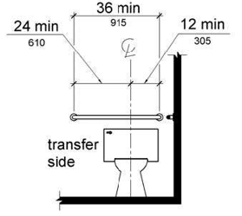

PHOTOGRAPH(S) OF THIS LOCATION

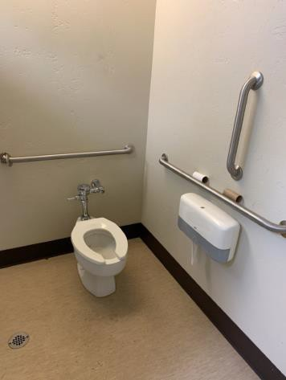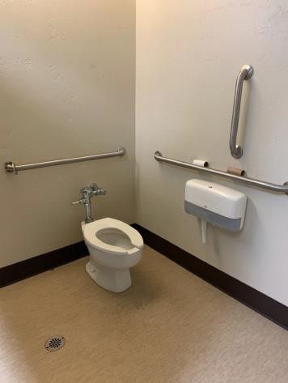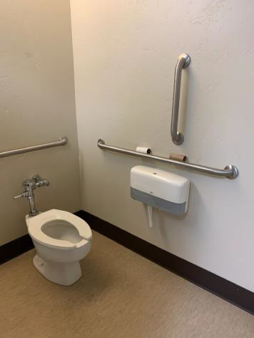

 | ID:  1469 | Facility:  Quail Hollow Golf Course

Location: Clubhouse Men’s Restroom
Schedule: 2022
Estimated Cost: $1,000.00

Priority Score 5
Quick Fix: No
Built before ADA: Yes

VIOLATIONS
2010 ADA Standards for Accessible Design Codes §604.2
The centerline of the toilet is located 22" from the sidewall.

RECOMMENDATIONS
Reposition the centerline of the toilet to be within 16" minimum and 18" maximum from the sidewall.

PHOTOGRAPH(S) OF THIS LOCATION

 | ID:  1450 | Facility:  Quail Hollow Golf Course

Location: Clubhouse Outdoor Seating
Schedule: 2022
Estimated Cost: $1,000.00

Priority Score 5
Quick Fix: No
Built before ADA: Yes

VIOLATIONS
2010 ADA Standards for Accessible Design Codes §404.2.5
The threshold at the doorway is 1.5" tall.

RECOMMENDATIONS
Reduce the metal lip on the door to no more than 0.5" to 0.75" if beveled on each side.

PHOTOGRAPH(S) OF THIS LOCATION

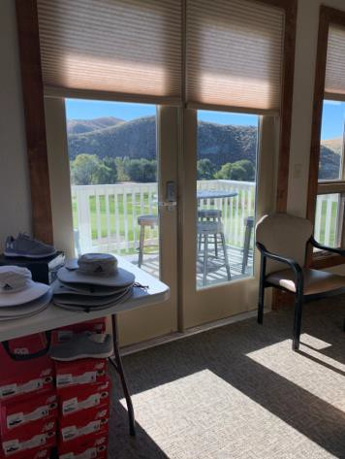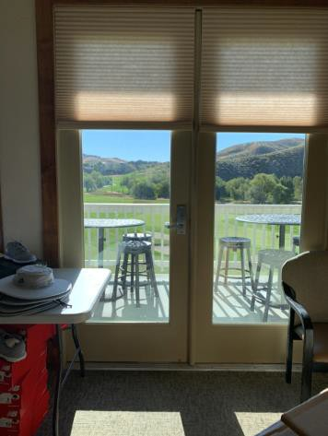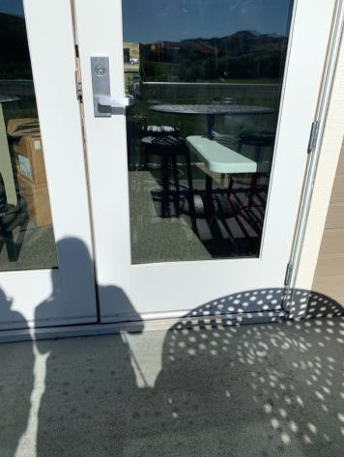

 | ID:  1454 | Facility:  Quail Hollow Golf Course

Location: Clubhouse Pro Shop
Schedule: 2021
Estimated Cost: $100.00

Priority Score 5
Quick Fix: Yes
Built before ADA: Yes

VIOLATIONS
2010 ADA Standards for Accessible Design Codes §403.5.1
There is not a clear 36" width for wheelchairs to pass between the merchandise.

RECOMMENDATIONS
Relocate some of the merchandise to different parts of the shop to allow for circulation paths that are a minimum of 36" wide.

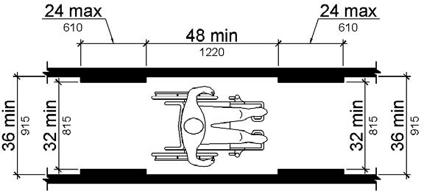

PHOTOGRAPH(S) OF THIS LOCATION

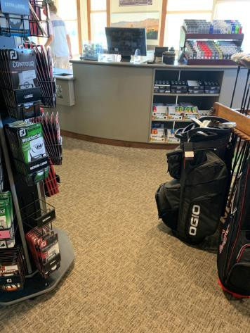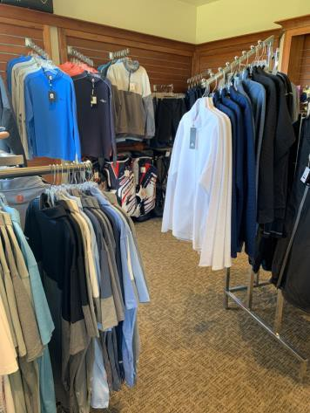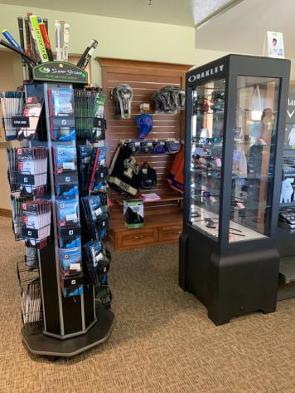

 | ID: | Facility:  Quail Hollow Golf Course

Location:
Schedule:
Estimated Cost:

Priority Score 3
Quick Fix: Yes
Built before ADA: Yes

VIOLATIONS
2010 ADA Standards for Accessible Design Codes §308.2.1

RECOMMENDATIONS

PHOTOGRAPH(S) OF THIS LOCATION

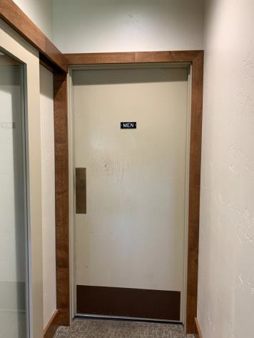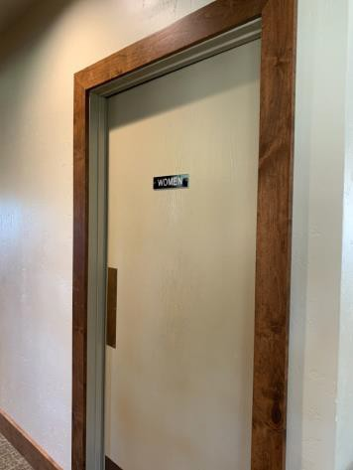

 | ID:  1455 | Facility:  Quail Hollow Golf Course

Location: Clubhouse Women’s Restroom
Schedule: 2021
Estimated Cost: $100.00

Priority Score 6
Quick Fix: Yes
Built before ADA: Yes

VIOLATIONS
2010 ADA Standards for Accessible Design Codes §403.5.1
The entrance into the Women's Restroom is 34" between the corner and cabinet.

RECOMMENDATIONS
Relocate the cabinet.

PHOTOGRAPH(S) OF THIS LOCATION

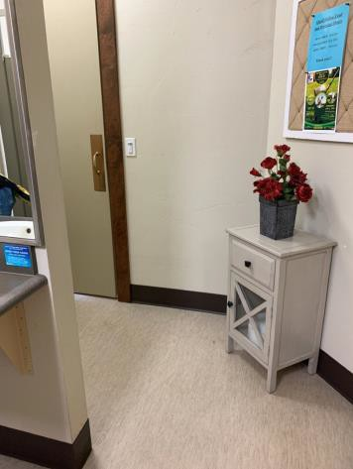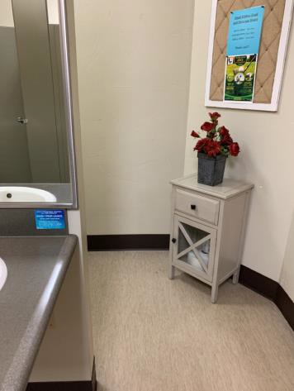

 | ID:  1456 | Facility:  Quail Hollow Golf Course

Location: Clubhouse Women’s Restroom
Schedule: 2021
Estimated Cost: $100.00

Priority Score 5
Quick Fix: Yes
Built before ADA: Yes

VIOLATIONS
2010 ADA Standards for Accessible Design Codes §604.8.1.2
The door to the accessible water closet is not self closing. Either self-closing hinges are not installed on the door or if installed, they are defective.

RECOMMENDATIONS
Install or reinstall self-closing hinges on the door to ensure that the door is self-closing per the ADA requirements.

PHOTOGRAPH(S) OF THIS LOCATION

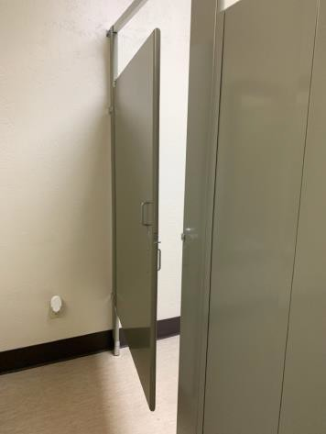

 | ID:  1461 | Facility:  Quail Hollow Golf Course

Location: Clubhouse Women’s Restroom
Schedule: 2021
Estimated Cost: $100.00

Priority Score 5
Quick Fix: Yes
Built before ADA: Yes

VIOLATIONS
2010 ADA Standards for Accessible Design Codes §604.7
The toilet paper dispenser is located out of the accessible reach range.

RECOMMENDATIONS
Remount the toilet paper dispenser to 7” minimum and 9” maximum in front of the water closet measured to the centerline of the dispenser.
The outlet of the dispenser shall be 15” minimum and 48” maximum above the floor and shall not be located behind.

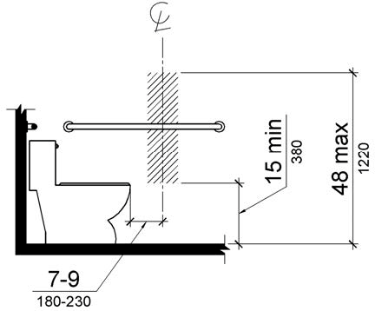

PHOTOGRAPH(S) OF THIS LOCATION

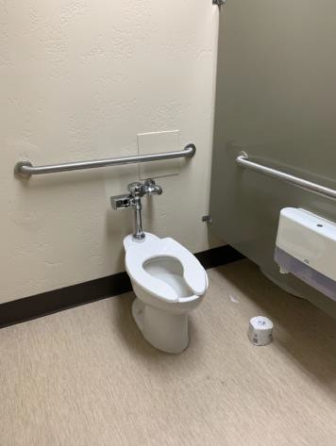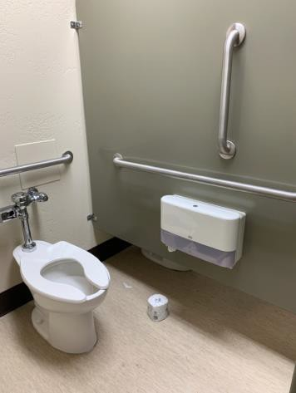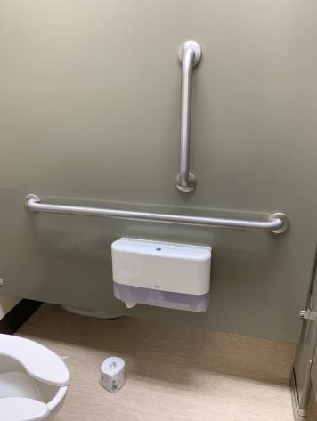

 | ID:  1462 | Facility:  Quail Hollow Golf Course

Location: Clubhouse Women’s Restroom
Schedule: 2021
Estimated Cost: $100.00

Priority Score 8
Quick Fix: Yes
Built before ADA: Yes

VIOLATIONS
2010 ADA Standards for Accessible Design Codes §308.2.1
The paper towel dispenser is outside of the unobstructed forward reach range at 50.25" above the floor.

RECOMMENDATIONS
Lower the paper towel dispenser by 2.25" to meet the accessible reach range of 48" maximum above the floor.

PHOTOGRAPH(S) OF THIS LOCATION

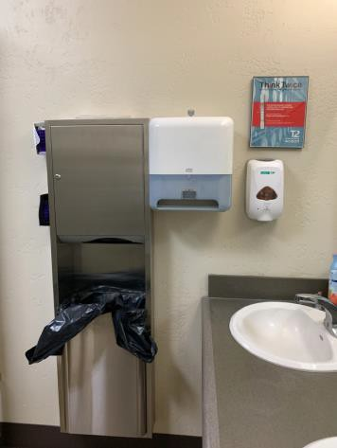

 | ID:  1463 | Facility:  Quail Hollow Golf Course

Location: Clubhouse Women’s Restroom
Schedule: 2021
Estimated Cost: $100.00

Priority Score 8
Quick Fix: Yes
Built before ADA: Yes

VIOLATIONS
2010 ADA Standards for Accessible Design Codes §308.2.1
The soap dispenser is outside of the unobstructed forward reach range at 49" above the floor.

RECOMMENDATIONS
Lower the soap dispenser by 1" to meet the accessible reach range of 48" maximum above the floor.

PHOTOGRAPH(S) OF THIS LOCATION

 | ID:  1457 | Facility:  Quail Hollow Golf Course

Location: Clubhouse Women’s Restroom
Schedule: 2021
Estimated Cost: $500.00

Priority Score 5
Quick Fix: Yes
Built before ADA: Yes

VIOLATIONS
2010 ADA Standards for Accessible Design Codes §604.5.2
The rear grab bar is located 10" to the center of the toilet.

RECOMMENDATIONS
Remount the rear grab bar 12" from the centerline of the water closet minimum on one side and 24" minimum on the other.

PHOTOGRAPH(S) OF THIS LOCATION

 | ID:  1460 | Facility:  Quail Hollow Golf Course

Location: Clubhouse Women’s Restroom
Schedule: 2022
Estimated Cost: $1,000.00

Priority Score 5
Quick Fix: No
Built before ADA: Yes

VIOLATIONS
2010 ADA Standards for Accessible Design Codes §604.2
The centerline of the toilet is located 21.5" from the sidewall.

RECOMMENDATIONS
Reposition the centerline of the toilet to be within 16" minimum and 18" maximum from the sidewall.

PHOTOGRAPH(S) OF THIS LOCATION

 | ID:  1415 | Facility:  Quail Hollow Golf Course

Location: Driving Range
Schedule: 2021
Estimated Cost: $5,000.00

Priority Score 3
Quick Fix: No
Built before ADA: Yes

VIOLATIONS
2010 ADA Standards for Accessible Design Codes §302.1, §305
There is not a firm, stable, and slip resistant route to the driving range.

RECOMMENDATIONS
Construct a firm, stable, and slip resistant accessible route to an accessible driving range bay with a maximum cross slope of 2% and maximum running slope of 5%.

PHOTOGRAPH(S) OF THIS LOCATION

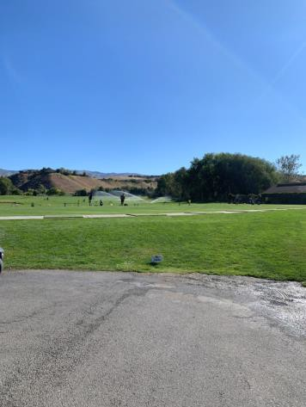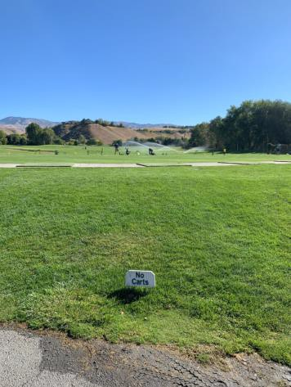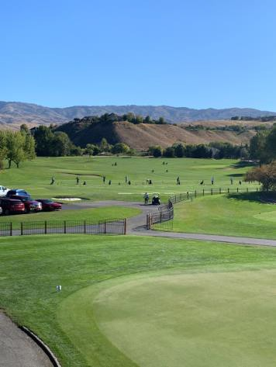

 | ID:  3699 | Facility:  Quail Hollow Golf Course

Location: Driving Range Parking
Schedule: 2021
Estimated Cost: $1,000.00

Priority Score 3
Quick Fix: No
Built before ADA: Yes

VIOLATIONS
2010 ADA Standards for Accessible Design Codes §208.2
There are no marked accessible parking spaces near the driving range or golf carts.

RECOMMENDATIONS
Install an accessible parking space that is a minimum of 96" wide. Ensure at least one accessible parking space is marked as "van" accessible.
Install a 60" wide access aisle connecting to an accessible route. Install a sign 60" above the ground.

PHOTOGRAPH(S) OF THIS LOCATION

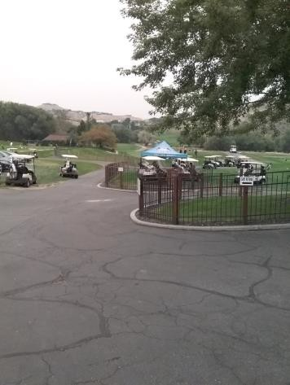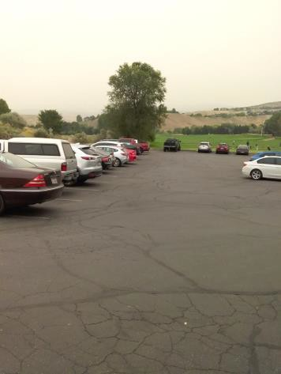

 | ID:  3670 | Facility:  Quail Hollow Golf Course

Location: Entrance Ramp
Schedule: 2021
Estimated Cost: $1,000.00

Priority Score 3
Quick Fix: No
Built before ADA: Yes

VIOLATIONS
2010 ADA Standards for Accessible Design Codes §405.3
The ramp has a 3.6% cross slope.

RECOMMENDATIONS
Reconstruct the ramp to have a cross slope of 2% or less.

PHOTOGRAPH(S) OF THIS LOCATION

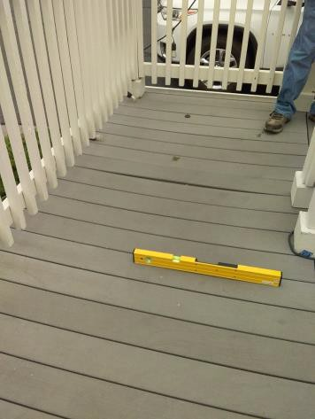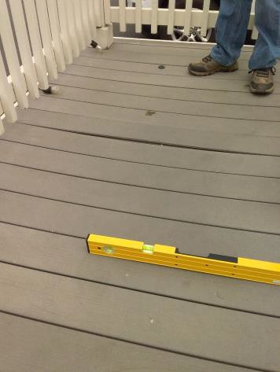

 | ID:  1422 | Facility:  Quail Hollow Golf Course

Location: Exterior Downstairs Men’s Restroom
Schedule: 2021
Estimated Cost: $100.00

Priority Score 7
Quick Fix: Yes
Built before ADA: Yes

VIOLATIONS
2010 ADA Standards for Accessible Design Codes §606.5
The pipes under the sink are not covered.

RECOMMENDATIONS
Wrap the pipes beneath the sink with soft protective wrap or plastic.

PHOTOGRAPH(S) OF THIS LOCATION

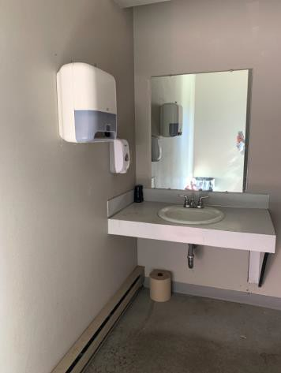

 | ID:  1423 | Facility:  Quail Hollow Golf Course

Location: Exterior Downstairs Men’s Restroom
Schedule: 2021
Estimated Cost: $4,000.00

Priority Score 3
Quick Fix: No
Built before ADA: Yes

VIOLATIONS
2010 ADA Standards for Accessible Design Codes §405.2, §505.2, §404.2.4.4
The entrances to the restrooms have a slope greater than 2%. The running slope of the ramp is 12.6%. There are no handrails.

RECOMMENDATIONS
Reconstruct the entryway to reduce the running slope to a maximum of 2% in all directions. Reconstruct the ramp to reduce the running slope to a maximum of 8.3%.
Install handrails at a minimum height of 34” and maximum of 38” above the ground. Make sure there are adequate handrail extensions both at the top and bottom of the handrail.

PHOTOGRAPH(S) OF THIS LOCATION

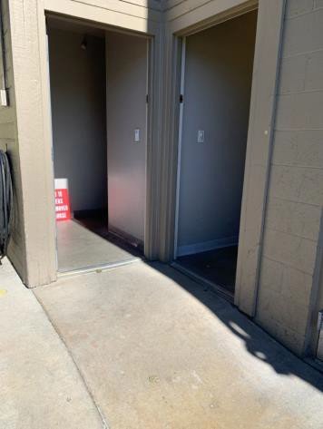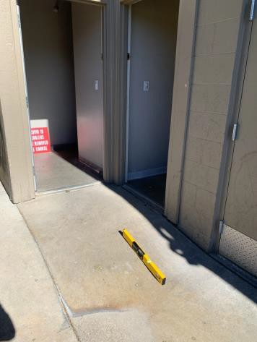

 | ID:  3320 | Facility:  Quail Hollow Golf Course

Location: Golf Cart Parking and Banquet Room Stairs
Schedule: 2022
Estimated Cost: $1,000.00

Priority Score 6
Quick Fix: No
Built before ADA: Yes

VIOLATIONS
2010 ADA Standards for Accessible Design Codes §505.2
There is only one handrail.

RECOMMENDATIONS
Install an additional handrail at a minimum height of 34” and maximum of 38” above the ground. Make sure there are adequate handrail extensions both at the top and bottom of the handrail.

PHOTOGRAPH(S) OF THIS LOCATION

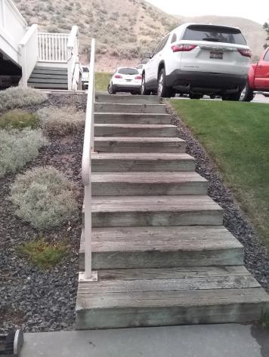

 | ID:  1428 | Facility:  Quail Hollow Golf Course

Location: Outdoor Banquet Room
Schedule: 2021
Estimated Cost: $100.00

Priority Score 5
Quick Fix: Yes
Built before ADA: Yes

VIOLATIONS
2010 ADA Standards for Accessible Design Codes §308.2.1, §307.2
The hand sanitizer dispenser protrudes 8" into the circulation space at 61" above the floor.
The hand sanitizer dispenser is outside of the unobstructed forward reach range at 61" above the floor.

RECOMMENDATIONS
Recess the hand sanitizer dispenser so it protrudes a maximum of 4" or place a cane detectable object beneath it.
Lower the hand sanitizer dispenser by 13" to meet the accessible reach range of 48" maximum above the floor.

PHOTOGRAPH(S) OF THIS LOCATION

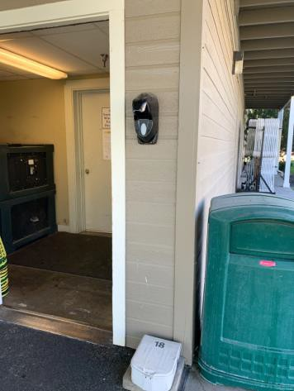

 | ID:  1429 | Facility:  Quail Hollow Golf Course

Location: Outdoor Banquet Room
Schedule: 2022
Estimated Cost: $1,000.00

Priority Score 5
Quick Fix: No
Built before ADA: Yes

VIOLATIONS
2010 ADA Standards for Accessible Design Codes §404.2.5
The thresholds at the five doorways are 1.25" tall.

RECOMMENDATIONS
Reduce the metal lips on the doors to no more than 0.5" to 0.75" if beveled on each side.

PHOTOGRAPH(S) OF THIS LOCATION

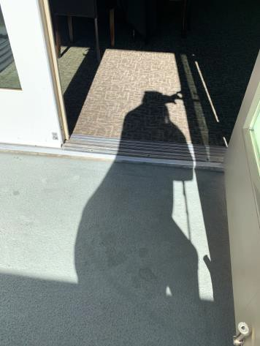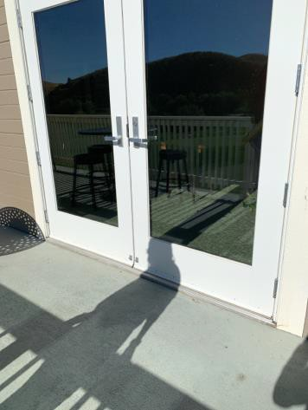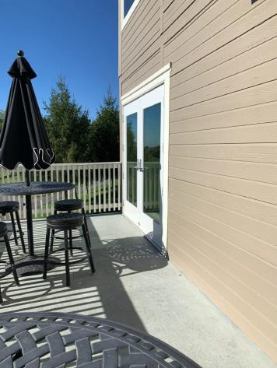

 | ID:  3278 | Facility:  Quail Hollow Golf Course

Location: Parking
Schedule: 2023
Estimated Cost: $1,500.00

Priority Score 9
Quick Fix: No
Built before ADA: Yes

VIOLATIONS
2010 ADA Standards for Accessible Design Codes §502.6, §502
The painted lines for the accessible parking spaces are faded.
The sign identifying the accessible parking space is located in the access aisle.

RECOMMENDATIONS
Restripe and repaint the accessible parking spaces, access aisles, and ISA symbols.
Relocate and install an accessible parking sign at the accessible space at a minimum height of 60" above the ground in front of the accessible parking space.

PHOTOGRAPH(S) OF THIS LOCATION

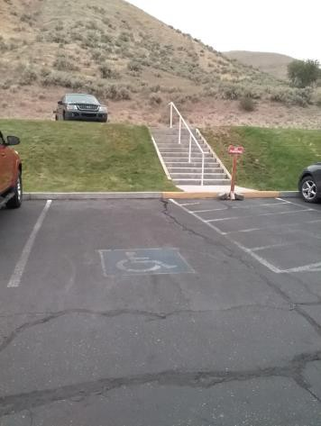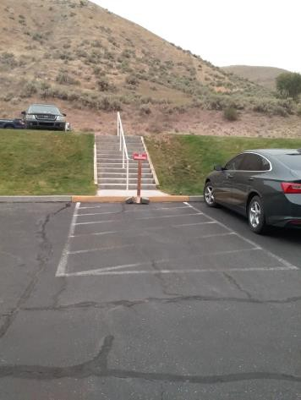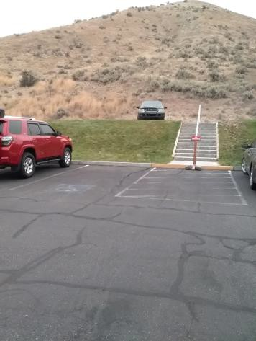

 | ID:  3277 | Facility:  Quail Hollow Golf Course

Location: Parking
Schedule: 2021
Estimated Cost: $2,000.00

Priority Score 3
Quick Fix: No
Built before ADA: Yes

VIOLATIONS
2010 ADA Standards for Accessible Design Codes §208.2.4, §502.4
The parking space has a 4% slope.
There are no marked "Van Accessible" spaces.

RECOMMENDATIONS
Resurface the parking space to reduce the slope to a maximum of 2% in all directions.
Expand the existing accessible parking space to be a 132" wide van accessible parking space. Add a “van accessible” parking sign at a minimum height of 60" above the ground.

PHOTOGRAPH(S) OF THIS LOCATION

 | ID:  3276 | Facility:  Quail Hollow Golf Course

Location: Parking
Schedule: 2021
Estimated Cost: $4,000.00

Priority Score 3
Quick Fix: No
Built before ADA: Yes

VIOLATIONS
2010 ADA Standards for Accessible Design Codes §208.2
There is a total of 116 parking spaces and only one accessible parking space at the main entrance for the entire facility.

RECOMMENDATIONS
Install accessible parking spaces that are a minimum of 96" wide so there are a minimum of four accessible car spaces and one accessible van space.
Install a 60" wide access aisle connecting to an accessible route. Install a sign 60" above the ground.

PHOTOGRAPH(S) OF THIS LOCATION

 | ID:  3769 | Facility:  Quail Hollow Golf Course

Location: Parking
Schedule: 2023
Estimated Cost: $10,000.00

Priority Score 9
Quick Fix: No
Built before ADA: Yes

VIOLATIONS
2010 ADA Standards for Accessible Design Codes §502
There are accessible parking spaces that do not connect to an accessible route as there is a step up to the accessible route.

RECOMMENDATIONS
Provide a curb ramp to access the clubhouse from the accessible parking space.

PHOTOGRAPH(S) OF THIS LOCATION

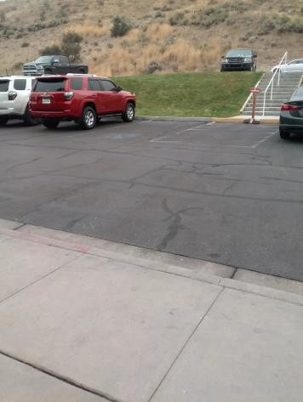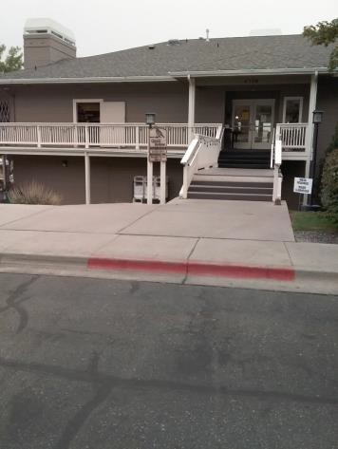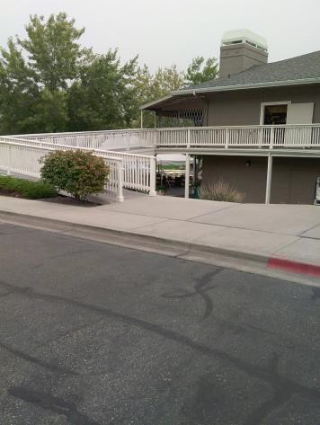

 | ID:  3077 | Facility:  Quail Hollow Golf Course

Location: Putting Green
Schedule: 2022
Estimated Cost: $1,000.00

Priority Score 6
Quick Fix: No
Built before ADA: Yes

VIOLATIONS
2010 ADA Standards for Accessible Design Codes §505.2
There is only one handrail.

RECOMMENDATIONS
Install an additional handrail at a minimum height of 34” and maximum of 38” above the ground. Make sure there are adequate handrail extensions both at the top and bottom of the handrail.

PHOTOGRAPH(S) OF THIS LOCATION

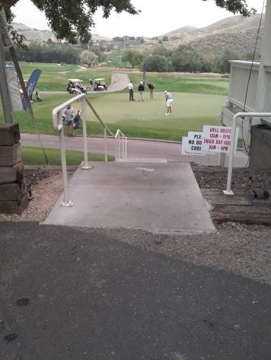

 | ID:  3547 | Facility:  Quail Hollow Golf Course

Location: Top Ramp
Schedule: 2022
Estimated Cost: $1,000.00

Priority Score 6
Quick Fix: No
Built before ADA: Yes

VIOLATIONS
2010 ADA Standards for Accessible Design Codes §505.2
There is only one handrail.

RECOMMENDATIONS
Install a second handrail at a minimum height of 34” and maximum of 38” above the ground. Make sure there are adequate handrail extensions both at the top and bottom of the handrail.

PHOTOGRAPH(S) OF THIS LOCATION

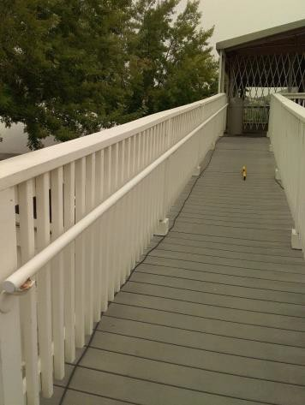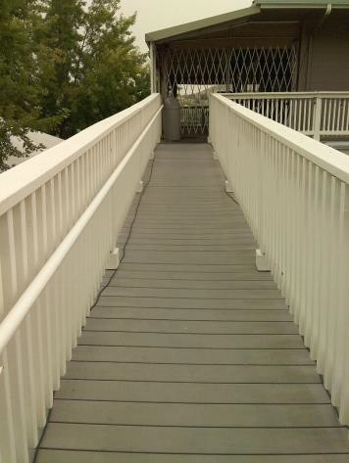

 | ID:  3548 | Facility:  Quail Hollow Golf Course

Location: Top Ramp
Schedule: 2022
Estimated Cost: $1,000.00

Priority Score 5
Quick Fix: No
Built before ADA: Yes

VIOLATIONS
2010 ADA Standards for Accessible Design Codes §505.10
There are no handrail extensions for the ramp.

RECOMMENDATIONS
Extend the ramp handrails 12” horizontally beyond the top and bottom of ramp runs.

PHOTOGRAPH(S) OF THIS LOCATION

 | ID:  3546 | Facility:  Quail Hollow Golf Course

Location: Top Ramp
Schedule: 2022
Estimated Cost: $5,000.00

Priority Score 7
Quick Fix: No
Built before ADA: Yes

VIOLATIONS
2010 ADA Standards for Accessible Design Codes §405.2
The running slope of the top ramp reaches 10%.

RECOMMENDATIONS
Reconstruct the ramp to reduce the running slope to a maximum of 8.3%.

PHOTOGRAPH(S) OF THIS LOCATION

