City of Boise ADA Assessment

Appendix A –Borah
Pool House

12/4/2020
Report #TO21-B0XX

Prepared by:
 | ID:  2141 | Facility:  Borah Pool House

Location: Bleachers
Schedule: 2021
Estimated Cost: $1,000.00

Priority Score 3
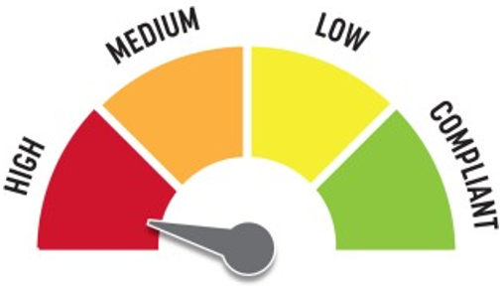
Quick Fix: No
Built before ADA: Yes

VIOLATIONS
2010 ADA Standards for Accessible Design Codes: §303.3
There is a 0.5" change in level at the top of the ramp.

RECOMMENDATIONS
Bevel the change in level with a slope not steeper than 1:2.

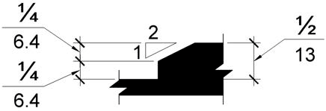

PHOTOGRAPH(S) OF THIS LOCATION

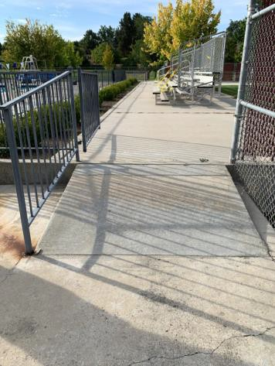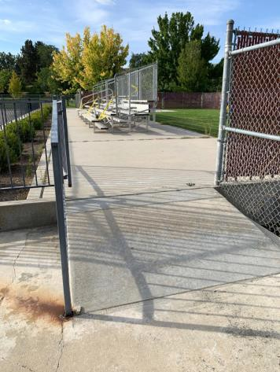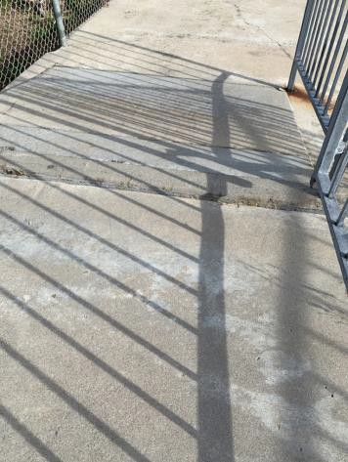

 | ID:  2137 | Facility:  Borah Pool House

Location:
Schedule:
Estimated Cost:

Priority Score 3
Quick Fix: No
Built before ADA: Yes

VIOLATIONS
2010 ADA Standards for Accessible Design Codes: §405.2
The ramp leading to the bleachers has a running slope of 14.9%, and there are no handrails.

RECOMMENDATIONS
Reconstruct the ramp to reduce the running slope to a maximum 8.3%. Install handrails at a minimum height of 34” and maximum of 38” above the ground.
Make sure there are adequate handrail extensions both at the top and bottom of the handrail and edge protection on each side of ramp runs.

PHOTOGRAPH(S) OF THIS LOCATION

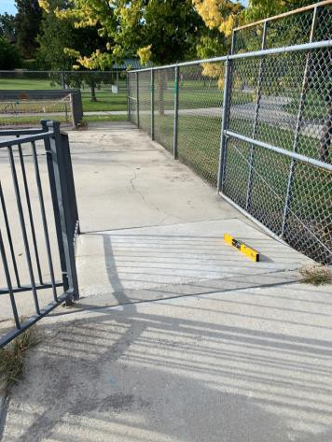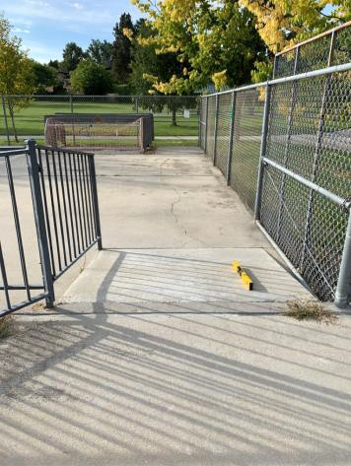

 | ID:  2139 | Facility:  Borah Pool House

Location:
Schedule:
Estimated Cost:

Priority Score 3
Quick Fix: No
Built before ADA: Yes

VIOLATIONS
2010 ADA Standards for Accessible Design Codes: §405.2, §505.2
The ramp leading to the bleachers has a running slope reaching 16.5%, and there are no handrails. The bleachers are located south of the swimming pool.

RECOMMENDATIONS
Reconstruct the ramp to reduce the running slope to a maximum of 8.3%. Install handrails at a minimum height of 34” and maximum of 38” above the ground.
Make sure there are adequate handrail extensions both at the top and bottom of the handrail and edge protection on each side of ramp runs.

PHOTOGRAPH(S) OF THIS LOCATION

 | ID:  2172 | Facility:  Borah Pool House

Location: Entrance
Schedule: 2021
Estimated Cost: $1,000.00

Priority Score 4
Quick Fix: No
Built before ADA: Yes

VIOLATIONS
2010 ADA Standards for Accessible Design Codes: §904.4.1
The check in counter is 37.25" above the floor.

RECOMMENDATIONS
A portion of the service counter must be no higher than 36” above the floor for a horizontal distance of 36”.

PHOTOGRAPH(S) OF THIS LOCATION

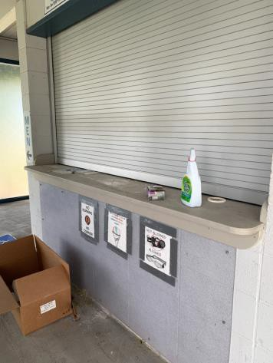

 | ID:  2409 | Facility:  Borah Pool House

Location: Entry Ramp
Schedule: 2021
Estimated Cost: $1,000.00

Priority Score 3
Quick Fix: No
Built before ADA: Yes

VIOLATIONS
2010 ADA Standards for Accessible Design Codes: §505.2
The ramp at the main entrance has no handrails.

RECOMMENDATIONS
Install handrails at a minimum height of 34” and maximum of 38” above the ground.
Make sure there are adequate handrail extensions both at the top and bottom of the handrail and edge protection on each side of ramp runs.

PHOTOGRAPH(S) OF THIS LOCATION

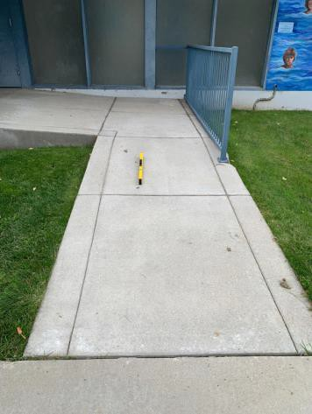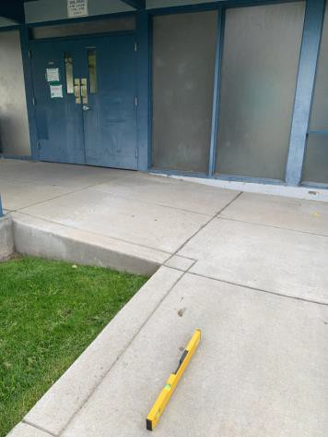

 | ID:  2408 | Facility:  Borah Pool House

Location: Entry Ramp
Schedule: 2021
Estimated Cost: $5,000.00

Priority Score 3
Quick Fix: No
Built before ADA: Yes

VIOLATIONS
2010 ADA Standards for Accessible Design Codes: §405.2
The ramp leading to the main entrance has a running slope of 11.4%.

RECOMMENDATIONS
Resurface the ramp to reduce the running slope to a maximum of 8.3%. Install handrails at a minimum height of 34” and maximum of 38” above the ground. Make sure there are adequate handrail extensions both at the top and bottom of the handrail and edge protection on each side of ramp runs.

PHOTOGRAPH(S) OF THIS LOCATION

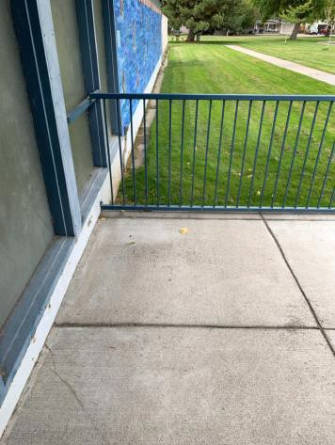

 | ID:  4459 | Facility:  Borah Pool House

Location: Entry Ramp
Schedule: 2021
Estimated Cost: $5,000.00

Priority Score 3
Quick Fix: No
Built before ADA: Yes

VIOLATIONS
2010 ADA Standards for Accessible Design Codes: §405.7.2, §405.7.3
The landing at the top of the entry ramp is not 60"x60".

RECOMMENDATIONS
Expand the provided landing to ensure that the clear length is 60" long minimum to allow adequate turning space.

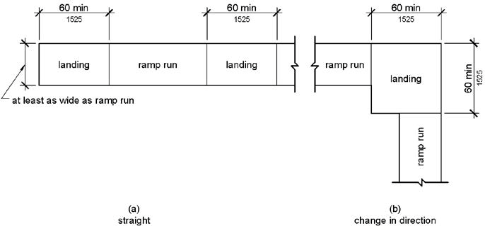

PHOTOGRAPH(S) OF THIS LOCATION

 | ID:  1926 | Facility:  Borah Pool House

Location: Exterior Restrooms
Schedule: 2021
Estimated Cost: $200.00

Priority Score 3
Quick Fix: Yes
Built before ADA: Yes

VIOLATIONS
2010 ADA Standards for Accessible Design Codes: §216.2, §703
There is no tactile sign identifying the restroom.

RECOMMENDATIONS
Install tactile signage on the latch side of the doorway at a height of 48” minimum to 60” maximum above the floor, identifying room by name or room number.
Signs shall be Braille with raised lettering and should be placed on the wall in the center of an 18"x18" clear floor space.

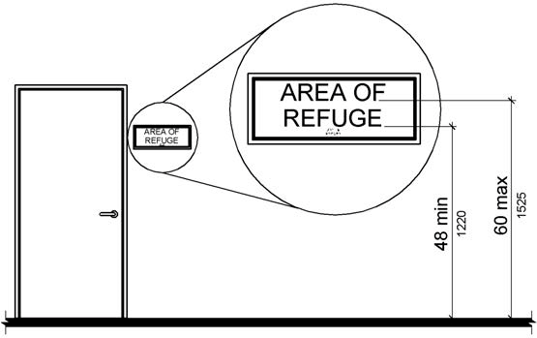

PHOTOGRAPH(S) OF THIS LOCATION

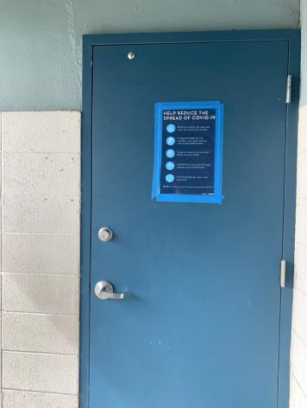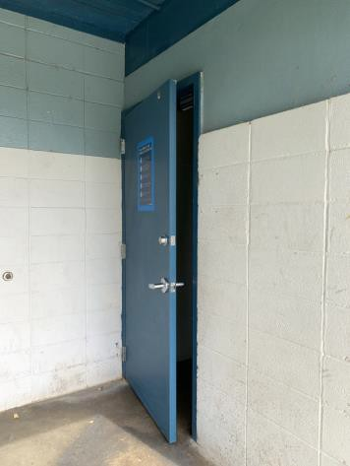

 | ID:  1925 | Facility:  Borah Pool House

Location: Exterior Restrooms
Schedule: 2022
Estimated Cost: $1,000.00

Priority Score 6
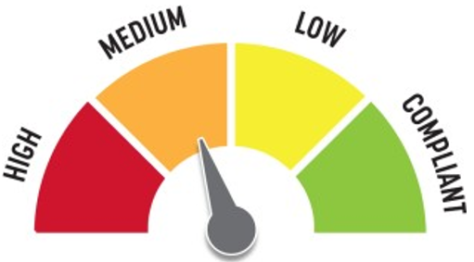
Quick Fix: No
Built before ADA: Yes

VIOLATIONS
2010 ADA Standards for Accessible Design Codes: §505.2
There are no handrails provided on either side of the ramp.

RECOMMENDATIONS
Install handrails at a minimum height of 34” and maximum of 38” above the ground.
Make sure there are adequate handrail extensions both at the top and bottom of the handrail and edge protection on each side of ramp runs.

PHOTOGRAPH(S) OF THIS LOCATION

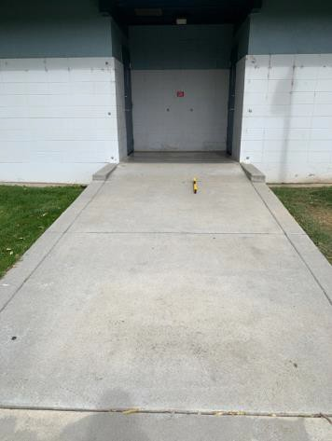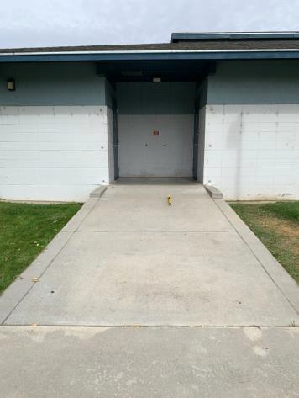

 | ID:  1915 | Facility:  Borah Pool House

Location: Men’s Exterior Restrooms
Schedule: 2022
Estimated Cost: $100.00

Priority Score 5
Quick Fix: Yes
Built before ADA: Yes

VIOLATIONS
2010 ADA Standards for Accessible Design Codes: §604.7
The toilet paper dispenser is located behind the rim of the toilet.

RECOMMENDATIONS
Remount the toilet paper dispenser so that the centerline is located 7" minimum to 9" maximum in front of the toilet.
Ensure that the height is within the accessible reach range of 15" minimum to 48" maximum above the floor.

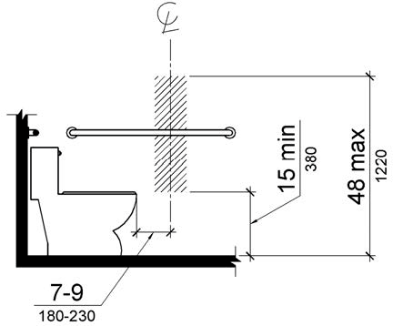

PHOTOGRAPH(S) OF THIS LOCATION

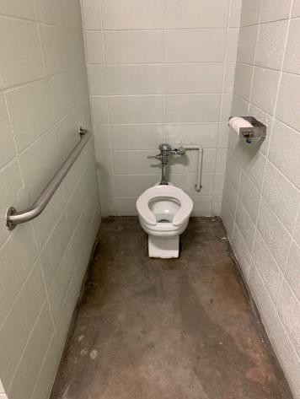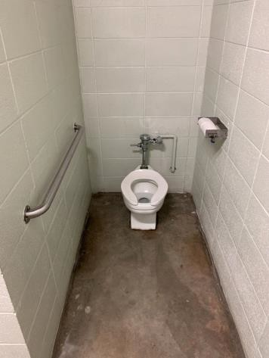

 | ID:  1923 | Facility:  Borah Pool House

Location: Men’s Exterior Restrooms
Schedule: 2022
Estimated Cost: $100.00

Priority Score 7
Quick Fix: Yes
Built before ADA: Yes

VIOLATIONS
2010 ADA Standards for Accessible Design Codes: §606.5
The pipes under the sink are not covered.

RECOMMENDATIONS
Wrap the pipes beneath the sink with soft protective wrap or plastic.

PHOTOGRAPH(S) OF THIS LOCATION

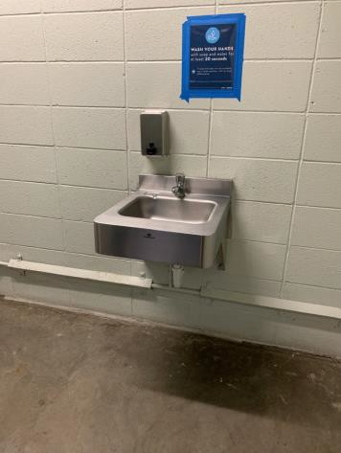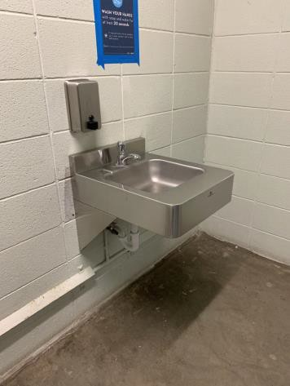

 | ID:  1917 | Facility:  Borah Pool House

Location: Men’s Exterior Restrooms
Schedule: 2021
Estimated Cost: $100.00

Priority Score 3
Quick Fix: Yes
Built before ADA: Yes

VIOLATIONS
2010 ADA Standards for Accessible Design Codes: §308.2.1
The exit button is outside of the unobstructed forward reach range at 50" above the floor.

RECOMMENDATIONS
Lower the exit button by 2" to meet the accessible reach range of 15" minimum and 48" maximum above the floor.

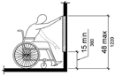

PHOTOGRAPH(S) OF THIS LOCATION

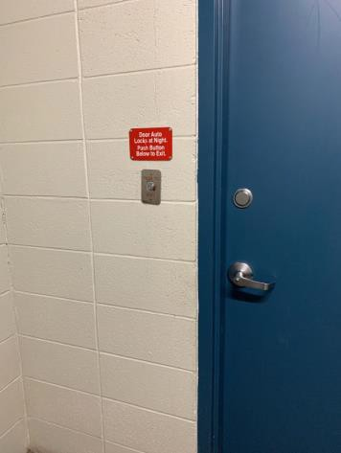

 | ID:  1920 | Facility:  Borah Pool House

Location: Men’s Exterior Restrooms
Schedule: 2022
Estimated Cost: $500.00

Priority Score 5
Quick Fix: Yes
Built before ADA: Yes

VIOLATIONS
2010 ADA Standards for Accessible Design Codes: §307.2
The sink protrudes 10.5" into the circulation space at 33.5" above the floor.

RECOMMENDATIONS
Recess the sink so it protrudes a maximum of 4", lower it so the bottom edge is 27" maximum above the floor, or extend the skirt underneath the sink to provide additional detectability.

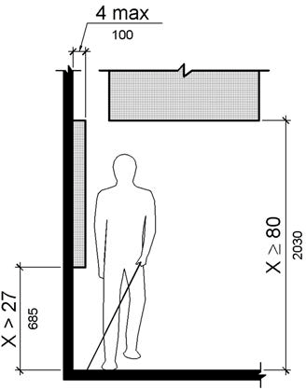

PHOTOGRAPH(S) OF THIS LOCATION

 | ID:  1918 | Facility:  Borah Pool House

Location: Men’s Exterior Restrooms
Schedule: 2022
Estimated Cost: $1,000.00

Priority Score 5
Quick Fix: No
Built before ADA: Yes

VIOLATIONS
2010 ADA Standards for Accessible Design Codes: §605.2
The urinal is 23.5" above the floor.

RECOMMENDATIONS
Lower the urinal to a maximum height of 17"above the floor.

PHOTOGRAPH(S) OF THIS LOCATION

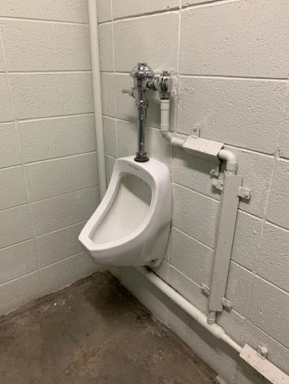

 | ID:  4464 | Facility:  Borah Pool House

Location: Men’s Exterior Restrooms
Schedule: 2022
Estimated Cost: $10,000.00

Priority Score 5
Quick Fix: No
Built before ADA: Yes

VIOLATIONS
2010 ADA Standards for Accessible Design Codes: §216.8, §604.8.1
There are no wheelchair accessible stalls, only a non-compliant ambulatory stall.

RECOMMENDATIONS
Construct a wheelchair accessible stall that is 60" minimum wide and 59" minimum deep complying with §604.8.1. This may be accomplished by the adjacent stall and making this a single-use restroom.
In the meantime, install a directional sign indicating the location of the nearby accessible restroom, currently located inside the locker rooms.

PHOTOGRAPH(S) OF THIS LOCATION

 | ID:  2163 | Facility:  Borah Pool House

Location: Men’s Locker Room
Schedule: 2023
Estimated Cost: $100.00

Priority Score 8
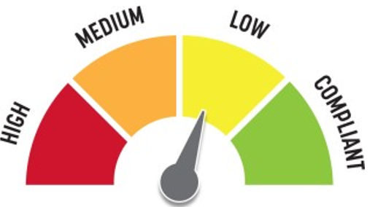
Quick Fix: Yes
Built before ADA: Yes

VIOLATIONS
2010 ADA Standards for Accessible Design Codes: §308.2.1
The hooks are outside of the unobstructed forward reach range at 63" above the floor.

RECOMMENDATIONS
Lower the hooks by 15" to meet the accessible reach range of 15" minimum and 48" maximum above the floor.

PHOTOGRAPH(S) OF THIS LOCATION

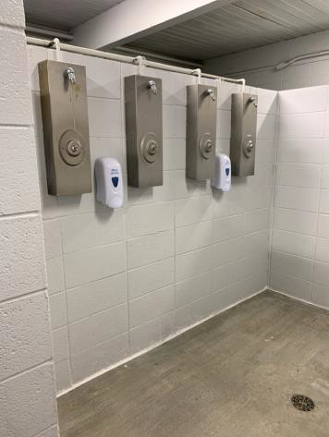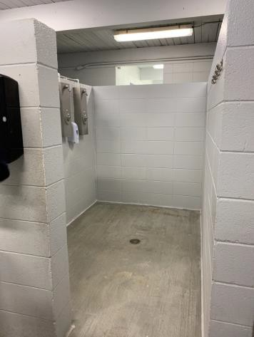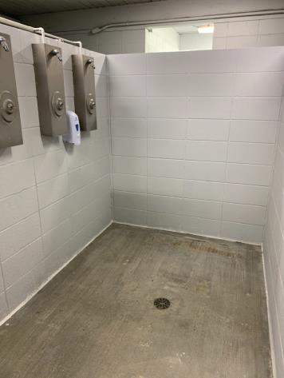

 | ID:  2154 | Facility:  Borah Pool House

Location: Men’s Locker Room
Schedule: 2022
Estimated Cost: $100.00

Priority Score 5
Quick Fix: Yes
Built before ADA: Yes

VIOLATIONS
2010 ADA Standards for Accessible Design Codes: §604.8.1.2
The door to the accessible water closet is not self closing. Either self-closing hinges are not installed on the door or if installed, they are defective.

RECOMMENDATIONS
Install or reinstall self-closing hinges on the door to ensure that the door is self-closing per the ADA requirements.

PHOTOGRAPH(S) OF THIS LOCATION

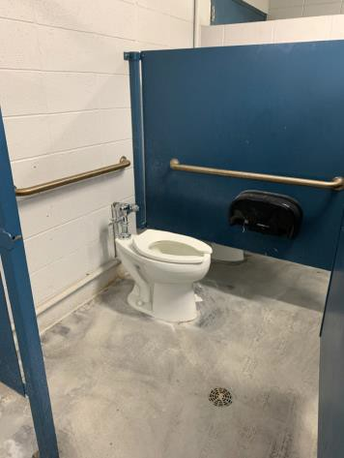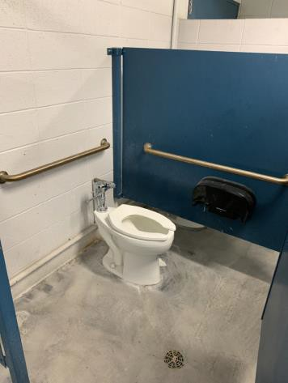

 | ID:  2156 | Facility:  Borah Pool House

Location: Men’s Locker Room
Schedule: 2022
Estimated Cost: $100.00

Priority Score 7
Quick Fix: Yes
Built before ADA: Yes

VIOLATIONS
2010 ADA Standards for Accessible Design Codes: §603.3
The mirror is too high to be accessible at 42" above the floor.

RECOMMENDATIONS
Lower the mirror its bottom edge is a maximum height of 40" above the floor.

PHOTOGRAPH(S) OF THIS LOCATION

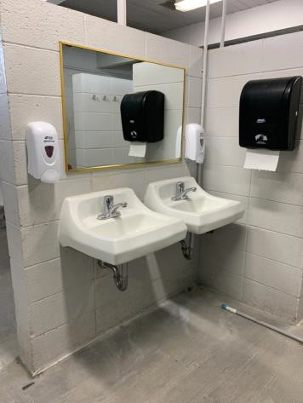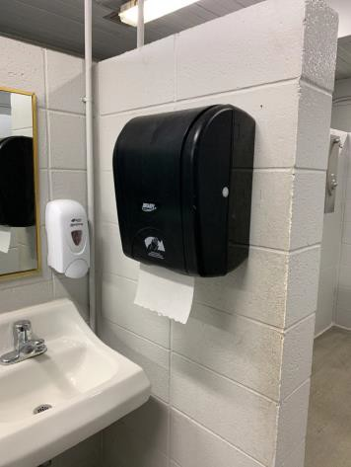

 | ID:  2157 | Facility:  Borah Pool House

Location: Men’s Locker Room
Schedule: 2022
Estimated Cost: $100.00

Priority Score 5
Quick Fix: Yes
Built before ADA: Yes

VIOLATIONS
2010 ADA Standards for Accessible Design Codes: §307.2
The paper towel dispenser protrudes 8" into the circulation space at 46" above the floor.

RECOMMENDATIONS
Recess the paper towel dispenser so it protrudes a maximum of 4", lower it so the bottom edge is 27" maximum above the floor, or place a cane detectable object beneath it.

PHOTOGRAPH(S) OF THIS LOCATION

 | ID:  2164 | Facility:  Borah Pool House

Location: Men’s Locker Room
Schedule: 2022
Estimated Cost: $100.00

Priority Score 5
Quick Fix: Yes
Built before ADA: Yes

VIOLATIONS
2010 ADA Standards for Accessible Design Codes: §307.2
The changing table protrudes 5" into the circulation space at 36" above the floor.

RECOMMENDATIONS
Recess the changing table so it protrudes a maximum of 4", lower it so the bottom edge is 27" maximum above the floor, or place a cane detectable object beneath it.

PHOTOGRAPH(S) OF THIS LOCATION

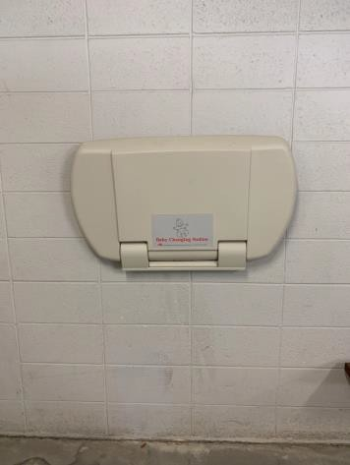

 | ID:  2147 | Facility:  Borah Pool House

Location: Men’s Locker Room
Schedule: 2021
Estimated Cost: $100.00

Priority Score 3
Quick Fix: Yes
Built before ADA: Yes

VIOLATIONS
2010 ADA Standards for Accessible Design Codes: §216.2, §703
There is no tactile sign identifying the men's locker room.

RECOMMENDATIONS
Install tactile signage on the latch side of the doorway at a height of 48” minimum to 60” maximum above the floor, identifying the locker room by name or room number.
Signs shall be Braille with raised lettering and should be placed on the wall in the center of an 18"x18" clear floor space.

PHOTOGRAPH(S) OF THIS LOCATION

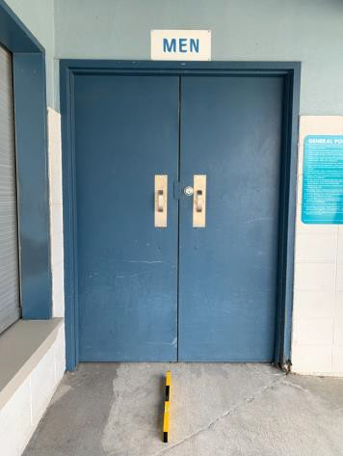

 | ID:  2165 | Facility:  Borah Pool House

Location: Men’s Locker Room
Schedule: 2021
Estimated Cost: $100.00

Priority Score 3
Quick Fix: Yes
Built before ADA: Yes

VIOLATIONS
2010 ADA Standards for Accessible Design Codes: §216.2, §703
There is no tactile sign identifying the men's locker room.

RECOMMENDATIONS
Install tactile signage on the latch side of the doorway at a height of 48” minimum to 60” maximum above the floor, identifying room by name or room number.
Signs shall be Braille with raised lettering and should be placed on the wall in the center of an 18"x18" clear floor space.

PHOTOGRAPH(S) OF THIS LOCATION

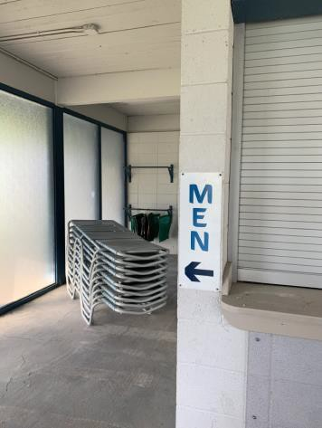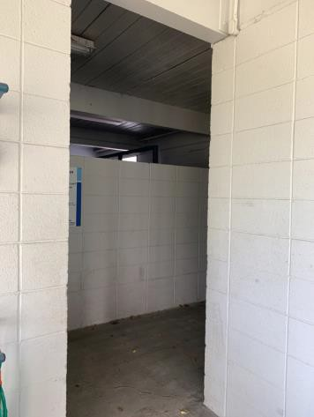

 | ID:  2155 | Facility:  Borah Pool House

Location: Men’s Locker Room
Schedule: 2022
Estimated Cost: $200.00

Priority Score 7
Quick Fix: Yes
Built before ADA: Yes

VIOLATIONS
2010 ADA Standards for Accessible Design Codes: §606.5
The pipes under the sinks are not covered.

RECOMMENDATIONS
Wrap the pipes beneath the sinks with soft protective wrap or plastic.

PHOTOGRAPH(S) OF THIS LOCATION

 | ID: | Facility:  Borah Pool House

Location: Men’s Locker Room
Schedule: 2022
Estimated Cost: $500.00

Priority Score 5
Quick Fix: Yes
Built before ADA: Yes

VIOLATIONS
2010 ADA Standards for Accessible Design Codes: §903.3
The benches in the men's locker room are 15" deep.

RECOMMENDATIONS
Install one new bench that is at least 42" long and 20" to 24" inches deep. The accessible bench shall have a back support or be affixed to a wall.

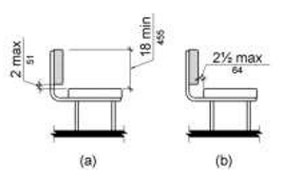

PHOTOGRAPH(S) OF THIS LOCATION

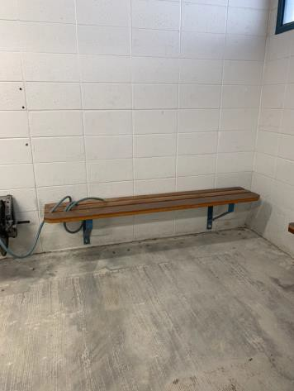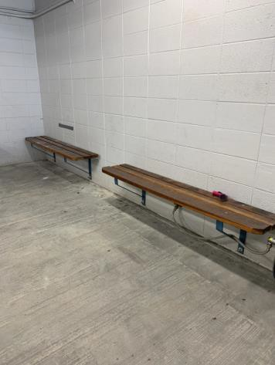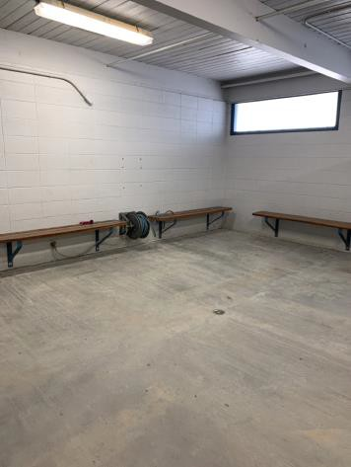

 | ID:  2160 | Facility:  Borah Pool House

Location: Men’s Locker Room
Schedule: 2022
Estimated Cost: $500.00

Priority Score 6
Quick Fix: Yes
Built before ADA: Yes

VIOLATIONS
2010 ADA Standards for Accessible Design Codes: §610.3.1, §610.3.2
The shower does not have a seat.

RECOMMENDATIONS
Install a permanent shower seat between 17" and 19" above the floor. The shower seat dimensions shall comply with §610.3.

PHOTOGRAPH(S) OF THIS LOCATION

 | ID:  4466 | Facility:  Borah Pool House

Location: Men’s Locker Room
Schedule: 2022
Estimated Cost: $500.00

Priority Score 5
Quick Fix: Yes
Built before ADA: Yes

VIOLATIONS
2010 ADA Standards for Accessible Design Codes: §604.7
The toilet paper is located at the rim of the toilet.

RECOMMENDATIONS
Remount the toilet paper dispenser so that the centerline is located 7" minimum to 9" maximum in front of the toilet.

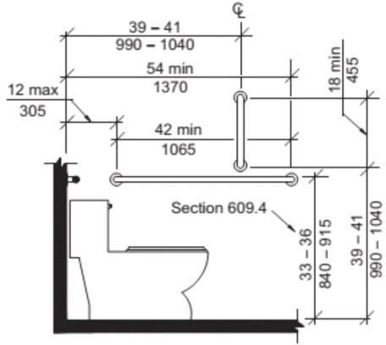

PHOTOGRAPH(S) OF THIS LOCATION

 | ID:  2149 | Facility:  Borah Pool House

Location: Men’s Locker Room
Schedule: 2022
Estimated Cost: $1,000.00

Priority Score 5
Quick Fix: No
Built before ADA: Yes

VIOLATIONS
2010 ADA Standards for Accessible Design Codes: §604.5.2
The rear grab bar is located 4.5" from the side wall.

RECOMMENDATIONS
Replace the rear grab bar with one that is a minimum of 36" long minimum and extends from the centerline of the water closet 12" minimum on one side and 24" minimum on the other.

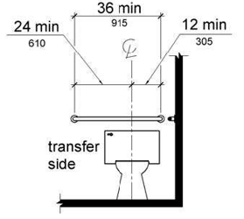

PHOTOGRAPH(S) OF THIS LOCATION

 | ID:  2153 | Facility:  Borah Pool House

Location: Men’s Locker Room
Schedule: 2022
Estimated Cost: $1,000.00

Priority Score 5
Quick Fix: No
Built before ADA: Yes

VIOLATIONS
2010 ADA Standards for Accessible Design Codes: ICC A117.1 §604.5.1
The accessible water closet does not have a vertical grab bar.

RECOMMENDATIONS
Install an 18" long (minimum) vertical grab bar, mounted with the bottom located at 39" minimum and 41" maximum above the floor.
The centerline of the vertical grab bar shall be located 39" minimum and 41" maximum from the rear wall.

PHOTOGRAPH(S) OF THIS LOCATION

 | ID:  2146 | Facility:  Borah Pool House

Location: Men’s Locker Room
Schedule: 2021
Estimated Cost: $2,500.00

Priority Score 3
Quick Fix: No
Built before ADA: Yes

VIOLATIONS
2010 ADA Standards for Accessible Design Codes: §404.2.4.4, §404.2.4.1
The maneuvering clearance outside the men's locker room door has a 5.2% slope.

RECOMMENDATIONS
Reconstruct the entryway to reduce the running slope to a maximum of 2% in all directions for 60" perpendicular to the doorway.

PHOTOGRAPH(S) OF THIS LOCATION

 | ID:  2158 | Facility:  Borah Pool House

Location: Men’s Locker Room
Schedule: 2021
Estimated Cost: $10,000.00

Priority Score 3
Quick Fix: No
Built before ADA: Yes

VIOLATIONS
2010 ADA Standards for Accessible Design Codes: §213.3.6
There is not an accessible shower provided in the men's locker room.

RECOMMENDATIONS
Install at least one accessible transfer or roll-in shower, complying with § 608 as shown in the Locker Room Showers section of this report.
Ensure appropriate seating, handrails, and shower hardware are provided.

PHOTOGRAPH(S) OF THIS LOCATION

 | ID:  2167 | Facility:  Borah Pool House

Location: Office
Schedule: 2023
Estimated Cost: $100.00

Priority Score 8
Quick Fix: Yes
Built before ADA: Yes

VIOLATIONS
2010 ADA Standards for Accessible Design Codes: §308.2.1
The microwave is outside of the unobstructed forward reach range at 53" above the floor.

RECOMMENDATIONS
Lower the microwave by 5" to meet the accessible reach range of 15" minimum and 48" maximum above the floor.

PHOTOGRAPH(S) OF THIS LOCATION

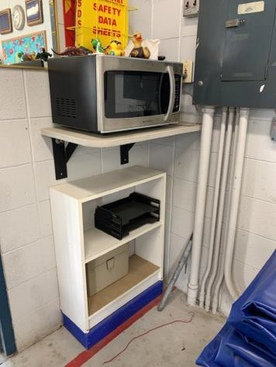

 | ID: | Facility:  Borah Pool House

Location: Office
Schedule: 2022
Estimated Cost: $100.00

Priority Score 5
Quick Fix: Yes
Built before ADA: Yes

VIOLATIONS
2010 ADA Standards for Accessible Design Codes: §305.3
There is not adequate clear floor space to access the microwave.

RECOMMENDATIONS
Relocate the microwave so that there is a minimum clear floor space of 30"x48".
This can be achieved by moving the mats.

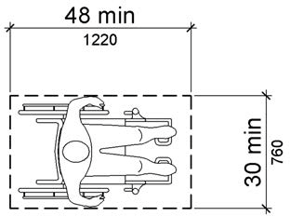

PHOTOGRAPH(S) OF THIS LOCATION

 | ID:  2170 | Facility:  Borah Pool House

Location: Office
Schedule: 2022
Estimated Cost: $100.00

Priority Score 7
Quick Fix: Yes
Built before ADA: Yes

VIOLATIONS
2010 ADA Standards for Accessible Design Codes: §603.3
The mirror is too high to be accessible at 53" above the floor.

RECOMMENDATIONS
Lower the mirror its bottom edge is a maximum height of 40" above the floor.

PHOTOGRAPH(S) OF THIS LOCATION

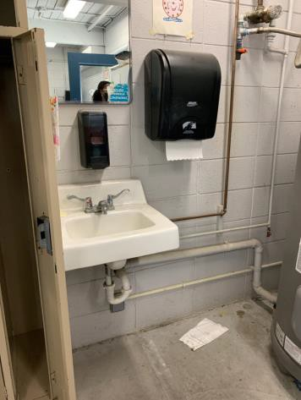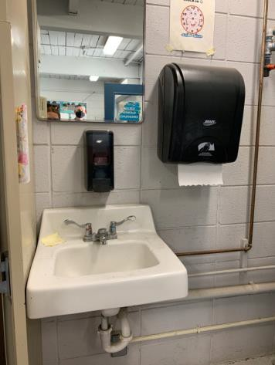

 | ID:  2171 | Facility:  Borah Pool House

Location: Office
Schedule: 2022
Estimated Cost: $100.00

Priority Score 7
Quick Fix: Yes
Built before ADA: Yes

VIOLATIONS
2010 ADA Standards for Accessible Design Codes: §606.5
The pipes under the sink are not covered.

RECOMMENDATIONS
Wrap the pipes beneath the sink with soft protective wrap or plastic.

PHOTOGRAPH(S) OF THIS LOCATION

 | ID:  2403 | Facility:  Borah Pool House

Location: Parking
Schedule: 2021
Estimated Cost: $1,000.00

Priority Score 3
Quick Fix: No
Built before ADA: Yes

VIOLATIONS
2010 ADA Standards for Accessible Design Codes: §502.4
The top of the parking space has a 3.2% slope.

RECOMMENDATIONS
Resurface the parking space to reduce the slope to a maximum of 2% in all directions.

PHOTOGRAPH(S) OF THIS LOCATION

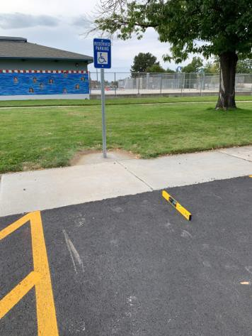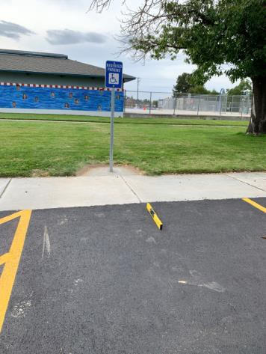

 | ID:  2404 | Facility:  Borah Pool House

Location: Parking
Schedule: 2021
Estimated Cost: $1,000.00

Priority Score 3
Quick Fix: No
Built before ADA: Yes

VIOLATIONS
2010 ADA Standards for Accessible Design Codes: §502.4
The top of the parking space has a 4.7% slope.

RECOMMENDATIONS
Resurface the parking space to reduce the slope to a maximum of 2% in all directions.

PHOTOGRAPH(S) OF THIS LOCATION

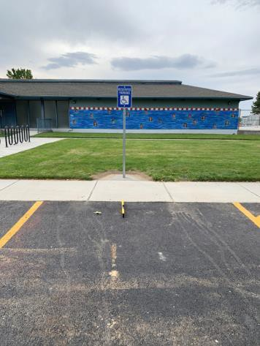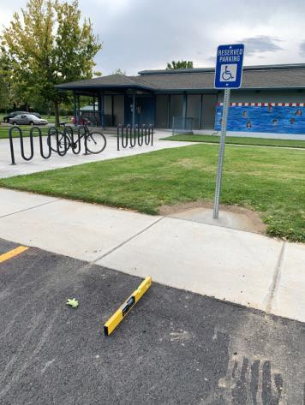

 | ID:  2407 | Facility:  Borah Pool House

Location: Picnic Table and Garbage Can
Schedule: 2022
Estimated Cost: $10,000.00

Priority Score 7
Quick Fix: No
Built before ADA: Yes

VIOLATIONS
2010 ADA Standards for Accessible Design Codes: §302.1, §305, §902.4
The picnic table is not compliant because there is no wheelchair seating available. There is not a firm, stable, and slip resistant route to the picnic table and garbage can.

RECOMMENDATIONS
Install a new accessible picnic table at a minimum height of 28" and maximum of 34". Provide knee clearance that is a minimum of 11" deep at 9" above the floor and 8" deep.
Construct a firm, stable, and slip resistant accessible route from the nearby sidewalk to the newly placed accessible table with a maximum cross slope of 2% and maximum running slope of 5%.

PHOTOGRAPH(S) OF THIS LOCATION

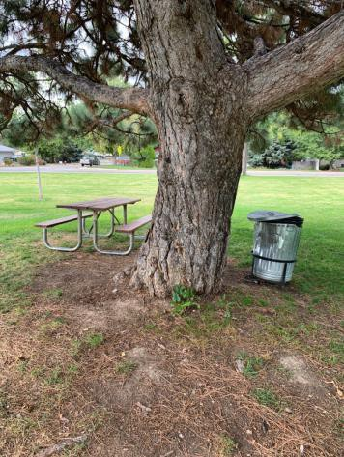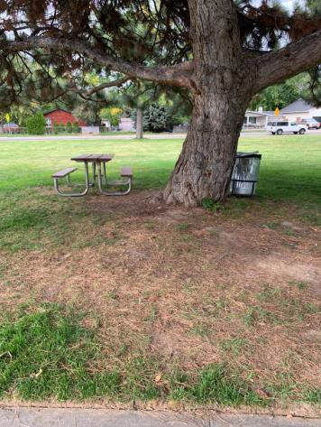

 | ID:  2136 | Facility:  Borah Pool House

Location: Picnic Tables
Schedule: 2021
Estimated Cost: $1,000.00

Priority Score 3
Quick Fix: No
Built before ADA: Yes

VIOLATIONS
2010 ADA Standards for Accessible Design Codes: §226.1, §902, §305, §306
The provided picnic table does not have an accessible clear space for a wheelchair user.

RECOMMENDATIONS
Add one or replace picnic tables so that at least 5% of the seating is wheelchair accessible.
Ensure that the wheelchair accessible seating has a clear floor space of 30" x 48" with a slope not steeper than 2% and that the tables have sufficient knee and toe clearance.

PHOTOGRAPH(S) OF THIS LOCATION

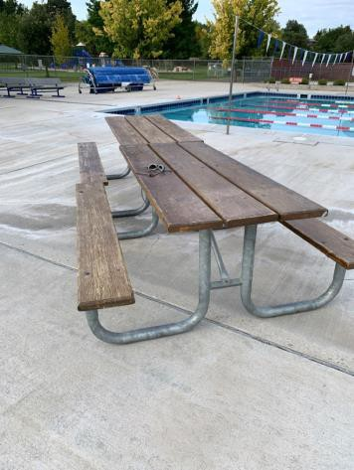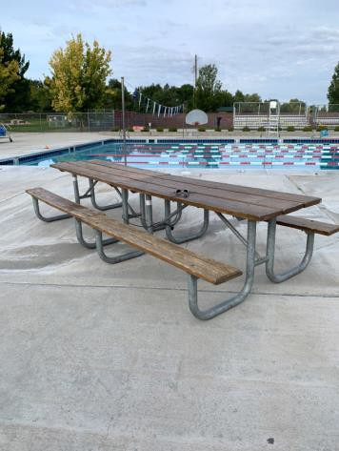

 | ID:  2144 | Facility:  Borah Pool House

Location: Pool Deck
Schedule: 2023
Estimated Cost: $100.00

Priority Score 10
Quick Fix: Yes
Built before ADA: Yes

VIOLATIONS
2010 ADA Standards for Accessible Design Codes: §602, §307.2
The higher drinking fountain protrudes 17" into the circulation path.

RECOMMENDATIONS
Place a drinking fountain skirt at this location to provide cane detectability.

PHOTOGRAPH(S) OF THIS LOCATION

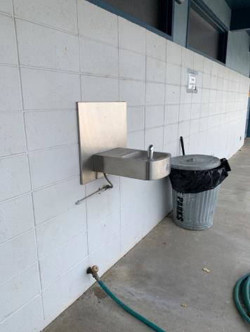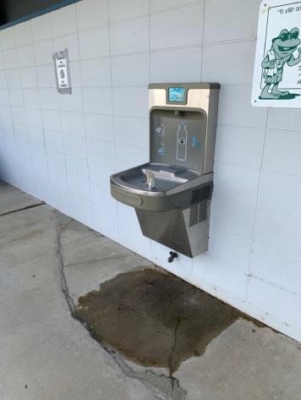

 | ID:  2145 | Facility:  Borah Pool House

Location: Pool Deck Sunscreen Dispenser
Schedule: 2023
Estimated Cost: $100.00

Priority Score 8
Quick Fix: Yes
Built before ADA: Yes

VIOLATIONS
2010 ADA Standards for Accessible Design Codes: §308.2.1
The sunscreen dispenser is outside of the unobstructed forward reach range at 49" above the floor.

RECOMMENDATIONS
Lower the sunscreen dispenser by 1" to meet the accessible reach range of 15" minimum and 48" maximum above the floor.

PHOTOGRAPH(S) OF THIS LOCATION

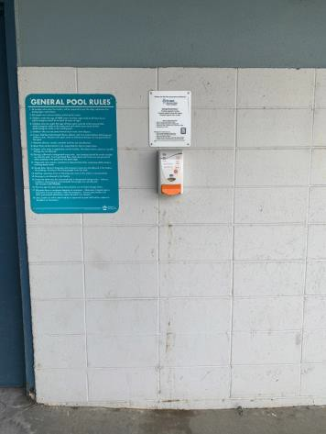

 | ID: | Facility:  Borah Pool House

Location: Pool Lift
Schedule: 2021
Estimated Cost: $500.00

Priority Score 3
Quick Fix: Yes
Built before ADA: Yes

VIOLATIONS
2010 ADA Standards for Accessible Design Codes: §1009.2.4
When installed, the pool lift seat is 14" above the pool deck.

RECOMMENDATIONS
Raise the height of the pool lift to be a minimum of 16" to a maximum of 19" above the pool deck.

PHOTOGRAPH(S) OF THIS LOCATION

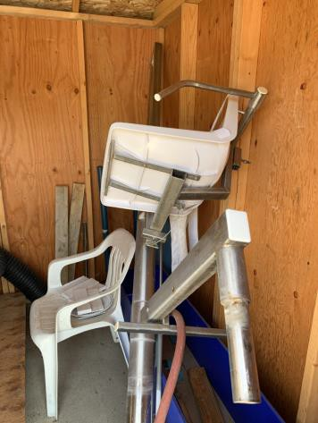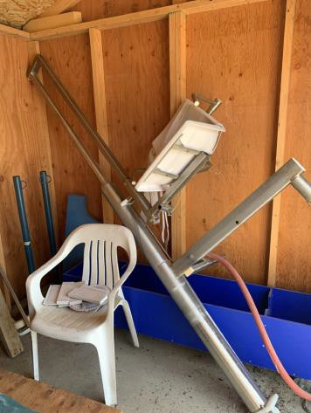

 | ID:  2405 | Facility:  Borah Pool House

Location: Splash Pad Ramp
Schedule: 2022
Estimated Cost: $1,000.00

Priority Score 6
Quick Fix: No
Built before ADA: Yes

VIOLATIONS
2010 ADA Standards for Accessible Design Codes: §505.2
Handrails are only on one side of the ramp.

RECOMMENDATIONS
Install handrails at a minimum height of 34” and maximum of 38” above the ground. Make sure there are adequate handrail extensions both at the top and bottom of the handrail.

PHOTOGRAPH(S) OF THIS LOCATION

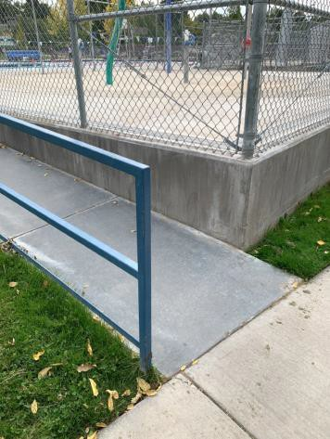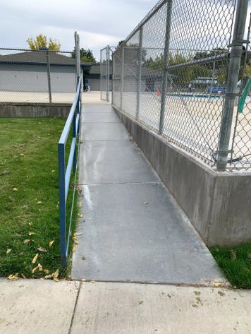

 | ID:  2406 | Facility:  Borah Pool House

Location: Splash Pad Ramp
Schedule: 2022
Estimated Cost: $1,000.00

Priority Score 5
Quick Fix: No
Built before ADA: Yes

VIOLATIONS
2010 ADA Standards for Accessible Design Codes: §505.10
There are no handrail extensions for the ramp.

RECOMMENDATIONS
Extend the ramp handrails 12” horizontally beyond the top and bottom of ramp runs.

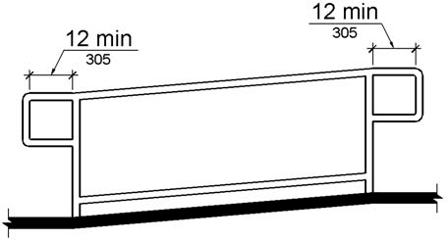

PHOTOGRAPH(S) OF THIS LOCATION

 | ID:  1904 | Facility:  Borah Pool House

Location: Women’s Exterior Restrooms
Schedule: 2022
Estimated Cost: $100.00

Priority Score 7
Quick Fix: Yes
Built before ADA: Yes

VIOLATIONS
2010 ADA Standards for Accessible Design Codes: §606.5
The pipes under the sink are not covered.

RECOMMENDATIONS
Wrap the pipes beneath the sink with soft protective wrap or plastic.

PHOTOGRAPH(S) OF THIS LOCATION

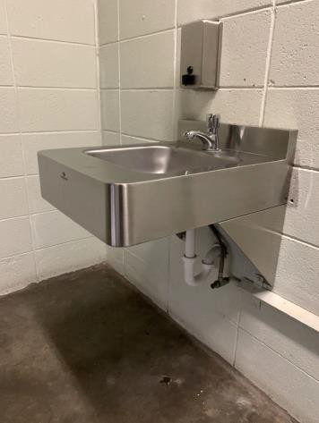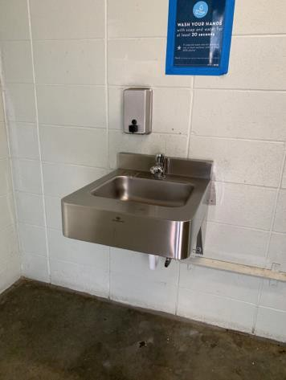

 | ID:  1907 | Facility:  Borah Pool House

Location: Women’s Exterior Restrooms
Schedule: 2022
Estimated Cost: $100.00

Priority Score 7
Quick Fix: Yes
Built before ADA: Yes

VIOLATIONS
2010 ADA Standards for Accessible Design Codes: §606.5
The pipes under the sink are not covered.

RECOMMENDATIONS
Wrap the pipes beneath the sink with soft protective wrap or plastic.

PHOTOGRAPH(S) OF THIS LOCATION

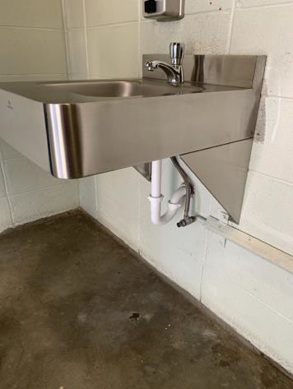

 | ID:  1906 | Facility:  Borah Pool House

Location: Women’s Exterior Restrooms
Schedule: 2021
Estimated Cost: $200.00

Priority Score 3
Quick Fix: Yes
Built before ADA: Yes

VIOLATIONS
2010 ADA Standards for Accessible Design Codes: §308.2.1
The exit button is outside of the unobstructed forward reach range at 50" above the floor.

RECOMMENDATIONS
Lower the exit button by 2" to meet the accessible reach range of 15" minimum and 48" maximum above the floor.

PHOTOGRAPH(S) OF THIS LOCATION

 | ID:  1903 | Facility:  Borah Pool House

Location: Women’s Exterior Restrooms
Schedule: 2022
Estimated Cost: $500.00

Priority Score 5
Quick Fix: Yes
Built before ADA: Yes

VIOLATIONS
2010 ADA Standards for Accessible Design Codes: §307.2
The sink protrudes 11" into the circulation space at 33" above the floor.

RECOMMENDATIONS
Recess the sink so it protrudes a maximum of 4", lower it so the bottom edge is 27" maximum above the floor, or extend the skirt underneath the sink to provide additional detectability.

PHOTOGRAPH(S) OF THIS LOCATION

 | ID:  1905 | Facility:  Borah Pool House

Location: Women’s Exterior Restrooms
Schedule: 2022
Estimated Cost: $1,000.00

Priority Score 5
Quick Fix: No
Built before ADA: Yes

VIOLATIONS
2010 ADA Standards for Accessible Design Codes: §604.2
The toilet is located 18.5" from the sidewall.

RECOMMENDATIONS
Reposition the toilet to be within 16" minimum and 18" maximum from the sidewall.

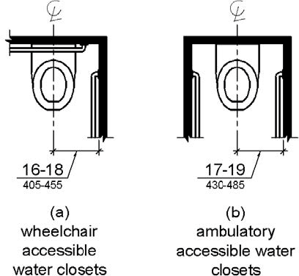

PHOTOGRAPH(S) OF THIS LOCATION

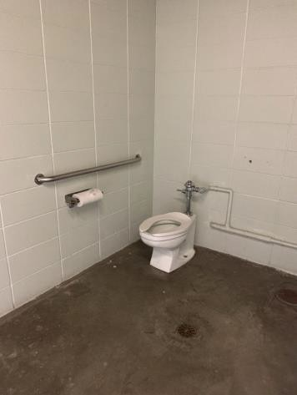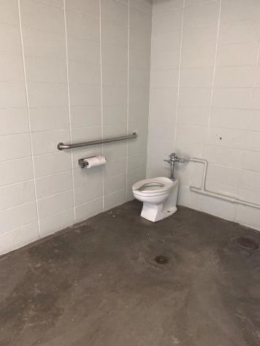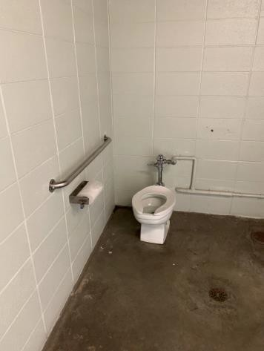

 | ID:  1909 | Facility:  Borah Pool House

Location: Women’s Exterior Restrooms
Schedule: 2022
Estimated Cost: $1,000.00

Priority Score 5
Quick Fix: No
Built before ADA: Yes

VIOLATIONS
2010 ADA Standards for Accessible Design Codes: §604.6
The flush control is located on the wall side of the toilet.

RECOMMENDATIONS
Either make the toilet flush automatically or relocate the flush control to be operated on the open side of the toilet.

PHOTOGRAPH(S) OF THIS LOCATION

 | ID:  1911 | Facility:  Borah Pool House

Location: Women’s Exterior Restrooms
Schedule: 2022
Estimated Cost: $1,000.00

Priority Score 5
Quick Fix: No
Built before ADA: Yes

VIOLATIONS
2010 ADA Standards for Accessible Design Codes: ICC A117.1 §604.5.1
The accessible water closet does not have vertical and rear grab bars.

RECOMMENDATIONS
Install an 18" long (minimum) vertical grab bar, mounted with the bottom located at 39" minimum and 41" maximum above the floor.
The centerline of the vertical grab bar shall be located 39" minimum and 41" maximum from the rear wall.

PHOTOGRAPH(S) OF THIS LOCATION

 | ID:  4469 | Facility:  Borah Pool House

Location: Women’s Exterior Restrooms
Schedule: 2022
Estimated Cost: $1,000.00

Priority Score 5
Quick Fix: No
Built before ADA: Yes

VIOLATIONS
2010 ADA Standards for Accessible Design Codes: §604.5.2
There is no rear grab bar in the women's exterior restroom.

RECOMMENDATIONS
Install a rear grab bar that is a minimum of 36" long minimum and extends from the centerline of the water closet 12" minimum on one side and 24" minimum on the other.

PHOTOGRAPH(S) OF THIS LOCATION

 | ID:  1910 | Facility:  Borah Pool House

Location: Women’s Exterior Restrooms
Schedule: 2022
Estimated Cost: $5,000.00

Priority Score 5
Quick Fix: No
Built before ADA: Yes

VIOLATIONS
2010 ADA Standards for Accessible Design Codes: §604.5.1
The side grab bar is located 10.5" from the rear wall.

RECOMMENDATIONS
Remount the side grab bar 12" maximum from the rear wall and extending 54" minimum from the rear wall.

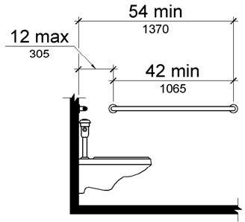

PHOTOGRAPH(S) OF THIS LOCATION

 | ID:  2129 | Facility:  Borah Pool House

Location: Women’s Locker Room
Schedule: 2023
Estimated Cost: $100.00

Priority Score 8
Quick Fix: Yes
Built before ADA: Yes

VIOLATIONS
2010 ADA Standards for Accessible Design Codes: §308.2.1
The hook is outside of the unobstructed forward reach range at 63" above the floor.

RECOMMENDATIONS
Lower at least one hook by 15" to meet the accessible reach range of 15" minimum and 48" maximum above the floor.

PHOTOGRAPH(S) OF THIS LOCATION

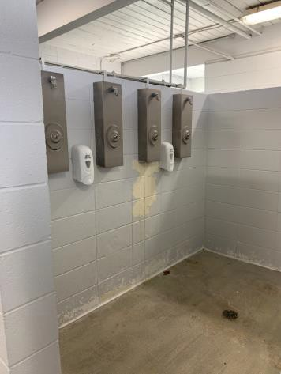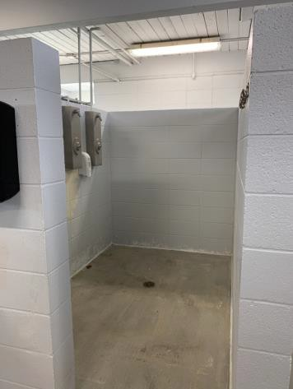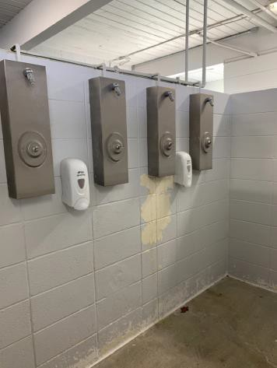

 | ID:  2131 | Facility:  Borah Pool House

Location: Women’s Locker Room
Schedule: 2022
Estimated Cost: $100.00

Priority Score 7
Quick Fix: Yes
Built before ADA: Yes

VIOLATIONS
2010 ADA Standards for Accessible Design Codes: §603.3
The mirror is too high to be accessible at 42.5" above the floor.

RECOMMENDATIONS
Lower the mirror its bottom edge is a maximum height of 40" above the floor.

PHOTOGRAPH(S) OF THIS LOCATION

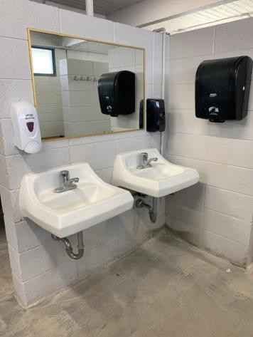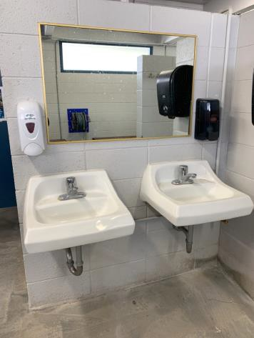

 | ID:  2132 | Facility:  Borah Pool House

Location: Women’s Locker Room
Schedule: 2022
Estimated Cost: $100.00

Priority Score 5
Quick Fix: Yes
Built before ADA: Yes

VIOLATIONS
2010 ADA Standards for Accessible Design Codes: §307.2
The paper towel dispenser protrudes 8" into the circulation space at 46.5" above the floor.

RECOMMENDATIONS
Recess the paper towel dispenser so it protrudes a maximum of 4", lower it so the bottom edge is 27" maximum above the floor, or place a cane detectable object beneath it.

PHOTOGRAPH(S) OF THIS LOCATION

 | ID:  2135 | Facility:  Borah Pool House

Location:
Schedule:
Estimated Cost:

Priority Score 3
Quick Fix: Yes
Built before ADA: Yes

VIOLATIONS
2010 ADA Standards for Accessible Design Codes: §216.2, §703
There is no tactile sign identifying the permanent room.

RECOMMENDATIONS
Install tactile signage on the latch side of the doorway at a height of 48” minimum to 60” maximum above the floor, identifying room by name or room number.
Signs shall be Braille with raised lettering and should be placed on the wall in the center of an 18"x18" clear floor space.

PHOTOGRAPH(S) OF THIS LOCATION

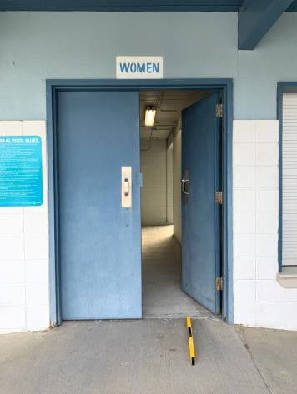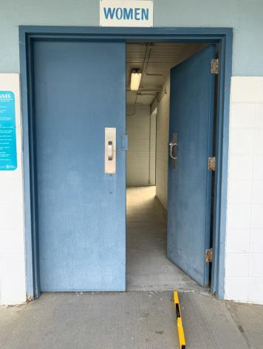

 | ID:  2130 | Facility:  Borah Pool House

Location: Women’s Locker Room
Schedule: 2022
Estimated Cost: $200.00

Priority Score 7
Quick Fix: Yes
Built before ADA: Yes

VIOLATIONS
2010 ADA Standards for Accessible Design Codes: §606.5
The pipes under the sinks are not covered.

RECOMMENDATIONS
Wrap the pipes beneath the sinks with soft protective wrap or plastic.

PHOTOGRAPH(S) OF THIS LOCATION

 | ID:  2121 | Facility:  Borah Pool House

Location: Women’s Locker Room
Schedule: 2022
Estimated Cost: $500.00

Priority Score 5
Quick Fix: Yes
Built before ADA: Yes

VIOLATIONS
2010 ADA Standards for Accessible Design Codes: §604.5.1
The side grab bar is located 10.5" from the rear wall.

RECOMMENDATIONS
Remount the side grab bar 12" maximum from the rear wall and extending 54" minimum from the rear wall.

PHOTOGRAPH(S) OF THIS LOCATION

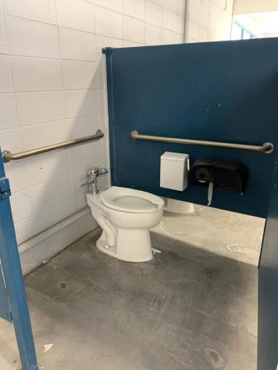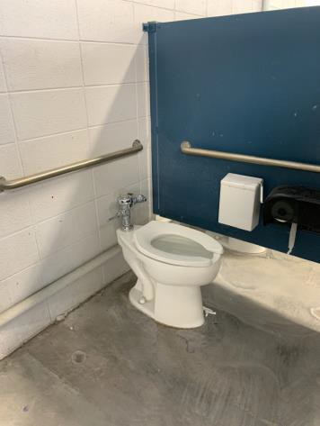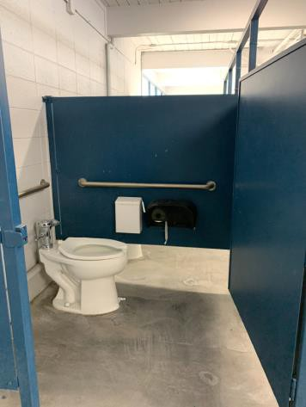

 | ID:  2133 | Facility:  Borah Pool House

Location: Women’s Locker Room
Schedule: 2022
Estimated Cost: $500.00

Priority Score 5
Quick Fix: Yes
Built before ADA: Yes

VIOLATIONS
2010 ADA Standards for Accessible Design Codes: §903.3
The benches in the women's locker room are 14" deep.

RECOMMENDATIONS
Install one new bench that is at least 42" long and 20" to 24" inches deep. The accessible bench shall have a back support or be affixed to a wall.

PHOTOGRAPH(S) OF THIS LOCATION

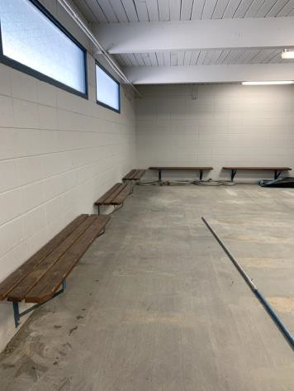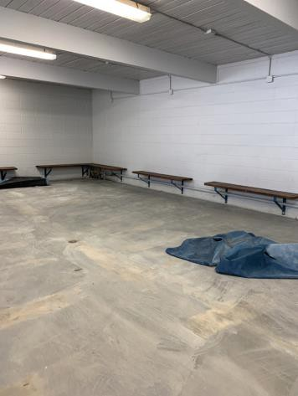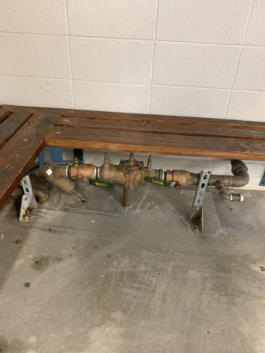

 | ID:  4467 | Facility:  Borah Pool House

Location: Women’s Locker Room
Schedule: 2022
Estimated Cost: $500.00

Priority Score 5
Quick Fix: Yes
Built before ADA: Yes

VIOLATIONS
2010 ADA Standards for Accessible Design Codes: §604.8.1.2
The door to the accessible water closet is not self closing. Either self-closing hinges are not installed on the door or if installed, they are defective.

RECOMMENDATIONS
Install or reinstall self-closing hinges on the door to ensure that the door is self-closing per the ADA requirements.

PHOTOGRAPH(S) OF THIS LOCATION

 | ID: | Facility:  Borah Pool House

Location: Women’s Locker Room
Schedule: 2022
Estimated Cost: $1,000.00

Priority Score 5
Quick Fix: No
Built before ADA: Yes

VIOLATIONS
2010 ADA Standards for Accessible Design Codes: ICC A117.1 §604.5.1
The accessible water closet does not have a vertical grab bar.

RECOMMENDATIONS
Install an 18" long (minimum) vertical grab bar, mounted with the bottom located at 39" minimum and 41" maximum above the floor.
The centerline of the vertical grab bar shall be located 39" minimum and 41" maximum from the rear wall.

PHOTOGRAPH(S) OF THIS LOCATION

 | ID:  2134 | Facility:  Borah Pool House

Location: Women’s Locker Room
Schedule: 2021
Estimated Cost: $1,000.00

Priority Score 3
Quick Fix: No
Built before ADA: Yes

VIOLATIONS
2010 ADA Standards for Accessible Design Codes: §404.2.4.4
The maneuvering clearance outside the women's locker room door has a 6.5% slope.

RECOMMENDATIONS
Reconstruct the entryway to reduce the running slope to a maximum of 2% in all directions for 60" perpendicular to the door.

PHOTOGRAPH(S) OF THIS LOCATION

 | ID:  2124 | Facility:  Borah Pool House

Location: Women’s Locker Room
Schedule: 2022
Estimated Cost: $10,000.00

Priority Score 6
Quick Fix: No
Built before ADA: Yes

VIOLATIONS
2010 ADA Standards for Accessible Design Codes: §213.3.6
There is not an accessible shower provided.

RECOMMENDATIONS
Install at least one accessible transfer or roll-in shower, complying with §608 as shown in the Locker Room Showers section of this report.
Ensure appropriate seating, handrails, and shower hardware are provided.

PHOTOGRAPH(S) OF THIS LOCATION

