City of Boise ADA Assessment

Appendix A –Library! At Hillcrest

2/19/2021
Report #TO21-B017

Prepared by:
 | ID:  2613 | Facility:  Hillcrest Library

Location: Book Return
Schedule: 2021
Estimated Cost: $100.00

Priority Score 8
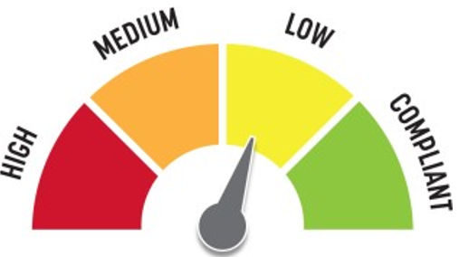
Quick Fix: Yes
Built before ADA: Unknown

VIOLATIONS
2010 ADA Standards for Accessible Design Codes §308.2.1
The book return is outside of the unobstructed forward reach range at 50" above the floor.

RECOMMENDATIONS
Lower the book return by 2" to meet the accessible reach range of 15" minimum and 48" maximum above the floor.
Or add a secondary lower book drop at the same location.

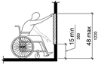

PHOTOGRAPH(S) OF THIS LOCATION

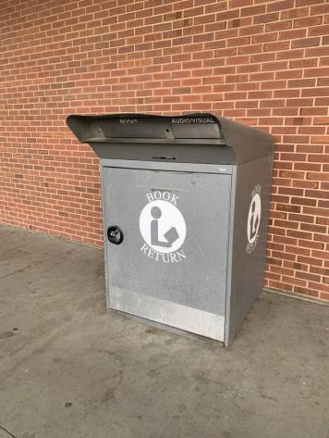

 | ID:  2666 | Facility:  Hillcrest Library

Location: Drinking Fountains
Schedule: 2022
Estimated Cost: $1,000.00

Priority Score 6
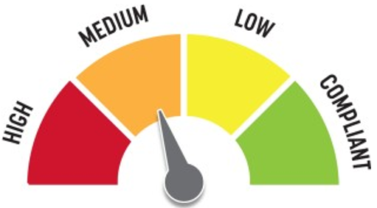
Quick Fix: No
Built before ADA: Unknown

VIOLATIONS
2010 ADA Standards for Accessible Design Codes §602.7

The spout heights of the drinking fountains are not compliant at 31

RECOMMENDATIONS
Raise the existing tall drinking fountain to a minimum spout height of 38" and maximum spout height of 43" above the floor.

PHOTOGRAPH(S) OF THIS LOCATION

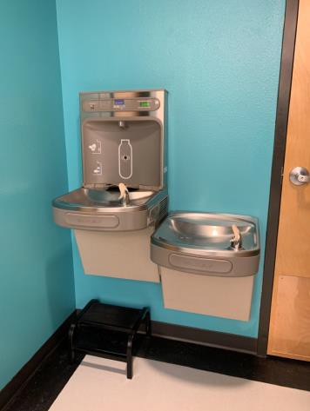

 | ID:  2639 | Facility:  Hillcrest Library

Location: Entire Facility
Schedule: 2021
Estimated Cost: $1,700.00

Priority Score 3
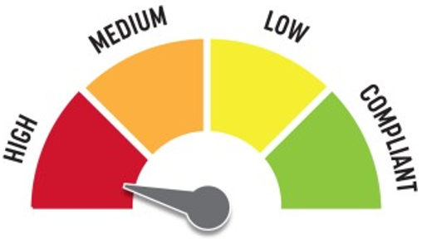
Quick Fix: Yes
Built before ADA: Unknown

VIOLATIONS
2010 ADA Standards for Accessible Design Codes §216.2, §703
There are no tactile signs identifying 17 permanent room.

RECOMMENDATIONS
Install tactile signage on the latch side of the doorway at a height of 48” minimum to 60” maximum above the floor, identifying room by name or room number.
Signs shall be Braille with raised lettering and should be placed on the wall in the center of an 18"x18" clear floor space.

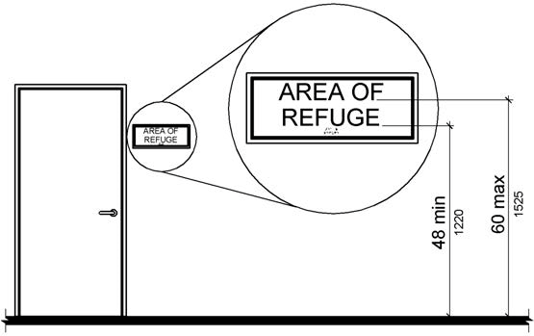

PHOTOGRAPH(S) OF THIS LOCATION

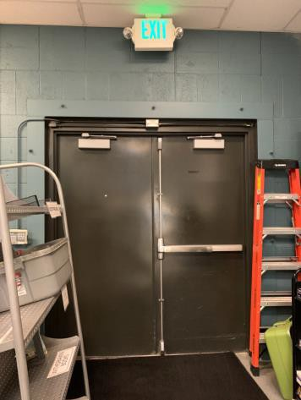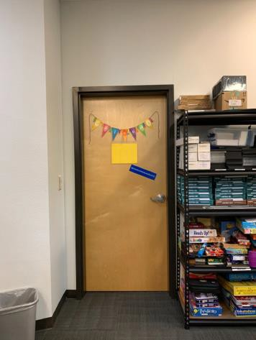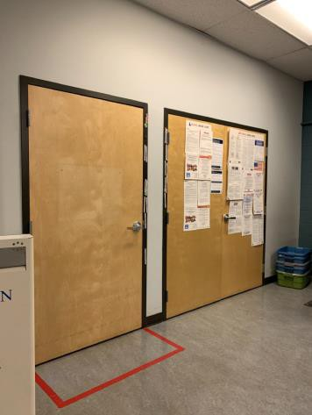

 | ID:  2634 | Facility:  Hillcrest Library

Location: Family Restroom
Schedule: 2021
Estimated Cost: $100.00

Priority Score 5
Quick Fix: Yes
Built before ADA: Unknown

VIOLATIONS
2010 ADA Standards for Accessible Design Codes §307.2
The sharps container protrudes 4.75" into the circulation space at 41" above the floor.

RECOMMENDATIONS
Recess the sharps container so it protrudes a maximum of 4", lower it so the bottom edge is 27" maximum above the floor, or place a cane detectable object beneath it.

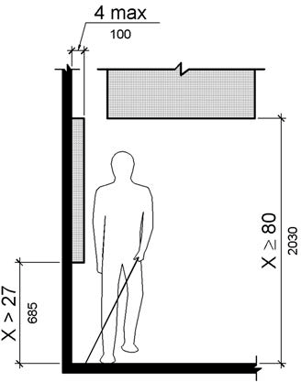

PHOTOGRAPH(S) OF THIS LOCATION

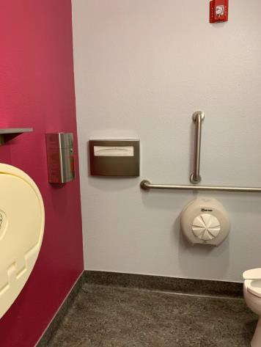

 | ID:  2635 | Facility:  Hillcrest Library

Location: Family Restroom
Schedule: 2021
Estimated Cost: $100.00

Priority Score 8
Quick Fix: Yes
Built before ADA: Unknown

VIOLATIONS
2010 ADA Standards for Accessible Design Codes §308.2.1
The hooks are outside of the unobstructed forward reach range at 62.5" above the floor.

RECOMMENDATIONS
Lower the hooks by 14.5" to meet the accessible reach range of 48" maximum above the floor.
Or install a secondary lower coat hook.

PHOTOGRAPH(S) OF THIS LOCATION

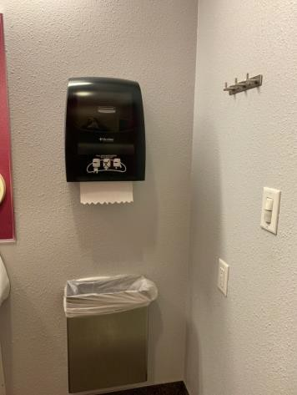

 | ID:  2636 | Facility:  Hillcrest Library

Location: Family Restroom
Schedule: 2021
Estimated Cost: $100.00

Priority Score 8
Quick Fix: Yes
Built before ADA: Unknown

VIOLATIONS
2010 ADA Standards for Accessible Design Codes §308.2.1
The paper towel dispenser is outside of the unobstructed forward reach range at 49.5" above the floor.

RECOMMENDATIONS
Lower the paper towel dispenser by 1.5" to meet the accessible reach range of 15" minimum and 48" maximum above the floor.

PHOTOGRAPH(S) OF THIS LOCATION

 | ID:  2633 | Facility:  Hillcrest Library

Location: Family Restroom
Schedule: 2022
Estimated Cost: $1,000.00

Priority Score 5
Quick Fix: No
Built before ADA: Unknown

VIOLATIONS
2010 ADA Standards for Accessible Design Codes §604.2
The centerline of the toilet is located 19" from the sidewall.

RECOMMENDATIONS
Reposition the centerline of the toilet to be within 16" minimum and 18" maximum from the sidewall.

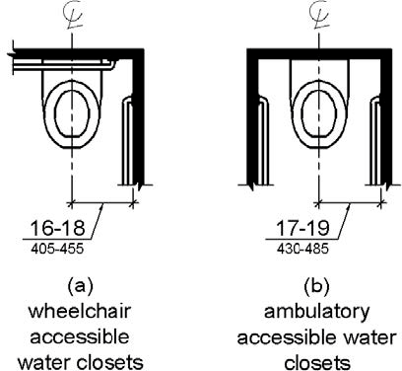

PHOTOGRAPH(S) OF THIS LOCATION

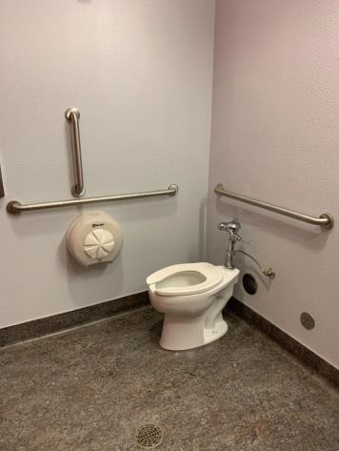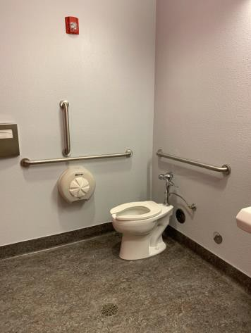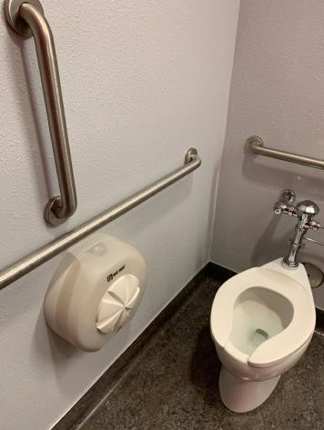

 | ID:  2627 | Facility:  Hillcrest Library

Location: Lemhi Room
Schedule: 2021
Estimated Cost: $0.00

Priority Score 0
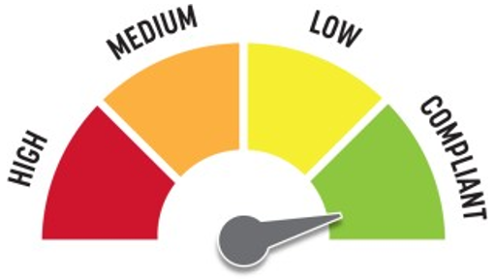
Quick Fix: Yes
Built before ADA: Unknown

VIOLATIONS
2010 ADA Standards for Accessible Design Codes §307.2
The TV protrudes 15" into the circulation space at 65" above the floor.

RECOMMENDATIONS
Ensure the desk remains underneath the TV to provide cane detectability.

PHOTOGRAPH(S) OF THIS LOCATION

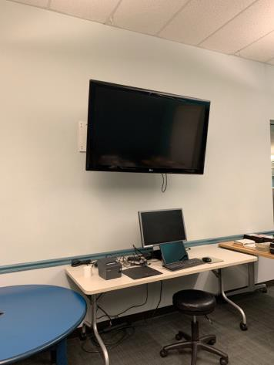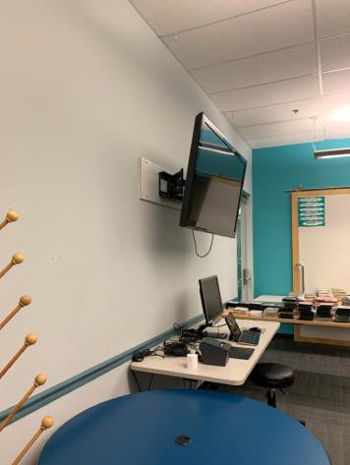

 | ID:  2629 | Facility:  Hillcrest Library

Location: Lemhi Room
Schedule: 2021
Estimated Cost: $100.00

Priority Score 8
Quick Fix: Yes
Built before ADA: Unknown

VIOLATIONS
2010 ADA Standards for Accessible Design Codes §308.2.2
The paper towel dispensers are outside of the obstructed forward reach range at 49.5" above the floor.

RECOMMENDATIONS
Lower the paper towel dispenser by 1.5" to meet the accessible reach range of 15" minimum and 48" maximum above the floor.

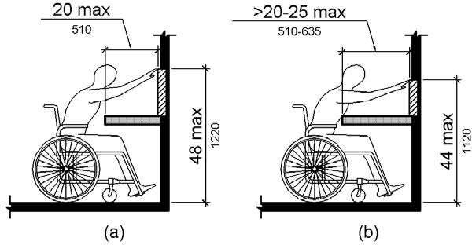

PHOTOGRAPH(S) OF THIS LOCATION

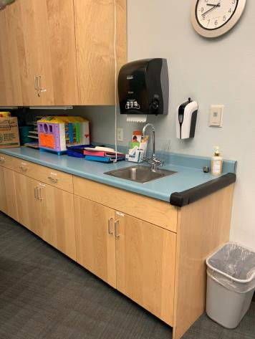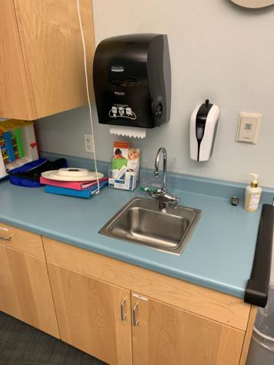

 | ID:  2628 | Facility:  Hillcrest Library

Location: Lemhi Room
Schedule: 2022
Estimated Cost: $1,000.00

Priority Score 5
Quick Fix: No
Built before ADA: Unknown

VIOLATIONS
2010 ADA Standards for Accessible Design Codes §306.3.3
There is no knee clearance underneath the counter.

RECOMMENDATIONS
Provide knee clearance underneath the counter at the sink that is a minimum of 11" deep at 9" above the floor and 8" deep at 27" above the floor.

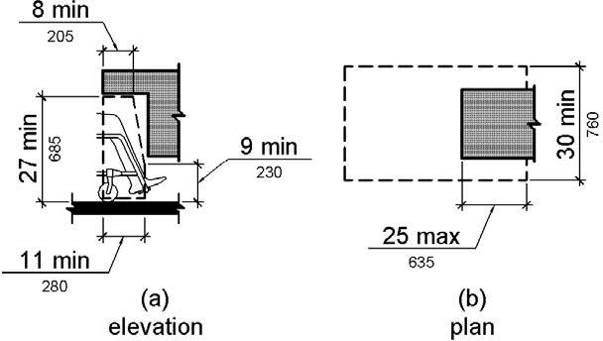

PHOTOGRAPH(S) OF THIS LOCATION

 | ID:  2671 | Facility:  Hillcrest Library

Location: Main Entrance
Schedule: 2021
Estimated Cost: $100.00

Priority Score 5
Quick Fix: Yes
Built before ADA: Unknown

VIOLATIONS
2010 ADA Standards for Accessible Design Codes §307.2
The paper towel dispenser protrudes 9" into the circulation space at 54.5" above the floor.

RECOMMENDATIONS
Recess the paper towel dispenser so it protrudes a maximum of 4", lower it so the bottom edge is 27" maximum above the floor, or place a cane detectable object beneath it.

PHOTOGRAPH(S) OF THIS LOCATION

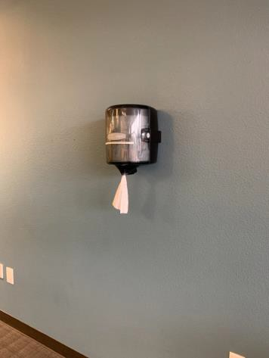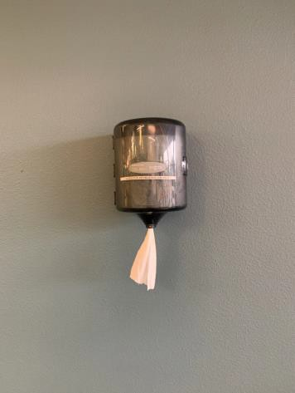

 | ID:  2670 | Facility:  Hillcrest Library

Location: Main Entrance
Schedule: 2023
Estimated Cost: $2,000.00

Priority Score 8
Quick Fix: No
Built before ADA: Unknown

VIOLATIONS
2010 ADA Standards for Accessible Design Codes §306.3.3, §902.3
The work surface counter is 40" above the floor. There is no knee clearance underneath the counter.

RECOMMENDATIONS
Lower the work surface counter to a maximum height of 34” above the floor or provide a lower, accessible computer work station.
Provide knee clearance underneath the counter at the sink that is a minimum of 11" deep at 9" above the floor and 8" deep at 27" above the floor.

PHOTOGRAPH(S) OF THIS LOCATION

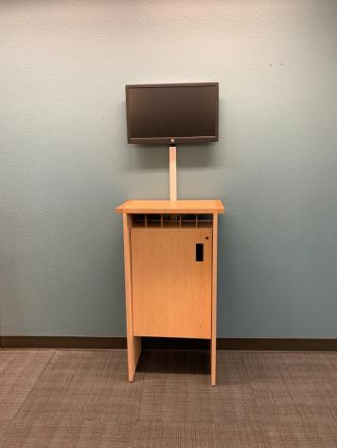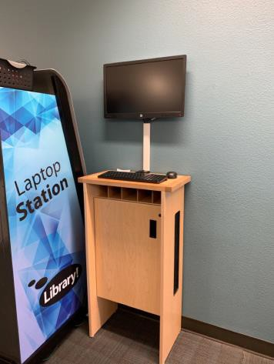

 | ID:  2614 | Facility:  Hillcrest Library

Location: Main Entrance
Schedule: 2023
Estimated Cost: $3,000.00

Priority Score 8
Quick Fix: No
Built before ADA: Unknown

VIOLATIONS
2010 ADA Standards for Accessible Design Codes §308.3.1
The exit push button is blocked by the sensor wall making it difficult to access the push button when going through the security sensors.
At the time of the assessment, the security sensors were not operable.

RECOMMENDATIONS
For the purposes of achieving greater accessibility and Human Centric Design, relocate the exit button to before the security sensors on the accessible route and consider removing or repairing the security sensors.

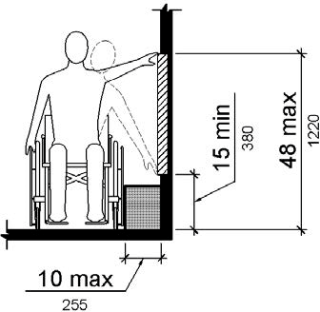

PHOTOGRAPH(S) OF THIS LOCATION

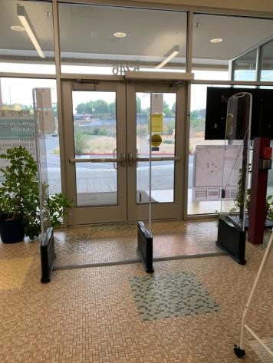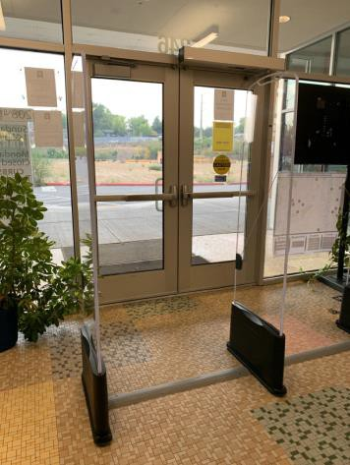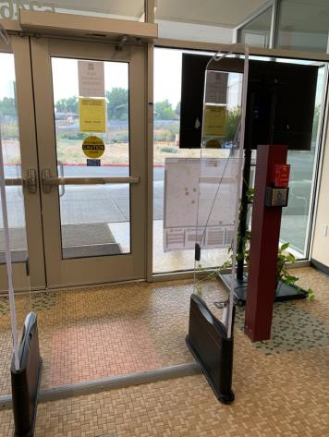

 | ID:  2669 | Facility:  Hillcrest Library

Location: Main Entrance Laptop Station
Schedule: 2023
Estimated Cost: $3,000.00

Priority Score 8
Quick Fix: No
Built before ADA: Unknown

VIOLATIONS
2010 ADA Standards for Accessible Design Codes §707
The interactive touch screen does not have any sound or tactile components. Therefore, a visually impaired person would not be able to access the information provided by the kiosk.

RECOMMENDATIONS
Audio instructions must be provided that guide the user through all the functions of the machine. Tactile instructions must be provided informing the user on the method of activating the audio instructions.
Controls to operate the kiosk must meet the requirements of §707.

PHOTOGRAPH(S) OF THIS LOCATION

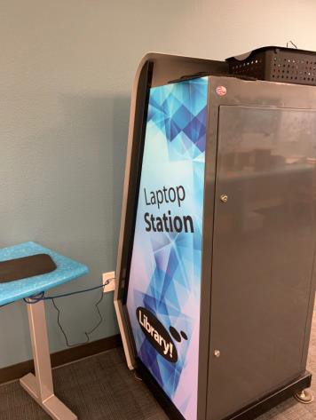

 | ID:  2656 | Facility:  Hillcrest Library

Location: Men’s Restroom
Schedule: 2021
Estimated Cost: $100.00

Priority Score 5
Quick Fix: Yes
Built before ADA: Unknown

VIOLATIONS
2010 ADA Standards for Accessible Design Codes §604.8.1.2
The door to the accessible water closet is not self closing. Either self-closing hinges are not installed on the door or if installed, they are defective.

RECOMMENDATIONS
Install or reinstall self-closing hinges on the door to ensure that the door is self-closing per the ADA requirements.

PHOTOGRAPH(S) OF THIS LOCATION

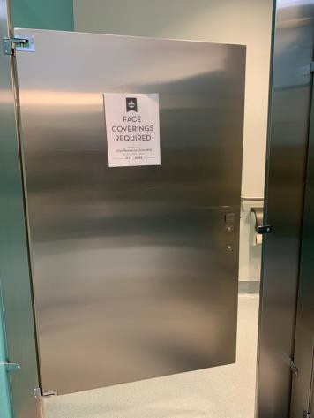

 | ID:  2661 | Facility:  Hillcrest Library

Location: Men’s Restroom
Schedule: 2021
Estimated Cost: $100.00

Priority Score 5
Quick Fix: Yes
Built before ADA: Unknown

VIOLATIONS
2010 ADA Standards for Accessible Design Codes §604.7
The toilet paper dispenser is located out of the accessible reach range at 13" in front of the toilet.

RECOMMENDATIONS
Remount the toilet paper dispenser to 7” minimum and 9” maximum in front of the water closet measured to the centerline of the dispenser.
The outlet of the dispenser shall be 15” minimum and 48” maximum above the floor and shall not be located behind.

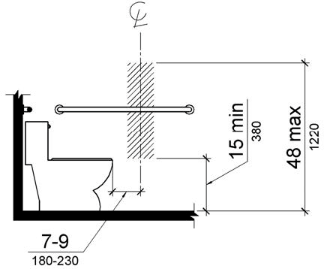

PHOTOGRAPH(S) OF THIS LOCATION

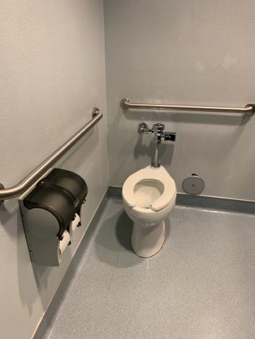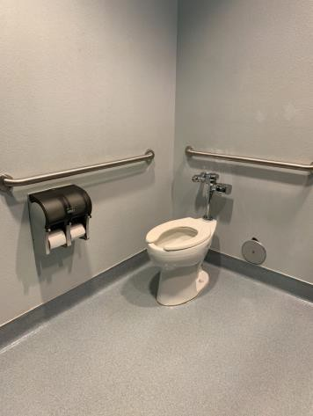

 | ID:  2663 | Facility:  Hillcrest Library

Location: Men’s Restroom
Schedule: 2021
Estimated Cost: $100.00

Priority Score 5
Quick Fix: Yes
Built before ADA: Unknown

VIOLATIONS
2010 ADA Standards for Accessible Design Codes §307.2
The sharps container protrudes 4.75" into the circulation space at 41" above the floor.

RECOMMENDATIONS
Recess the sharps container so it protrudes a maximum of 4", lower it so the bottom edge is 27" maximum above the floor, or place a cane detectable object beneath it.

PHOTOGRAPH(S) OF THIS LOCATION

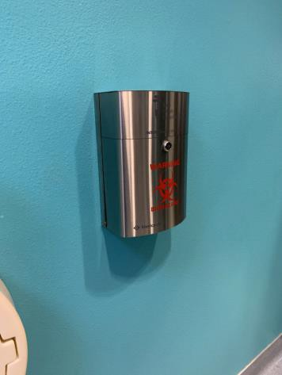

 | ID:  2665 | Facility:  Hillcrest Library

Location: Men’s Restroom
Schedule: 2021
Estimated Cost: $100.00

Priority Score 5
Quick Fix: Yes
Built before ADA: Unknown

VIOLATIONS
2010 ADA Standards for Accessible Design Codes §307.2
The paper towel dispenser protrudes 8.5" into the circulation space at 48" above the floor.

RECOMMENDATIONS
Recess the paper towel dispenser so it protrudes a maximum of 4" or place a cane detectable object beneath it.

PHOTOGRAPH(S) OF THIS LOCATION

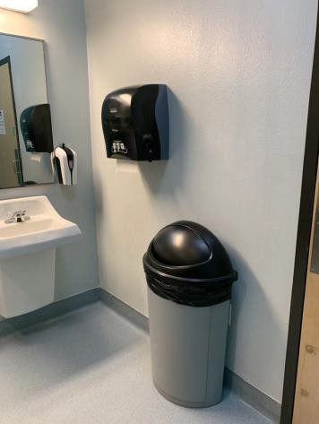

 | ID:  2664 | Facility:  Hillcrest Library

Location: Men’s Restroom
Schedule: 2022
Estimated Cost: $200.00

Priority Score 7
Quick Fix: Yes
Built before ADA: Unknown

VIOLATIONS
2010 ADA Standards for Accessible Design Codes §603.3
The mirrors are too high to be accessible at 41" above the floor.

RECOMMENDATIONS
Lower the mirror its bottom edge is a maximum height of 40" above the floor.

PHOTOGRAPH(S) OF THIS LOCATION

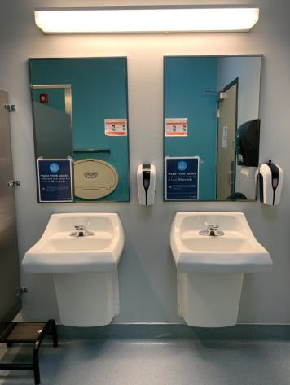

 | ID:  2657 | Facility:  Hillcrest Library

Location: Men’s Restroom
Schedule: 2022
Estimated Cost: $1,000.00

Priority Score 5
Quick Fix: No
Built before ADA: Unknown

VIOLATIONS
2010 ADA Standards for Accessible Design Codes ICC A117.1 §604.5.1
The accessible water closet does not have a vertical grab bar.

RECOMMENDATIONS
Install an 18" long (minimum) vertical grab bar on the side wall. The grab bar shall be mounted with the bottom located at 39" minimum and 41" maximum above the floor.
The centerline of the vertical grab bar shall be located 39" minimum and 41" maximum from the real wall.

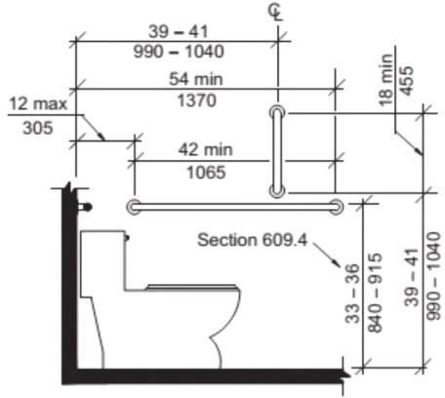

PHOTOGRAPH(S) OF THIS LOCATION

 | ID:  2644 | Facility:  Hillcrest Library

Location: New Book Shelf
Schedule: 2021
Estimated Cost: $100.00

Priority Score 8
Quick Fix: Yes
Built before ADA: Unknown

VIOLATIONS
2010 ADA Standards for Accessible Design Codes §308.2.1
The top shelf is outside of the unobstructed forward reach range at 63" above the floor.

RECOMMENDATIONS
Ensure that the library has a policy that provides assistance to employees and volunteers reaching for shelves that are located beyond 48” above the floor.

PHOTOGRAPH(S) OF THIS LOCATION

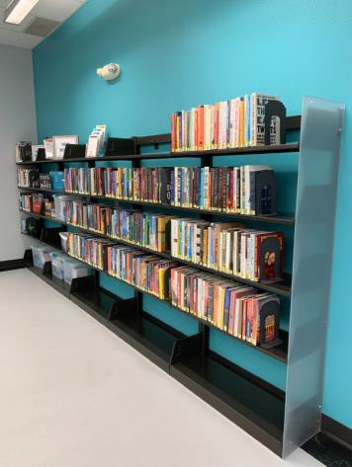

 | ID:  2674 | Facility:  Hillcrest Library

Location: Parking
Schedule: 2021
Estimated Cost: $400.00

Priority Score 9
Quick Fix: Yes
Built before ADA: Unknown

VIOLATIONS
2010 ADA Standards for Accessible Design Codes §502.6
The accessible parking signs are 50" and 48" above the ground. The signs are also crooked.

RECOMMENDATIONS
Remount the accessible parking signs at each accessible space at a minimum height of 60" above the ground.

PHOTOGRAPH(S) OF THIS LOCATION

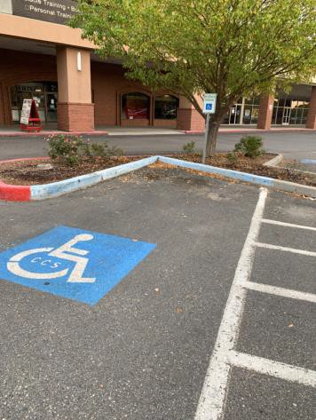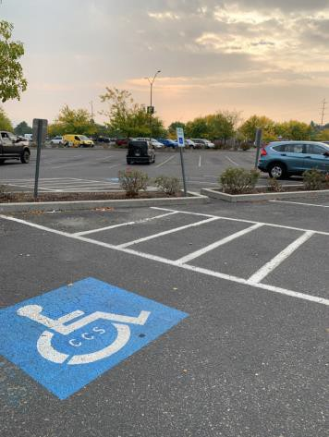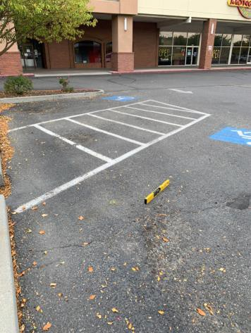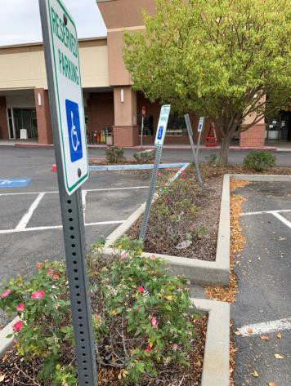

 | ID:  2672 | Facility:  Hillcrest Library

Location: Parking
Schedule: 2021
Estimated Cost: $1,000.00

Priority Score 2
Quick Fix: No
Built before ADA: Unknown

VIOLATIONS
2010 ADA Standards for Accessible Design Codes §208.2.4
There are no marked "Van accessible" spaces.

RECOMMENDATIONS
Add a 132" wide van accessible parking space for every six vehicle parking spaces. Add a “van accessible” parking sign at a minimum height of 60" above the ground.

PHOTOGRAPH(S) OF THIS LOCATION

 | ID:  2609 | Facility:  Hillcrest Library

Location: Parking
Schedule: 2021
Estimated Cost: $3,000.00

Priority Score 3
Quick Fix: No
Built before ADA: Unknown

VIOLATIONS
2010 ADA Standards for Accessible Design Codes §502.4
The parking spaces closest to Camp Rhino Boise have slopes ranging from 2.6% to 5.4%. The access aisle has a 2.7% slope.

RECOMMENDATIONS
Resurface the parking spaces and access aisle to reduce the slope to a maximum of 2% in all directions.

PHOTOGRAPH(S) OF THIS LOCATION

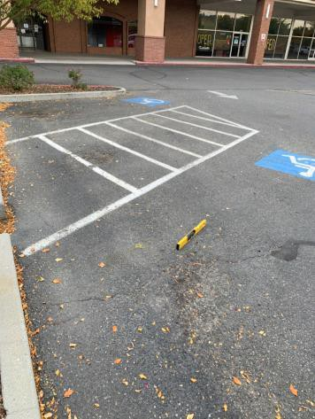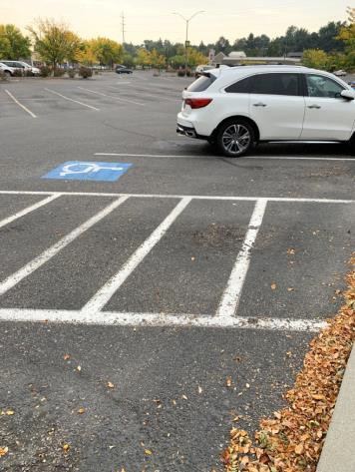
 | ID:  2612 | Facility:  Hillcrest Library

Location: Parking
Schedule: 2021
Estimated Cost: $3,000.00

Priority Score 3
Quick Fix: No
Built before ADA: Unknown

VIOLATIONS
2010 ADA Standards for Accessible Design Codes §502.4
The parking spaces have a 4% to 4.4% slope. The access aisle has a 2.6% slope

RECOMMENDATIONS
Resurface the parking spaces and access aisle to reduce the slope to a maximum of 2% in all directions.

PHOTOGRAPH(S) OF THIS LOCATION

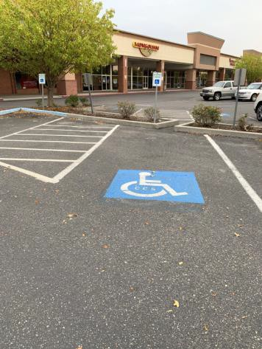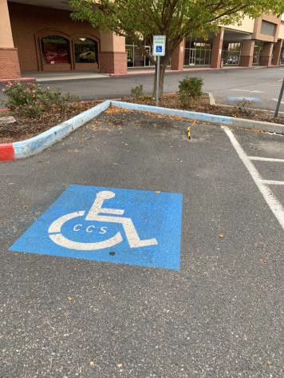

 | ID:  2611 | Facility:  Hillcrest Library

Location: Parking
Schedule: 2022
Estimated Cost: $5,000.00

Priority Score 5
Quick Fix: No
Built before ADA: Unknown

VIOLATIONS
2010 ADA Standards for Accessible Design Codes Advisory §502.3
The accessible route passes behind parked vehicles.

RECOMMENDATIONS
For the purposes of achieving greater accessibility and Human Centric Design, where possible, it is preferable that a sidewalk be constructed in front of the accessible parking spaces.
The sidewalk shall be connected to a marked crosswalk to access the library.

PHOTOGRAPH(S) OF THIS LOCATION

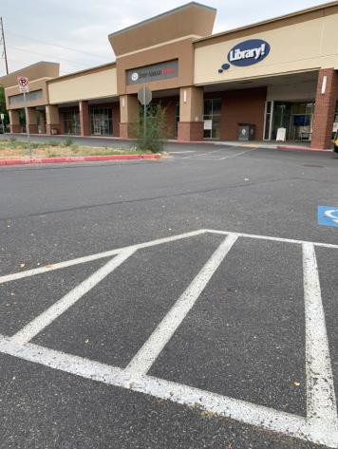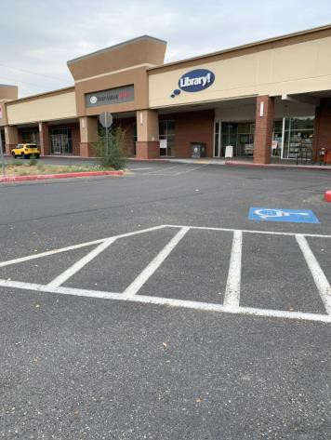

 | ID:  2667 | Facility:  Hillcrest Library

Location: Reference Desk
Schedule: 2021
Estimated Cost: $100.00

Priority Score 5
Quick Fix: Yes
Built before ADA: Unknown

VIOLATIONS
2010 ADA Standards for Accessible Design Codes §307.2
The TV protrudes 7.75" into the circulation space at 59" above the floor.

RECOMMENDATIONS
Recess the TV so it protrudes a maximum of 4", raise it so the bottom edge is 80" maximum above the floor, or place a cane detectable object beneath it.

PHOTOGRAPH(S) OF THIS LOCATION

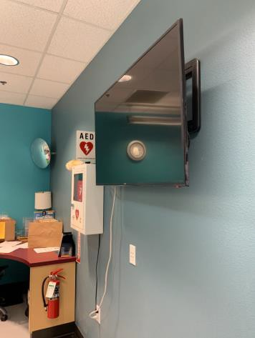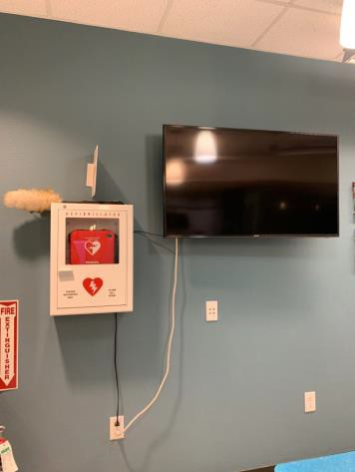

 | ID:  2668 | Facility:  Hillcrest Library

Location: Reference Desk
Schedule: 2021
Estimated Cost: $100.00

Priority Score 5
Quick Fix: Yes
Built before ADA: Unknown

VIOLATIONS
2010 ADA Standards for Accessible Design Codes §307.2
The AED protrudes 6" into the circulation space at 44" above the floor.

RECOMMENDATIONS
Recess the AED so it protrudes a maximum of 4", lower it so the bottom edge is 27" maximum above the floor, or place a cane detectable object beneath it.

PHOTOGRAPH(S) OF THIS LOCATION

 | ID:  2637 | Facility:  Hillcrest Library

Location: Staff Area
Schedule: 2021
Estimated Cost: $100.00

Priority Score 5
Quick Fix: Yes
Built before ADA: Unknown

VIOLATIONS
2010 ADA Standards for Accessible Design Codes §307.2
The MSDS protrudes 5" into the circulation space at 37" above the floor.

RECOMMENDATIONS
Recess the MSDS so it protrudes a maximum of 4" or place a cane detectable object beneath it.

PHOTOGRAPH(S) OF THIS LOCATION

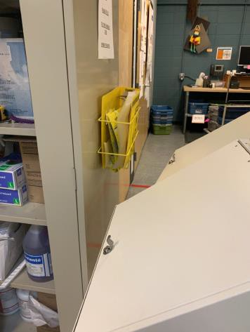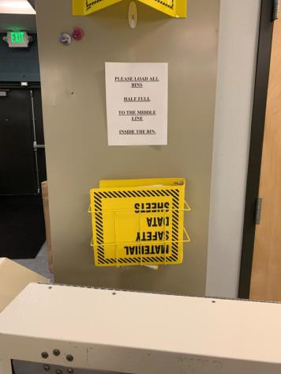

 | ID:  2640 | Facility:  Hillcrest Library

Location: Staff Area
Schedule: 2021
Estimated Cost: $100.00

Priority Score 5
Quick Fix: Yes
Built before ADA: Unknown

VIOLATIONS
2010 ADA Standards for Accessible Design Codes §307.2
The fire extinguisher protrudes 4.25" into the circulation space at 37.5" above the floor.

RECOMMENDATIONS
Recess the fire extinguisher so it protrudes a maximum of 4", lower it so the bottom edge is 27" maximum above the floor, or place a cane detectable object beneath it.

PHOTOGRAPH(S) OF THIS LOCATION

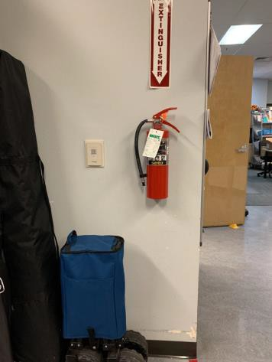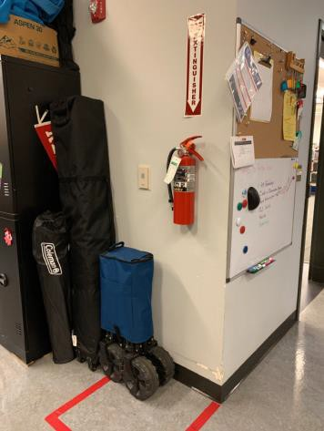

 | ID:  2642 | Facility:  Hillcrest Library

Location: Staff Area
Schedule: 2021
Estimated Cost: $100.00

Priority Score 8
Quick Fix: Yes
Built before ADA: Unknown

VIOLATIONS
2010 ADA Standards for Accessible Design Codes §308.2.2
The paper towel dispensers are outside of the obstructed forward reach range at 52" above the floor.

RECOMMENDATIONS
Lower the paper towel dispenser by 8" to meet the accessible reach range of 15" minimum and 44" maximum above the floor.

PHOTOGRAPH(S) OF THIS LOCATION

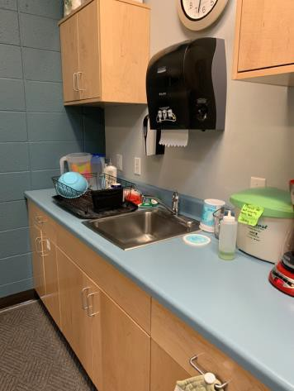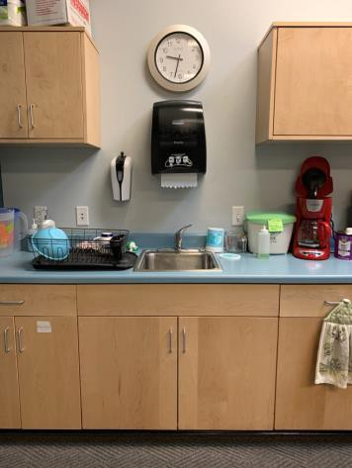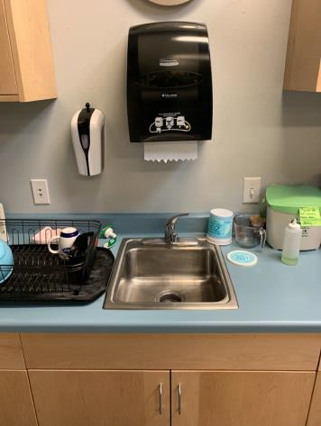

 | ID:  2643 | Facility:  Hillcrest Library

Location: Staff Area
Schedule: 2021
Estimated Cost: $100.00

Priority Score 5
Quick Fix: Yes
Built before ADA: Unknown

VIOLATIONS
2010 ADA Standards for Accessible Design Codes §307.2
The first aid kit protrudes 6.5" into the circulation space at 50" above the floor.

RECOMMENDATIONS
Recess the first aid kit so it protrudes a maximum of 4" or place a cane detectable object beneath it.

PHOTOGRAPH(S) OF THIS LOCATION

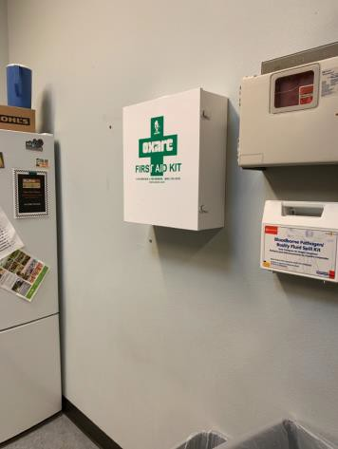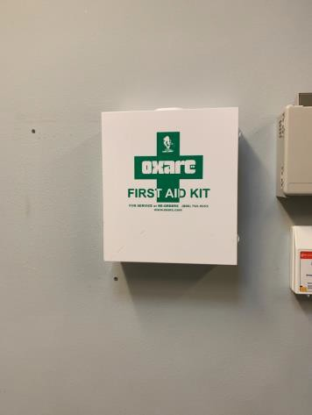

 | ID:  2638 | Facility:  Hillcrest Library

Location: Staff Area
Schedule: 2021
Estimated Cost: $500.00

Priority Score 5
Quick Fix: Yes
Built before ADA: Unknown

VIOLATIONS
2010 ADA Standards for Accessible Design Codes §307.2
The electrical box protrudes 6.25" into the circulation space at 33.75" above the floor.

RECOMMENDATIONS
Recess the electrical box so it protrudes a maximum of 4", lower it so the bottom edge is 27" maximum above the floor, or place a cane detectable object beneath it.

PHOTOGRAPH(S) OF THIS LOCATION

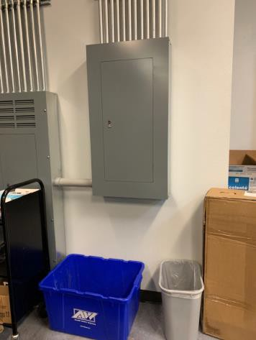

 | ID:  2616 | Facility:  Hillcrest Library

Location: Step Ahead Idaho
Schedule: 2021
Estimated Cost: $200.00

Priority Score 8
Quick Fix: Yes
Built before ADA: Unknown

VIOLATIONS
2010 ADA Standards for Accessible Design Codes §308.2.1
The top two rows of the paper holders are outside of the unobstructed forward reach range.

RECOMMENDATIONS
Lower the paper holders to meet the accessible reach range of 15" minimum and 48" maximum above the floor.

PHOTOGRAPH(S) OF THIS LOCATION

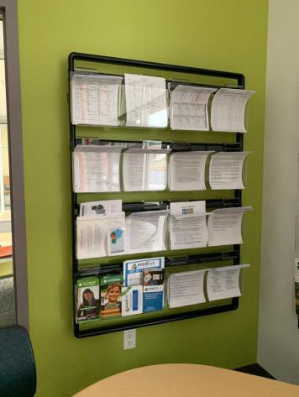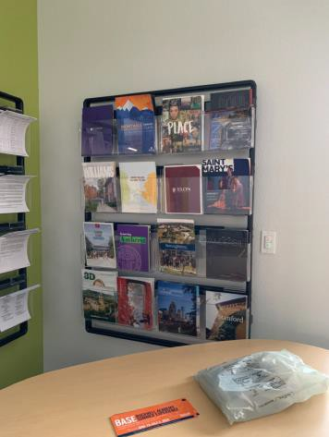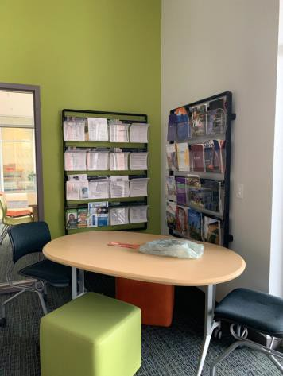

 | ID:  2617 | Facility:  Hillcrest Library

Location: Step Ahead Idaho
Schedule: 2021
Estimated Cost: $300.00

Priority Score 3
Quick Fix: Yes
Built before ADA: Unknown

VIOLATIONS
2010 ADA Standards for Accessible Design Codes §216.2, §703
There are no tactile signs identifying the three permanent rooms.

RECOMMENDATIONS
Install tactile signage on the latch side of the doorway at a height of 48” minimum to 60” maximum above the floor, identifying room by name or room number.
Signs shall be Braille with raised lettering and should be placed on the wall in the center of an 18"x18" clear floor space.

PHOTOGRAPH(S) OF THIS LOCATION

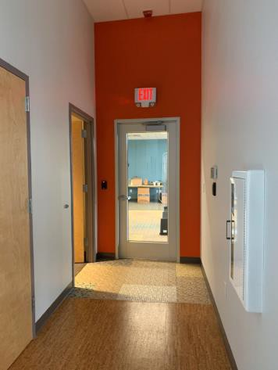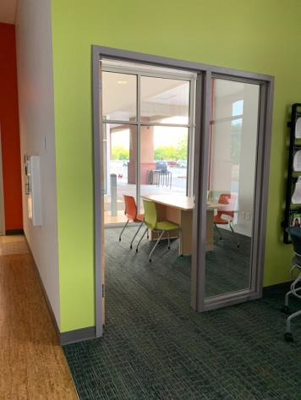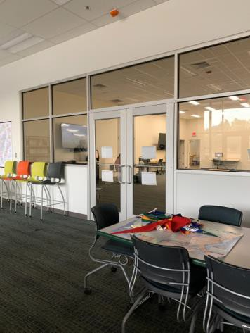

 | ID:  2615 | Facility:  Hillcrest Library

Location: Step Ahead Idaho
Schedule: 2021
Estimated Cost: $1,000.00

Priority Score 4
Quick Fix: No
Built before ADA: Unknown

VIOLATIONS
2010 ADA Standards for Accessible Design Codes §904.4.1
The counter is 42" above the floor and the table is 28.5" above the floor.

RECOMMENDATIONS
A portion of the service counter must be no higher than 36" above the floor for a horizontal distance of 36".
If necessary, utilize the low table as the lower counter for users with disabilities.

PHOTOGRAPH(S) OF THIS LOCATION

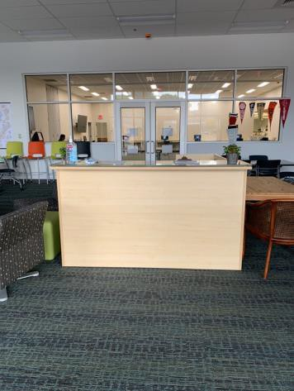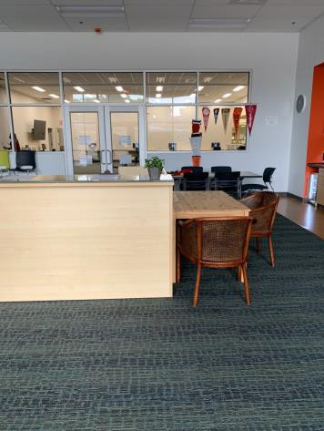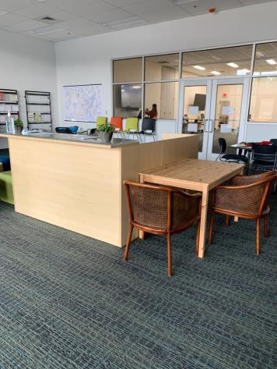

 | ID:  2623 | Facility:  Hillcrest Library

Location: Step Ahead Idaho Restroom
Schedule: 2021
Estimated Cost: $100.00

Priority Score 5
Quick Fix: Yes
Built before ADA: Unknown

VIOLATIONS
2010 ADA Standards for Accessible Design Codes §307.2
The paper towel dispenser protrudes 9" into the circulation space at 46" above the floor.

RECOMMENDATIONS
Recess the paper towel dispenser so it protrudes a maximum of 4", lower it so the bottom edge is 27" maximum above the floor, or place a cane detectable object beneath it.

PHOTOGRAPH(S) OF THIS LOCATION

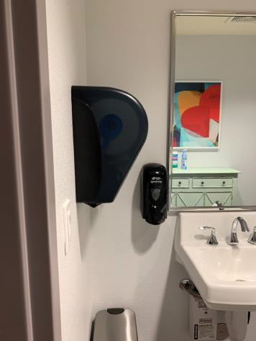
 | ID:  2618 | Facility:  Hillcrest Library

Location: Step Ahead Idaho Restroom
Schedule: 2022
Estimated Cost: $1,000.00

Priority Score 5
Quick Fix: No
Built before ADA: Unknown

VIOLATIONS
2010 ADA Standards for Accessible Design Codes §306.3.3
There is no knee clearance underneath the counter.

RECOMMENDATIONS
Provide knee clearance underneath the counter at the sink that is a minimum of 11" deep at 9" above the floor and 8" deep at 27" above the floor.

PHOTOGRAPH(S) OF THIS LOCATION

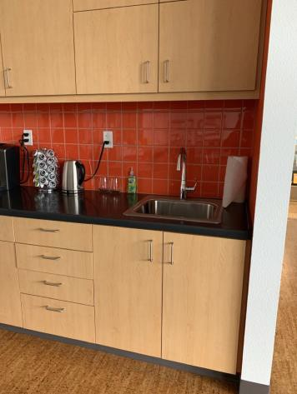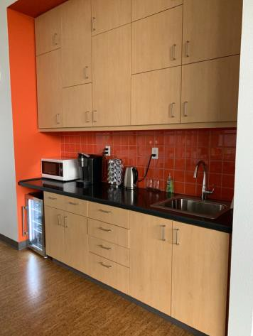

 | ID:  2655 | Facility:  Hillcrest Library

Location: Storage
Schedule: 2021
Estimated Cost: $100.00

Priority Score 6
Quick Fix: Yes
Built before ADA: Unknown

VIOLATIONS
2010 ADA Standards for Accessible Design Codes §703.4
The tactile sign identifying the room is not in the correct location.

RECOMMENDATIONS
Reinstall the sign on the latch side of the door at 48" minimum above the floor measured from the baseline of the lowest character and 60" maximum measured from the baseline of the highest character.

PHOTOGRAPH(S) OF THIS LOCATION

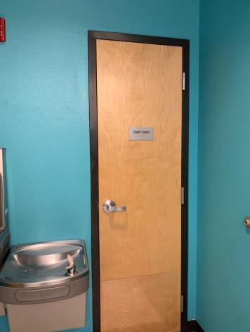

 | ID:  2624 | Facility:  Hillcrest Library

Location: Study Rooms
Schedule: 2021
Estimated Cost: $300.00

Priority Score 3
Quick Fix: Yes
Built before ADA: Unknown

VIOLATIONS
2010 ADA Standards for Accessible Design Codes §216.2, §703
There are no tactile signs identifying three permanent rooms.

RECOMMENDATIONS
Install tactile signage on the latch side of the doorway at a height of 48” minimum to 60” maximum above the floor, identifying room by name or room number.
Signs shall be Braille with raised lettering and should be placed on the wall in the center of an 18"x18" clear floor space.

PHOTOGRAPH(S) OF THIS LOCATION

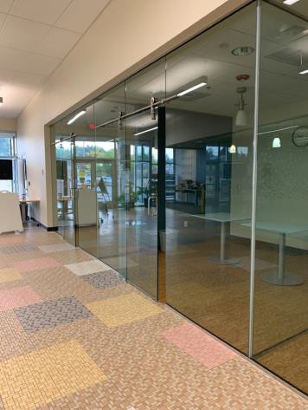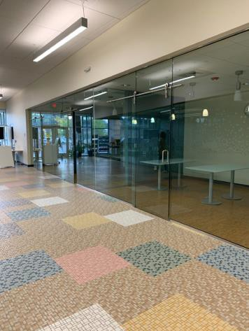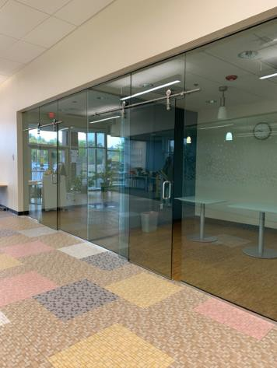

 | ID:  2626 | Facility:  Hillcrest Library

Location: Teton Room B
Schedule: 2021
Estimated Cost: $0.00

Priority Score 0
Quick Fix: Yes
Built before ADA: Unknown

VIOLATIONS
2010 ADA Standards for Accessible Design Codes §307.2
The TVs protrude 11.5" and 9.5" into the circulation space at 56" and 59" above the floor.

RECOMMENDATIONS
Ensure that the desks and chairs remain underneath the TVs to provide cane detectability.

PHOTOGRAPH(S) OF THIS LOCATION

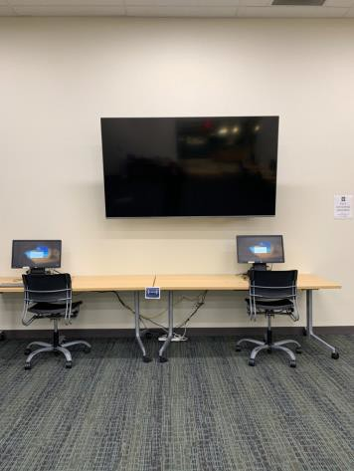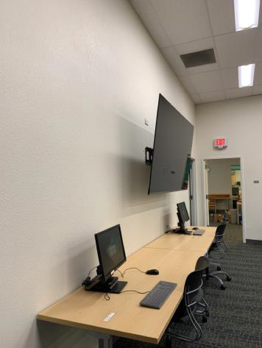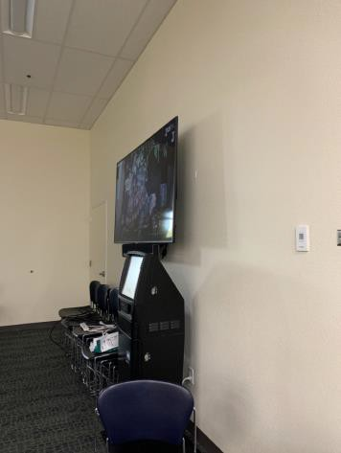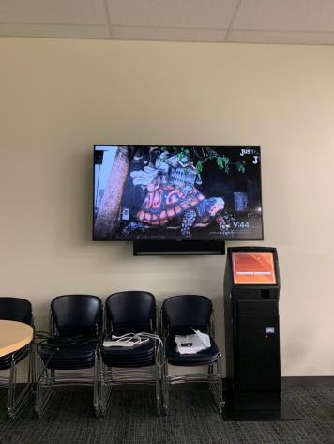

 | ID:  2625 | Facility:  Hillcrest Library

Location: Teton Room B
Schedule: 2023
Estimated Cost: $3,000.00

Priority Score 8
Quick Fix: No
Built before ADA: Unknown

VIOLATIONS
2010 ADA Standards for Accessible Design Codes §707
The interactive touch screen does not have any sound or tactile components. Therefore, a visually impaired person would not be able to access the information provided by the kiosk.

RECOMMENDATIONS
Audio instructions must be provided that guide the user through all the functions of the machine. Tactile instructions must be provided informing the user on the method of activating the audio instructions.
Controls to operate the kiosk must meet the requirements of §707.

PHOTOGRAPH(S) OF THIS LOCATION

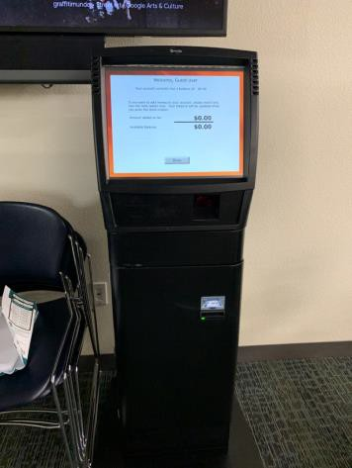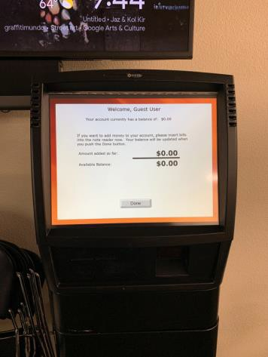

 | ID:  2653 | Facility:  Hillcrest Library

Location: Women’s Restroom
Schedule: 2021
Estimated Cost: $0.00

Priority Score 0
Quick Fix: Yes
Built before ADA: Unknown

VIOLATIONS
2010 ADA Standards for Accessible Design Codes §307.2
The dispenser protrudes 5" into the circulation space at 33.75" above the floor.

RECOMMENDATIONS
Ensure that the garbage can remains underneath the dispenser and paper towel dispenser.

PHOTOGRAPH(S) OF THIS LOCATION

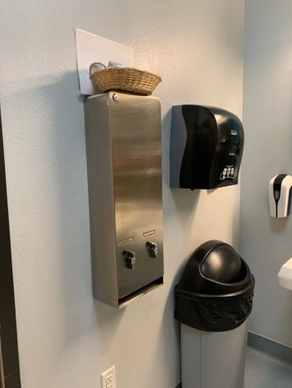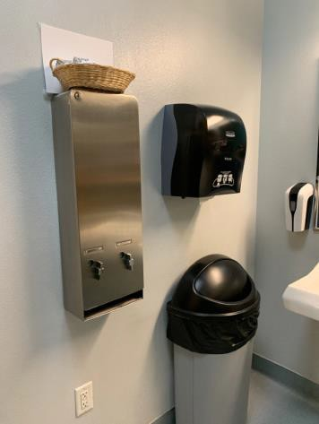

 | ID:  2645 | Facility:  Hillcrest Library

Location: Women’s Restroom
Schedule: 2021
Estimated Cost: $100.00

Priority Score 5
Quick Fix: Yes
Built before ADA: Unknown

VIOLATIONS
2010 ADA Standards for Accessible Design Codes §604.8.1.2
The door to the accessible water closet is not self closing. Either self-closing hinges are not installed on the door or if installed, they are defective.

RECOMMENDATIONS
Install or reinstall self-closing hinges on the door to ensure that the door is self-closing per the ADA requirements.

PHOTOGRAPH(S) OF THIS LOCATION

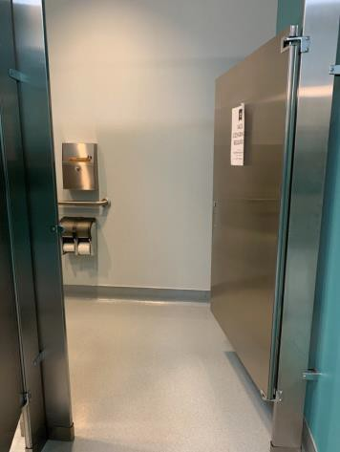
 | ID:  2649 | Facility:  Hillcrest Library

Location: Women’s Restroom
Schedule: 2021
Estimated Cost: $100.00

Priority Score 5
Quick Fix: Yes
Built before ADA: Unknown

VIOLATIONS
2010 ADA Standards for Accessible Design Codes §604.7
The toilet paper dispenser is located out of the accessible reach range at 13" in front of the toilet.

RECOMMENDATIONS
Remount the toilet paper dispenser to 7” minimum and 9” maximum in front of the water closet measured to the centerline of the dispenser.
The outlet of the dispenser shall be 15” minimum and 48” maximum above the floor and shall not be located behind.

PHOTOGRAPH(S) OF THIS LOCATION

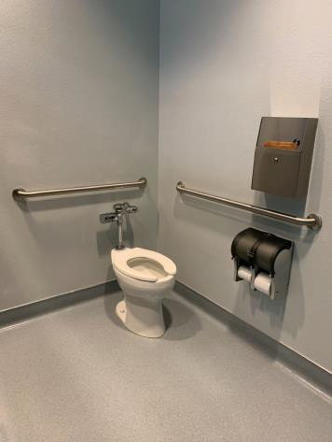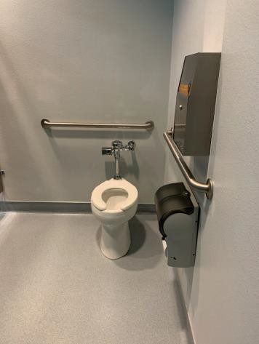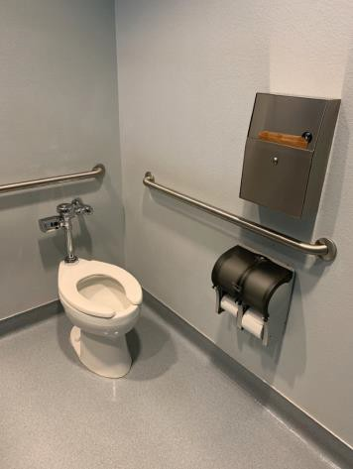

 | ID:  2650 | Facility:  Hillcrest Library

Location: Women’s Restroom
Schedule: 2021
Estimated Cost: $100.00

Priority Score 5
Quick Fix: Yes
Built before ADA: Unknown

VIOLATIONS
2010 ADA Standards for Accessible Design Codes §609.3
The space between the grab bar and the toilet seat cover dispenser is 4".

RECOMMENDATIONS
Relocate the toilet paper seat dispenser to a location that is at least a distance of 12" or greater above the top of the grab bar. Ensure that the dispenser is not greater than 48" above the floor.

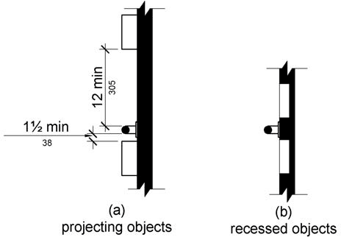

PHOTOGRAPH(S) OF THIS LOCATION

 | ID:  2651 | Facility:  Hillcrest Library

Location: Women’s Restroom
Schedule: 2021
Estimated Cost: $100.00

Priority Score 5
Quick Fix: Yes
Built before ADA: Unknown

VIOLATIONS
2010 ADA Standards for Accessible Design Codes §307.2
The sharps container protrudes 4.75" into the circulation space at 41" above the floor.

RECOMMENDATIONS
Recess the sharps container so it protrudes a maximum of 4", lower it so the bottom edge is 27" maximum above the floor, or place a cane detectable object beneath it.

PHOTOGRAPH(S) OF THIS LOCATION

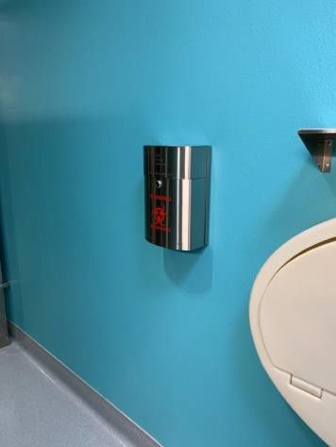

 | ID:  2654 | Facility:  Hillcrest Library

Location: Women’s Restroom
Schedule: 2021
Estimated Cost: $100.00

Priority Score 8
Quick Fix: Yes
Built before ADA: Unknown

VIOLATIONS
2010 ADA Standards for Accessible Design Codes §308.2.1
The paper towel dispenser is outside of the unobstructed forward reach range at 49" above the floor.

RECOMMENDATIONS
Lower the paper towel dispenser by 1" to meet the accessible reach range of 15" minimum and 48" maximum above the floor.
Ensure that the garbage can remains underneath the paper towel dispenser at all times to provide cane detectability.

PHOTOGRAPH(S) OF THIS LOCATION

 | ID:  2652 | Facility:  Hillcrest Library

Location: Women’s Restroom
Schedule: 2022
Estimated Cost: $200.00

Priority Score 7
Quick Fix: Yes
Built before ADA: Unknown

VIOLATIONS
2010 ADA Standards for Accessible Design Codes §603.3
The mirror is too high to be accessible at 41" above the floor.

RECOMMENDATIONS
Lower the mirror its bottom edge is a maximum height of 40" above the floor.

PHOTOGRAPH(S) OF THIS LOCATION

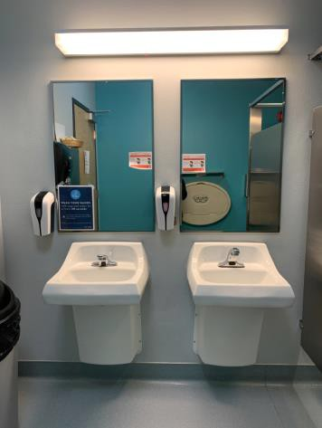

 | ID:  2647 | Facility:  Hillcrest Library

Location: Women’s Restroom
Schedule: 2021
Estimated Cost: $500.00

Priority Score 5
Quick Fix: Yes
Built before ADA: Unknown

VIOLATIONS
2010 ADA Standards for Accessible Design Codes §604.5.1
The side grab bar is located 11" from the rear wall.

RECOMMENDATIONS
Remount the side grab bar 12" maximum from the rear wall and extending 54" minimum from the rear wall.

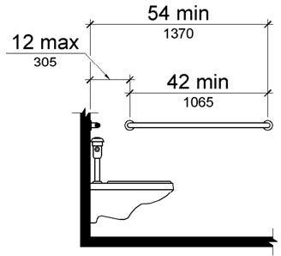

PHOTOGRAPH(S) OF THIS LOCATION

