City of Boise ADA Assessment

Appendix A –Public Works Farm Office Shop Building

12/30/2020
Report #TO20-B010

Prepared by:
 | ID:  1377 | Facility:  Public Works Farm Office/Shop Building

Location: AED in Public Area
Schedule: 2021
Estimated Cost: $100.00

Priority Score 5
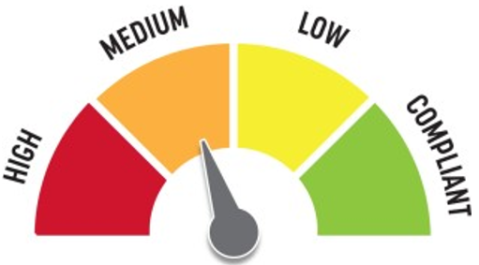
Quick Fix: Yes
Built before ADA: No

VIOLATIONS
2010 ADA Standards for Accessible Design Codes: §307.2
The AED protrudes 6" into the circulation space at 46" above the floor.

RECOMMENDATIONS
Recess the AED so it protrudes a maximum of 4", lower it so the bottom edge is 27" maximum above the floor, or place a cane detectable object beneath it.

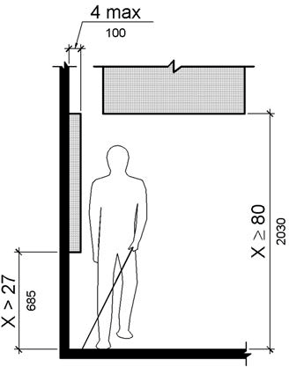

PHOTOGRAPH(S) OF THIS LOCATION

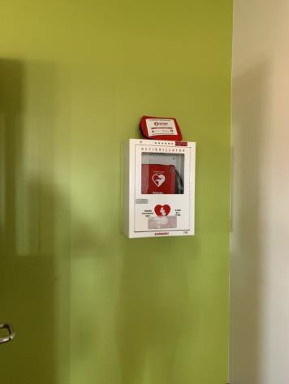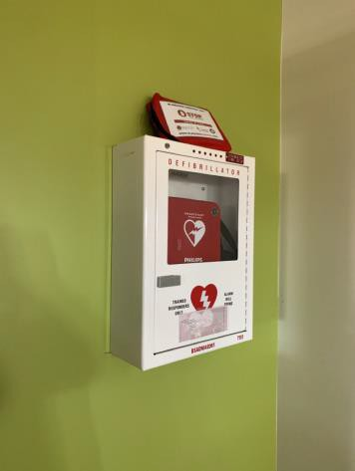

 | ID:  1373 | Facility:  Public Works Farm Office/Shop Building

Location: Back Office TV
Schedule: 2021
Estimated Cost: $100.00

Priority Score 5
Quick Fix: Yes
Built before ADA: No

VIOLATIONS
2010 ADA Standards for Accessible Design Codes: §307.2
The TV protrudes 9.5" into the circulation space at 71" above the floor.

RECOMMENDATIONS
Recess the TV so it protrudes a maximum of 4", raise it so the bottom edge is 80" maximum above the floor, or place a cane detectable object beneath it.

PHOTOGRAPH(S) OF THIS LOCATION

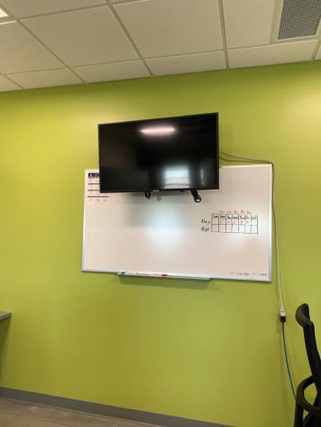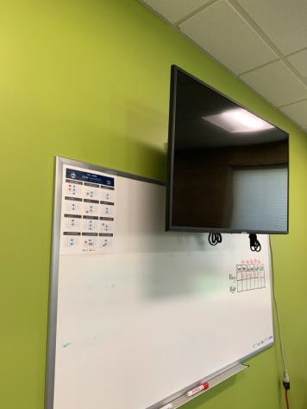

 | ID:  1363 | Facility:  Public Works Farm Office/Shop Building

Location: Entrance
Schedule: 2021
Estimated Cost: $100.00

Priority Score 8
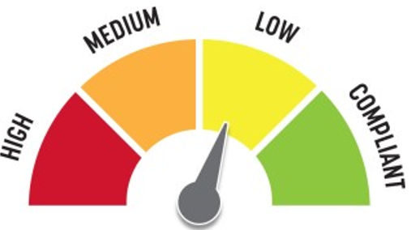
Quick Fix: Yes
Built before ADA: No

VIOLATIONS
2010 ADA Standards for Accessible Design Codes: §308.2.1
The push button is outside of the unobstructed forward reach range at 50" above the floor.

RECOMMENDATIONS
Lower the push button by at least 2" to meet the accessible reach range of 15" minimum and 48" maximum above the floor.

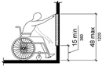

PHOTOGRAPH(S) OF THIS LOCATION

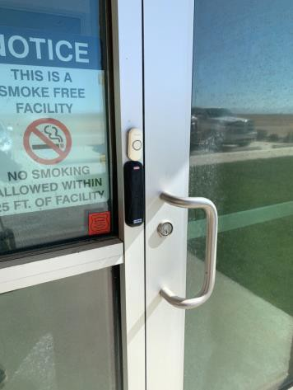

 | ID:  1374 | Facility:  Public Works Farm Office/Shop Building

Location: Entrance
Schedule: 2021
Estimated Cost: $1,000.00

Priority Score 4
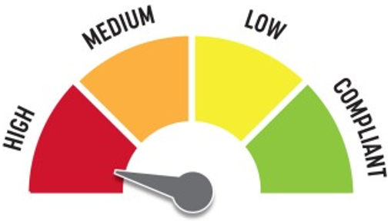
Quick Fix: No
Built before ADA: No

VIOLATIONS
2010 ADA Standards for Accessible Design Codes: §904.4.1
The counter is 40" above the floor.

RECOMMENDATIONS
A horizontal distance of 36" of the service counter must be no higher than 36” above the floor.

PHOTOGRAPH(S) OF THIS LOCATION

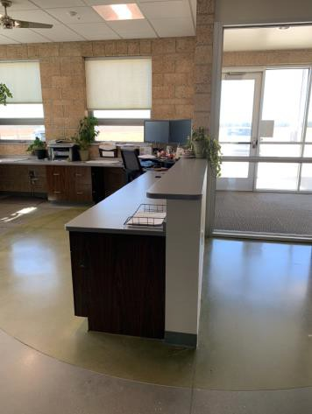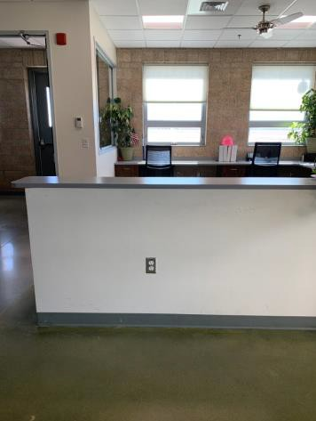

 | ID:  1376 | Facility:  Public Works Farm Office/Shop Building

Location: Kestrel Conference Room
Schedule: 2021
Estimated Cost: $100.00

Priority Score 8
Quick Fix: Yes
Built before ADA: No

VIOLATIONS
2010 ADA Standards for Accessible Design Codes: §308.2.2
The paper towel dispenser is outside of the obstructed forward reach range at 69" above the floor.

RECOMMENDATIONS
Lower the paper towel dispenser by 21" to meet the accessible reach range of 44" maximum above the floor.

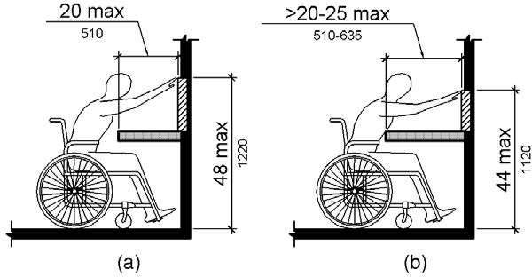

PHOTOGRAPH(S) OF THIS LOCATION

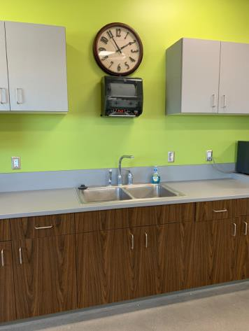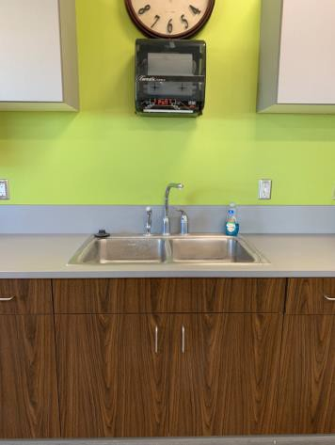

 | ID:  1375 | Facility:  Public Works Farm Office/Shop Building

Location: Kestrel Conference Room
Schedule: 2022
Estimated Cost: $1,000.00

Priority Score 5
Quick Fix: No
Built before ADA: No

VIOLATIONS
2010 ADA Standards for Accessible Design Codes: §306.3.3
There is no knee clearance underneath the counter.

RECOMMENDATIONS
Provide knee clearance underneath the counter at the sink that is a minimum of 11" deep at 9" above the floor and 8" deep at 27" above the floor.

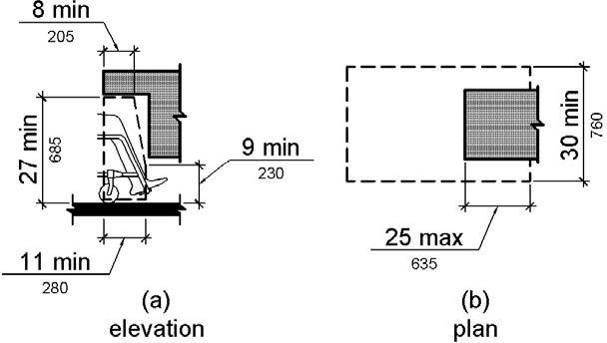

PHOTOGRAPH(S) OF THIS LOCATION

 | ID:  1398 | Facility:  Public Works Farm Office/Shop Building

Location: Men’s Locker Room
Schedule: 2021
Estimated Cost: $100.00

Priority Score 5
Quick Fix: Yes
Built before ADA: No

VIOLATIONS
2010 ADA Standards for Accessible Design Codes: §604.8.1.2
The door to the accessible water closet is not self closing. Either self-closing hinges are not installed on the door or if installed, they are defective.

RECOMMENDATIONS
Install or reinstall self-closing hinges on the door to ensure that the door is self-closing per the ADA requirements.

PHOTOGRAPH(S) OF THIS LOCATION

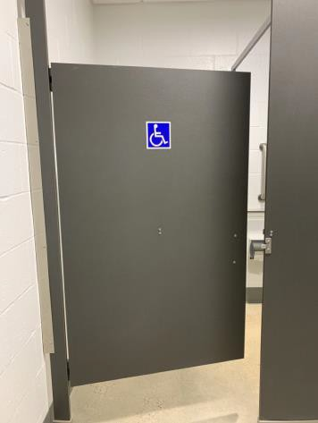

 | ID:  1403 | Facility:  Public Works Farm Office/Shop Building

Location: Men’s Locker Room
Schedule: 2021
Estimated Cost: $100.00

Priority Score 5
Quick Fix: Yes
Built before ADA: No

VIOLATIONS
2010 ADA Standards for Accessible Design Codes: §307.2
The shower curtain rod is 75" above the floor.

RECOMMENDATIONS
Raise the shower curtain rod by 5" so it is 80" above the floor.

PHOTOGRAPH(S) OF THIS LOCATION

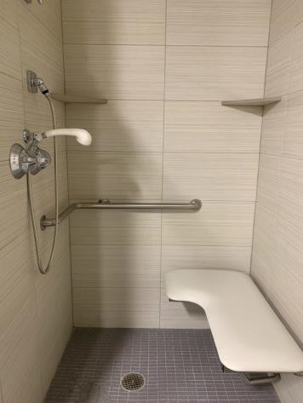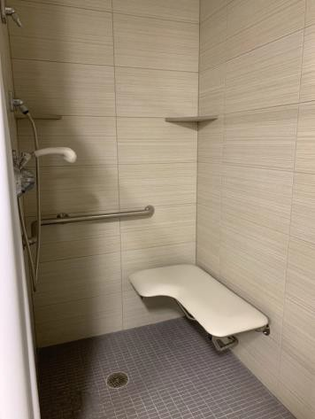

 | ID:  1409 | Facility:  Public Works Farm Office/Shop Building

Location: Men’s Locker Room
Schedule: 2021
Estimated Cost: $100.00

Priority Score 5
Quick Fix: Yes
Built before ADA: No

VIOLATIONS
2010 ADA Standards for Accessible Design Codes: §307.2, §308.2.1
The paper towel dispenser is outside of the unobstructed forward reach range at 52" above the floor. The paper towel dispenser protrudes 8" into the circulation space at 52" above the floor.

RECOMMENDATIONS
Lower the paper towel dispenser by 4" to meet the accessible reach range of 48" maximum above the floor.
Recess the paper towel dispenser so it protrudes a maximum of 4" or place a cane detectable object beneath it.

PHOTOGRAPH(S) OF THIS LOCATION

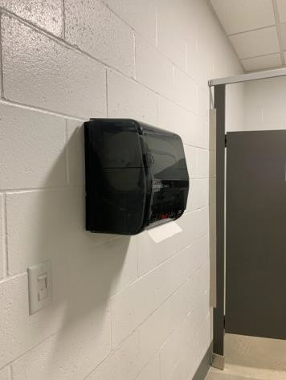

 | ID:  1406 | Facility:  Public Works Farm Office/Shop Building

Location: Men’s Locker Room
Schedule: 2021
Estimated Cost: $200.00

Priority Score 8
Quick Fix: Yes
Built before ADA: No

VIOLATIONS
2010 ADA Standards for Accessible Design Codes: §308.2.1
The shelves are outside of the unobstructed forward reach range at 59.5" above the floor.

RECOMMENDATIONS
Lower the shelves by 11.5" to meet the accessible reach range of 48" maximum above the floor.

PHOTOGRAPH(S) OF THIS LOCATION

 | ID:  1408 | Facility:  Public Works Farm Office/Shop Building

Location: Men’s Locker Room
Schedule: 2021
Estimated Cost: $500.00

Priority Score 6
Quick Fix: Yes
Built before ADA: No

VIOLATIONS
2010 ADA Standards for Accessible Design Codes: §610.3.2
The L-shaped shower seat does not meet the minimum requirements with a long side depth of 21" and a short side depth of 13.5".

RECOMMENDATIONS
Replace the L-shaped shower seat with one that has a long side depth from the seat wall to the front edge of 22" minimum and 23" maximum and a short side depth from the seat wall to the front edge 15" minimum and 16" maximum.

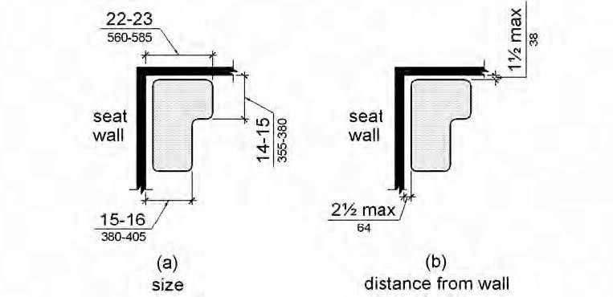

PHOTOGRAPH(S) OF THIS LOCATION

 | ID:  1402 | Facility:  Public Works Farm Office/Shop Building

Location: Men’s Locker Room
Schedule: 2022
Estimated Cost: $1,000.00

Priority Score 5
Quick Fix: No
Built before ADA: No

VIOLATIONS
2010 ADA Standards for Accessible Design Codes: §604.2
The toilet is located 18.5" from the sidewall.

RECOMMENDATIONS
Reposition the toilet to be within 16" minimum and 18" maximum from the sidewall.

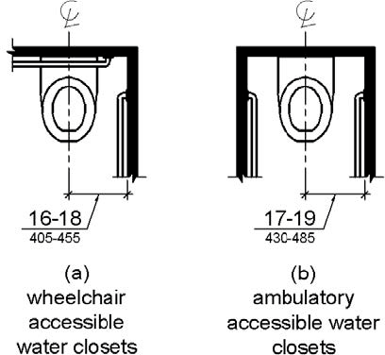

PHOTOGRAPH(S) OF THIS LOCATION

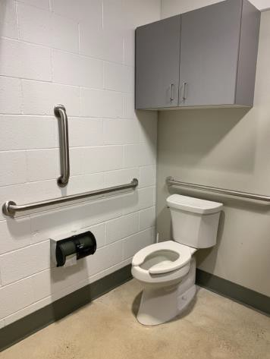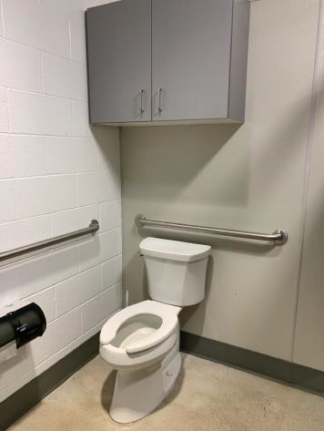

 | ID:  1405 | Facility:  Public Works Farm Office/Shop Building

Location: Men’s Locker Room
Schedule: 2022
Estimated Cost: $1,000.00

Priority Score 6
Quick Fix: No
Built before ADA: No

VIOLATIONS
2010 ADA Standards for Accessible Design Codes: §607.6, §608.5.1
The shower controls exceed a height of 48" above ground. The adjustable shower head is 52" above the floor.

RECOMMENDATIONS
Adjust the height of shower controls to a minimum height of 38" and a maximum height of 48" above the floor.
Install a secondary shower head with a 59" long minimum hose to allow for a user to sit or stand that is a maximum of 48" above the floor.

PHOTOGRAPH(S) OF THIS LOCATION

 | ID:  1407 | Facility:  Public Works Farm Office/Shop Building

Location: Men’s Locker Room
Schedule: 2022
Estimated Cost: $1,000.00

Priority Score 6
Quick Fix: No
Built before ADA: No

VIOLATIONS
2010 ADA Standards for Accessible Design Codes: §608.3.1
The control wall grab bar is 16" long.

RECOMMENDATIONS
Replace the control wall grab bar with one that is a minimum of 36" long, which is the full length of the control wall for a transfer type shower.

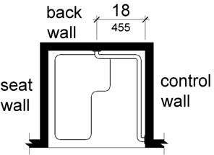

PHOTOGRAPH(S) OF THIS LOCATION

 | ID:  1410 | Facility:  Public Works Farm Office/Shop Building

Location: Men’s Locker Room
Schedule: 2022
Estimated Cost: $1,000.00

Priority Score 5
Quick Fix: No
Built before ADA: No

VIOLATIONS
2010 ADA Standards for Accessible Design Codes: §903.4
The benches do not have back support.

RECOMMENDATIONS
Provide back support that is 42” long minimum and extends from a point 2” maximum above the seat surface to a point 18” minimum above the seat surface.
Back support shall be 2½” maximum from the rear edge of the seat measured horizontally.

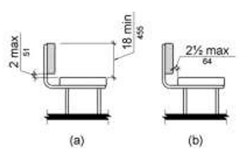

PHOTOGRAPH(S) OF THIS LOCATION

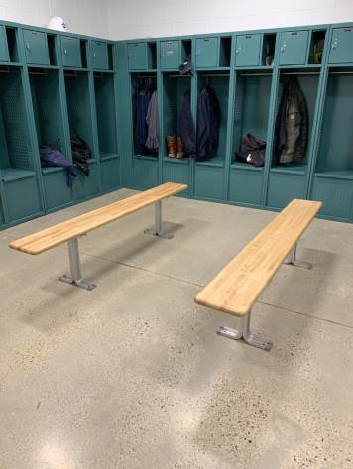

 | ID:  1410 | Facility:  Public Works Farm Office/Shop Building

Location: Men’s Locker Room
Schedule: 2022
Estimated Cost: $1,000.00

Priority Score 3
Quick Fix: No
Built before ADA: No

VIOLATIONS
2010 ADA Standards for Accessible Design Codes: §403.5.1, §903.4
The bench does not have back support.
There is not a clear 36" width for wheelchairs to pass. The width is 34" between the bench and lockers.

RECOMMENDATIONS
Provide back support that is 42” long minimum and extends from a point 2” maximum above the seat surface to a point 18” minimum above the seat surface.
Back support shall be 2½” maximum from the rear edge of the seat measured horizontally. This can be achieved by relocating one bench to utilize a nearby wall as back support. Shift the bench 2" away from the lockers.

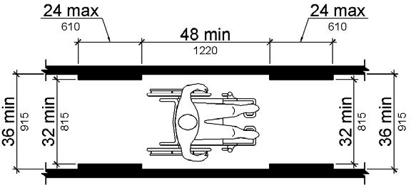

PHOTOGRAPH(S) OF THIS LOCATION

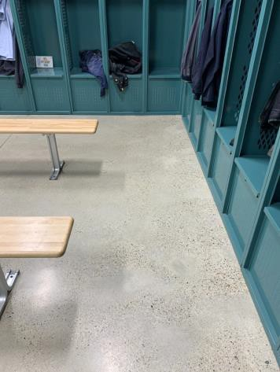

 | ID:  1411 | Facility:  Public Works Farm Office/Shop Building

Location: Men’s Locker Room
Schedule: 2021
Estimated Cost: $1,500.00

Priority Score 8
Quick Fix: No
Built before ADA: No

VIOLATIONS
2010 ADA Standards for Accessible Design Codes: §308.2.1
The lockers are outside of the unobstructed forward reach range at 57" above the floor.

RECOMMENDATIONS
Lower 5% of the lockers by 9" to meet the accessible reach range of 15" minimum and 48" maximum above the floor.

PHOTOGRAPH(S) OF THIS LOCATION

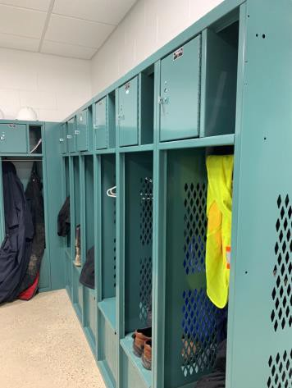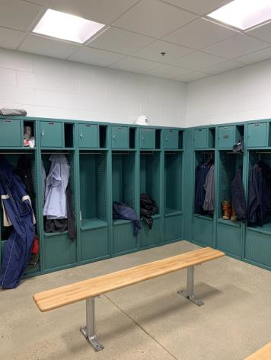

 | ID:  1365 | Facility:  Public Works Farm Office/Shop Building

Location: Parking
Schedule: 2021
Estimated Cost: $1,000.00

Priority Score 3
Quick Fix: No
Built before ADA: No

VIOLATIONS
2010 ADA Standards for Accessible Design Codes: §502.2, §208.2.4
There is only one space and it is not van accessible. The accessible parking space is not of sufficient width at 108" wide.

RECOMMENDATIONS
Expand the accessible parking space to a minimum of 132" wide. Add a “van accessible” parking sign at a minimum height of 60" above the ground. Ensure the access aisle is a minimum width of 60".

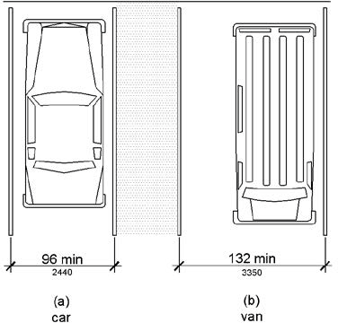

PHOTOGRAPH(S) OF THIS LOCATION

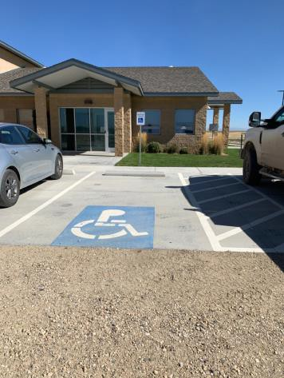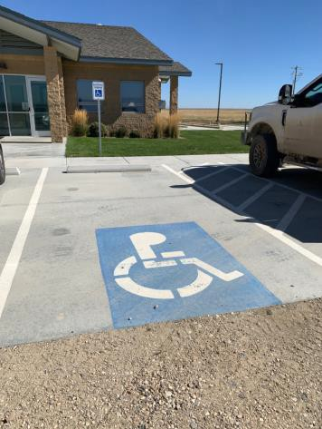

 | ID:  1367 | Facility:  Public Works Farm Office/Shop Building

Location: Public Restroom
Schedule: 2021
Estimated Cost: $200.00

Priority Score 6
Quick Fix: Yes
Built before ADA: No

VIOLATIONS
2010 ADA Standards for Accessible Design Codes: §404.2.8.1, §404.2.9
The opening and closing force of the door is 20 pounds. The time required for the door to shut is 2.9 seconds.

RECOMMENDATIONS
Adjust the resistance on the door so that it allows the doors to be continuously opened at a maximum force of 5 pounds.
Adjust the closing speed to a minimum of 5 or more seconds.

PHOTOGRAPH(S) OF THIS LOCATION

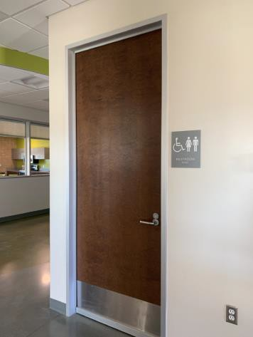

 | ID:  1372 | Facility:  Public Works Farm Office/Shop Building

Location: Public Restroom
Schedule: 2022
Estimated Cost: $1,000.00

Priority Score 5
Quick Fix: No
Built before ADA: No

VIOLATIONS
2010 ADA Standards for Accessible Design Codes: §604.2
The toilet is located 18.5" from the sidewall.

RECOMMENDATIONS
Reposition the toilet to be within 16" minimum and 18" maximum from the sidewall.

PHOTOGRAPH(S) OF THIS LOCATION

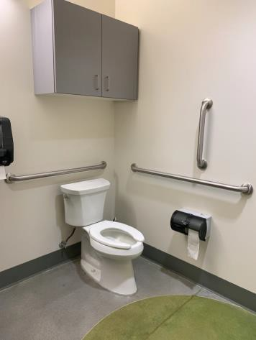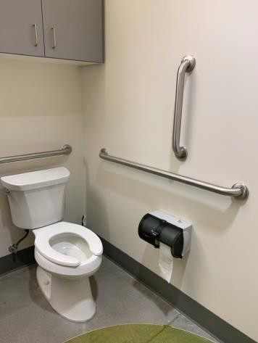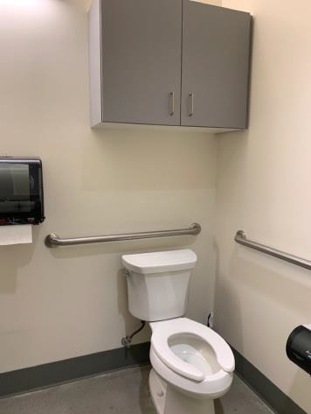

 | ID:  1378 | Facility:  Public Works Farm Office/Shop Building

Location: Women’s Locker Room
Schedule: 2021
Estimated Cost: $100.00

Priority Score 5
Quick Fix: Yes
Built before ADA: No

VIOLATIONS
2010 ADA Standards for Accessible Design Codes: §307.2
The shower curtain rod is 74" above the floor.

RECOMMENDATIONS
Raise the shower curtain rod by 6" so it is 80" above the floor.

PHOTOGRAPH(S) OF THIS LOCATION

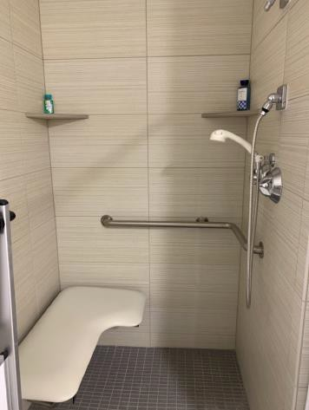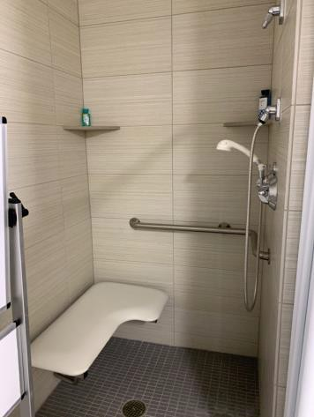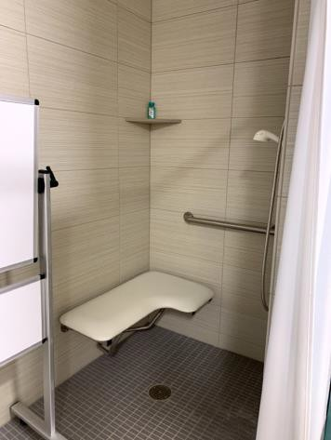

 | ID:  1389 | Facility:  Public Works Farm Office/Shop Building

Location: Women’s Locker Room
Schedule: 2021
Estimated Cost: $100.00

Priority Score 5
Quick Fix: Yes
Built before ADA: No

VIOLATIONS
2010 ADA Standards for Accessible Design Codes: §604.8.1.2
The door to the accessible water closet is not self closing. Either self-closing hinges are not installed on the door or if installed, they are defective.

RECOMMENDATIONS
Install or reinstall self-closing hinges on the door to ensure that the door is self-closing per the ADA requirements.

PHOTOGRAPH(S) OF THIS LOCATION

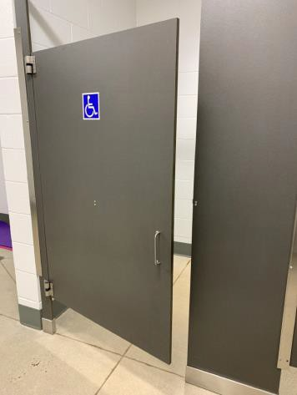

 | ID:  1395 | Facility:  Public Works Farm Office/Shop Building

Location: Women’s Locker Room
Schedule: 2021
Estimated Cost: $100.00

Priority Score 7
Quick Fix: Yes
Built before ADA: No

VIOLATIONS
2010 ADA Standards for Accessible Design Codes: §603.3
The mirror is too high to be accessible at 40.25" above the floor.

RECOMMENDATIONS
Lower the mirror its bottom edge is a maximum height of 40" above the floor.

PHOTOGRAPH(S) OF THIS LOCATION

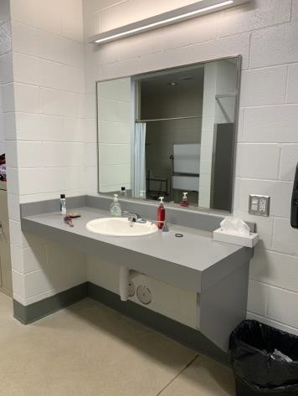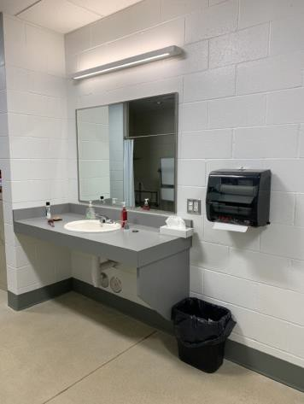

 | ID:  1396 | Facility:  Public Works Farm Office/Shop Building

Location: Women’s Locker Room
Schedule: 2021
Estimated Cost: $100.00

Priority Score 0
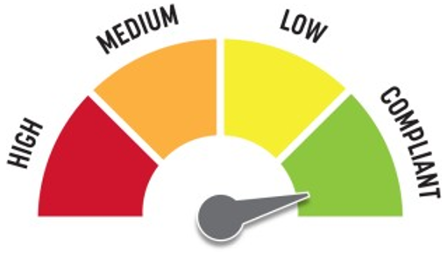
Quick Fix: Yes
Built before ADA: No

VIOLATIONS
2010 ADA Standards for Accessible Design Codes: §307.2
The paper towel dispenser protrudes 8" into the circulation space at 41" above the floor.

RECOMMENDATIONS
Recess the paper towel dispenser so it protrudes a maximum of 4" or ensure the detectable object remains beneath it at all times.

PHOTOGRAPH(S) OF THIS LOCATION

 | ID:  1379 | Facility:  Public Works Farm Office/Shop Building

Location: Women’s Locker Room
Schedule: 2021
Estimated Cost: $100.00

Priority Score 8
Quick Fix: Yes
Built before ADA: No

VIOLATIONS
2010 ADA Standards for Accessible Design Codes: §308.2.1
The corner shelves are outside of the unobstructed forward reach range at 59" above the floor.

RECOMMENDATIONS
Lower the corner shelves by 11" to meet the accessible reach range of 48" maximum above the floor.

PHOTOGRAPH(S) OF THIS LOCATION

 | ID:  1382 | Facility:  Public Works Farm Office/Shop Building

Location: Women’s Locker Room
Schedule: 2021
Estimated Cost: $500.00

Priority Score 6
Quick Fix: Yes
Built before ADA: No

VIOLATIONS
2010 ADA Standards for Accessible Design Codes: §607.6
The adjustable shower head is 50" above the floor.

RECOMMENDATIONS
Install a secondary shower head with a 59" long minimum hose to allow for a user to sit or stand that is a maximum of 48" above the floor.

PHOTOGRAPH(S) OF THIS LOCATION

 | ID:  1284 | Facility:  Public Works Farm Office/Shop Building

Location: Women’s Locker Room
Schedule: 2021
Estimated Cost: $500.00

Priority Score 6
Quick Fix: Yes
Built before ADA: No

VIOLATIONS
2010 ADA Standards for Accessible Design Codes: §610.3.2
The L-shaped shower seat does not meet the minimum requirements with a long side depth of 21" and a short side depth of 13".

RECOMMENDATIONS
Replace the L-shaped shower seat with one that has a long side depth from the seat wall to the front edge of 22" minimum and 23" maximum and a short side depth from the seat wall to the front edge 15" minimum and 16" maximum.

PHOTOGRAPH(S) OF THIS LOCATION

 | ID:  1385 | Facility:  Public Works Farm Office/Shop Building

Location: Women’s Locker Room
Schedule: 2021
Estimated Cost: $500.00

Priority Score 5
Quick Fix: Yes
Built before ADA: No

VIOLATIONS
2010 ADA Standards for Accessible Design Codes: §903.4
The bench does not have back support.

RECOMMENDATIONS
Provide back support that is 42” long minimum and extends from a point 2” maximum above the seat surface to a point 18” minimum above the seat surface.
Back support shall be 2.5” maximum from the rear edge of the seat measured horizontally.

PHOTOGRAPH(S) OF THIS LOCATION

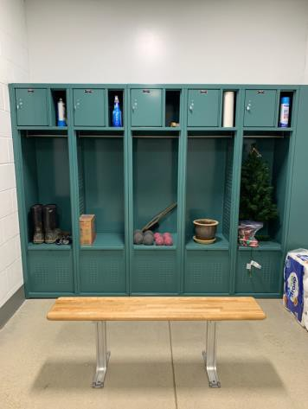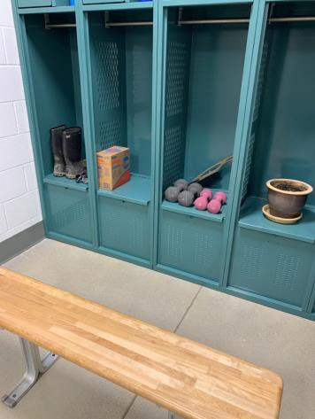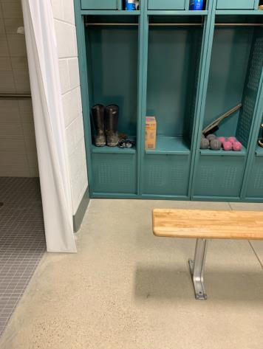

 | ID:  1388 | Facility:  Public Works Farm Office/Shop Building

Location: Women’s Locker Room
Schedule: 2021
Estimated Cost: $500.00

Priority Score 8
Quick Fix: Yes
Built before ADA: No

VIOLATIONS
2010 ADA Standards for Accessible Design Codes: §308.2.1
The lockers and locker curtain rods are outside of the unobstructed forward reach range at 63" and 57" above the floor.

RECOMMENDATIONS
Lower 5% of the lockers and locker curtain rods by 15" and 9" to meet the accessible reach range of 15" minimum and 48" maximum above the floor.

PHOTOGRAPH(S) OF THIS LOCATION

 | ID:  1381 | Facility:  Public Works Farm Office/Shop Building

Location: Women’s Locker Room
Schedule: 2022
Estimated Cost: $1,000.00

Priority Score 6
Quick Fix: No
Built before ADA: No

VIOLATIONS
2010 ADA Standards for Accessible Design Codes: §608.3.1
The control wall grab bar is 16" long.

RECOMMENDATIONS
Replace the control wall grab bar with one that is a minimum of 36" long, which is the full length of the control wall for a transfer type shower.

PHOTOGRAPH(S) OF THIS LOCATION

 | ID:  1394 | Facility:  Public Works Farm Office/Shop Building

Location: Women’s Locker Room
Schedule: 2022
Estimated Cost: $1,000.00

Priority Score 5
Quick Fix: No
Built before ADA: No

VIOLATIONS
2010 ADA Standards for Accessible Design Codes: §606.3
The sink is 34.5" above the floor.

RECOMMENDATIONS
Lower the sink to a maximum height of 34" above the floor.

PHOTOGRAPH(S) OF THIS LOCATION

 | ID:  1386 | Facility:  Public Works Farm Office/Shop Building

Location: Women’s Locker Room
Schedule: 2021
Estimated Cost: $1,500.00

Priority Score 3
Quick Fix: No
Built before ADA: No

VIOLATIONS
2010 ADA Standards for Accessible Design Codes: §403.5.1, §903.4
The bench does not have back support. There is not a clear 36" width for wheelchairs to pass between the bench and lockers and the shower.
The width is 31" between the bench and lockers and 25" between the bench and shower.

RECOMMENDATIONS
Provide back support that is 42” long minimum and extends from a point 2” maximum above the seat surface to a point 18” minimum above the seat surface. Shift the bench 11" away from the shower and 5" away from the lockers.
Back support shall be 2½” maximum from the rear edge of the seat measured horizontally. This can be achieved by relocating one bench to utilize a nearby wall as back support.

PHOTOGRAPH(S) OF THIS LOCATION

