City of Boise ADA Assessment

Appendix A –Warm Springs Golf Course

2/19/2021
Report #TO21-B019

Prepared by:
 | ID:  1492 | Facility:  Warm Springs Golf Course

Location: Clubhouse
Schedule: 2021
Estimated Cost: $100.00

Priority Score 3
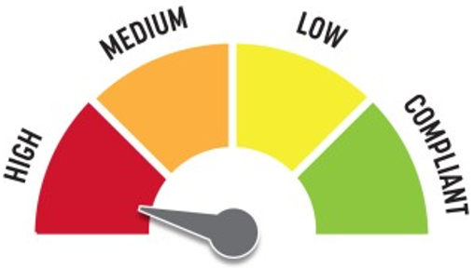
Quick Fix: Yes
Built before ADA: Yes

VIOLATIONS
2010 ADA Standards for Accessible Design Codes §216.2, §703
There is no tactile sign identifying the permanent room.

RECOMMENDATIONS
Install tactile signage on the latch side of the doorway at a height of 48” minimum to 60” maximum above the floor, identifying room by name or room number.

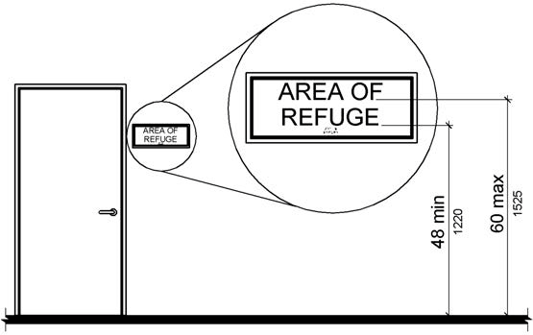

PHOTOGRAPH(S) OF THIS LOCATION

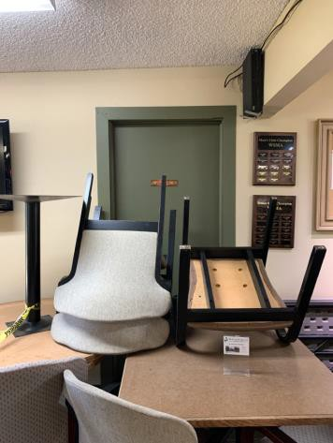

 | ID:  1493 | Facility:  Warm Springs Golf Course

Location: Clubhouse
Schedule: 2021
Estimated Cost: $100.00

Priority Score 5
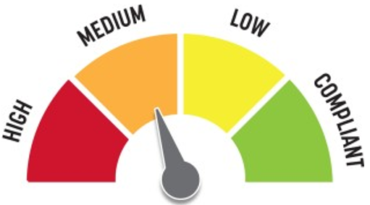
Quick Fix: Yes
Built before ADA: Yes

VIOLATIONS
2010 ADA Standards for Accessible Design Codes §307.2
The TV protrudes 6.75" into the circulation space at 55" above the floor.

RECOMMENDATIONS
Recess the TV so it protrudes a maximum of 4", raise it so the bottom edge is 80" maximum above the floor, or place a cane detectable object beneath it.

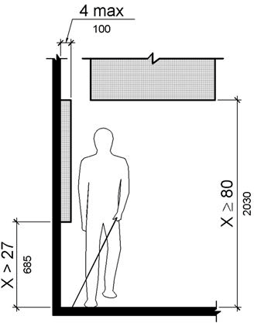

PHOTOGRAPH(S) OF THIS LOCATION

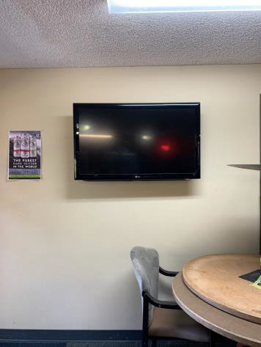

 | ID:  1500 | Facility:  Warm Springs Golf Course

Location: Clubhouse
Schedule: 2021
Estimated Cost: $100.00

Priority Score 7
Quick Fix: Yes
Built before ADA: Yes

VIOLATIONS
2010 ADA Standards for Accessible Design Codes §309.4
The door knob requires twisting of the wrist.

RECOMMENDATIONS
Replace the door knob with a lever handle that can be operated with a closed fist and without twisting the wrist.

PHOTOGRAPH(S) OF THIS LOCATION

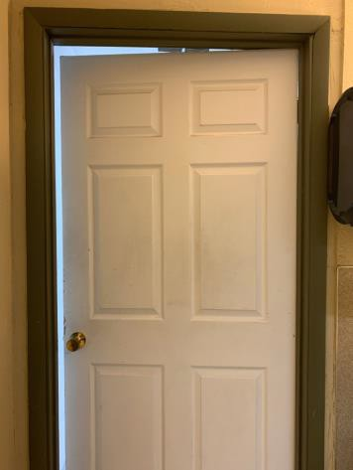

 | ID:  4483 | Facility:  Warm Springs Golf Course

Location: Clubhouse
Schedule: 2021
Estimated Cost: $100.00

Priority Score 7
Quick Fix: Yes
Built before ADA: Yes

VIOLATIONS
2010 ADA Standards for Accessible Design Codes §309.4
The door knob requires twisting of the wrist.

RECOMMENDATIONS
Replace the door knob with a lever handle that can be operated with a closed fist and without twisting the wrist.

PHOTOGRAPH(S) OF THIS LOCATION

 | ID:  5 | Facility:  Warm Springs Golf Course

Location: Clubhouse
Schedule: 2021
Estimated Cost: $100.00

Priority Score 3
Quick Fix: Yes
Built before ADA: Yes

VIOLATIONS
2010 ADA Standards for Accessible Design Codes §216.2, §703
There is no tactile sign identifying the permanent room.

RECOMMENDATIONS
Install tactile signage on the latch side of the doorway at a height of 48” minimum to 60” maximum above the floor, identifying room by name or room number.
Signs shall be Braille with raised lettering and should be placed on the wall in the center of an 18"x18" clear floor space.

PHOTOGRAPH(S) OF THIS LOCATION

 | ID:  1489 | Facility:  Warm Springs Golf Course

Location: Clubhouse
Schedule: 2021
Estimated Cost: $1,000.00

Priority Score 4
Quick Fix: No
Built before ADA: Yes

VIOLATIONS
2010 ADA Standards for Accessible Design Codes §904.4.1
The counter is 42" above the floor.

RECOMMENDATIONS
A portion of the service counter must be no higher than 36" above the floor for a horizontal distance of 36".

PHOTOGRAPH(S) OF THIS LOCATION

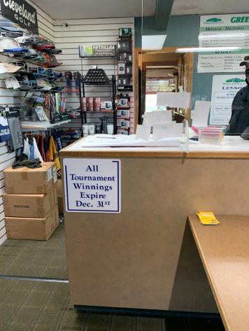

 | ID:  1494 | Facility:  Warm Springs Golf Course

Location: Clubhouse Counter
Schedule: 2021
Estimated Cost: $1,000.00

Priority Score 4
Quick Fix: No
Built before ADA: Yes

VIOLATIONS
2010 ADA Standards for Accessible Design Codes §904.4.1
The counter is 44.5" above the floor. The side condiment counter is 38" above the floor.

RECOMMENDATIONS
A portion of the service counter must be no higher than 36" above the floor for a horizontal distance of 36".

PHOTOGRAPH(S) OF THIS LOCATION

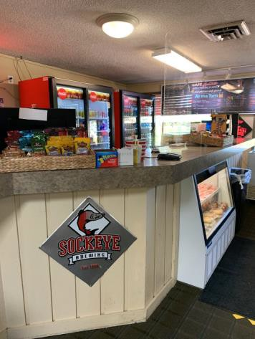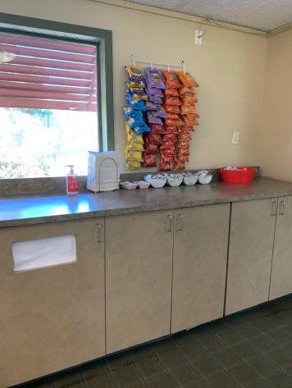

 | ID:  1471 | Facility:  Warm Springs Golf Course

Location: Clubhouse entrance
Schedule: 2021
Estimated Cost: $100.00

Priority Score 8
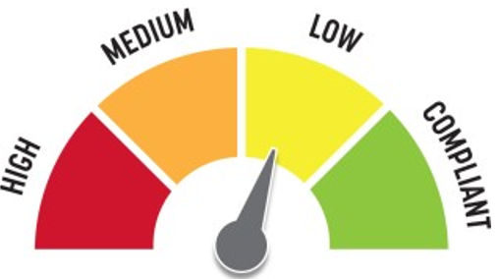
Quick Fix: Yes
Built before ADA: Yes

VIOLATIONS
2010 ADA Standards for Accessible Design Codes §308.2.1
The hand sanitizer is outside of the unobstructed forward reach range at 55" above the floor.

RECOMMENDATIONS
Lower the hand sanitizer by 7" to meet the accessible reach range of 48" maximum above the floor.

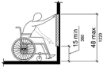

PHOTOGRAPH(S) OF THIS LOCATION

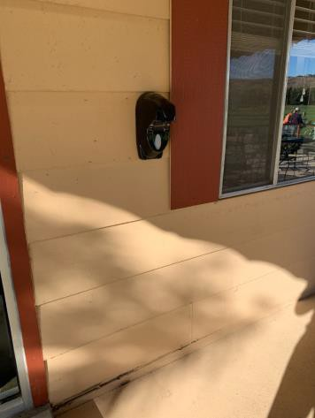

 | ID:  1485 | Facility:  Warm Springs Golf Course

Location: Clubhouse entrance
Schedule: 2021
Estimated Cost: $1,000.00

Priority Score 3
Quick Fix: No
Built before ADA: Yes

VIOLATIONS
2010 ADA Standards for Accessible Design Codes §403.3
The running slope to the entrance is 6.5%.

RECOMMENDATIONS
Resurface the route to reduce the running slope to a maximum of 5%. Or install handrails at a minimum height of 34” and maximum of 38” above the ground. Make sure there are adequate handrail extensions both at the top and bottom of the handrail.

PHOTOGRAPH(S) OF THIS LOCATION

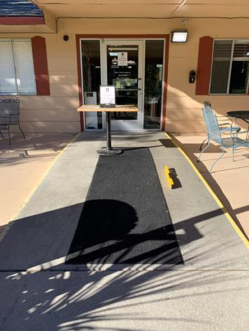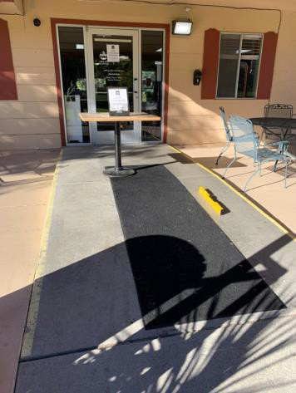

 | ID:  1508 | Facility:  Warm Springs Golf Course

Location: Clubhouse Men's Restroom
Schedule: 2022
Estimated Cost: $100.00

Priority Score 7
Quick Fix: Yes
Built before ADA: Yes

VIOLATIONS
2010 ADA Standards for Accessible Design Codes §603.3
The mirror is too high to be accessible at 54" above the floor.

RECOMMENDATIONS
Lower the mirror its bottom edge is a maximum height of 40" above the floor.

PHOTOGRAPH(S) OF THIS LOCATION

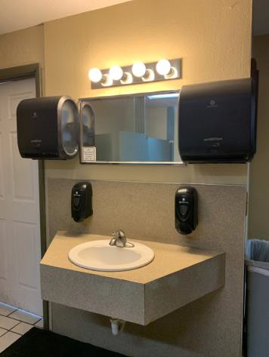

 | ID:  1499 | Facility:  Warm Springs Golf Course

Location: Clubhouse Men's Restroom
Schedule: 2021
Estimated Cost: $100.00

Priority Score 7
Quick Fix: Yes
Built before ADA: Yes

VIOLATIONS
2010 ADA Standards for Accessible Design Codes §309.4
The door knob requires twisting of the wrist.

RECOMMENDATIONS
Replace the door knob with a lever handle that can be operated with a closed fist and without twisting the wrist.

PHOTOGRAPH(S) OF THIS LOCATION

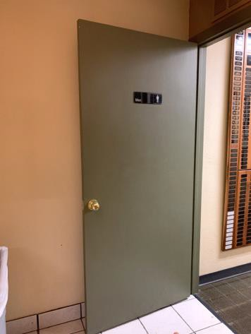

 | ID:  1510 | Facility:  Warm Springs Golf Course

Location: Clubhouse Men's Restroom
Schedule: 2021
Estimated Cost: $100.00

Priority Score 7
Quick Fix: Yes
Built before ADA: Yes

VIOLATIONS
2010 ADA Standards for Accessible Design Codes §606.5
The pipes under the sink are not covered.

RECOMMENDATIONS
Wrap the pipes beneath the sink with soft protective wrap or plastic.

PHOTOGRAPH(S) OF THIS LOCATION

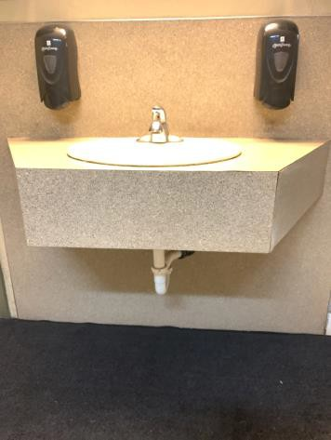

 | ID:  4485 | Facility:  Warm Springs Golf Course

Location: Clubhouse Men's Restroom
Schedule: 2021
Estimated Cost: $100.00

Priority Score 3
Quick Fix: Yes
Built before ADA: Yes

VIOLATIONS
2010 ADA Standards for Accessible Design Codes §216.2, §703
There is no tactile sign identifying the permanent room.

RECOMMENDATIONS
Install tactile signage on the latch side of the doorway at a height of 48” minimum to 60” maximum above the floor, identifying room by name or room number.
Signs shall be Braille with raised lettering and should be placed on the wall in the center of an 18"x18" clear floor space

PHOTOGRAPH(S) OF THIS LOCATION

 | ID:  1509 | Facility:  Warm Springs Golf Course

Location: Clubhouse Men's Restroom
Schedule: 2021
Estimated Cost: $200.00

Priority Score 8
Quick Fix: Yes
Built before ADA: Yes

VIOLATIONS
2010 ADA Standards for Accessible Design Codes §308.2.1
The paper towel dispensers are outside of the unobstructed forward reach range at 55" above the floor.

RECOMMENDATIONS
Lower the paper towel dispensers by 7" to meet the accessible reach range of 48" maximum above the floor.

PHOTOGRAPH(S) OF THIS LOCATION

 | ID:  1507 | Facility:  Warm Springs Golf Course

Location: Clubhouse Men's Restroom
Schedule: 2022
Estimated Cost: $1,000.00

Priority Score 5
Quick Fix: No
Built before ADA: Yes

VIOLATIONS
2010 ADA Standards for Accessible Design Codes §605.2
The urinal is 22.5" above the floor.

RECOMMENDATIONS
Lower the urinal to a maximum height of 17" above the floor.

PHOTOGRAPH(S) OF THIS LOCATION

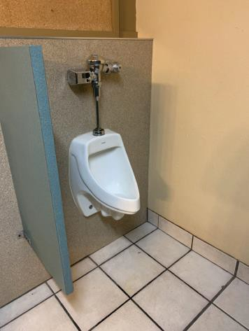

 | ID:  1505 | Facility:  Warm Springs Golf Course

Location: Clubhouse Men's Restroom - Ambulatory
Schedule: 2021
Estimated Cost: $100.00

Priority Score 5
Quick Fix: Yes
Built before ADA: Yes

VIOLATIONS
2010 ADA Standards for Accessible Design Codes §604.8.2.2
The door to the ambulatory water closet is not self closing. Either self-closing hinges are not installed on the door or if installed, they are defective.

RECOMMENDATIONS
Install or reinstall self-closing hinges on the door to ensure that the door is self-closing per the ADA requirements.

PHOTOGRAPH(S) OF THIS LOCATION

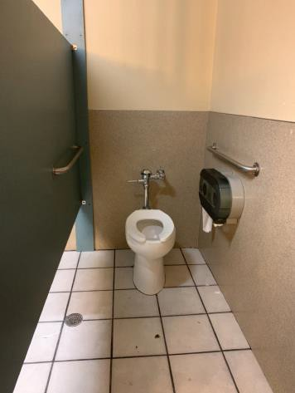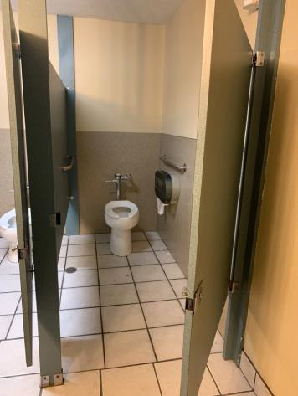

 | ID:  1503 | Facility:  Warm Springs Golf Course

Location: Clubhouse Men's Restroom - Ambulatory
Schedule: 2022
Estimated Cost: $1,000.00

Priority Score 5
Quick Fix: No
Built before ADA: Yes

VIOLATIONS
2010 ADA Standards for Accessible Design Codes §604.2
The centerline of the toilet is located 20.5" from the sidewall.

RECOMMENDATIONS
Reposition the centerline of the toilet to be within 16" minimum and 18" maximum from the sidewall.

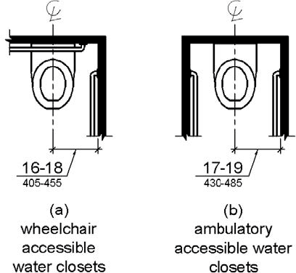

PHOTOGRAPH(S) OF THIS LOCATION

 | ID:  1506 | Facility:  Warm Springs Golf Course

Location: Clubhouse Men's Restroom - Ambulatory
Schedule: 2022
Estimated Cost: $2,500.00

Priority Score 5
Quick Fix: No
Built before ADA: Yes

VIOLATIONS
2010 ADA Standards for Accessible Design Codes §604.3.1, §213.3.1, §604.8.1.1, §604.5.1
The sied grab bars are located 8.5" and 7" from the rear wall and are 31" long.
There is not a wheelchair accessible stall in this restroom. The stall is too narrow at 42.5" wide.

RECOMMENDATIONS
Replace the side grab bar with one that is a minimum of 42" long minimum, located 12" maximum from the rear wall, and extending 54" from the rear wall.
Expand the restroom to ensure 60" minimum measured perpendicular from the side wall and 56" minimum measured perpendicular from the rear wall.

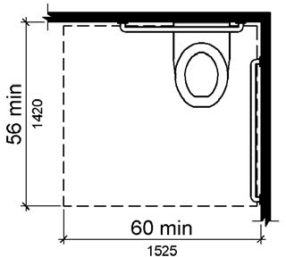

PHOTOGRAPH(S) OF THIS LOCATION

 | ID:  1483 | Facility:  Warm Springs Golf Course

Location: Clubhouse Outdoor Seating
Schedule: 2022
Estimated Cost: $1,000.00

Priority Score 5
Quick Fix: No
Built before ADA: Yes

VIOLATIONS
2010 ADA Standards for Accessible Design Codes §505.10
There are no handrail extensions for the ramp.

RECOMMENDATIONS
Extend the ramp handrails 12” horizontally beyond the top and bottom of ramp runs.

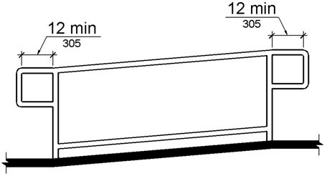

PHOTOGRAPH(S) OF THIS LOCATION

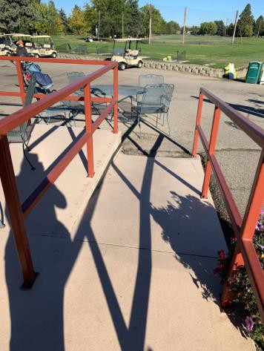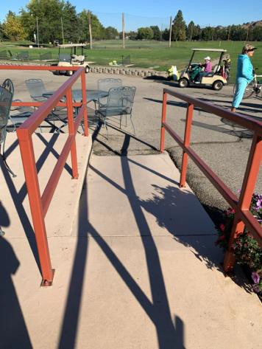

 | ID:  1482 | Facility:  Warm Springs Golf Course

Location: Clubhouse Outdoor Seating
Schedule: 2022
Estimated Cost: $2,500.00

Priority Score 7
Quick Fix: No
Built before ADA: Yes

VIOLATIONS
2010 ADA Standards for Accessible Design Codes §405.2
The running slope of the ramp ranges from 9.7% to 11.3%.

RECOMMENDATIONS
Reconstruct the ramp to reduce the running slope to a maximum of 8.3%.

PHOTOGRAPH(S) OF THIS LOCATION

 | ID:  1484 | Facility:  Warm Springs Golf Course

Location: Clubhouse Outdoor Seating
Schedule: 2022
Estimated Cost: $2,500.00

Priority Score 3
Quick Fix: No
Built before ADA: Yes

VIOLATIONS
2010 ADA Standards for Accessible Design Codes §405.9, §505.2
There is no handrail on the left side of the ramp. There is no edge protection on either side of the ramp.

RECOMMENDATIONS
Install a handrail at a minimum height of 34” and maximum of 38” above the ground. Make sure there are adequate handrail extensions both at the top and bottom of the handrail.
Install edge protection on either side of the ramp by extending the floor surface an additional 12" beyond the inside face of the handrails or by installing new handrails that have a lower barrier to prevent the passage of a 4" diameter sphere.

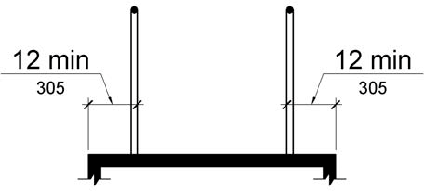

PHOTOGRAPH(S) OF THIS LOCATION

 | ID:  1487 | Facility:  Warm Springs Golf Course

Location: Clubhouse Pro Shop
Schedule: 2021
Estimated Cost: $100.00

Priority Score 5
Quick Fix: Yes
Built before ADA: Yes

VIOLATIONS
2010 ADA Standards for Accessible Design Codes §403.5.1
The path in the back of the pro shop is 28.5" wide.

RECOMMENDATIONS
Widen the path to allow for a minimum clear width of 36". This can be achieved by reorganizing the displays and relocating one of the golf club displays.

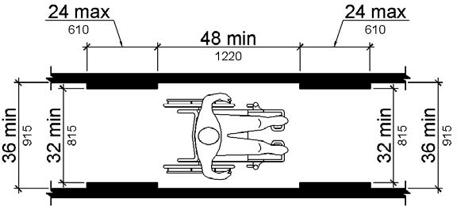

PHOTOGRAPH(S) OF THIS LOCATION

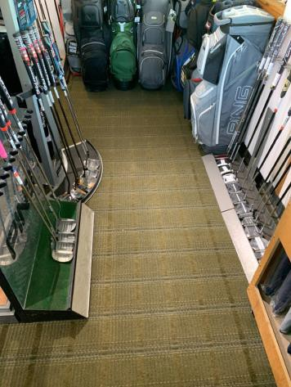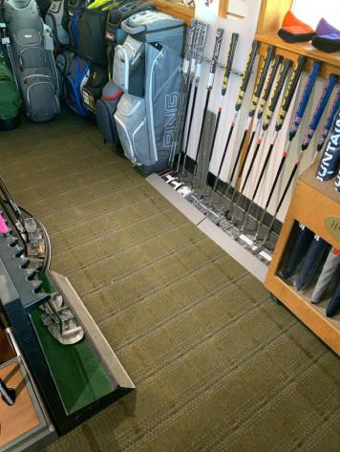

 | ID:  1488 | Facility:  Warm Springs Golf Course

Location: Clubhouse Pro Shop
Schedule: 2021
Estimated Cost: $100.00

Priority Score 5
Quick Fix: Yes
Built before ADA: Yes

VIOLATIONS
2010 ADA Standards for Accessible Design Codes §403.5.1
Due to the table, the circulation path is reduced to 22.5" wide.

RECOMMENDATIONS
Remove the table to widen the route to 36".

PHOTOGRAPH(S) OF THIS LOCATION

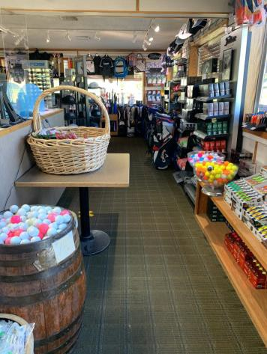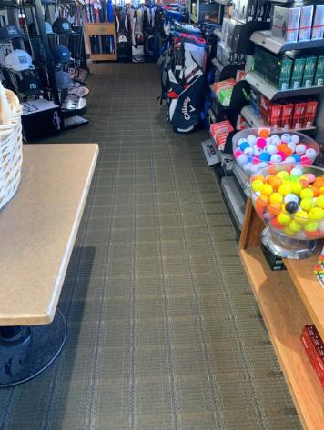

 | ID:  1490 | Facility:  Warm Springs Golf Course

Location: Clubhouse Women’s Restroom
Schedule: 2021
Estimated Cost: $100.00

Priority Score 8
Quick Fix: Yes
Built before ADA: Yes

VIOLATIONS
2010 ADA Standards for Accessible Design Codes §308.2.1
The hook is outside of the unobstructed forward reach range at 63" above the floor.

RECOMMENDATIONS
Lower the hook by 15" to meet the accessible reach range of 48" maximum above the floor.

PHOTOGRAPH(S) OF THIS LOCATION

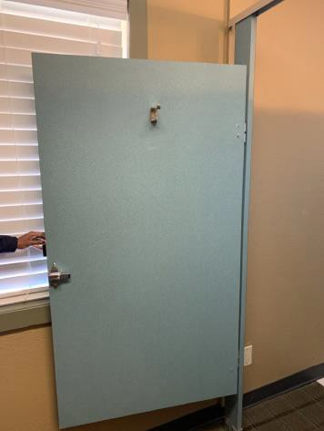

 | ID:  1497 | Facility:  Warm Springs Golf Course

Location: Clubhouse Women’s Restroom
Schedule: 2021
Estimated Cost: $100.00

Priority Score 8
Quick Fix: Yes
Built before ADA: Yes

VIOLATIONS
2010 ADA Standards for Accessible Design Codes §308.2.1
The paper towel dispenser is outside of the unobstructed forward reach range at 55" above the floor.

RECOMMENDATIONS
Lower the paper towel dispenser by 7" to meet the accessible reach range of 48" maximum above the floor.

PHOTOGRAPH(S) OF THIS LOCATION

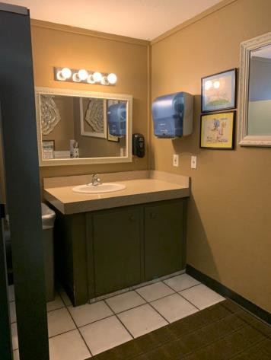

 | ID:  1498 | Facility:  Warm Springs Golf Course

Location: Clubhouse Women’s Restroom
Schedule: 2021
Estimated Cost: $100.00

Priority Score 7
Quick Fix: Yes
Built before ADA: Yes

VIOLATIONS
2010 ADA Standards for Accessible Design Codes §309.4
The door knob requires twisting of the wrist.

RECOMMENDATIONS
Replace the door knob with a lever handle that can be operated with a closed fist and without twisting the wrist.

PHOTOGRAPH(S) OF THIS LOCATION

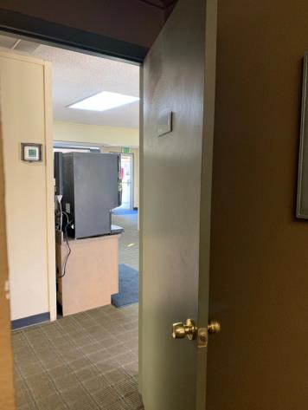
 | ID:  4486 | Facility:  Warm Springs Golf Course

Location: Clubhouse Women’s Restroom
Schedule: 2021
Estimated Cost: $100.00

Priority Score 3
Quick Fix: Yes
Built before ADA: Yes

VIOLATIONS
2010 ADA Standards for Accessible Design Codes §216.2, §703
There is no tactile sign identifying the permanent room.

RECOMMENDATIONS
Install tactile signage on the latch side of the doorway at a height of 48” minimum to 60” maximum above the floor, identifying room by name or room number.
Signs shall be Braille with raised lettering and should be placed on the wall in the center of an 18"x18" clear floor space.

PHOTOGRAPH(S) OF THIS LOCATION

 | ID:  1495 | Facility:  Warm Springs Golf Course

Location: Clubhouse Women’s Restroom
Schedule: 2022
Estimated Cost: $1,000.00

Priority Score 5
Quick Fix: No
Built before ADA: Yes

VIOLATIONS
2010 ADA Standards for Accessible Design Codes §606.3, §306.3.3
There is no knee clearance underneath the sink. The sink is 35.25" above the floor.

RECOMMENDATIONS
Provide knee clearance underneath the counter at the sink that is a minimum of 11" deep at 9" above the floor and 8" deep at 27" above the floor.
Lower the sink to a maximum height of 34" above the floor.

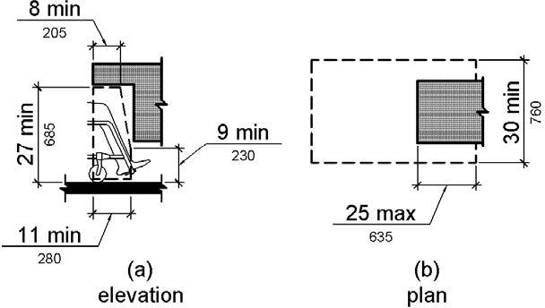

PHOTOGRAPH(S) OF THIS LOCATION

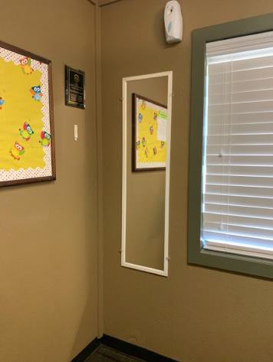

 | ID:  1491 | Facility:  Warm Springs Golf Course

Location: Clubhouse Women’s Restroom
Schedule: 2022
Estimated Cost: $5,000.00

Priority Score 5
Quick Fix: No
Built before ADA: Yes

VIOLATIONS
2010 ADA Standards for Accessible Design Codes §604.8.1.1, §604.5, §604.6
The flush control is located on the wall side of the toilet. The toilet compartment size is too small at 43" wide and 76.5" long.
There are no grab bars.

RECOMMENDATIONS
Either make the toilet flush automatically or relocate the flush control to be operated on the open side of the toilet. Expand the non-accessible stall to be one 60" wide wheelchair accessible toilet stall, complying with §604.8.
Install a side and rear grab bar at a minimum height of 33” and maximum height of 36” above the floor. The side grab bar shall have a minimum length of 42”. The side grab bar shall be a maximum of 12” from the back wall.

PHOTOGRAPH(S) OF THIS LOCATION

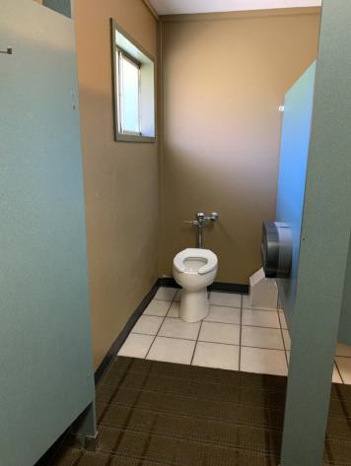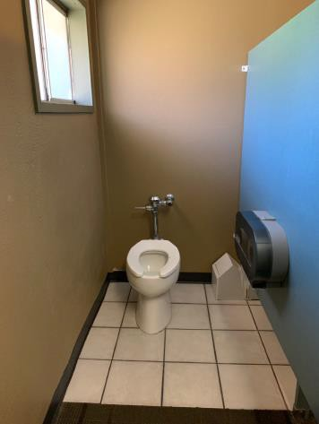

 | ID:  1551 | Facility:  Warm Springs Golf Course

Location: Driving Range
Schedule: 2021
Estimated Cost: $2,500.00

Priority Score 3
Quick Fix: No
Built before ADA: Yes

VIOLATIONS
2010 ADA Standards for Accessible Design Codes §305.2
The clear floor spaces at the first three driving range bays have a 4.4%, 3.8%, and 2.7% slope.

RECOMMENDATIONS
Reconstruct one of the driving range bays so that the 30"x48" clear floor space to have a maximum slope of 2% in all directions.
In the interests of Human Centered Design, consider reconstructing all three of the driving range bays to comply with §305.2.

PHOTOGRAPH(S) OF THIS LOCATION

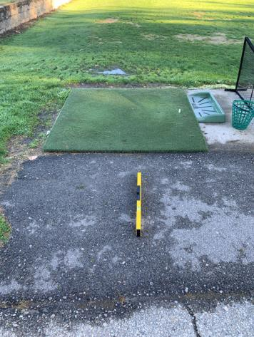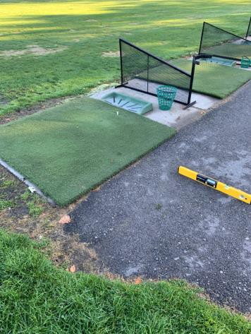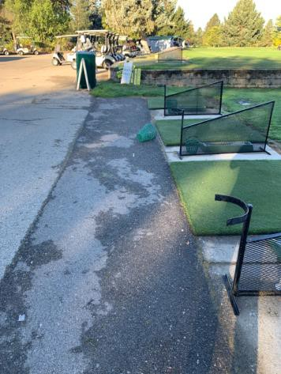

 | ID:  1517 | Facility:  Warm Springs Golf Course

Location: Hole 15 Men’s Restroom
Schedule: 2022
Estimated Cost: $1,000.00

Priority Score 5
Quick Fix: No
Built before ADA: Yes

VIOLATIONS
2010 ADA Standards for Accessible Design Codes §604.5.1
The side grab bar is 53" long.

RECOMMENDATIONS
Replace the side grab bar with one that is a minimum of 42" long minimum, located 12" maximum from the rear wall and extending 54" minimum from the rear wall.

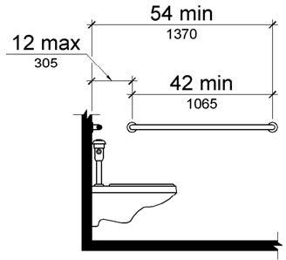

PHOTOGRAPH(S) OF THIS LOCATION

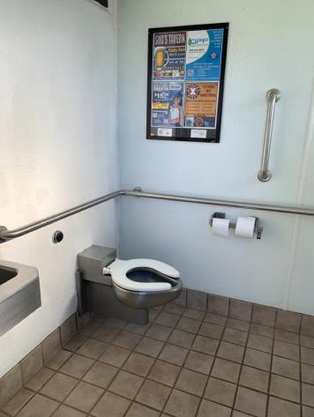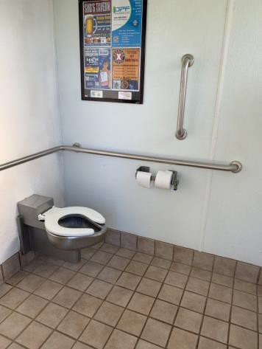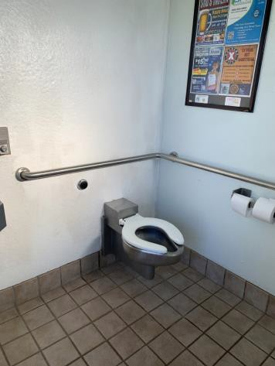

 | ID:  1524 | Facility:  Warm Springs Golf Course

Location: Hole 15 Restrooms
Schedule: 2021
Estimated Cost: $5,000.00

Priority Score 3
Quick Fix: No
Built before ADA: Yes

VIOLATIONS
2010 ADA Standards for Accessible Design Codes §302.1, §305
There is not a firm, stable, and slip resistant route to the restrooms from the golf cart path.

RECOMMENDATIONS
Construct a firm, stable, and slip resistant accessible route with a maximum cross slope of 2% and maximum running slope of 5% from the golf cart parking to the restroom entrance.
Ensure that the cement in front of the restroom doors is a minimum of 60" deep to allow for accessible maneuvering clearance and turning space. Additionally, the accessible route shall be a minimum of 36" wide.

PHOTOGRAPH(S) OF THIS LOCATION

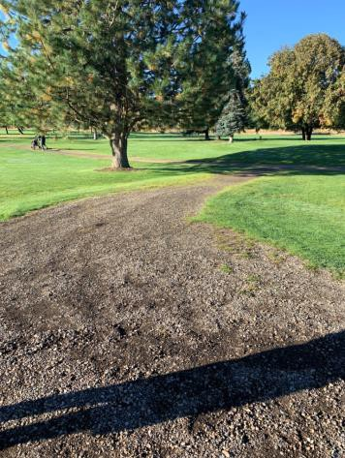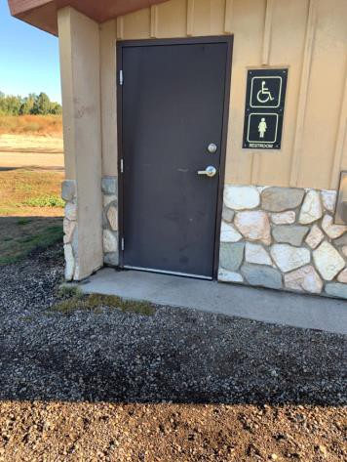

 | ID:  1522 | Facility:  Warm Springs Golf Course

Location: Hole 15 Women’s Restroom
Schedule: 2022
Estimated Cost: $1,000.00

Priority Score 5
Quick Fix: No
Built before ADA: Yes

VIOLATIONS
2010 ADA Standards for Accessible Design Codes §604.5.1
The side grab bar is 52" long.

RECOMMENDATIONS
Replace the side grab bar with one that is a minimum of 42" long minimum, located 12" maximum from the rear wall and extending 54" minimum from the rear wall.

PHOTOGRAPH(S) OF THIS LOCATION

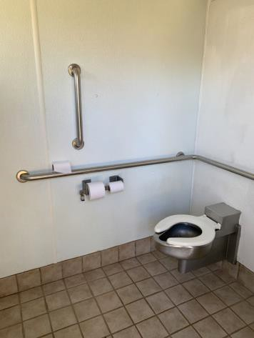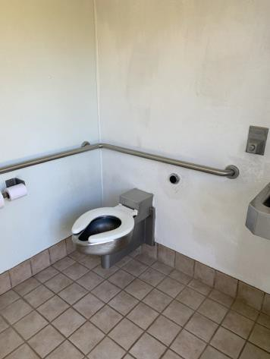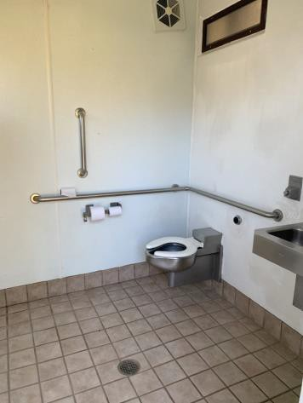

 | ID:  1530 | Facility:  Warm Springs Golf Course

Location: Maintenance Shed
Schedule: 2021
Estimated Cost: $0.00

Priority Score 0
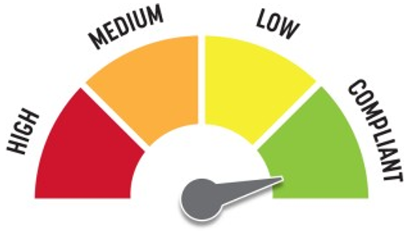
Quick Fix: Yes
Built before ADA: Yes

VIOLATIONS
2010 ADA Standards for Accessible Design Codes §308.2.2
The microwave is outside of the obstructed forward reach range at 64" above the floor.

RECOMMENDATIONS
If requested, lower the microwave to the counter.

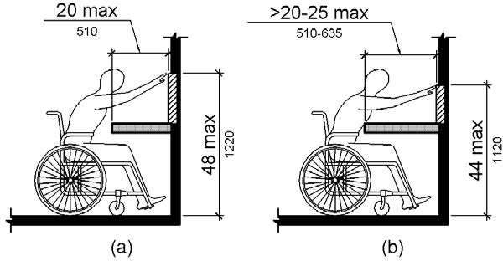

PHOTOGRAPH(S) OF THIS LOCATION

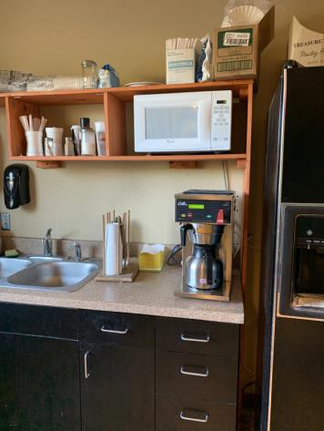

 | ID:  1526 | Facility:  Warm Springs Golf Course

Location: Maintenance Shed
Schedule: 2021
Estimated Cost: $100.00

Priority Score 5
Quick Fix: Yes
Built before ADA: Yes

VIOLATIONS
2010 ADA Standards for Accessible Design Codes §307.2, §308.2.1
The hand sanitizer is outside of the unobstructed forward reach range at 64" above the floor. The hand sanitizer protrudes 7" into the circulation space at 67" above the floor.

RECOMMENDATIONS
Lower the hand sanitizer by 16" to meet the accessible reach range of 48" maximum above the floor.
Recess the hand sanitizer so it protrudes a maximum of 4" or place a cane detectable object beneath it.

PHOTOGRAPH(S) OF THIS LOCATION

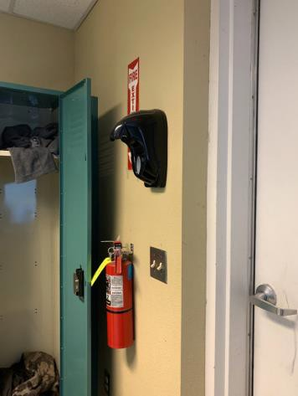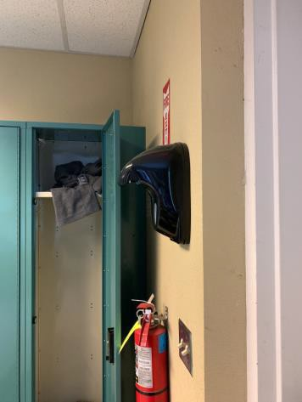

 | ID:  1529 | Facility:  Warm Springs Golf Course

Location: Maintenance Shed
Schedule: 2021
Estimated Cost: $100.00

Priority Score 8
Quick Fix: Yes
Built before ADA: Yes

VIOLATIONS
2010 ADA Standards for Accessible Design Codes §308.2.2
The paper towel dispenser is outside of the obstructed forward reach range at 50" above the floor.

RECOMMENDATIONS
Lower the paper towel dispenser by 2" to meet the accessible reach range of 48" maximum above the floor.

PHOTOGRAPH(S) OF THIS LOCATION

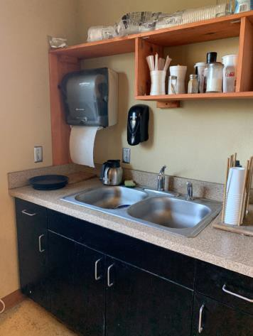

 | ID:  1531 | Facility:  Warm Springs Golf Course

Location: Maintenance Shed
Schedule: 2021
Estimated Cost: $100.00

Priority Score 5
Quick Fix: Yes
Built before ADA: Yes

VIOLATIONS
2010 ADA Standards for Accessible Design Codes §307.2
The TV protrudes 4.5" into the circulation space at 71" above the floor.

RECOMMENDATIONS
Recess the TV so it protrudes a maximum of 4", raise it so the bottom edge is 80" maximum above the floor, or place a cane detectable object beneath it.

PHOTOGRAPH(S) OF THIS LOCATION

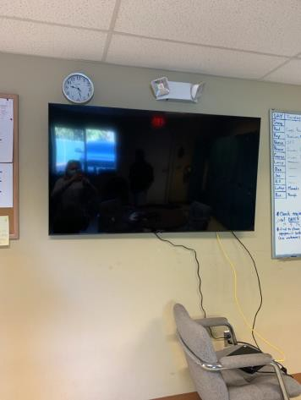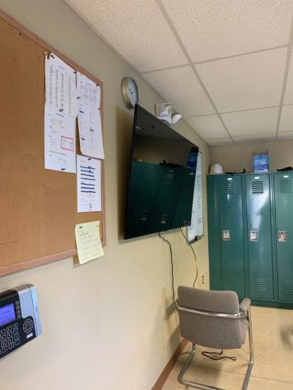

 | ID:  1532 | Facility:  Warm Springs Golf Course

Location: Maintenance Shed
Schedule: 2021
Estimated Cost: $100.00

Priority Score 8
Quick Fix: Yes
Built before ADA: Yes

VIOLATIONS
2010 ADA Standards for Accessible Design Codes §308.2.1
The hooks are outside of the unobstructed forward reach range at 73" above the floor.

RECOMMENDATIONS
Ensure 5% of the hooks are lowered to be a maximum of 48" above the floor.

PHOTOGRAPH(S) OF THIS LOCATION

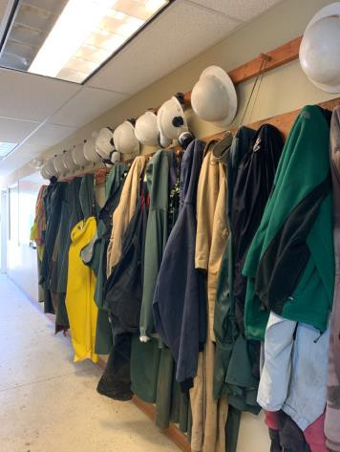

 | ID:  1533 | Facility:  Warm Springs Golf Course

Location: Maintenance Shed
Schedule: 2021
Estimated Cost: $100.00

Priority Score 5
Quick Fix: Yes
Built before ADA: Yes

VIOLATIONS
2010 ADA Standards for Accessible Design Codes §307.2
The paper towel dispenser protrudes 7.5" into the circulation space at 48" above the floor.

RECOMMENDATIONS
Remove the protruding paper towel dispenser.
Remove the pallet and cardboard box from underneath the paper towel dispenser to provide a 30"x48" clear floor space.

PHOTOGRAPH(S) OF THIS LOCATION

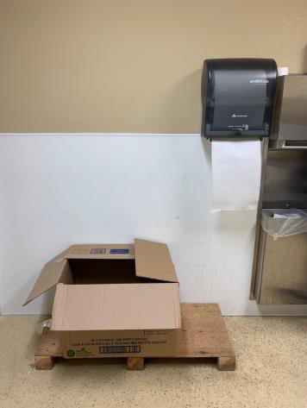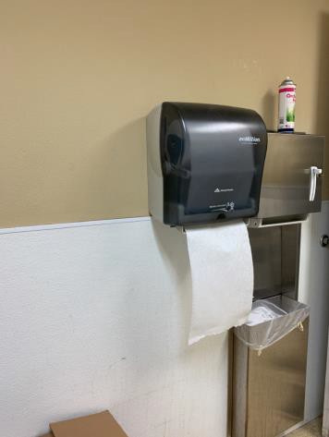

 | ID:  1536 | Facility:  Warm Springs Golf Course

Location: Maintenance Shed
Schedule: 2021
Estimated Cost: $100.00

Priority Score 6
Quick Fix: Yes
Built before ADA: Yes

VIOLATIONS
2010 ADA Standards for Accessible Design Codes §302.3, §608.7
There is a lip at the entry of the shower is 1" tall.

RECOMMENDATIONS
Remove the rubber lip to create a flat surface.

PHOTOGRAPH(S) OF THIS LOCATION

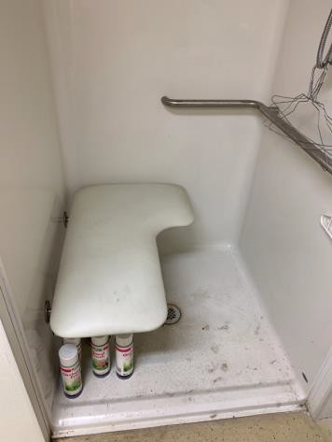

 | ID:  1543 | Facility:  Warm Springs Golf Course

Location: Maintenance Shed
Schedule: 2021
Estimated Cost: $100.00

Priority Score 7
Quick Fix: Yes
Built before ADA: Yes

VIOLATIONS
2010 ADA Standards for Accessible Design Codes §603.3
The mirror is too high to be accessible at 42" above the floor.

RECOMMENDATIONS
Lower the mirror so its bottom edge is a maximum height of 40" above the floor.

PHOTOGRAPH(S) OF THIS LOCATION

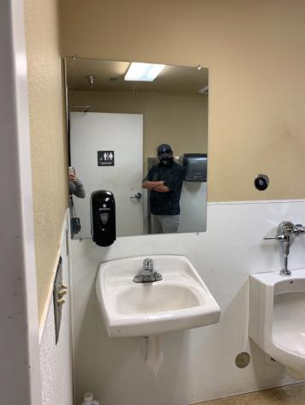

 | ID:  1544 | Facility:  Warm Springs Golf Course

Location: Maintenance Shed
Schedule: 2021
Estimated Cost: $100.00

Priority Score 8
Quick Fix: Yes
Built before ADA: Yes

VIOLATIONS
2010 ADA Standards for Accessible Design Codes §308.2.1
The hand sanitizer is outside of the unobstructed forward reach range at 59" above the floor.

RECOMMENDATIONS
Lower the hand sanitizer by 11" to meet the accessible reach range of 48" maximum above the floor.

PHOTOGRAPH(S) OF THIS LOCATION

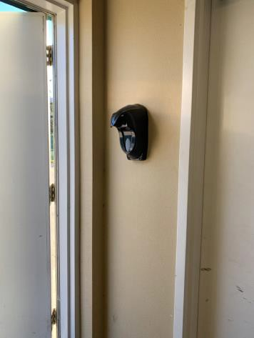

 | ID:  1550 | Facility:  Warm Springs Golf Course

Location: Maintenance Shed
Schedule: 2021
Estimated Cost: $100.00

Priority Score 9
Quick Fix: Yes
Built before ADA: Yes

VIOLATIONS
2010 ADA Standards for Accessible Design Codes §502.6
The sign at the accessible parking space is 59.5" above the ground.

RECOMMENDATIONS
Remount the accessible parking sign at a minimum height of 60" above the ground.

PHOTOGRAPH(S) OF THIS LOCATION

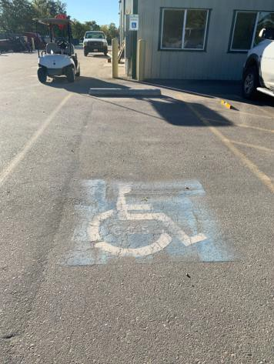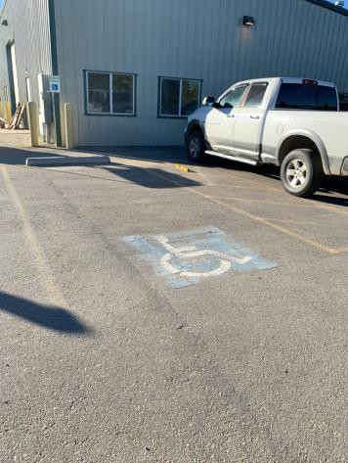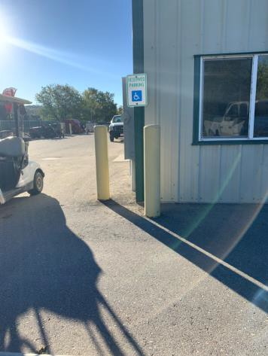

 | ID:  1527 | Facility:  Warm Springs Golf Course

Location: Maintenance Shed
Schedule: 2021
Estimated Cost: $200.00

Priority Score 3
Quick Fix: Yes
Built before ADA: Yes

VIOLATIONS
2010 ADA Standards for Accessible Design Codes §216.4, §703
Doors serving as exits are not marked by tactile signage.

RECOMMENDATIONS
Place a tactile exit sign, that complies with §703.1, §703.2 and §703.5, identifying the exit doors.
Install missing signage at 48" minimum above the floor measured from the baseline of the lowest character and 60" maximum measured from the baseline of the highest character.

PHOTOGRAPH(S) OF THIS LOCATION

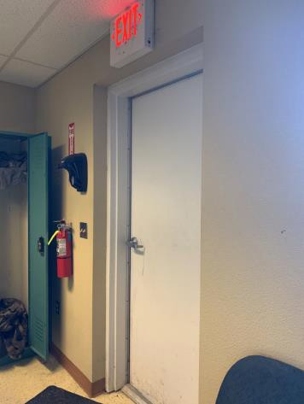

 | ID:  1537 | Facility:  Warm Springs Golf Course

Location: Maintenance Shed
Schedule: 2021
Estimated Cost: $500.00

Priority Score 6
Quick Fix: Yes
Built before ADA: Yes

VIOLATIONS
2010 ADA Standards for Accessible Design Codes §607.6
The adjustable shower head is 68" above the floor.

RECOMMENDATIONS
Install a secondary handheld shower that is mounted a maximum of 48" above the floor.

PHOTOGRAPH(S) OF THIS LOCATION

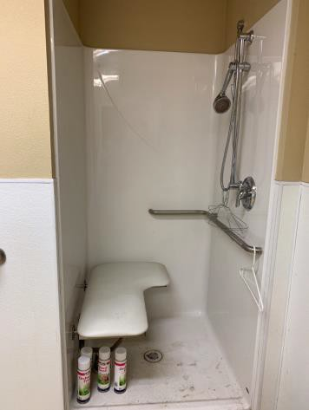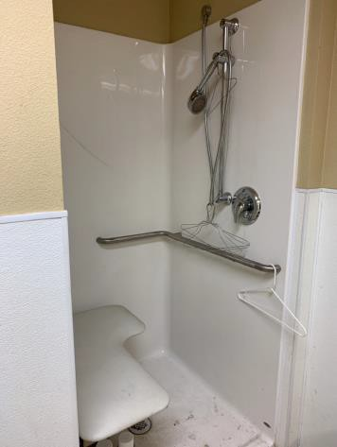

 | ID:  1540 | Facility:  Warm Springs Golf Course

Location: Maintenance Shed
Schedule: 2021
Estimated Cost: $500.00

Priority Score 5
Quick Fix: Yes
Built before ADA: Yes

VIOLATIONS
2010 ADA Standards for Accessible Design Codes §604.5.1
The side grab bar is located 6.5" from the rear wall.

RECOMMENDATIONS
Remount the side grab bar 12" maximum from the rear wall and extending 54" minimum from the rear wall.

PHOTOGRAPH(S) OF THIS LOCATION

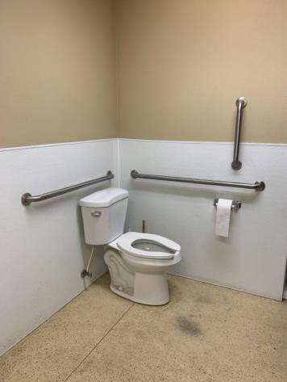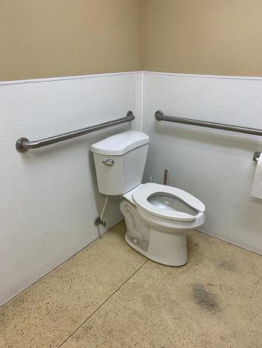

 | ID:  1548 | Facility:  Warm Springs Golf Course

Location: Maintenance Shed
Schedule: 2021
Estimated Cost: $600.00

Priority Score 3
Quick Fix: No
Built before ADA: Yes

VIOLATIONS
2010 ADA Standards for Accessible Design Codes §216.2, §703
There are no tactile signs identifying six permanent room.

RECOMMENDATIONS
Install tactile signage on the latch side of the doorway at a height of 48” minimum to 60” maximum above the floor, identifying room by name or room number.
Signs shall be Braille with raised lettering and should be placed on the wall in the center of an 18"x18" clear floor space.

PHOTOGRAPH(S) OF THIS LOCATION

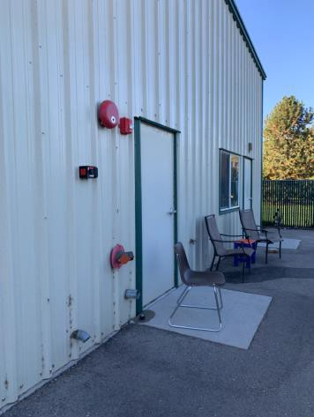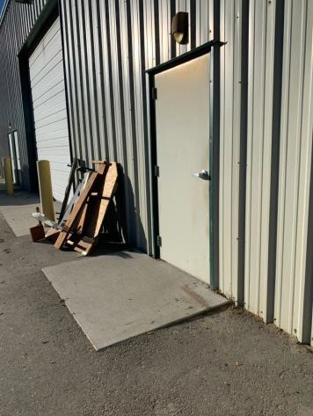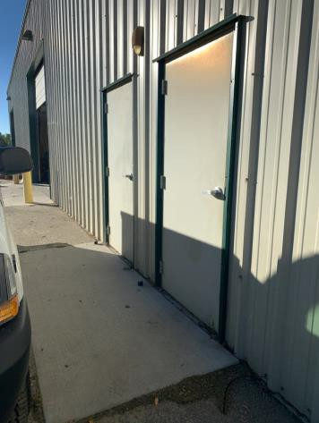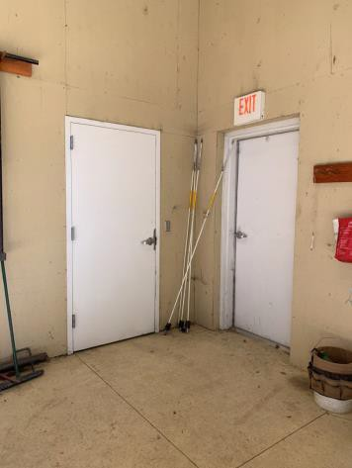

 | ID:  1545 | Facility:  Warm Springs Golf Course

Location: Maintenance Shed
Schedule: 2023
Estimated Cost: $1,000.00

Priority Score 8
Quick Fix: No
Built before ADA: Yes

VIOLATIONS
2010 ADA Standards for Accessible Design Codes §404.2.4.4
The entrance has a 2.5%-2.8% slope.

RECOMMENDATIONS
Resurface the entryway to reduce the running slope to a maximum of 2% in all directions for a distance of 60".

PHOTOGRAPH(S) OF THIS LOCATION

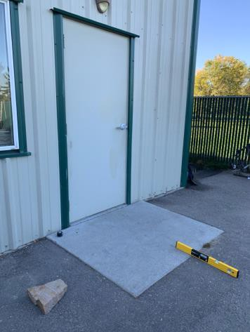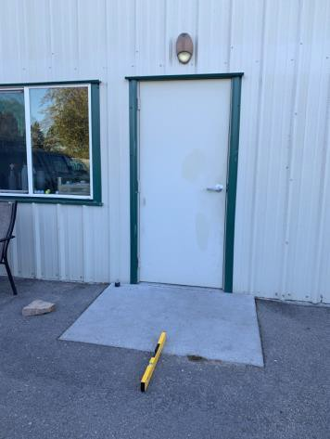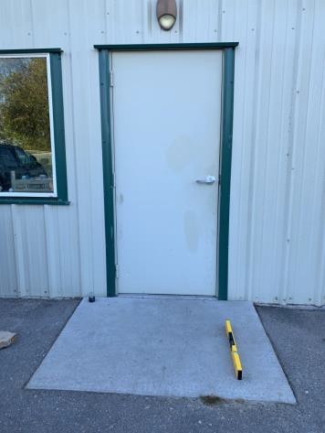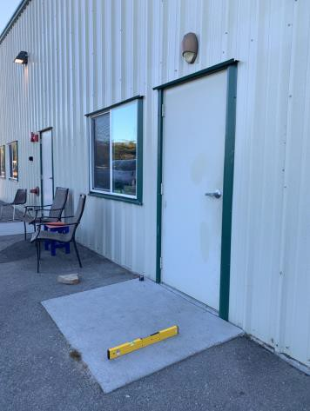

 | ID:  1546 | Facility:  Warm Springs Golf Course

Location: Maintenance Shed
Schedule: 2023
Estimated Cost: $1,000.00

Priority Score 8
Quick Fix: No
Built before ADA: Yes

VIOLATIONS
2010 ADA Standards for Accessible Design Codes §404.2.4.4
The entrance has a 2.4% slope.

RECOMMENDATIONS
Resurface the entryway to reduce the running slope to a maximum of 2% in all directions for a distance of 60".

PHOTOGRAPH(S) OF THIS LOCATION

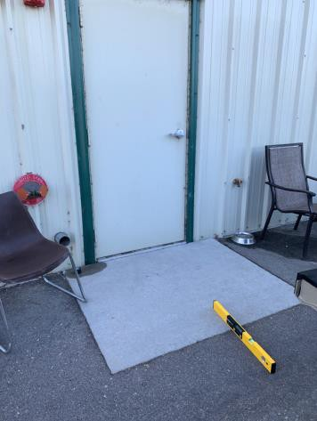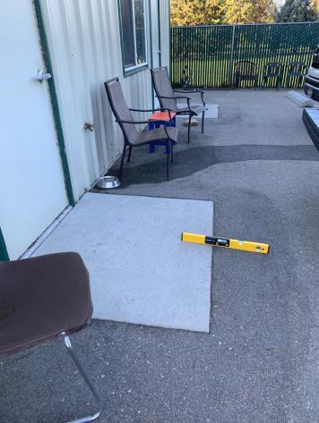

 | ID:  1549 | Facility:  Warm Springs Golf Course

Location: Maintenance Shed
Schedule: 2023
Estimated Cost: $1,000.00

Priority Score 9
Quick Fix: No
Built before ADA: Yes

VIOLATIONS
2010 ADA Standards for Accessible Design Codes §502
The painted lines for the accessible parking spaces are faded.

RECOMMENDATIONS
Restripe and repaint the accessible parking spaces, access aisles, and ISA symbols.

PHOTOGRAPH(S) OF THIS LOCATION

 | ID:  1535 | Facility:  Warm Springs Golf Course

Location: Maintenance Shed
Schedule: 2022
Estimated Cost: $1,000.00

Priority Score 6
Quick Fix: No
Built before ADA: Yes

VIOLATIONS
2010 ADA Standards for Accessible Design Codes §608.3, §609
The back wall grab bar is 16.5" long.

RECOMMENDATIONS
Install a back wall grab bar to a point 18" from the control wall at a maximum height of 36" above the bathroom floor.

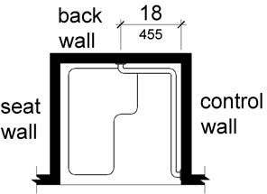

PHOTOGRAPH(S) OF THIS LOCATION

 | ID:  1475 | Facility:  Warm Springs Golf Course

Location: Parking
Schedule: 2021
Estimated Cost: $200.00

Priority Score 9
Quick Fix: Yes
Built before ADA: Yes

VIOLATIONS
2010 ADA Standards for Accessible Design Codes §502.6
The accessible parking signs are 45" and 51" above the ground.

RECOMMENDATIONS
Remount the accessible parking signs at a minimum height of 60" above the ground.

PHOTOGRAPH(S) OF THIS LOCATION

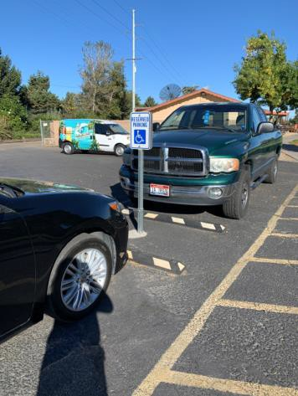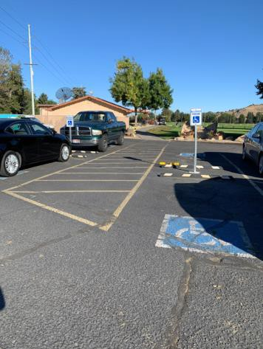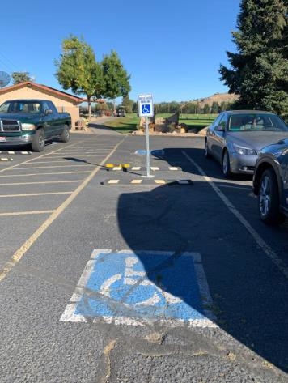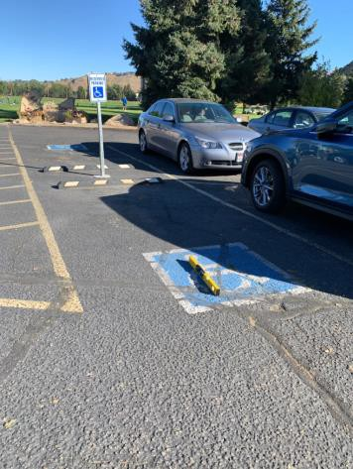

 | ID:  1473 | Facility:  Warm Springs Golf Course

Location: Parking
Schedule: 2021
Estimated Cost: $1,000.00

Priority Score 3
Quick Fix: No
Built before ADA: Yes

VIOLATIONS
2010 ADA Standards for Accessible Design Codes §302.1
There are tripping hazards in the accessible route.

RECOMMENDATIONS
Repave the area of the sidewalk to remove the hazard.

PHOTOGRAPH(S) OF THIS LOCATION

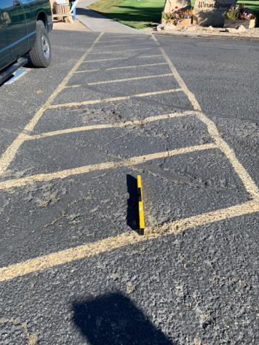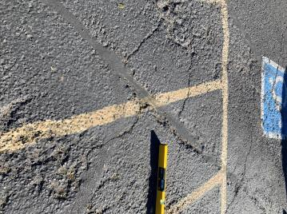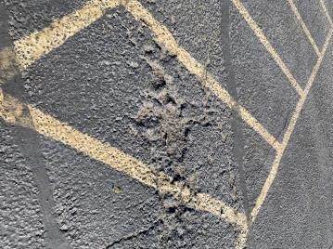

 | ID:  1476 | Facility:  Warm Springs Golf Course

Location: Parking
Schedule: 2021
Estimated Cost: $1,000.00

Priority Score 3
Quick Fix: No
Built before ADA: Yes

VIOLATIONS
2010 ADA Standards for Accessible Design Codes §502.4
The parking space has a 2.5% slope.

RECOMMENDATIONS
Resurface the parking space to reduce the slope to a maximum of 2% in all directions.

PHOTOGRAPH(S) OF THIS LOCATION

 | ID:  1474 | Facility:  Warm Springs Golf Course

Location: Parking
Schedule: 2021
Estimated Cost: $2,500.00

Priority Score 3
Quick Fix: No
Built before ADA: Yes

VIOLATIONS
2010 ADA Standards for Accessible Design Codes §208.2.4, §208.2
There is a total of 134 parking spaces and four accessible parking spaces. There are no marked "Van accessible" spaces.

RECOMMENDATIONS
Add one 132" wide van accessible parking space. Install a 60" wide access aisle connecting to an accessible route.
Add a “van accessible” parking sign at a minimum height of 60" above the ground.

PHOTOGRAPH(S) OF THIS LOCATION

 | ID:  1472 | Facility:  Warm Springs Golf Course

Location: Parking
Schedule: 2021
Estimated Cost: $5,000.00

Priority Score 3
Quick Fix: No
Built before ADA: Yes

VIOLATIONS
2010 ADA Standards for Accessible Design Codes §502.4
The parking space and access aisle have a 4% slope.

RECOMMENDATIONS
Reconstruct the parking space and access aisle to reduce the slope to a maximum of 2% in all directions.

PHOTOGRAPH(S) OF THIS LOCATION

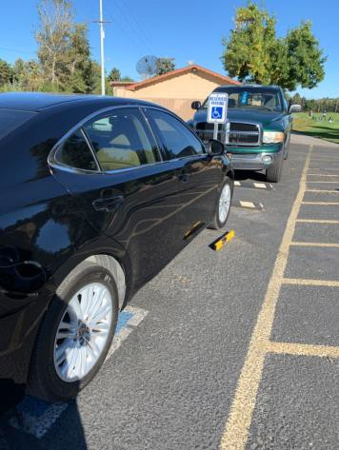

 | ID:  1515 | Facility:  Warm Springs Golf Course

Location: Pavilion
Schedule: 2021
Estimated Cost: $500.00

Priority Score 3
Quick Fix: Yes
Built before ADA: Yes

VIOLATIONS
2010 ADA Standards for Accessible Design Codes §403.5.1, §226.1, §902, §305, §306
The provided picnic tables do not have an accessible clear space for a wheelchair user.
There is not a clear 36" width for wheelchairs to pass between the picnic tables at the pavilion

RECOMMENDATIONS
Add/replace picnic tables so that at least 5% of the seating is wheelchair accessible. Reorganize or remove the picnic tables from the pavilion to allow for compliant 36" wide accessible paths to access the tables.
Ensure that the wheelchair accessible seating has a clear floor space of 30" x 48" with a slope not steeper than 2% and that the tables have sufficient knee and toe clearance.

PHOTOGRAPH(S) OF THIS LOCATION

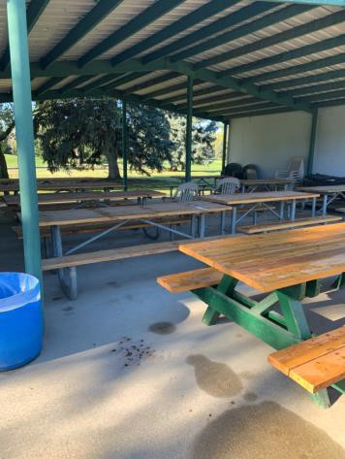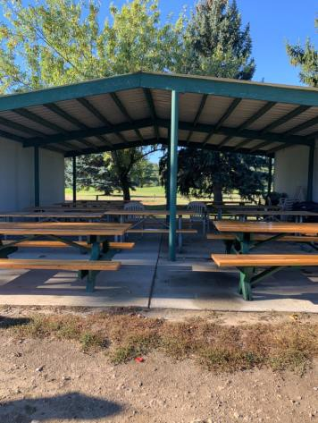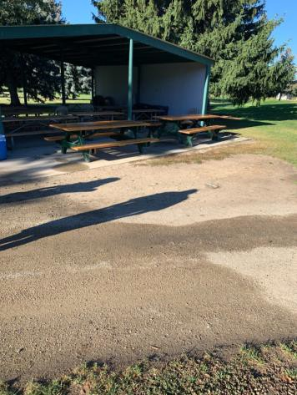

 | ID:  1514 | Facility:  Warm Springs Golf Course

Location: Pavilion
Schedule: 2021
Estimated Cost: $5,000.00

Priority Score 3
Quick Fix: No
Built before ADA: Yes

VIOLATIONS
2010 ADA Standards for Accessible Design Codes §302.1, §305
There is not a firm, stable, and slip resistant route to the garbage cans and benches.

RECOMMENDATIONS
Construct a firm, stable, and slip resistant accessible route with a maximum cross slope of 2% and maximum running slope of 5%. Relocate a portion of the benches and garbage cans to be adjacent to the new path to the pavilion.

PHOTOGRAPH(S) OF THIS LOCATION

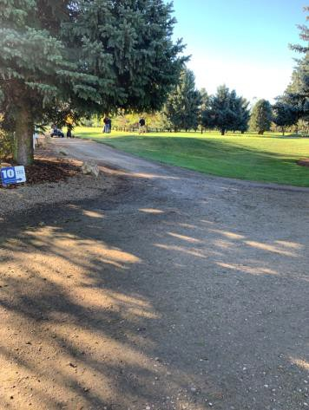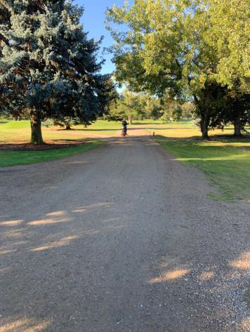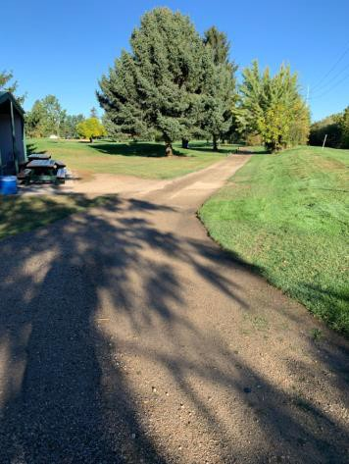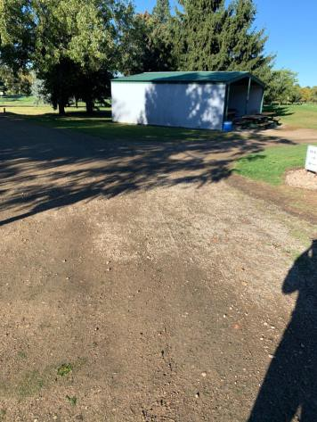

 | ID:  1513 | Facility:  Warm Springs Golf Course

Location: Pavilion
Schedule: 2021
Estimated Cost: $10,000.00

Priority Score 3
Quick Fix: No
Built before ADA: Yes

VIOLATIONS
2010 ADA Standards for Accessible Design Codes §302.1, §305
There is not a firm, stable, and slip resistant route to the pavilion.

RECOMMENDATIONS
Construct a firm, stable, and slip resistant accessible route with a maximum cross slope of 2% and maximum running slope of 5%.

PHOTOGRAPH(S) OF THIS LOCATION

 | ID:  1478 | Facility:  Warm Springs Golf Course

Location: Route to Clubhouse from Parking
Schedule: 2021
Estimated Cost: $200.00

Priority Score 7
Quick Fix: Yes
Built before ADA: Yes

VIOLATIONS
2010 ADA Standards for Accessible Design Codes §302.1, §305
There is not a firm, stable, and slip resistant route to the garbage can or bench.

RECOMMENDATIONS
Move the garbage can and bench adjacent to the accessible route.

PHOTOGRAPH(S) OF THIS LOCATION

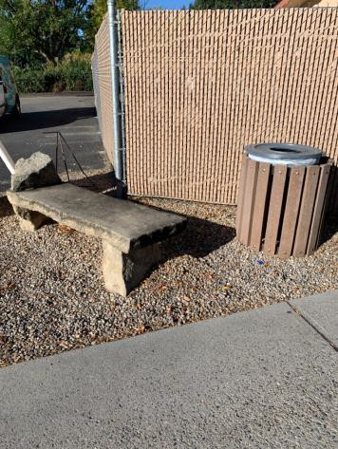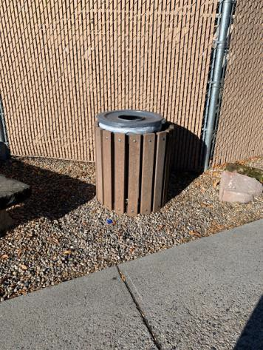

 | ID:  1477 | Facility:  Warm Springs Golf Course

Location: Route to Clubhouse from Parking
Schedule: 2021
Estimated Cost: $500.00

Priority Score 3
Quick Fix: Yes
Built before ADA: Yes

VIOLATIONS
2010 ADA Standards for Accessible Design Codes §302.3
There is a 2.5" gap in the accessible route posing a tripping hazard.

RECOMMENDATIONS
Fill in the gap to ensure that it is a maximum of 0.5" wide.

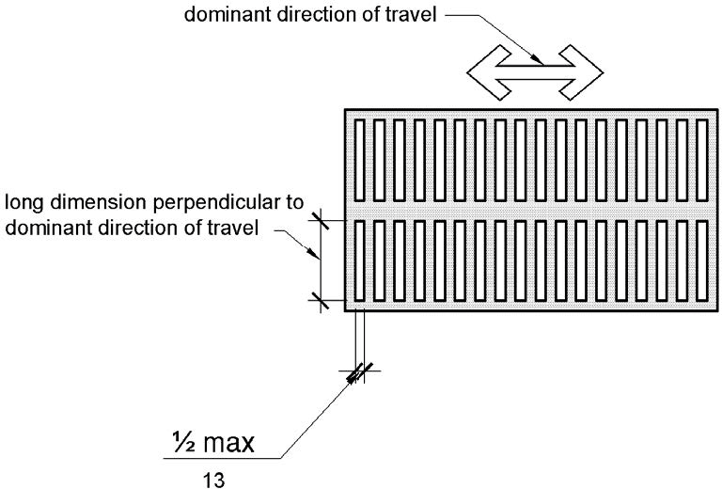

PHOTOGRAPH(S) OF THIS LOCATION

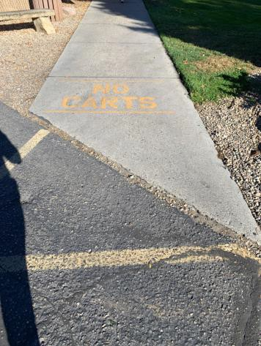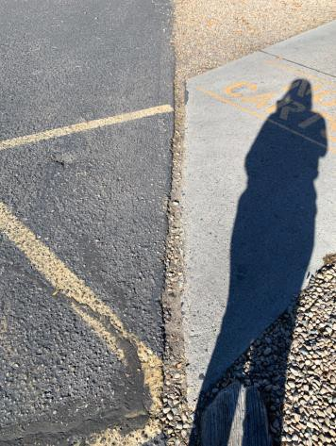

 | ID:  1481 | Facility:  Warm Springs Golf Course

Location: Route to Clubhouse from Parking
Schedule: 2021
Estimated Cost: $500.00

Priority Score 5
Quick Fix: Yes
Built before ADA: Yes

VIOLATIONS
2010 ADA Standards for Accessible Design Codes §303.2
There is a 0.75" change in level.

RECOMMENDATIONS
Resurface the pathway to reduce the change in level to 0.5" if beveled.

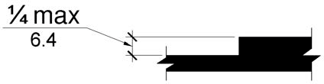

PHOTOGRAPH(S) OF THIS LOCATION

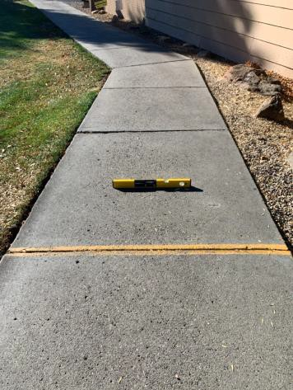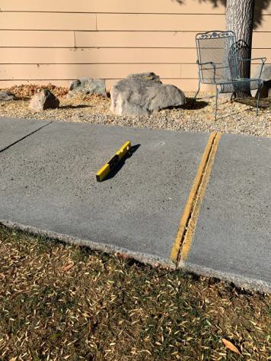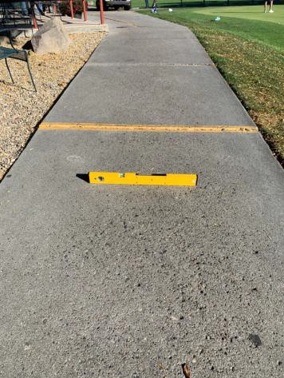

 | ID:  1479 | Facility:  Warm Springs Golf Course

Location: Route to Clubhouse from Parking
Schedule: 2021
Estimated Cost: $1,000.00

Priority Score 3
Quick Fix: No
Built before ADA: Yes

VIOLATIONS
2010 ADA Standards for Accessible Design Codes §304.2
The turning space has a 5.6% slope.

RECOMMENDATIONS
Resurface the turning space to reduce the slope to the maximum allowable 2% in all directions.

PHOTOGRAPH(S) OF THIS LOCATION

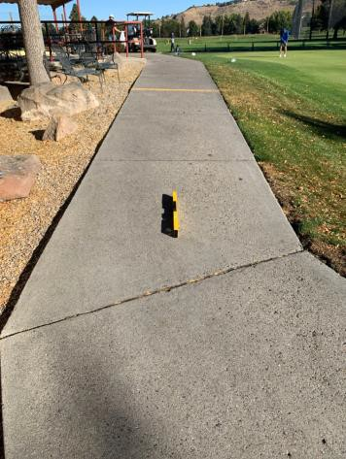

 | ID:  1480 | Facility:  Warm Springs Golf Course

Location: Route to Clubhouse from Parking
Schedule: 2021
Estimated Cost: $2,500.00

Priority Score 3
Quick Fix: No
Built before ADA: Yes

VIOLATIONS
2010 ADA Standards for Accessible Design Codes §403.3
The cross slope is 5.2%.

RECOMMENDATIONS
Reconstruct the route to reduce the cross slope to a maximum of 2%.

PHOTOGRAPH(S) OF THIS LOCATION

