City of Boise
ADA Assessment

Appendix A – Lander Street Water Pollution Control Facility

04/16/2021
Report # TO21-B025

Prepared by:

 | ID:  1554 | Facility:  Lander Street - Water Pollution Control Facility

Location: Admin Building
Schedule: 2022
Estimated Cost: $1,000.00

Priority Score 5
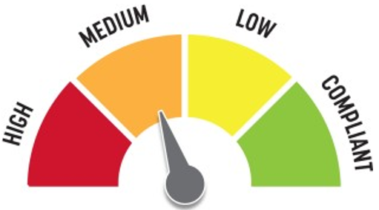
Quick Fix: No
Built before ADA::Yes

VIOLATIONS
2010 ADA Standards for Accessible Design Codes §303.2
There is a change in level greater than 0.25".

RECOMMENDATIONS
Resurface the pathway to reduce the change in level to less than 0.25" or 0.5" if beveled.

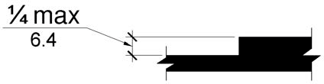

PHOTOGRAPH(S) OF THIS LOCATION

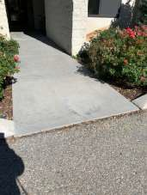

 | ID:  1555 | Facility:  Lander Street - Water Pollution Control Facility

Location: Admin Building
Schedule: 2021
Estimated Cost: $1,000.00

Priority Score 8
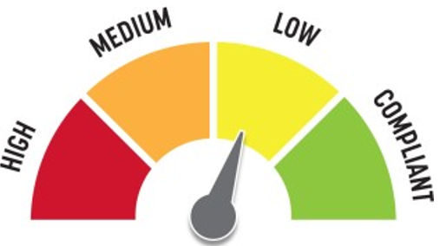
Quick Fix: No
Built before ADA: Yes

VIOLATIONS
2010 ADA Standards for Accessible Design Codes §904.4.1
The counter is 42" above the floor.

RECOMMENDATIONS
A portion of the service counter must be no higher than 36” above the floor for a horizontal distance of 36”.

PHOTOGRAPH(S) OF THIS LOCATION

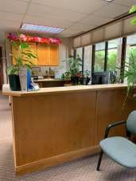

 | ID:  1553 | Facility:  Lander Street - Water Pollution Control Facility

Location: Admin Building
Schedule: 2021
Estimated Cost: $2,000.00

Priority Score 3
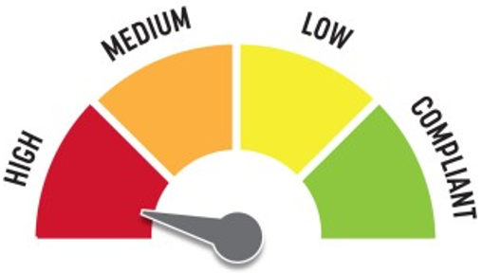
Quick Fix: No
Built before ADA: Yes

VIOLATIONS
2010 ADA Standards for Accessible Design Codes §208.2
There are 27 parking spaces. None of the parking spaces are marked for accessibility.

RECOMMENDATIONS
Install two accessible parking spaces that are a minimum of 96" wide. Ensure that the accessible parking spaces are marked as "van" accessible.
Install 60" wide access aisles connecting to an accessible route. Install signs 60" above the ground.

PHOTOGRAPH(S) OF THIS LOCATION

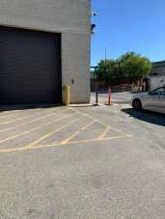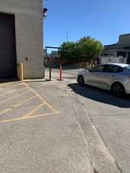

 | ID:  1610 | Facility:  Lander Street - Water Pollution Control Facility

Location: Admin Building Conference Room
Schedule: 2021
Estimated Cost: $0.00

Priority Score 0
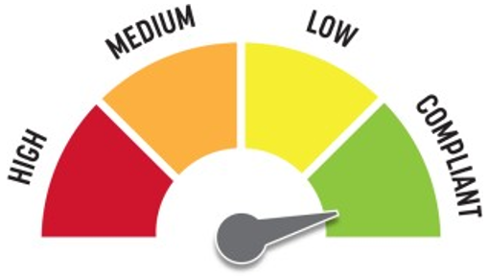
Quick Fix: Yes
Built before ADA: Yes

VIOLATIONS
2010 ADA Standards for Accessible Design Codes §308.2.2
The microwaves are outside of the obstructed forward reach range at 63" above the floor.

RECOMMENDATIONS
Although the microwaves are too high to be accessible, since they are not permanently mounted, they are acceptable in their current location. However, one must be lowered if requested by a qualified employee.

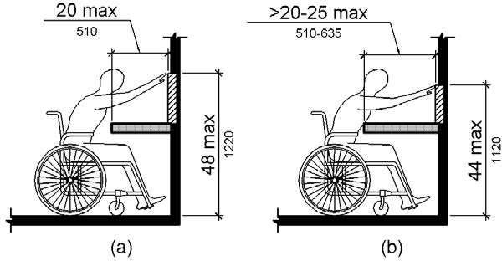

PHOTOGRAPH(S) OF THIS LOCATION

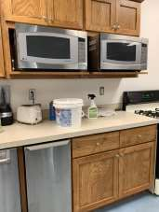

 | ID:  1612 | Facility:  Lander Street - Water Pollution Control Facility

Location: Admin Building Conference Room
Schedule: 2021
Estimated Cost: $100.00

Priority Score 8
Quick Fix: Yes
Built before ADA: Yes

VIOLATIONS
2010 ADA Standards for Accessible Design Codes §308.2.2
The paper towel dispenser is outside of the obstructed forward reach range at 51.5" above the floor.

RECOMMENDATIONS
Lower the paper towel dispenser by 7.5" to meet the accessible reach range of 44" maximum above the floor.

PHOTOGRAPH(S) OF THIS LOCATION

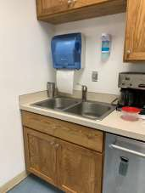

 | ID:  1613 | Facility:  Lander Street - Water Pollution Control Facility

Location: Admin Building Conference Room
Schedule: 2021
Estimated Cost: $100.00

Priority Score 8
Quick Fix: Yes
Built before ADA: Yes

VIOLATIONS
2010 ADA Standards for Accessible Design Codes §308.2.2
The soap dispenser is outside of the obstructed forward reach range at 64" above the floor.

RECOMMENDATIONS
Lower the soap dispenser by 20" to meet the accessible reach range of 44" maximum above the floor.

PHOTOGRAPH(S) OF THIS LOCATION

 | ID:  1614 | Facility:  Lander Street - Water Pollution Control Facility

Location: Admin Building Conference Room
Schedule: 2021
Estimated Cost: $100.00

Priority Score 5
Quick Fix: Yes
Built before ADA: Yes

VIOLATIONS
2010 ADA Standards for Accessible Design Codes §307.2
The computer box protrudes 5.25" into the circulation space at 32" above the floor.

RECOMMENDATIONS
Recess the computer box so it protrudes a maximum of 4" or place a cane detectable object beneath it.

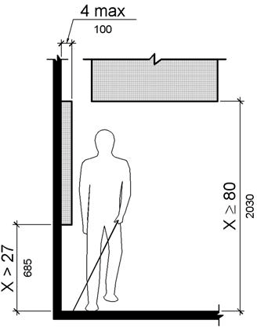

PHOTOGRAPH(S) OF THIS LOCATION

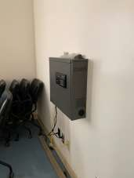

 | ID:  1616 | Facility:  Lander Street - Water Pollution Control Facility

Location: Admin Building Conference Room
Schedule: 2021
Estimated Cost: $100.00

Priority Score 5
Quick Fix: Yes
Built before ADA: Yes

VIOLATIONS
2010 ADA Standards for Accessible Design Codes §307.2
The TV protrudes 4.75" into the circulation space at 51" above the floor.

RECOMMENDATIONS
Recess the TV so it protrudes a maximum of 4", raise it so the bottom edge is 80" maximum above the floor, or place a cane detectable object beneath it.

PHOTOGRAPH(S) OF THIS LOCATION

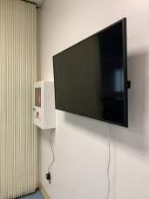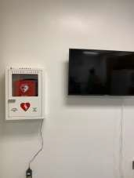
 | ID:  1616 | Facility:  Lander Street - Water Pollution Control Facility

Location: Admin Building Conference Room
Schedule: 2021
Estimated Cost: $100.00

Priority Score 5
Quick Fix: Yes
Built before ADA: Yes

VIOLATIONS
2010 ADA Standards for Accessible Design Codes §307.2
The first aid box protrudes 5" into the circulation space at 41.5" above the floor.

RECOMMENDATIONS
Recess the first aid box so it protrudes a maximum of 4" or place a cane detectable object beneath it.

PHOTOGRAPH(S) OF THIS LOCATION

 | ID:  1608 | Facility:  Lander Street - Water Pollution Control Facility

Location: Admin Building Conference Room
Schedule: 2022
Estimated Cost: $1,000.00

Priority Score 6
Quick Fix: No
Built before ADA: Yes

VIOLATIONS
2010 ADA Standards for Accessible Design Codes §211.2, §602.7
There is only one drinking fountain provided at 33.5" above the floor.

RECOMMENDATIONS
Install an additional drinking fountain at a minimum spout height of 38" and maximum of 43" above the floor.

PHOTOGRAPH(S) OF THIS LOCATION

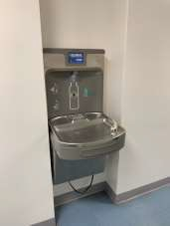

 | ID:  1609 | Facility:  Lander Street - Water Pollution Control Facility

Location: Admin Building Conference Room
Schedule: 2022
Estimated Cost: $2,000.00

Priority Score 5
Quick Fix: No
Built before ADA: Yes

VIOLATIONS
2010 ADA Standards for Accessible Design Codes §902.3, §606.3, §306.3.3
There is no knee clearance underneath the sink.
The dining and work surface counter is 36" above the floor. The sink is 36" above the floor.

RECOMMENDATIONS
Provide knee clearance underneath the counter at the sink that is a minimum of 11" deep at 9" above the floor and 8" deep at 27" above the floor.
A portion of the dining and work surface must be no higher than 34” above the floor. Lower the sink to the maximum height of 34" above the floor.

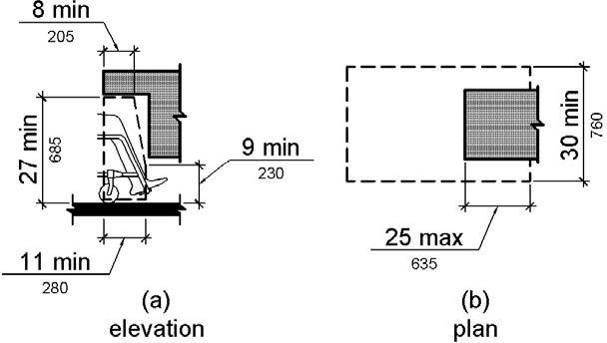

PHOTOGRAPH(S) OF THIS LOCATION

 | ID:  1574 | Facility:  Lander Street - Water Pollution Control Facility

Location: Admin Building Men’s Locker Room
Schedule: 2021
Estimated Cost: $100.00

Priority Score 8
Quick Fix: Yes
Built before ADA: Yes

VIOLATIONS
2010 ADA Standards for Accessible Design Codes §308.2.1
The hooks are outside of the unobstructed forward reach range at 75" and 69" above the floor.

RECOMMENDATIONS
Lower at least one of the hooks to meet the accessible reach range of 48" maximum above the floor.

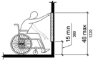

PHOTOGRAPH(S) OF THIS LOCATION

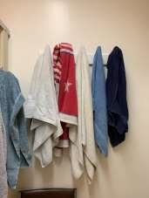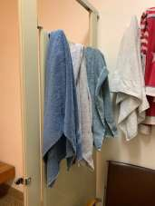

 | ID:  1588 | Facility:  Lander Street - Water Pollution Control Facility

Location: Admin Building Men's Locker Room
Schedule: 2021
Estimated Cost: $100.00

Priority Score 7
Quick Fix: Yes
Built before ADA: Yes

VIOLATIONS
2010 ADA Standards for Accessible Design Codes §606.5
The pipes under the sink are not covered.

RECOMMENDATIONS
Wrap the pipes beneath the sink with soft protective wrap or plastic.

PHOTOGRAPH(S) OF THIS LOCATION

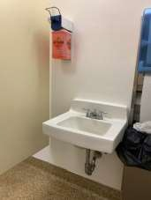

 | ID:  1589 | Facility:  Lander Street - Water Pollution Control Facility

Location: Admin Building Men's Locker Room
Schedule: 2021
Estimated Cost: $100.00

Priority Score 8
Quick Fix: Yes
Built before ADA: Yes

VIOLATIONS
2010 ADA Standards for Accessible Design Codes §308.2.1
The soap dispenser is outside of the unobstructed forward reach range at 61" above the floor.

RECOMMENDATIONS
Lower the soap dispenser by 13" to meet the accessible reach range of 48" maximum above the floor.

PHOTOGRAPH(S) OF THIS LOCATION

 | ID:  1572 | Facility:  Lander Street - Water Pollution Control Facility

Location: Admin Building Men's Locker Room
Schedule: 2021
Estimated Cost: $500.00

Priority Score 5
Quick Fix: Yes
Built before ADA: Yes

VIOLATIONS
2010 ADA Standards for Accessible Design Codes §308.2.2
The lockers are outside of the obstructed forward reach range at 52" above the floor.

RECOMMENDATIONS
Lower a minimum of 5% of the lockers by 4" to 48" maximum above the floor.

PHOTOGRAPH(S) OF THIS LOCATION

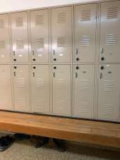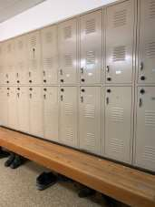

 | ID:  1573 | Facility:  Lander Street - Water Pollution Control Facility

Location: Admin Building Men's Locker Room
Schedule: 2021
Estimated Cost: $500.00

Priority Score 5
Quick Fix: Yes
Built before ADA: Yes

VIOLATIONS
2010 ADA Standards for Accessible Design Codes §903.3
The bench is 16" deep.

RECOMMENDATIONS
Install a new bench that is at least 42" long and 20" to 24" inches deep ensuring that at least 5% of the seating is accessible. Ensure that the back on the accessible section remains against the lockers.

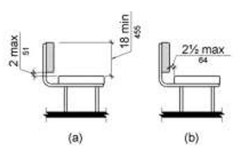

PHOTOGRAPH(S) OF THIS LOCATION

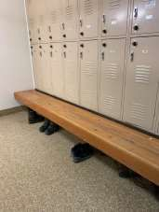

 | ID:  1587 | Facility:  Lander Street - Water Pollution Control Facility

Location: Admin Building Men’s Locker Room
Schedule: 2022
Estimated Cost: $1,000.00

Priority Score 5
Quick Fix: No
Built before ADA: Yes

VIOLATIONS
2010 ADA Standards for Accessible Design Codes §605.2
The urinal is 24.5" above the floor.

RECOMMENDATIONS
Lower the urinal to a maximum height of 17" above the floor.

PHOTOGRAPH(S) OF THIS LOCATION

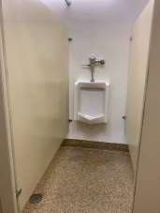

 | ID:  1581 | Facility:  Lander Street - Water Pollution Control Facility

Location: Admin Building Men's Locker Room
Schedule: 2022
Estimated Cost: $5,000.00

Priority Score 6
Quick Fix: No
Built before ADA: Yes

VIOLATIONS
2010 ADA Standards for Accessible Design Codes §608.2.1
The shower dimensions do not meet the requirements for a transfer type shower at 32"x32", has an 8" step, and is lacking accessible hardware.

RECOMMENDATIONS
Expand one of the transfer type shower compartments to meet the minimum dimensions of 36"x36" measured at the center points of opposing sides with a 36" wide minimum entry on the face of the shower compartment.
Ensure that grab bars, a shower seat, and accessible hardware is installed. Ensure that the lip at the shower entrance is a maximum of 0.5" high.

PHOTOGRAPH(S) OF THIS LOCATION

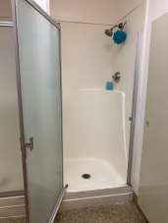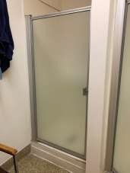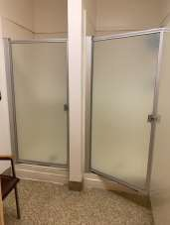

 | ID:  4503 | Facility:  Lander Street - Water Pollution Control Facility

Location: Admin Building Men’s Locker Room - Ambulatory
Schedule: 2022
Estimated Cost: $1,000.00

Priority Score 5
Quick Fix: No
Built before ADA: Yes

VIOLATIONS
2010 ADA Standards for Accessible Design Codes ICC A117.1 §604.5.1
The accessible water closet does not have a vertical grab bar.

RECOMMENDATIONS
Install an 18" long (minimum) vertical grab bar on the side wall. The grab bar shall be mounted with the bottom located at 39" minimum and 41" maximum above the floor.
The centerline of the vertical grab bar shall be located 39" minimum and 41" maximum from the rear wall.

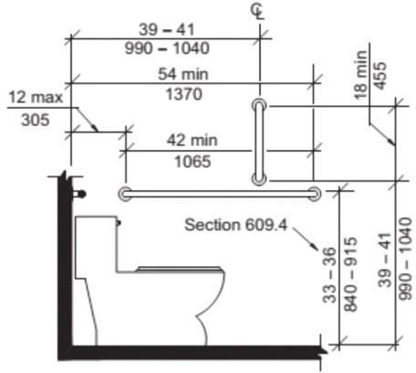

PHOTOGRAPH(S) OF THIS LOCATION

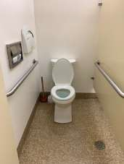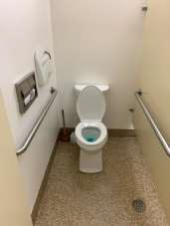

 | ID:  1584 | Facility:  Lander Street - Water Pollution Control Facility

Location: Admin Building Men’s Locker Room - Ambulatory
Schedule: 2021
Estimated Cost: $5,000.00

Priority Score 5
Quick Fix: No
Built before ADA: Yes

VIOLATIONS
2010 ADA Standards for Accessible Design Codes §604.5.1, §213.3.1, §604.8.1.1
There is not an accessible stall provided.
The side grab bar is 43" long and is located 10.5" from the rear wall therefore, the side grab bar extends 53.5" from the rear wall.

RECOMMENDATIONS
Expand the restroom to ensure 60" minimum measured perpendicular from the side wall and 56" minimum measured perpendicular from the rear wall. Adjust the fixtures accordingly.
Remount the side grab bar 12" maximum from the rear wall and extending 54" minimum from the rear wall.

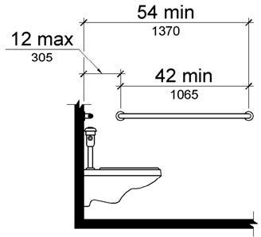

PHOTOGRAPH(S) OF THIS LOCATION

 | ID:  1568 | Facility:  Lander Street - Water Pollution Control Facility

Location: Admin Building Men’s Restroom
Schedule: 2021
Estimated Cost: $100.00

Priority Score 5
Quick Fix: Yes
Built before ADA: Yes

VIOLATIONS
2010 2010 ADA Standards for Accessible Design Codes §604.7
The toilet paper dispenser is located out of the accessible reach range at the rim of the toilet.

RECOMMENDATIONS
Remount the toilet paper dispenser to 7” minimum and 9” maximum in front of the water closet measured to the centerline of the dispenser.
The outlet of the dispenser shall be 15” minimum and 48” maximum above the floor and shall not be located behind the grab bar.

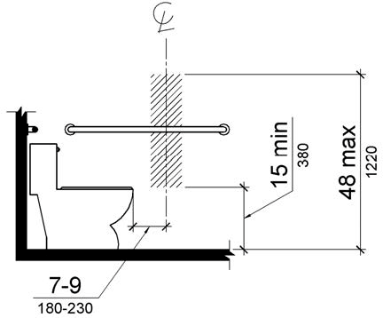

PHOTOGRAPH(S) OF THIS LOCATION

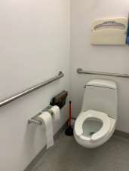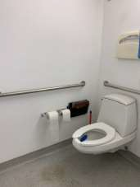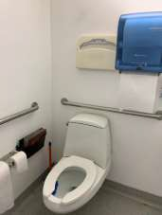

 | ID:  1569 | Facility:  Lander Street - Water Pollution Control Facility

Location: Admin Building Men's Restroom
Schedule: 2021
Estimated Cost: $100.00

Priority Score 8
Quick Fix: Yes
Built before ADA: Yes

VIOLATIONS
2010 ADA Standards for Accessible Design Codes §308.2.1
The toilet seat covers are outside of the unobstructed forward reach range at 57" above the floor.

RECOMMENDATIONS
Lower the toilet seat covers by 9" to meet the accessible reach range of 48" maximum above the floor and is not within 12" of the top of the grab bar.

PHOTOGRAPH(S) OF THIS LOCATION

 | ID:  1570 | Facility:  Lander Street - Water Pollution Control Facility

Location: Admin Building Men's Restroom
Schedule: 2021
Estimated Cost: $100.00

Priority Score 8
Quick Fix: Yes
Built before ADA: Yes

VIOLATIONS
2010 ADA Standards for Accessible Design Codes §308.2.1
The paper towel dispenser is outside of the unobstructed forward reach range at 50.5" above the floor.

RECOMMENDATIONS
Lower the paper towel dispenser by 2.5" to meet the accessible reach range of 48" maximum above the floor and is not within 12" of the top of the grab bar.

PHOTOGRAPH(S) OF THIS LOCATION

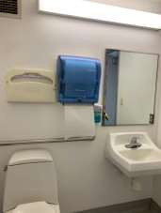

 | ID:  1565 | Facility:  Lander Street - Water Pollution Control Facility

Location: Admin Building Men's Restroom
Schedule: 2021
Estimated Cost: $500.00

Priority Score 5
Quick Fix: Yes
Built before ADA: Yes

VIOLATIONS
2010 ADA Standards for Accessible Design Codes §604.5.2
The rear grab bar is located 11.5" to the center of the toilet.

RECOMMENDATIONS
Remount the rear grab bar 12" minimum on one side and 24" minimum on the other.

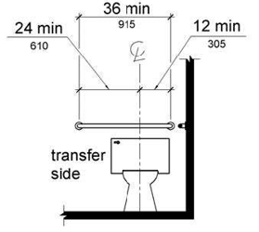

PHOTOGRAPH(S) OF THIS LOCATION

 | ID:  1566 | Facility:  Lander Street - Water Pollution Control Facility

Location: Admin Building Men's Restroom
Schedule: 2022
Estimated Cost: $1,000.00

Priority Score 5
Quick Fix: No
Built before ADA: Yes

VIOLATIONS
2010 ADA Standards for Accessible Design Codes ICC A117.1 §604.5.1
The accessible water closet does not have a vertical grab bar.

RECOMMENDATIONS
Install an 18" long (minimum) vertical grab bar on the side wall. The grab bar shall be mounted with the bottom located at 39" minimum and 41" maximum above the floor.
The centerline of the vertical grab bar shall be located 39" minimum and 41" maximum from the rear wall.

PHOTOGRAPH(S) OF THIS LOCATION

 | ID:  1567 | Facility:  Lander Street - Water Pollution Control Facility

Location: Admin Building Men's Restroom
Schedule: 2022
Estimated Cost: $1,000.00

Priority Score 5
Quick Fix: No
Built before ADA: Yes

VIOLATIONS
2010 ADA Standards for Accessible Design Codes §604.2
The centerline of the toilet is located 20" from the sidewall.

RECOMMENDATIONS
Reposition the centerline of the toilet to be within 16" minimum and 18" maximum from the sidewall.

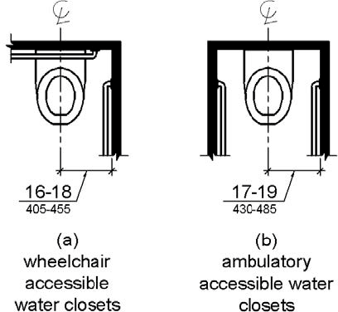

PHOTOGRAPH(S) OF THIS LOCATION

 | ID:  4493 | Facility:  Lander Street - Water Pollution Control Facility

Location: Admin Building Men's Restroom
Schedule: 2022
Estimated Cost: $1,000.00

Priority Score 5
Quick Fix: No
Built before ADA: Yes

VIOLATIONS
2010 ADA Standards for Accessible Design Codes §604.6
The flush control is located on the wall side of the toilet.

RECOMMENDATIONS
Either make the toilet flush automatically or relocate the flush control to be operated on the open side of the toilet.

PHOTOGRAPH(S) OF THIS LOCATION

 | ID:  4504 | Facility:  Lander Street - Water Pollution Control Facility

Location: Admin Building Men's Restroom
Schedule: 2022
Estimated Cost: $1,000.00

Priority Score 5
Quick Fix: No
Built before ADA: Yes

VIOLATIONS
2010 ADA Standards for Accessible Design Codes ICC A117.1 §604.5.1
The accessible water closet does not have a vertical grab bar.

RECOMMENDATIONS
Install an 18" long (minimum) vertical grab bar on the side wall. The grab bar shall be mounted with the bottom located at 39" minimum and 41" maximum above the floor.
The centerline of the vertical grab bar shall be located 39" minimum and 41" maximum from the rear wall.

PHOTOGRAPH(S) OF THIS LOCATION

 | ID:  1571 | Facility:  Lander Street - Water Pollution Control Facility

Location: Admin Building Restrooms
Schedule: 2021
Estimated Cost: $100.00

Priority Score 6
Quick Fix: Yes
Built before ADA: Yes

VIOLATIONS
2010 ADA Standards for Accessible Design Codes §703.4
The tactile sign identifying the room is not in the correct location.

RECOMMENDATIONS
Reinstall the sign on the latch side of the door at 48" minimum above the floor measured from the baseline of the lowest character and 60" maximum measured from the baseline of the highest character.

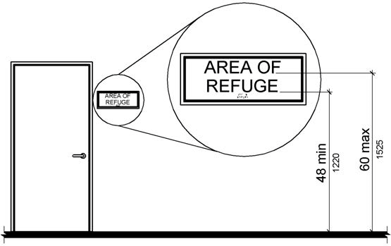

PHOTOGRAPH(S) OF THIS LOCATION

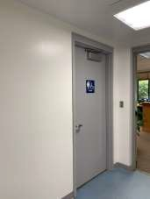

 | ID:  1592 | Facility:  Lander Street - Water Pollution Control Facility

Location: Admin Building Women's Locker Room
Schedule: 2021
Estimated Cost: $100.00

Priority Score 8
Quick Fix: Yes
Built before ADA: Yes

VIOLATIONS
2010 ADA Standards for Accessible Design Codes §308.2.1
The hooks are outside of the unobstructed forward reach range at 61" above the floor.

RECOMMENDATIONS
Lower at least one hook to meet the accessible reach range of 48" above the floor.

PHOTOGRAPH(S) OF THIS LOCATION

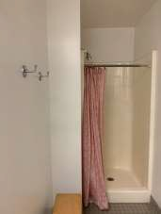

 | ID:  1597 | Facility:  Lander Street - Water Pollution Control Facility

Location: Admin Building Women's Locker Room
Schedule: 2021
Estimated Cost: $100.00

Priority Score 10
Quick Fix: Yes
Built before ADA: Yes

VIOLATIONS
2010 ADA Standards for Accessible Design Codes §307.2
The shower curtain rod is 67.5" above the floor.

RECOMMENDATIONS
Raise the shower curtain rod to a minimum of 80" above the floor.

PHOTOGRAPH(S) OF THIS LOCATION

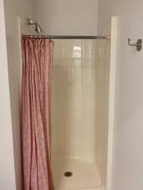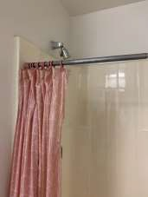
 | ID:  1599 | Facility:  Lander Street - Water Pollution Control Facility

Location: Admin Building Women's Locker Room
Schedule: 2021
Estimated Cost: $100.00

Priority Score 5
Quick Fix: Yes
Built before ADA: Yes

VIOLATIONS
2010 ADA Standards for Accessible Design Codes §604.7
The toilet paper dispenser is located out of the accessible reach range.

RECOMMENDATIONS
Remount the toilet paper dispenser to 7” minimum and 9” maximum in front of the water closet measured to the centerline of the dispenser.
The outlet of the dispenser shall be 15” minimum and 48” maximum above the floor and shall not be located behind the grab bar.

PHOTOGRAPH(S) OF THIS LOCATION

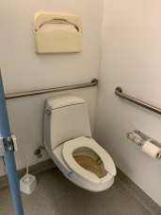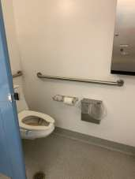

 | ID:  1602 | Facility:  Lander Street - Water Pollution Control Facility

Location: Admin Bulding Women's Locker Room
Schedule: 2021
Estimated Cost: $100.00

Priority Score 5
Quick Fix: Yes
Built before ADA: Yes

VIOLATIONS
2010 ADA Standards for Accessible Design Codes §604.8.1.2
The door to the accessible water closet is not self closing. Either self-closing hinges are not installed on the door or if installed, they are defective.

RECOMMENDATIONS
Install or reinstall self-closing hinges on the door to ensure that the door is self-closing per the ADA requirements.

PHOTOGRAPH(S) OF THIS LOCATION

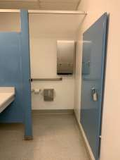

 | ID:  1603 | Facility:  Lander Street - Water Pollution Control Facility

Location: Admin Building Women's Locker Room
Schedule: 2021
Estimated Cost: $100.00

Priority Score 5
Quick Fix: Yes
Built before ADA: Yes

VIOLATIONS
2010 ADA Standards for Accessible Design Codes §308.2.1, §609.3
The space between the grab bar and the dispenser is less than 12".
The dispenser is outside of the unobstructed forward reach range at 49" above the floor.

RECOMMENDATIONS
Relocate the dispenser to a location that is at least a distance of 12" or greater above the grab bar. Ensure that the dispenser is not greater than 48" above the floor.
Lower the dispenser by 1" to meet the accessible reach range of 48" maximum above the floor.

PHOTOGRAPH(S) OF THIS LOCATION

 | ID:  1604 | Facility:  Lander Street - Water Pollution Control Facility

Location: Admin Building Women's Locker Room
Schedule: 2021
Estimated Cost: $100.00

Priority Score 8
Quick Fix: Yes
Built before ADA: Yes

VIOLATIONS
2010 ADA Standards for Accessible Design Codes §308.2.1
The hook is outside of the unobstructed forward reach range at 53" above the floor.

RECOMMENDATIONS
Lower the hook by 5" to meet the accessible reach range of 48" maximum above the floor.

PHOTOGRAPH(S) OF THIS LOCATION

 | ID:  1606 | Facility:  Lander Street - Water Pollution Control Facility

Location: Admin Building Women's Locker Room
Schedule: 2021
Estimated Cost: $100.00

Priority Score 7
Quick Fix: Yes
Built before ADA: Yes

VIOLATIONS
2010 ADA Standards for Accessible Design Codes §603.3
The mirror is too high to be accessible at 44.5" above the floor.

RECOMMENDATIONS
Lower the mirror so its bottom edge is a maximum height of 40" above the floor.

PHOTOGRAPH(S) OF THIS LOCATION

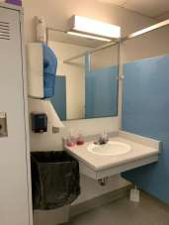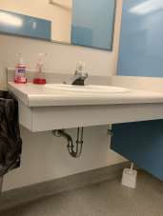

 | ID:  1606 | Facility:  Lander Street - Water Pollution Control Facility

Location: Admin Building Women's Locker Room
Schedule: 2021
Estimated Cost: $100.00

Priority Score 7
Quick Fix: Yes
Built before ADA: Yes

VIOLATIONS
2010 ADA Standards for Accessible Design Codes §603.3
The mirror is too high to be accessible at 44.5" above the floor.

RECOMMENDATIONS
Lower the mirror so its bottom edge is a maximum height of 40" above the floor.

PHOTOGRAPH(S) OF THIS LOCATION

 | ID: | Facility:  Lander Street - Water Pollution Control Facility

Location: Admin Building Women's Locker Room
Schedule: 2021
Estimated Cost: $100.00

Priority Score 8
Quick Fix: Yes
Built before ADA: Yes

VIOLATIONS
2010 2010 ADA Standards for Accessible Design Codes §308.2.1
The paper towel dispenser is outside of the unobstructed forward reach range at 55" above the floor.

RECOMMENDATIONS
Lower the paper towel dispenser by 7" to meet the accessible reach range of 48" maximum above the floor.

PHOTOGRAPH(S) OF THIS LOCATION

 | ID:  1590 | Facility:  Lander Street - Water Pollution Control Facility

Location: Admin Building Women's Locker Room
Schedule: 2021
Estimated Cost: $500.00

Priority Score 5
Quick Fix: Yes
Built before ADA: Yes

VIOLATIONS
2010 ADA Standards for Accessible Design Codes §404.2.5
The threshold at the doorway is 1".

RECOMMENDATIONS
Reduce the metal lip on the door to no more than 0.5" to 0.75" if beveled on each side.

PHOTOGRAPH(S) OF THIS LOCATION

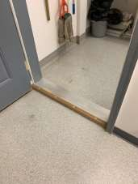

 | ID:  1591 | Facility:  Lander Street - Water Pollution Control Facility

Location: Admin Building Women's Locker Room
Schedule: 2021
Estimated Cost: $500.00

Priority Score 5
Quick Fix: Yes
Built before ADA: Yes

VIOLATIONS
2010 ADA Standards for Accessible Design Codes §903.3
The bench is 19.5" deep.

RECOMMENDATIONS
Install a new bench that is at least 42" long and 20" to 24" inches deep. Ensure that the back on the remains against the lockers.

PHOTOGRAPH(S) OF THIS LOCATION

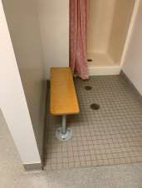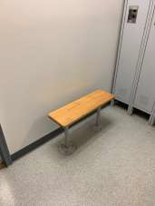

 | ID:  1600 | Facility:  Lander Street - Water Pollution Control Facility

Location: Admin Building Women's Locker Room
Schedule: 2021
Estimated Cost: $500.00

Priority Score 5
Quick Fix: Yes
Built before ADA: Yes

VIOLATIONS
2010 ADA Standards for Accessible Design Codes §604.5.2
The rear grab bar is located 20" to the center of the toilet.

RECOMMENDATIONS
Remount the rear grab bar 12" minimum on one side and 24" minimum on the other.

PHOTOGRAPH(S) OF THIS LOCATION

 | ID:  1601 | Facility:  Lander Street - Water Pollution Control Facility

Location: Admin Building Women’s Locker Room
Schedule: 2022
Estimated Cost: $1,000.00

Priority Score 5
Quick Fix: No
Built before ADA: Yes

VIOLATIONS
2010 ADA Standards for Accessible Design Codes §604.5.1
The side grab bar extends 45" from the rear wall.

RECOMMENDATIONS
Replace the side grab bar with one that is a minimum of 42" long minimum, located 12" maximum from the rear wall and extending 54" minimum from the rear wall.

PHOTOGRAPH(S) OF THIS LOCATION

 | ID: | Facility:  Lander Street - Water Pollution Control Facility

Location:
Schedule:
Estimated Cost:

Priority Score 5
Quick Fix: No
Built before ADA: Yes

VIOLATIONS
2010 ADA Standards for Accessible Design Codes ICC A117.1 §604.5.1
The accessible water closet does not have a vertical grab bar.

RECOMMENDATIONS
Install an 18" long (minimum) vertical grab bar on the side wall. The grab bar shall be mounted with the bottom located at 39" minimum and 41" maximum above the floor.
The centerline of the vertical grab bar shall be located 39" minimum and 41" maximum from the rear wall.

PHOTOGRAPH(S) OF THIS LOCATION

 | ID:  1595 | Facility:  Lander Street - Water Pollution Control Facility

Location: Admin Building Women's Locker Room
Schedule: 2022
Estimated Cost: $5,000.00

Priority Score 6
Quick Fix: No
Built before ADA: Yes

VIOLATIONS
2010 ADA Standards for Accessible Design Codes §608.2.1
The shower dimensions do not meet the requirements for a transfer type shower at 28.5"x31".

RECOMMENDATIONS
Expand the transfer type shower compartment to meet the minimum dimensions of 36"x36" measured at the center points of opposing sides with a 36" wide minimum entry on the face of the shower compartment. Ensure that a compliant entry step, accessible seat, grab bars, and shower spray unit is added.

PHOTOGRAPH(S) OF THIS LOCATION

 | ID:  1559 | Facility:  Lander Street - Water Pollution Control Facility

Location: Admin Building Women's Restroom
Schedule: 2021
Estimated Cost: $100.00

Priority Score 5
Quick Fix: No
Built before ADA: Yes

VIOLATIONS
2010 ADA Standards for Accessible Design Codes §308.2.1
The toilet seat covers are outside of the unobstructed forward reach range at 57" above the floor.

RECOMMENDATIONS
Lower the toilet seat covers by 9" to meet the accessible reach range of 48" maximum above the floor and is not within 12" of the top of the grab bar.

PHOTOGRAPH(S) OF THIS LOCATION

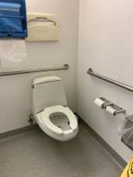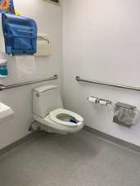

 | ID:  1561 | Facility:  Lander Street - Water Pollution Control Facility

Location: Admin Building Women's Restroom
Schedule: 2021
Estimated Cost: $100.00

Priority Score 5
Quick Fix: Yes
Built before ADA: Yes

VIOLATIONS
2010 ADA Standards for Accessible Design Codes §604.7
The toilet paper dispenser is located out of the accessible reach range at the rim of the toilet.

RECOMMENDATIONS
Remount the toilet paper dispenser to 7” minimum and 9” maximum in front of the water closet measured to the centerline of the dispenser.
The outlet of the dispenser shall be 15” minimum and 48” maximum above the floor and shall not be located behind the water closet.

PHOTOGRAPH(S) OF THIS LOCATION

 | ID:  1562 | Facility:  Lander Street - Water Pollution Control Facility

Location: Admin Building Women's Restroom
Schedule: 2021
Estimated Cost: $100.00

Priority Score 10
Quick Fix: Yes
Built before ADA: Yes

VIOLATIONS
2010 ADA Standards for Accessible Design Codes §603.3
The mirror is too high to be accessible at 40.5" above the floor.

RECOMMENDATIONS
Lower the mirror so its bottom edge is a maximum height of 40" above the floor.

PHOTOGRAPH(S) OF THIS LOCATION

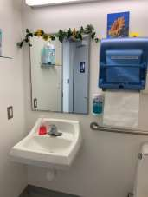

 | ID:  1564 | Facility:  Lander Street - Water Pollution Control Facility

Location: Admin Building Women's Restroom
Schedule: 2021
Estimated Cost: $100.00

Priority Score 8
Quick Fix: Yes
Built before ADA: Yes

VIOLATIONS
2010 ADA Standards for Accessible Design Codes §308.2.1
The paper towel dispenser is outside of the unobstructed forward reach range at 52" above the floor.

RECOMMENDATIONS
Lower the paper towel dispenser by 4" to meet the accessible reach range of 48" maximum above the floor and is not within 12" of the top of the grab bar.

PHOTOGRAPH(S) OF THIS LOCATION

 | ID:  1557 | Facility:  Lander Street - Water Pollution Control Facility

Location: Admin Building Women's Restroom
Schedule: 2021
Estimated Cost: $500.00

Priority Score 5
Quick Fix: Yes
Built before ADA: Yes

VIOLATIONS
2010 ADA Standards for Accessible Design Codes §604.5.2
The rear grab bar is located 10" to the center of the toilet.

RECOMMENDATIONS
Remount the rear grab bar 12" minimum on one side and 24" minimum on the other.

PHOTOGRAPH(S) OF THIS LOCATION

 | ID:  1558 | Facility:  Lander Street - Water Pollution Control Facility

Location: Admin Building Women's Restroom
Schedule: 2022
Estimated Cost: $1,000.00

Priority Score 5
Quick Fix: No
Built before ADA: Yes

VIOLATIONS
2010 ADA Standards for Accessible Design Codes ICC A117.1 §604.5.1
The accessible water closet does not have a vertical grab bar.

RECOMMENDATIONS
Install an 18" long (minimum) vertical grab bar on the side wall. The grab bar shall be mounted with the bottom located at 39" minimum and 41" maximum above the floor.
The centerline of the vertical grab bar shall be located 39" minimum and 41" maximum from the rear wall.

PHOTOGRAPH(S) OF THIS LOCATION

 | ID:  1560 | Facility:  Lander Street - Water Pollution Control Facility

Location: Admin Building Women's Restroom
Schedule: 2022
Estimated Cost: $1,000.00

Priority Score 5
Quick Fix: No
Built before ADA: Yes

VIOLATIONS
2010 ADA Standards for Accessible Design Codes §604.2
The centerline of the toilet is located 20" from the sidewall.

RECOMMENDATIONS
Reposition the centerline of the toilet to be within 16" minimum and 18" maximum from the sidewall.

PHOTOGRAPH(S) OF THIS LOCATION

 | ID:  1655 | Facility:  Lander Street - Water Pollution Control Facility

Location: Engineer's Trailer
Schedule: 2021
Estimated Cost: $200.00

Priority Score 5
Quick Fix: Yes
Built before ADA: Yes

VIOLATIONS
2010 ADA Standards for Accessible Design Codes §216.2, §703
There is no tactile sign identifying the permanent room.

RECOMMENDATIONS
Install tactile signage on the latch side of the doorway at a height of 48” minimum to 60” maximum above the floor, identifying room by name or room number.
Signs shall be Braille with raised lettering and should be placed on the wall in the center of an 18"x18" clear floor space.

PHOTOGRAPH(S) OF THIS LOCATION

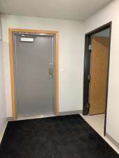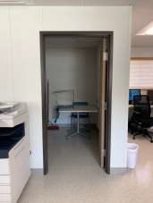

 | ID:  1665 | Facility:  Lander Street - Water Pollution Control Facility

Location: Engineers Trailer
Schedule: 2023
Estimated Cost: $1,000.00

Priority Score 8
Quick Fix: No
Built before ADA: Yes

VIOLATIONS
2010 ADA Standards for Accessible Design Codes §405
The engineer,s trailer is only accessible via stairs.

RECOMMENDATIONS
Add vertical access to the amenity. This can either be by a lift or a ramp. If a ramp is added, ensure that the slope does not exceed 8.3%, handrails are provided, and there is sufficient room for a level landing at the top and bottom of the ramp.

PHOTOGRAPH(S) OF THIS LOCATION

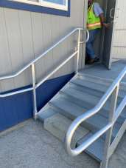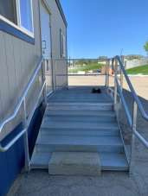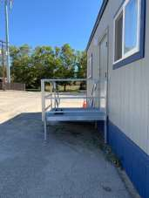

 | ID:  1658 | Facility:  Lander Street - Water Pollution Control Facility

Location: Engineers Trailer Kitchen
Schedule: 2021
Estimated Cost: $100.00

Priority Score 8
Quick Fix: Yes
Built before ADA: Yes

VIOLATIONS
2010 ADA Standards for Accessible Design Codes §308.2.2
The paper towel dispenser is outside of the obstructed forward reach range at 58" above the floor.

RECOMMENDATIONS
Lower the paper towel dispenser by 14" to meet the accessible reach range of 44" maximum above the floor.

PHOTOGRAPH(S) OF THIS LOCATION

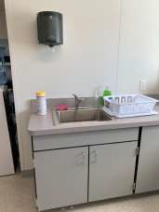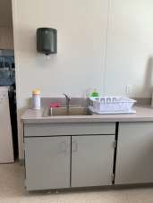
 | ID:  1656 | Facility:  Lander Street - Water Pollution Control Facility

Location: Engineers Trailer Kitchen
Schedule: 2021
Estimated Cost: $100.00

Priority Score 5
Quick Fix: No
Built before ADA: Yes

VIOLATIONS
2010 ADA Standards for Accessible Design Codes §306.3.3
There is no knee clearance underneath the counter.

RECOMMENDATIONS
Provide knee clearance underneath the counter at the sink that is a minimum of 11" deep at 9" above the floor and 8" deep at 27" above the floor.

PHOTOGRAPH(S) OF THIS LOCATION

 | ID:  1659 | Facility:  Lander Street - Water Pollution Control Facility

Location: Engineers Trailer Restroom
Schedule: 2021
Estimated Cost: $100.00

Priority Score 8
Quick Fix: Yes
Built before ADA: Yes

VIOLATIONS
2010 ADA Standards for Accessible Design Codes §308.2.1
The paper towel dispenser is outside of the unobstructed forward reach range at 58" above the floor.

RECOMMENDATIONS
Lower the paper towel dispenser by 10" to meet the accessible reach range of 48" maximum above the floor.

PHOTOGRAPH(S) OF THIS LOCATION

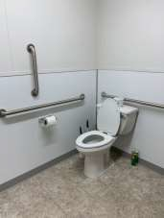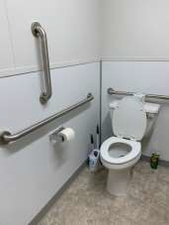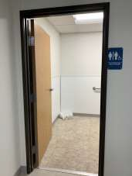

 | ID:  1664 | Facility:  Lander Street - Water Pollution Control Facility

Location: Engineer's Trailer Restroom
Schedule: 2021
Estimated Cost: $100.00

Priority Score 5
Quick Fix: Yes
Built before ADA: Yes

VIOLATIONS
2010 ADA Standards for Accessible Design Codes §604.8.1.2
The door to the accessible water closet is not self closing. Either self-closing hinges are not installed on the door or if installed, they are defective.

RECOMMENDATIONS
Install or reinstall self-closing hinges on the door to ensure that the door is self-closing per the ADA requirements.

PHOTOGRAPH(S) OF THIS LOCATION

 | ID:  1627 | Facility:  Lander Street - Water Pollution Control Facility

Location: Operations Building
Schedule: 2021
Estimated Cost: $100.00

Priority Score 5
Quick Fix: Yes
Built before ADA: Yes

VIOLATIONS
2010 ADA Standards for Accessible Design Codes §307.2
The TV protrudes 6" into the circulation space at 51" above the floor.

RECOMMENDATIONS
Recess the TV so it protrudes a maximum of 4", raise it so the bottom edge is 80" maximum above the floor, or place a cane detectable object beneath it.

PHOTOGRAPH(S) OF THIS LOCATION

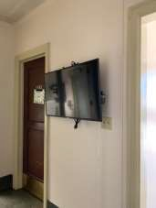

 | ID:  1635 | Facility:  Lander Street - Water Pollution Control Facility

Location: Operations Building
Schedule: 2021
Estimated Cost: $100.00

Priority Score 5
Quick Fix: Yes
Built before ADA: Yes

VIOLATIONS
2010 ADA Standards for Accessible Design Codes §307.2
The AED protrudes 6" into the circulation space at 31" above the floor.

RECOMMENDATIONS
Recess the AED so it protrudes a maximum of 4" or place a cane detectable object beneath it.

PHOTOGRAPH(S) OF THIS LOCATION

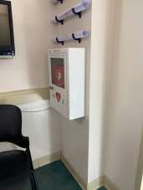

 | ID:  1629 | Facility:  Lander Street - Water Pollution Control Facility

Location: Operations Building
Schedule: 2022
Estimated Cost: $1,000.00

Priority Score 6
Quick Fix: No
Built before ADA: Yes

VIOLATIONS
2010 ADA Standards for Accessible Design Codes §211.2, §602.4
There is only one drinking fountain provided at 41" above the floor.

RECOMMENDATIONS
Install an additional drinking fountain at a maximum spout height of 36" above the floor.

PHOTOGRAPH(S) OF THIS LOCATION

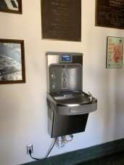

 | ID:  1617 | Facility:  Lander Street - Water Pollution Control Facility

Location: Operations Building
Schedule: 2023
Estimated Cost: $5,000.00

Priority Score 8
Quick Fix: No
Built before ADA: Yes

VIOLATIONS
2010 ADA Standards for Accessible Design Codes §405
The Operations Building is only accessible via stairs.

RECOMMENDATIONS
Add vertical access to the amenity. This can either be by a lift or a ramp. If a ramp is added, ensure that the slope does not exceed 8.3%, handrails are provided, and there is sufficient room for a level landing at the top and bottom of the ramp.

PHOTOGRAPH(S) OF THIS LOCATION

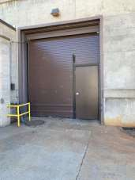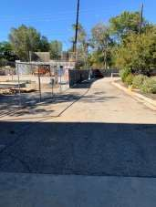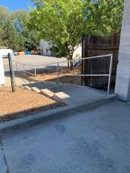
 | ID:  1634 | Facility:  Lander Street - Water Pollution Control Facility

Location: Operations Building Break Room
Schedule: 2021
Estimated Cost: $0.00

Priority Score 0
Quick Fix: Yes
Built before ADA: Yes

VIOLATIONS
2010 ADA Standards for Accessible Design Codes §308.2.2
The microwave is outside of the obstructed forward reach range at 63" above the floor.

RECOMMENDATIONS
Although the microwave is too high to be accessible, since it is not permanently mounted, it is acceptable in its current location. However, it must be lowered if requested by a qualified employee.

PHOTOGRAPH(S) OF THIS LOCATION

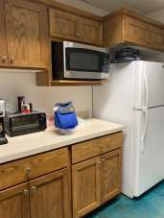

 | ID:  1633 | Facility:  Lander Street - Water Pollution Control Facility

Location: Operations Building Break Room
Schedule: 2021
Estimated Cost: $100.00

Priority Score 8
Quick Fix: Yes
Built before ADA: Yes

VIOLATIONS
2010 ADA Standards for Accessible Design Codes §308.2.2
The paper towel dispenser is outside of the obstructed forward reach range at 52.5" above the floor.

RECOMMENDATIONS
Lower the paper towel dispenser by 8.5" to meet the accessible reach range of 44" maximum above the floor.

PHOTOGRAPH(S) OF THIS LOCATION

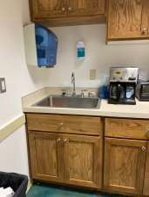

 | ID:  1630 | Facility:  Lander Street - Water Pollution Control Facility

Location: Operations Building Break Room
Schedule: 2023
Estimated Cost: $2,000.00

Priority Score 5
Quick Fix: No
Built before ADA: Yes

VIOLATIONS
2010 ADA Standards for Accessible Design Codes §902.3, §606.3
The sink is 36.5" above the floor.
The dining and work surface counter is 36.5" above the floor.

RECOMMENDATIONS
Lower the sink to the maximum height of 34" above the floor.
A portion of the dining and work surface must be no higher than 34” above the floor

PHOTOGRAPH(S) OF THIS LOCATION

 | ID:  1619 | Facility:  Lander Street - Water Pollution Control Facility

Location: Operations Building Men's Restroom
Schedule: 2021
Estimated Cost: $100.00

Priority Score 7
Quick Fix: Yes
Built before ADA: Yes

VIOLATIONS
2010 ADA Standards for Accessible Design Codes §603.3
The mirror is too high to be accessible at 50" above the floor.

RECOMMENDATIONS
Lower the mirror so its bottom edge is a maximum height of 40" above the floor.

PHOTOGRAPH(S) OF THIS LOCATION

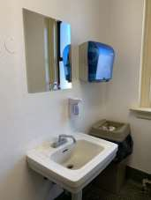

 | ID:  1620 | Facility:  Lander Street - Water Pollution Control Facility

Location: Operations Building Men's Restroom
Schedule: 2021
Estimated Cost: $100.00

Priority Score 8
Quick Fix: Yes
Built before ADA: Yes

VIOLATIONS
2010 ADA Standards for Accessible Design Codes §308.2.1
The paper towel dispenser is outside of the unobstructed forward reach range at 53" above the floor.

RECOMMENDATIONS
Lower the paper towel dispenser by 5" to meet the accessible reach range of 48" maximum above the floor.

PHOTOGRAPH(S) OF THIS LOCATION

 | ID:  1618 | Facility:  Lander Street - Water Pollution Control Facility

Location: Operations Building Men's Restroom
Schedule: 2022
Estimated Cost: $1,000.00

Priority Score 5
Quick Fix: No
Built before ADA: Yes

VIOLATIONS
2010 ADA Standards for Accessible Design Codes §605.2
The urinal is 24" above the floor.

RECOMMENDATIONS
Lower the urinal to a maximum height of 17" above the floor.

PHOTOGRAPH(S) OF THIS LOCATION

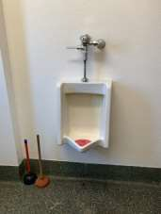

 | ID:  4499 | Facility:  Lander Street - Water Pollution Control Facility

Location: Operations Building Men's Restroom
Schedule: 2022
Estimated Cost: $1,000.00

Priority Score 5
Quick Fix: No
Built before ADA: Yes

VIOLATIONS
2010 ADA Standards for Accessible Design Codes ICC A117.1 §604.5.1
The accessible water closet does not have a vertical grab bar.

RECOMMENDATIONS
Install an 18" long (minimum) vertical grab bar on the side wall. The grab bar shall be mounted with the bottom located at 39" minimum and 41" maximum above the floor.
The centerline of the vertical grab bar shall be located 39" minimum and 41" maximum from the rear wall.

PHOTOGRAPH(S) OF THIS LOCATION

(No Photograph Available)

 | ID:  1626 | Facility:  Lander Street - Water Pollution Control Facility

Location: Operations Building Men's Restroom
Schedule: 2022
Estimated Cost: $5,000.00

Priority Score 7
Quick Fix: No
Built before ADA: Yes

VIOLATIONS
2010 ADA Standards for Accessible Design Codes §604.8.1.1
The toilet compartment size is too small.

RECOMMENDATIONS
Create one single use restroom with a 60" wide wheelchair accessible toilet stall, complying with §604.8.

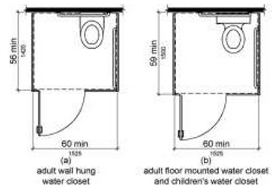

PHOTOGRAPH(S) OF THIS LOCATION

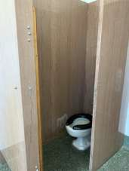

 | ID:  1622 | Facility:  Lander Street - Water Pollution Control Facility

Location: Operations Building Women's Restroom
Schedule: 2021
Estimated Cost: $100.00

Priority Score 5
Quick Fix: Yes
Built before ADA: Yes

VIOLATIONS
2010 ADA Standards for Accessible Design Codes §307.2, §308.2.1
The dispenser is outside of the unobstructed forward reach range at 54" above the floor. The dispenser protrudes 5.5" into the circulation space at 54" above the floor.

RECOMMENDATIONS
Lower the dispenser by 6" to meet the accessible reach range of 48" maximum above the floor.
Recess the dispenser so it protrudes a maximum of 4" or place a cane detectable object beneath it.

PHOTOGRAPH(S) OF THIS LOCATION

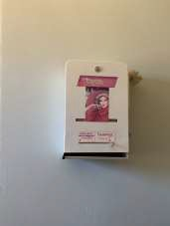

 | ID:  1623 | Facility:  Lander Street - Water Pollution Control Facility

Location: Operations Building Women's Restroom
Schedule: 2021
Estimated Cost: $100.00

Priority Score 7
Quick Fix: Yes
Built before ADA: Yes

VIOLATIONS
2010 ADA Standards for Accessible Design Codes §603.3
The mirror is too high to be accessible at 51" above the floor.

RECOMMENDATIONS
Lower the mirror so its bottom edge is a maximum height of 40" above the floor.

PHOTOGRAPH(S) OF THIS LOCATION

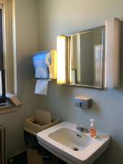

 | ID:  1624 | Facility:  Lander Street - Water Pollution Control Facility

Location: Operations Building Women's Restroom
Schedule: 2021
Estimated Cost: $100.00

Priority Score 8
Quick Fix: Yes
Built before ADA: Yes

VIOLATIONS
2010 ADA Standards for Accessible Design Codes §308.2.1
The paper towel dispenser is outside of the unobstructed forward reach range at 54" above the floor.

RECOMMENDATIONS
Lower the paper towel dispenser by 6" to meet the accessible reach range of 48" maximum above the floor.

PHOTOGRAPH(S) OF THIS LOCATION

 | ID:  4500 | Facility:  Lander Street - Water Pollution Control Facility

Location: Operations Building Women's Restroom
Schedule: 2022
Estimated Cost: $1,000.00

Priority Score 5
Quick Fix: No
Built before ADA: Yes

VIOLATIONS
2010 ADA Standards for Accessible Design Codes ICC A117.1 §604.5.1
The accessible water closet does not have a vertical grab bar.

RECOMMENDATIONS
Install an 18" long (minimum) vertical grab bar on the side wall. The grab bar shall be mounted with the bottom located at 39" minimum and 41" maximum above the floor.
The centerline of the vertical grab bar shall be located 39" minimum and 41" maximum from the rear wall.

PHOTOGRAPH(S) OF THIS LOCATION

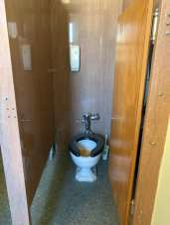

 | ID:  1621 | Facility:  Lander Street - Water Pollution Control Facility

Location: Operations Building Women's Restroom
Schedule: 2022
Estimated Cost: $5,000.00

Priority Score 7
Quick Fix: No
Built before ADA: Yes

VIOLATIONS
2010 ADA Standards for Accessible Design Codes §604.8.1.1
The toilet compartment size is 31" wide.

RECOMMENDATIONS
Create one single use restroom with a 60" wide wheelchair accessible toilet stall, complying with §604.8.

PHOTOGRAPH(S) OF THIS LOCATION

 | ID:  1672 | Facility:  Lander Street - Water Pollution Control Facility

Location: Primary Digester
Schedule: 2021
Estimated Cost: $500.00

Priority Score 5
Quick Fix: Yes
Built before ADA: Yes

VIOLATIONS
2010 ADA Standards for Accessible Design Codes §404.2.5
The threshold at the doorway is 4".

RECOMMENDATIONS
Reduce the metal lip on the door to no more than 0.5" to 0.75" if beveled on each side.

PHOTOGRAPH(S) OF THIS LOCATION

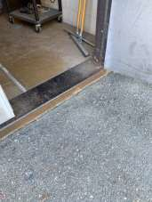

 | ID:  1670 | Facility:  Lander Street - Water Pollution Control Facility

Location: Primary Digester Locker Room
Schedule: 2022
Estimated Cost: $5,000.00

Priority Score 6
Quick Fix: No
Built before ADA: Yes

VIOLATIONS
2010 ADA Standards for Accessible Design Codes §213.3.6
There is not an accessible shower provided.

RECOMMENDATIONS
Install at least one accessible shower complying with §607 or §608.

PHOTOGRAPH(S) OF THIS LOCATION

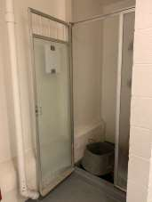

 | ID:  1667 | Facility:  Lander Street - Water Pollution Control Facility

Location: Primary Digester Restroom
Schedule: 2021
Estimated Cost: $100.00

Priority Score 7
Quick Fix: Yes
Built before ADA: Yes

VIOLATIONS
2010 ADA Standards for Accessible Design Codes §606.5
The pipes under the sink are not covered.

RECOMMENDATIONS
Wrap the pipes beneath the sink with soft protective wrap or plastic.

PHOTOGRAPH(S) OF THIS LOCATION

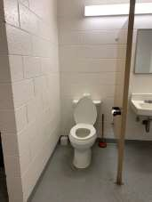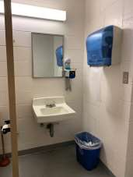

 | ID:  1668 | Facility:  Lander Street - Water Pollution Control Facility

Location: Primary Digester Restroom
Schedule: 2021
Estimated Cost: $100.00

Priority Score 7
Quick Fix: Yes
Built before ADA: Yes

VIOLATIONS
2010 ADA Standards for Accessible Design Codes §603.3
The mirror is too high to be accessible at 47.5" above the floor.

RECOMMENDATIONS
Lower the mirror its bottom edge is a maximum height of 40" above the floor.

PHOTOGRAPH(S) OF THIS LOCATION

 | ID:  1669 | Facility:  Lander Street - Water Pollution Control Facility

Location: Primary Digester Restroom
Schedule: 2021
Estimated Cost: $100.00

Priority Score 8
Quick Fix: Yes
Built before ADA: Yes

VIOLATIONS
2010 ADA Standards for Accessible Design Codes §308.2.1
The paper towel dispenser is outside of the unobstructed forward reach range at 54.5" above the floor.

RECOMMENDATIONS
Lower the paper towel dispenser by 6.5" to meet the accessible reach range of 15" minimum and 48" maximum above the floor.

PHOTOGRAPH(S) OF THIS LOCATION

 | ID:  1670 | Facility:  Lander Street - Water Pollution Control Facility

Location: Primary Digester Restroom
Schedule: 2021
Estimated Cost: $100.00

Priority Score 8
Quick Fix: Yes
Built before ADA: Yes

VIOLATIONS
2010 ADA Standards for Accessible Design Codes §308.2.1
The soap dispenser is outside of the unobstructed forward reach range at 58" above the floor.

RECOMMENDATIONS
Lower the soap dispenser by 10" to meet the accessible reach range of 15" minimum and 48" maximum above the floor.

PHOTOGRAPH(S) OF THIS LOCATION

 | ID:  4497 | Facility:  Lander Street - Water Pollution Control Facility

Location: Primary Digester Restroom
Schedule: 2022
Estimated Cost: $1,000.00

Priority Score 5
Quick Fix: No
Built before ADA: Yes

VIOLATIONS
2010 ADA Standards for Accessible Design Codes ICC A117.1 §604.5.1
The accessible water closet does not have a vertical grab bar.

RECOMMENDATIONS
Install an 18" long (minimum) vertical grab bar on the side wall. The grab bar shall be mounted with the bottom located at 39" minimum and 41" maximum above the floor.
The centerline of the vertical grab bar shall be located 39" minimum and 41" maximum from the rear wall.

PHOTOGRAPH(S) OF THIS LOCATION

 | ID:  1666 | Facility:  Lander Street - Water Pollution Control Facility

Location: Primary Digester Restroom
Schedule: 2023
Estimated Cost: $5,000.00

Priority Score 8
Quick Fix: No
Built before ADA: Yes

VIOLATIONS
2010 ADA Standards for Accessible Design Codes §213.3.1, §604.8.2.1, §606.5, §604.5
There are no grab bars. The pipes under the sink are not covered. There is not an accessible stall.

RECOMMENDATIONS
Install a side and rear grab bar at a minimum height of 33” and maximum height of 36” above the finish floor. The side grab bar shall have a minimum length of 42”. The side grab bar shall begin at a maximum of 12” from the back wall.
Create a single user restroom that is at least a 60" wide wheelchair accessible toilet stall, complying with §604.8. Wrap the pipes beneath the sink with soft protective wrap or plastic.

PHOTOGRAPH(S) OF THIS LOCATION

 | ID:  1653 | Facility:  Lander Street - Water Pollution Control Facility

Location: RAS Building
Schedule: 2023
Estimated Cost: $5,000.00

Priority Score 8
Quick Fix: No
Built before ADA: Yes

VIOLATIONS
2010 ADA Standards for Accessible Design Codes §405
The RAS Building is only accessible via stairs.

RECOMMENDATIONS
Add vertical access to the amenity. This can either be by a lift or a ramp. If a ramp is added, ensure that the slope does not exceed 8.3%, handrails are provided, and there is sufficient room for a level landing at the top and bottom of the ramp.

PHOTOGRAPH(S) OF THIS LOCATION

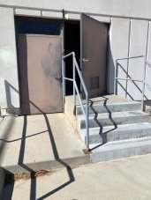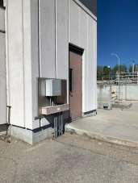

 | ID:  1651 | Facility:  Lander Street - Water Pollution Control Facility

Location: Thickener Control Building
Schedule: 2021
Estimated Cost: $100.00

Priority Score 5
Quick Fix: Yes
Built before ADA: Yes

VIOLATIONS
2010 ADA Standards for Accessible Design Codes §307.2
The first aid box protrudes 5.75" into the circulation space at 47.25" above the floor.

RECOMMENDATIONS
Recess the first aid box so it protrudes a maximum of 4" or place a cane detectable object beneath it.

PHOTOGRAPH(S) OF THIS LOCATION

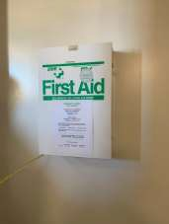

 | ID:  1652 | Facility:  Lander Street - Water Pollution Control Facility

Location: Thickener Control Building
Schedule: 2022
Estimated Cost: $1,000.00

Priority Score 6
Quick Fix: No
Built before ADA: Yes

VIOLATIONS
2010 ADA Standards for Accessible Design Codes §211.2, §602.4
There is only one drinking fountain provided at 40" above the floor.

RECOMMENDATIONS
Install an additional drinking fountain at a maximum spout height of 36" above the floor.

PHOTOGRAPH(S) OF THIS LOCATION

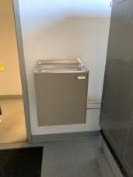

 | ID:  1636 | Facility:  Lander Street - Water Pollution Control Facility

Location: Thickener Control Building
Schedule: 2021
Estimated Cost: $5,000.00

Priority Score 3
Quick Fix: No
Built before ADA: Yes

VIOLATIONS
2010 ADA Standards for Accessible Design Codes §405
The thickener control building is only accessible via a 6.5" step.

RECOMMENDATIONS
Add vertical access to the building by installing a ramp.
Ensure that the slope does not exceed 8.3%, handrails are provided, and there is sufficient room for a level landing at the top and bottom of the ramp.

PHOTOGRAPH(S) OF THIS LOCATION

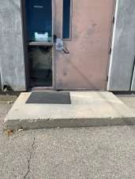

 | ID:  1637 | Facility:  Lander Street - Water Pollution Control Facility

Location: Thickener Control Building Locker Room
Schedule: 2021
Estimated Cost: $100.00

Priority Score 8
Quick Fix: Yes
Built before ADA: Yes

VIOLATIONS
2010 ADA Standards for Accessible Design Codes §308.2.1
The hook is outside of the unobstructed forward reach range at 53" above the floor.

RECOMMENDATIONS
Lower the hook by 5" to meet the accessible reach range of 48" maximum above the floor.

PHOTOGRAPH(S) OF THIS LOCATION

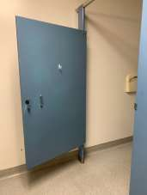

 | ID:  1638 | Facility:  Lander Street - Water Pollution Control Facility

Location: Thickener Control Building Locker Room
Schedule: 2021
Estimated Cost: $100.00

Priority Score 5
Quick Fix: Yes
Built before ADA: Yes

VIOLATIONS
2010 ADA Standards for Accessible Design Codes §604.8.1.2
The door to the accessible water closet is not self closing. Either self-closing hinges are not installed on the door or if installed, they are defective.

RECOMMENDATIONS
Install or reinstall self-closing hinges on the door to ensure that the door is self-closing per the ADA requirements.

PHOTOGRAPH(S) OF THIS LOCATION

 | ID:  1642 | Facility:  Lander Street - Water Pollution Control Facility

Location: Thickener Control Building Locker Room
Schedule: 2021
Estimated Cost: $100.00

Priority Score 8
Quick Fix: Yes
Built before ADA: Yes

VIOLATIONS
2010 ADA Standards for Accessible Design Codes §307.2
The shower curtain rod is 74" above the floor.

RECOMMENDATIONS
Raise the shower curtain rod to a minimum of 80" above the floor.

PHOTOGRAPH(S) OF THIS LOCATION

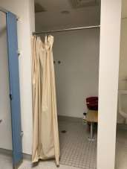

 | ID: | Facility:  Lander Street - Water Pollution Control Facility

Location: Thickener Control Building Locker Room
Schedule: 2021
Estimated Cost: $100.00

Priority Score 8
Quick Fix: Yes
Built before ADA: Yes

VIOLATIONS
2010 ADA Standards for Accessible Design Codes §308.2.1
The hooks are outside of the unobstructed forward reach range at 61" and 64" above the floor.

RECOMMENDATIONS
Lower at least one hook to meet the accessible reach range of 48" above the floor.

PHOTOGRAPH(S) OF THIS LOCATION

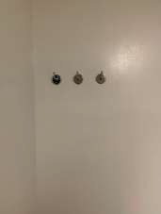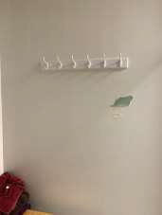

 | ID:  1650 | Facility:  Lander Street - Water Pollution Control Facility

Location: Thickener Control Building Locker Room
Schedule: 2021
Estimated Cost: $100.00

Priority Score 7
Quick Fix: Yes
Built before ADA: Yes

VIOLATIONS
2010 ADA Standards for Accessible Design Codes §606.5
The pipes under the sink are not covered.

RECOMMENDATIONS
Wrap the pipes beneath the sink with soft protective wrap or plastic.

PHOTOGRAPH(S) OF THIS LOCATION

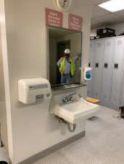

 | ID:  1640 | Facility:  Lander Street - Water Pollution Control Facility

Location: Thickener Control Building Locker Room
Schedule: 2021
Estimated Cost: $500.00

Priority Score 5
Quick Fix: Yes
Built before ADA: Yes

VIOLATIONS
2010 ADA Standards for Accessible Design Codes §604.5.1
The side grab bar is located 8.25" from the rear wall.

RECOMMENDATIONS
Remount the side grab bar 12" maximum from the rear wall and extending 54" minimum from the rear wall.

PHOTOGRAPH(S) OF THIS LOCATION

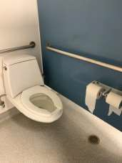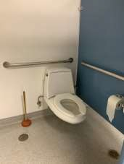

 | ID:  1649 | Facility:  Lander Street - Water Pollution Control Facility

Location: Thickener Control Building Locker Room
Schedule: 2021
Estimated Cost: $500.00

Priority Score 5
Quick Fix: Yes
Built before ADA: Yes

VIOLATIONS
2010 ADA Standards for Accessible Design Codes §903.4
Four benches do not have back support.

RECOMMENDATIONS
Provide back support to at least 5% of the seating that is 42” long minimum and extends from a point 2” maximum above the seat surface to a point 18” minimum above the seat surface.
Back support shall be 2.5” maximum from the rear edge of the seat measured horizontally.

PHOTOGRAPH(S) OF THIS LOCATION

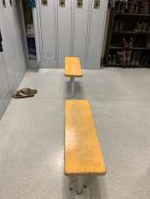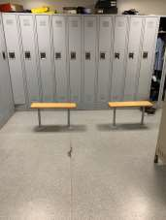

 | ID:  1648 | Facility:  Lander Street - Water Pollution Control Facility

Location: Thickener Control Building Locker Room
Schedule: 2022
Estimated Cost: $1,000.00

Priority Score 5
Quick Fix: No
Built before ADA: Yes

VIOLATIONS
2010 ADA Standards for Accessible Design Codes §605.2
The urinal is 18.5" above the floor.

RECOMMENDATIONS
Lower the urinal to a maximum height of 17" above the floor.

PHOTOGRAPH(S) OF THIS LOCATION

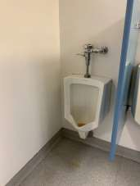

 | ID:  4495 | Facility:  Lander Street - Water Pollution Control Facility

Location: Thickener Control Building Locker Room
Schedule: 2022
Estimated Cost: $1,000.00

Priority Score 5
Quick Fix: No
Built before ADA: Yes

VIOLATIONS
2010 ADA Standards for Accessible Design Codes ICC A117.1 §604.5.1
The accessible water closet does not have a vertical grab bar.

RECOMMENDATIONS
Install an 18" long (minimum) vertical grab bar on the side wall. The grab bar shall be mounted with the bottom located at 39" minimum and 41" maximum above the floor.
The centerline of the vertical grab bar shall be located 39" minimum and 41" maximum from the rear wall.

PHOTOGRAPH(S) OF THIS LOCATION

