City of Boise
ADA Assessment

Appendix A - Fire Training Center

03/26/2021
Report # TO21-B024

Prepared by:

 | ID:  1359 | Facility:  Fire Training/Safety Building

Location: Break Room
Schedule: 2021
Estimated Cost: $100.00

Priority Score 8
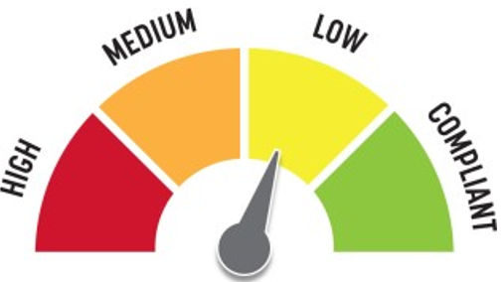
Quick Fix: Yes
Built before ADA:No

VIOLATIONS
2010 ADA Standards for Accessible Design Codes §308.2.2
The soap dispenser is outside of the obstructed forward reach range at 48.5" above the floor.

RECOMMENDATIONS
Lower the soap dispenser by 0.5" to meet the accessible reach range of 48" maximum above the floor.

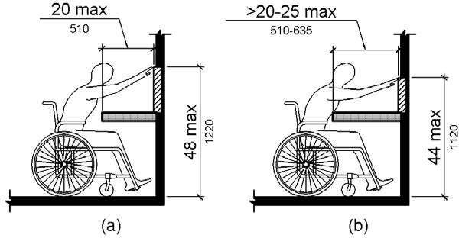

PHOTOGRAPH(S) OF THIS LOCATION

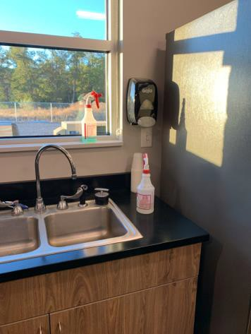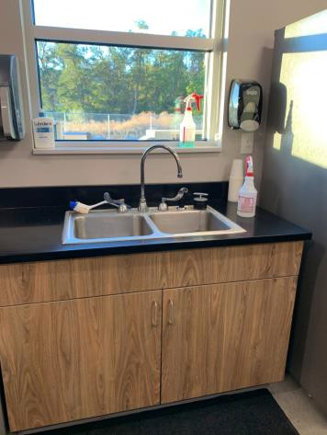

 | ID:  1360 | Facility:  Fire Training/Safety Building

Location: Break Room
Schedule: 2021
Estimated Cost: $100.00

Priority Score 5
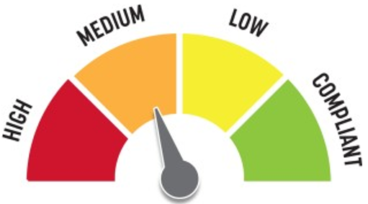
Quick Fix: Yes
Built before ADA:No

VIOLATIONS
2010 ADA Standards for Accessible Design Codes §307.2
The AED protrudes 6" into the circulation space at 34" above the floor.

RECOMMENDATIONS
Recess the AED so it protrudes a maximum of 4", lower it so the bottom edge is 27" maximum above the floor, or place a cane detectable object beneath it.

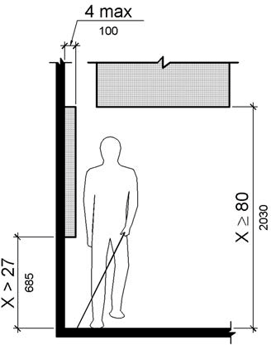

PHOTOGRAPH(S) OF THIS LOCATION

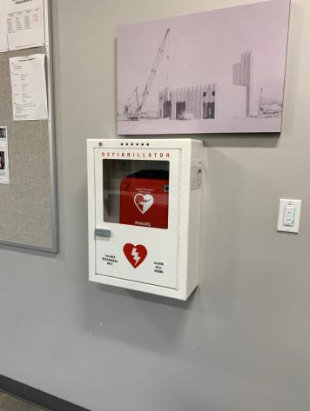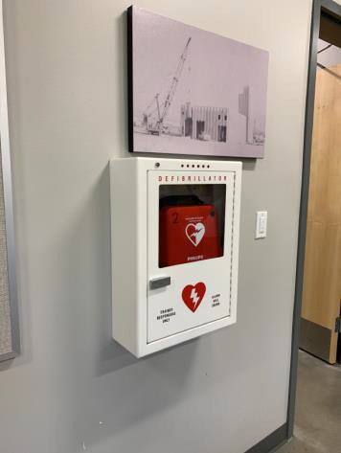

 | ID:  1317 | Facility:  Fire Training/Safety Building

Location: Break Room
Schedule: 2
Estimated Cost: $1,000.00

Priority Score 8
Quick Fix: No
Built before ADA:No

VIOLATIONS
2010 ADA Standards for Accessible Design Codes §902.3
The dining and work surface counter is 34.5" above the floor.

RECOMMENDATIONS
A 30" portion of the dining and work surface must be no higher than 34” above the floor.

PHOTOGRAPH(S) OF THIS LOCATION

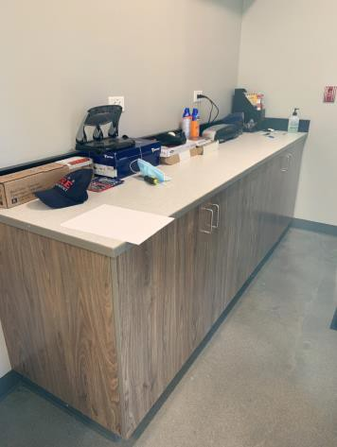

 | ID:  1318 | Facility:  Fire Training/Safety Building

Location: Break Room
Schedule: 2022
Estimated Cost: $1,000.00

Priority Score 6
Quick Fix: No
Built before ADA:No

VIOLATIONS
2010 ADA Standards for Accessible Design Codes §602.4, §602.7
The height of the tall drinking fountain is not compliant at 37" above the floor.

RECOMMENDATIONS
Raise the existing drinking fountain in order to comply with the 38" minimum and 43" maximum spout height above the floor.

PHOTOGRAPH(S) OF THIS LOCATION

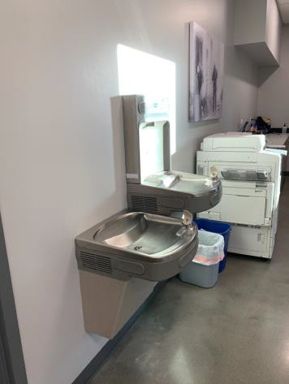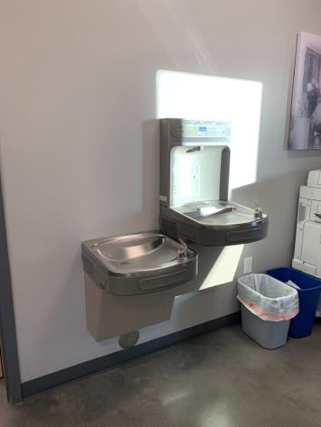

 | ID:  1357 | Facility:  Fire Training/Safety Building

Location: Break Room
Schedule: 2022
Estimated Cost: $1,000.00

Priority Score 5
Quick Fix: No
Built before ADA:No

VIOLATIONS
2010 ADA Standards for Accessible Design Codes §306.3.3
There is no knee clearance underneath the sink.

RECOMMENDATIONS
Provide knee clearance underneath the counter at the sink that is a minimum of 11" deep at 9" above the floor and 8" deep at 27" above the floor.

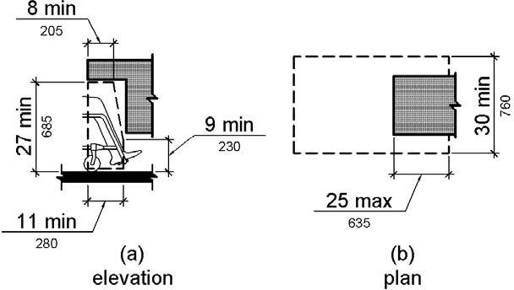

PHOTOGRAPH(S) OF THIS LOCATION

 | ID:  1361 | Facility:  Fire Training/Safety Building

Location: Classrooms
Schedule: 2021
Estimated Cost: $200.00

Priority Score 3
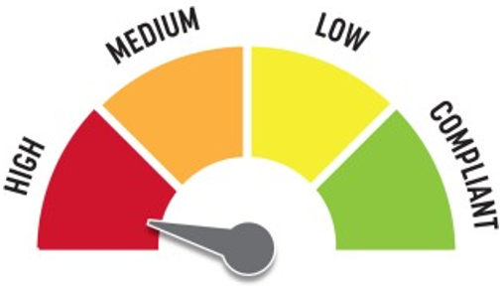
Quick Fix: Yes
Built before ADA:No

VIOLATIONS
2010 ADA Standards for Accessible Design Codes §216.4, §703
Doors serving as exits are not marked by tactile signage.

RECOMMENDATIONS
Place a tactile exit sign, that complies with §703.1, §703.2 and §703.5, identifying the exit doors.
Install missing signage at 48" minimum above the floor measured from the baseline of the lowest character and 60" maximum measured from the baseline of the highest character.

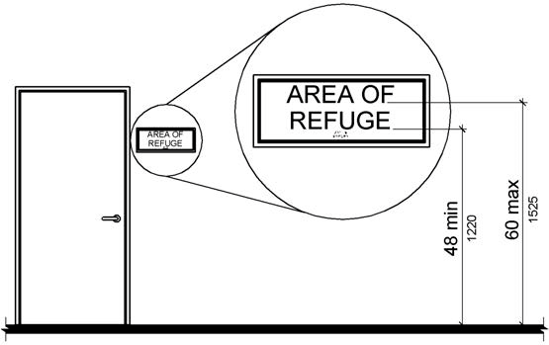

PHOTOGRAPH(S) OF THIS LOCATION

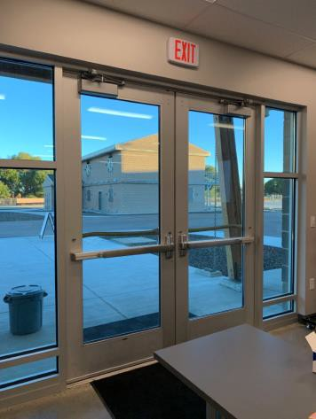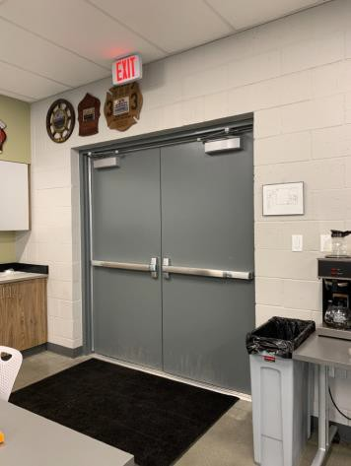

 | ID:  1300 | Facility:  Fire Training/Safety Building

Location: Conference Room
Schedule: 2021
Estimated Cost: $100.00

Priority Score 5
Quick Fix: Yes
Built before ADA:No

VIOLATIONS
2010 ADA Standards for Accessible Design Codes §307.2
The TV protrudes 6" into the circulation space at 45.5" above the floor.

RECOMMENDATIONS
Recess the TV so it protrudes a maximum of 4" or place a cane detectable object beneath it.

PHOTOGRAPH(S) OF THIS LOCATION

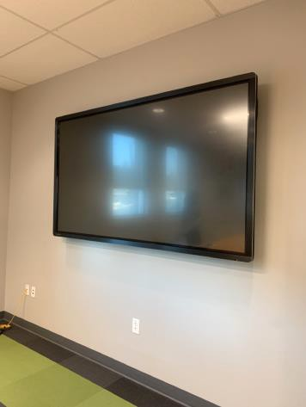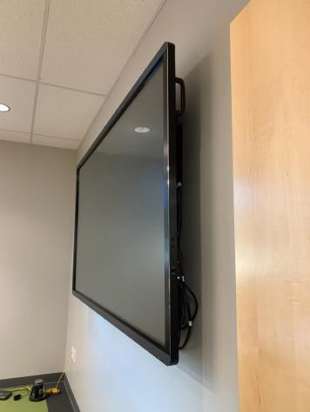

 | ID:  1302 | Facility:  Fire Training/Safety Building

Location: Drinking Fountains
Schedule: 2022
Estimated Cost: $1,000.00

Priority Score 6
Quick Fix: No
Built before ADA:No

VIOLATIONS
2010 ADA Standards for Accessible Design Codes §602.4, §602.7
The height of the tall drinking fountain is not compliant at 37" above the floor.

RECOMMENDATIONS
Raise the existing drinking fountain in order to comply with the 38" minimum and 43" maximum spout height above the floor.

PHOTOGRAPH(S) OF THIS LOCATION

 | ID:  1294 | Facility:  Fire Training/Safety Building

Location: Entrance
Schedule: 2021
Estimated Cost: $1,000.00

Priority Score 3
Quick Fix: No
Built before ADA:No

VIOLATIONS
2010 ADA Standards for Accessible Design Codes §404.2.4.4
The entrance has a 3%.

RECOMMENDATIONS
Resurface the entryway to reduce the running slope to a maximum of 2% in all directions.

PHOTOGRAPH(S) OF THIS LOCATION

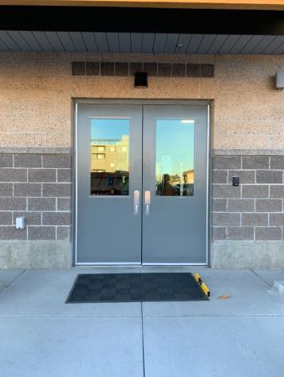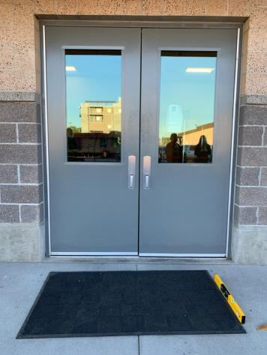

 | ID:  1295 | Facility:  Fire Training/Safety Building

Location: Entrance
Schedule: 2022
Estimated Cost: $2,500.00

Priority Score 5
Quick Fix: No
Built before ADA:No

VIOLATIONS
2010 ADA Standards for Accessible Design Codes §404.2.6
Between the two hinged or pivoted doors, the width is 46".

RECOMMENDATIONS
Remove the inside set of doors or reverse the swing of the inside set of doors.

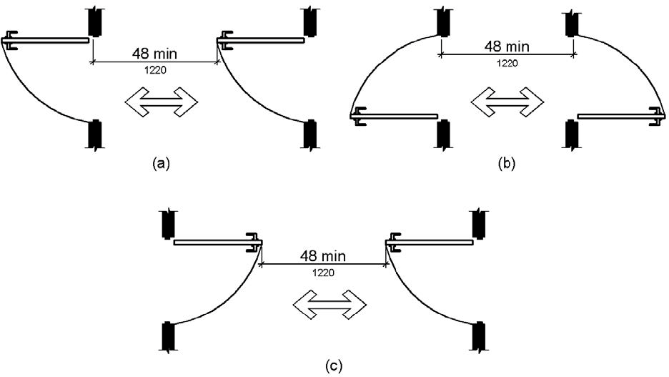

PHOTOGRAPH(S) OF THIS LOCATION

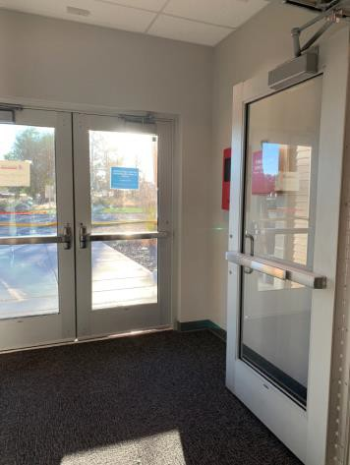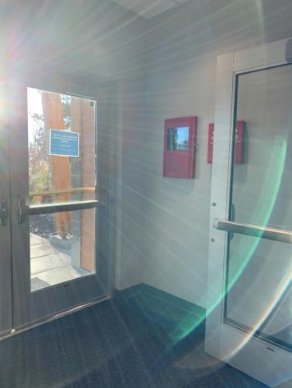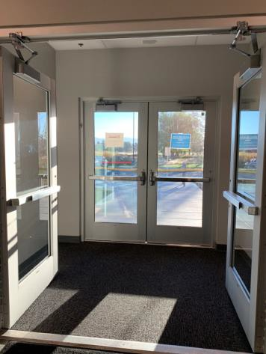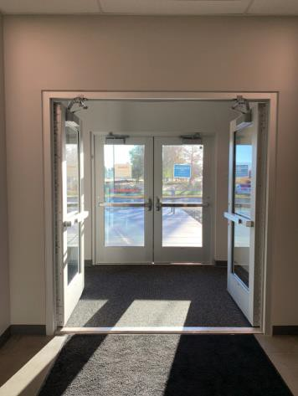

 | ID:  1299 | Facility:  Fire Training/Safety Building

Location: Garage
Schedule: 2021
Estimated Cost: $100.00

Priority Score 5
Quick Fix: Yes
Built before ADA:No

VIOLATIONS
2010 ADA Standards for Accessible Design Codes §307.2
The gas tanks protrude 6.5" into the circulation space at 28" above the floor.

RECOMMENDATIONS
Recess the gas tanks so they protrude a maximum of 4", lower them so the bottom edge is 27" maximum above the floor, or place a cane detectable object beneath them.

PHOTOGRAPH(S) OF THIS LOCATION

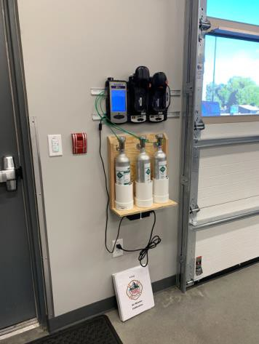

 | ID:  1315 | Facility:  Fire Training/Safety Building

Location: Kitchen
Schedule: 2021
Estimated Cost: $100.00

Priority Score 5
Quick Fix: Yes
Built before ADA:No

VIOLATIONS
2010 ADA Standards for Accessible Design Codes §307.2
The AED protrudes 6" into the circulation space at 34" above the floor.

RECOMMENDATIONS
Recess the AED so it protrudes a maximum of 4", lower it so the bottom edge is 27" maximum above the floor, or place a cane detectable object beneath it.

PHOTOGRAPH(S) OF THIS LOCATION

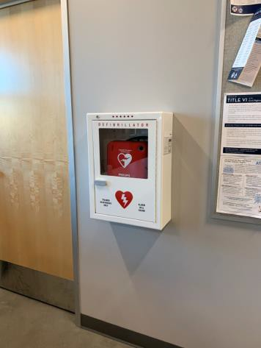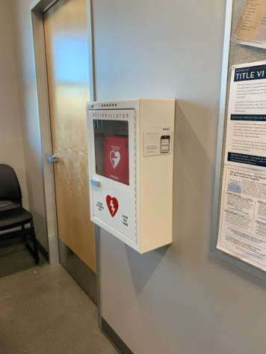

 | ID:  1279 | Facility:  Fire Training/Safety Building

Location: Main Entrance
Schedule: 2021
Estimated Cost: $100.00

Priority Score 8
Quick Fix: Yes
Built before ADA:No

VIOLATIONS
2010 ADA Standards for Accessible Design Codes §308.2.1
The badge scanner is outside of the unobstructed forward reach range at 52" above the floor.

RECOMMENDATIONS
Lower the badge scanner by 4" to meet the accessible reach range of 48" maximum above the floor.

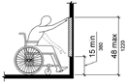

PHOTOGRAPH(S) OF THIS LOCATION

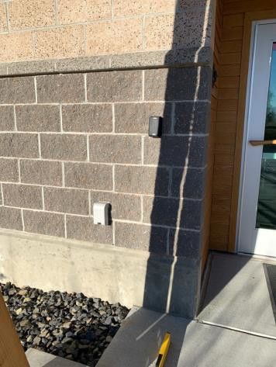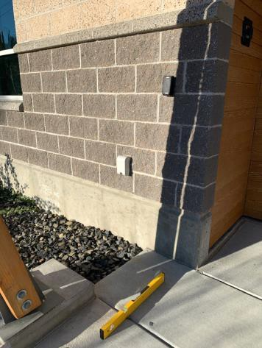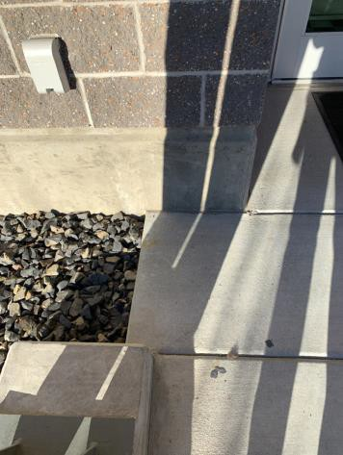

 | ID:  1280 | Facility:  Fire Training/Safety Building

Location: Main Entrance
Schedule: 2021
Estimated Cost: $2,500.00

Priority Score 3
Quick Fix: No
Built before ADA:No

VIOLATIONS
2010 ADA Standards for Accessible Design Codes §305.2
The clear floor space to access the card scanner at the main entrance is not large enough.

RECOMMENDATIONS
Expand the clear floor space to be 30"x48" with a maximum slope of 2% in all directions.

PHOTOGRAPH(S) OF THIS LOCATION

 | ID:  1309 | Facility:  Fire Training/Safety Building

Location: Men's Restroom
Schedule: 2021
Estimated Cost: $100.00

Priority Score 5
Quick Fix: Yes
Built before ADA:No

VIOLATIONS
2010 ADA Standards for Accessible Design Codes §604.8.1.2
The door to the accessible water closet is not self closing. Either self-closing hinges are not installed on the door or if installed, they are defective.

RECOMMENDATIONS
Install or reinstall self-closing hinges on the door to ensure that the door is self-closing per the ADA requirements.

PHOTOGRAPH(S) OF THIS LOCATION

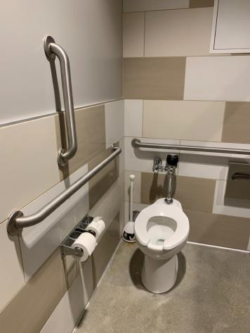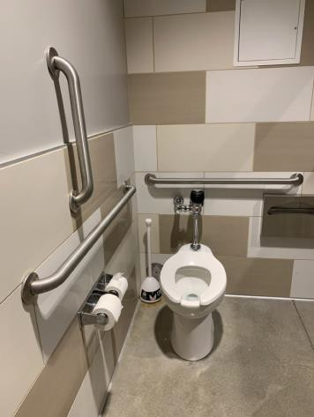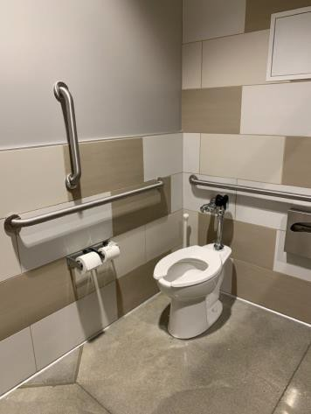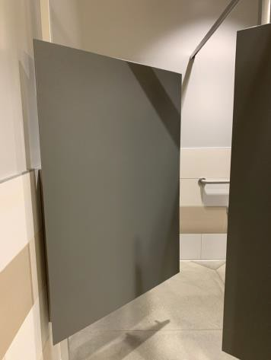

 | ID:  1316 | Facility:  Fire Training/Safety Building

Location: Offices
Schedule: 2021
Estimated Cost: $3,600.00

Priority Score 3
Quick Fix: Yes
Built before ADA:No

VIOLATIONS
2010 ADA Standards for Accessible Design Codes §216.2, §703
Throughout the Fire Department buildings, there are no tactile signs identifying 36 permanent rooms.

RECOMMENDATIONS
Install tactile signage on the latch side of the doorway at a height of 48” minimum to 60” maximum above the floor, identifying room by name or room number.
Signs shall be Braille with raised lettering and should be placed on the wall in the center of an 18"x18" clear floor space.

PHOTOGRAPH(S) OF THIS LOCATION

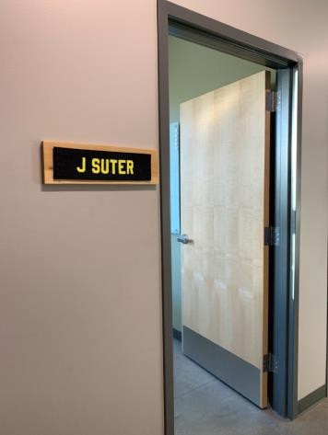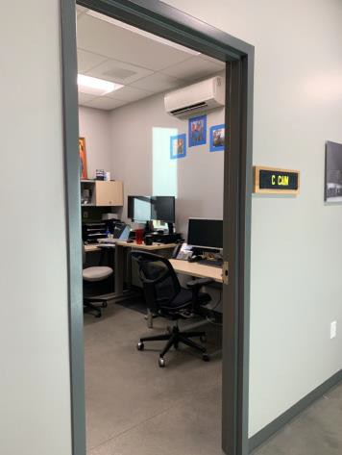

 | ID:  1277 | Facility:  Fire Training/Safety Building

Location: Parking
Schedule: 2021
Estimated Cost: $100.00

Priority Score 6
Quick Fix: Yes
Built before ADA:No

VIOLATIONS
2010 ADA Standards for Accessible Design Codes §216.5
The parking sign identifying the accessible parking space does not meet the minimum height requirement of 60" from the ground.

RECOMMENDATIONS
Remount the accessible parking sign to ensure 60" minimum height from the ground.

PHOTOGRAPH(S) OF THIS LOCATION

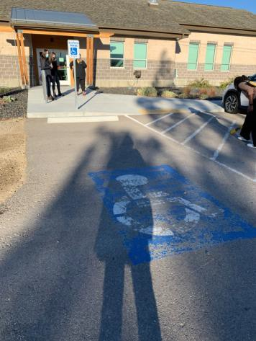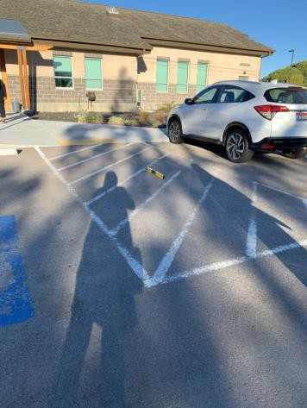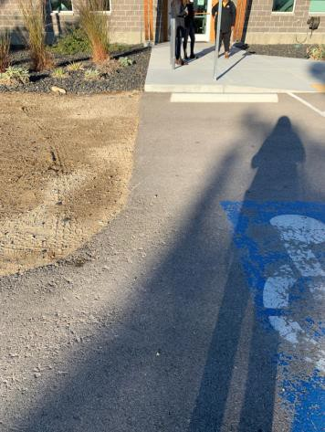

 | ID:  1276 | Facility:  Fire Training/Safety Building

Location: Parking
Schedule: 2021
Estimated Cost: $1,500.00

Priority Score 3
Quick Fix: No
Built before ADA:No

VIOLATIONS
2010 ADA Standards for Accessible Design Codes §208.2.4, §502
There are no painted lines on the left side of the accessible parking space and ISA symbols are fading.

RECOMMENDATIONS
Stripe the left side of the accessible parking space and repaint the ISA symbols.

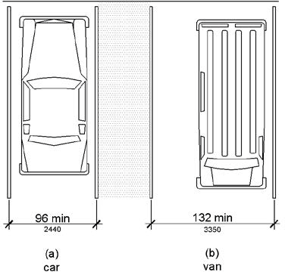

PHOTOGRAPH(S) OF THIS LOCATION

 | ID:  1343 | Facility:  Fire Training/Safety Building

Location: Restroom 1
Schedule: 2021
Estimated Cost: $100.00

Priority Score 8
Quick Fix: Yes
Built before ADA:No

VIOLATIONS
2010 ADA Standards for Accessible Design Codes §308.2.1
The hook is outside of the unobstructed forward reach range at 64" above the floor.

RECOMMENDATIONS
Lower the hook by 16" to meet the accessible reach range of 48" maximum above the floor.

PHOTOGRAPH(S) OF THIS LOCATION

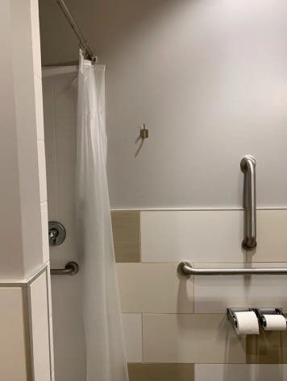

 | ID:  1348 | Facility:  Fire Training/Safety Building

Location: Restroom 1
Schedule: 2021
Estimated Cost: $100.00

Priority Score 8
Quick Fix: Yes
Built before ADA:No

VIOLATIONS
2010 ADA Standards for Accessible Design Codes §308.2.1
The soap dispenser is outside of the unobstructed forward reach range at 54" above the floor.

RECOMMENDATIONS
Lower the soap dispenser by 6" to meet the accessible reach range of 48" maximum above the floor.

PHOTOGRAPH(S) OF THIS LOCATION

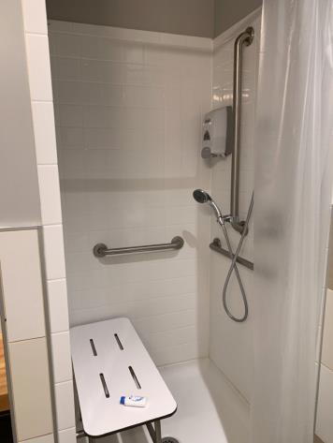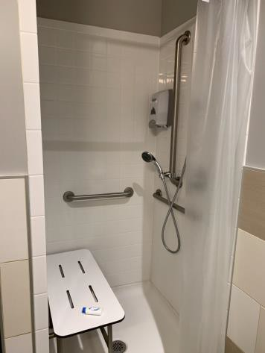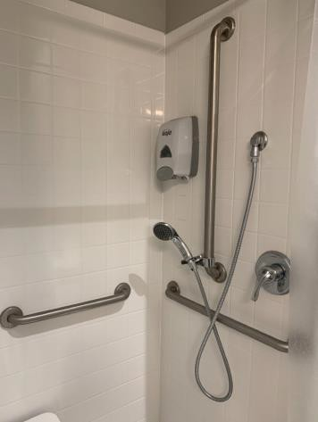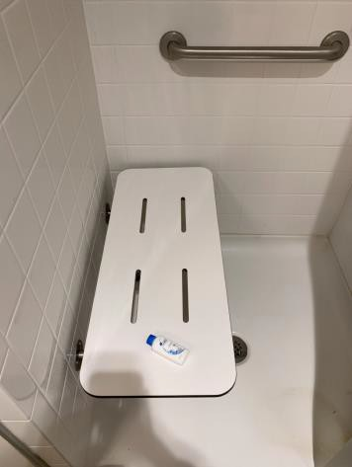

 | ID:  1356 | Facility:  Fire Training/Safety Building

Location: Restroom 1
Schedule: 2021
Estimated Cost: $200.00

Priority Score 8
Quick Fix: Yes
Built before ADA:No

VIOLATIONS
2010 ADA Standards for Accessible Design Codes §308.2.1
The hooks are outside of the unobstructed forward reach range at 64.5" above the floor.

RECOMMENDATIONS
Lower at least one of the hooks by 16.5" to meet the accessible reach range of 48" maximum above the floor.

PHOTOGRAPH(S) OF THIS LOCATION

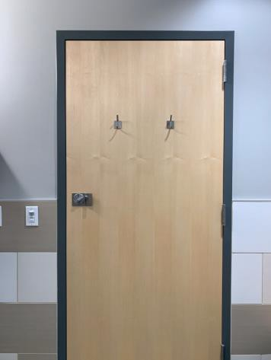

 | ID:  1336 | Facility:  Fire Training/Safety Building

Location: Restroom 2
Schedule: 2021
Estimated Cost: $100.00

Priority Score 8
Quick Fix: Yes
Built before ADA:No

VIOLATIONS
2010 ADA Standards for Accessible Design Codes §308.2.1
The soap dispenser is outside of the unobstructed forward reach range at 54" above the floor.

RECOMMENDATIONS
Lower the soap dispenser by 6" to meet the accessible reach range of 48" maximum above the floor.

PHOTOGRAPH(S) OF THIS LOCATION

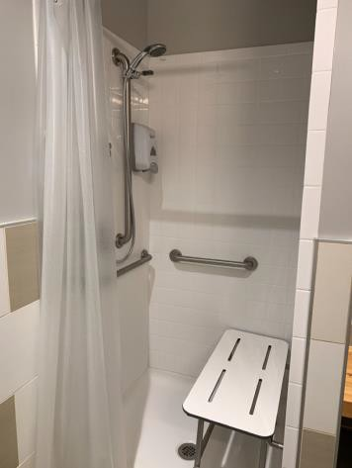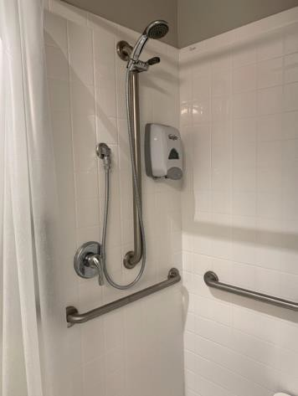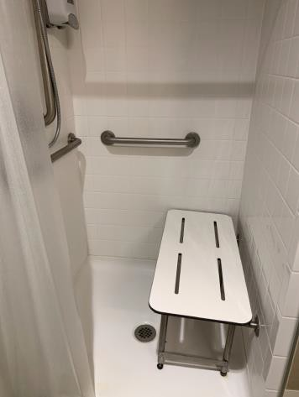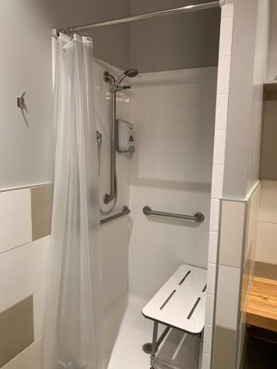

 | ID:  1338 | Facility:  Fire Training/Safety Building

Location: Restroom 2
Schedule: 2021
Estimated Cost: $100.00

Priority Score 8
Quick Fix: Yes
Built before ADA:No

VIOLATIONS
2010 ADA Standards for Accessible Design Codes §308.2.1
The hooks are outside of the unobstructed forward reach range at 64" above the floor.

RECOMMENDATIONS
Lower at least one of the hooks by 16" to meet the accessible reach range of 48" maximum above the floor.

PHOTOGRAPH(S) OF THIS LOCATION

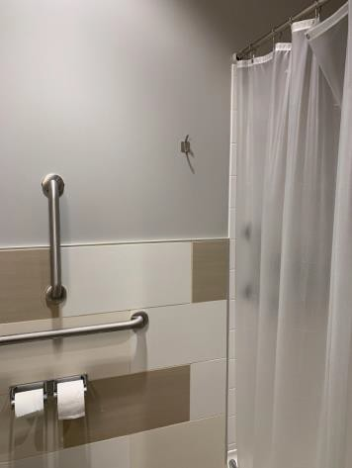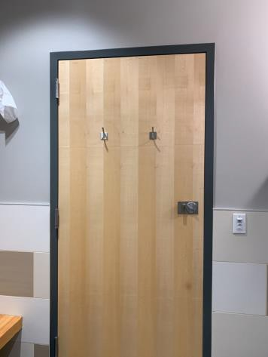

 | ID:  1321 | Facility:  Fire Training/Safety Building

Location: Restroom 3
Schedule: 2021
Estimated Cost: $100.00

Priority Score 8
Quick Fix: Yes
Built before ADA:No

VIOLATIONS
2010 ADA Standards for Accessible Design Codes §308.2.1
The hooks are outside of the unobstructed forward reach range at 64" above the floor.

RECOMMENDATIONS
Lower at least one of the hooks by 16" to meet the accessible reach range of 48" maximum above the floor.

PHOTOGRAPH(S) OF THIS LOCATION

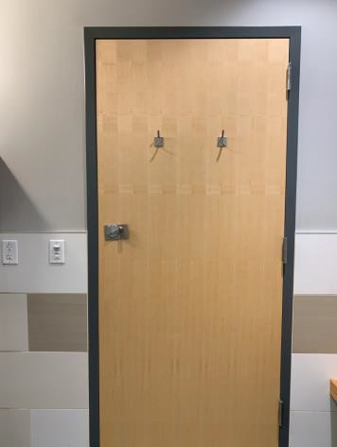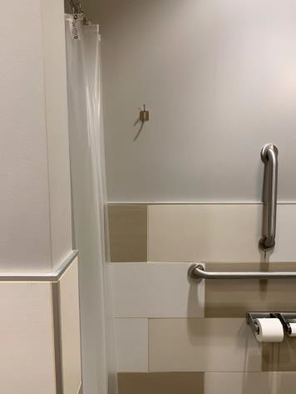

 | ID:  1326 | Facility:  Fire Training/Safety Building

Location: Restroom 3
Schedule: 2022
Estimated Cost: $1,000.00

Priority Score 5
Quick Fix: No
Built before ADA:No

VIOLATIONS
2010 ADA Standards for Accessible Design Codes §606.3
The sink is 35" above the floor.

RECOMMENDATIONS
Lower the sink to the maximum height of 34" above the floor.

PHOTOGRAPH(S) OF THIS LOCATION

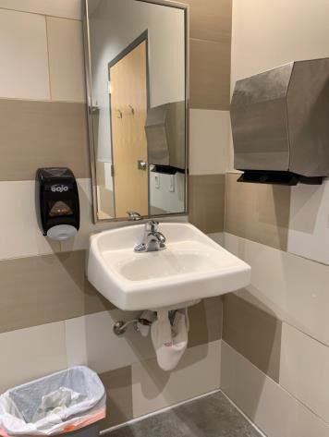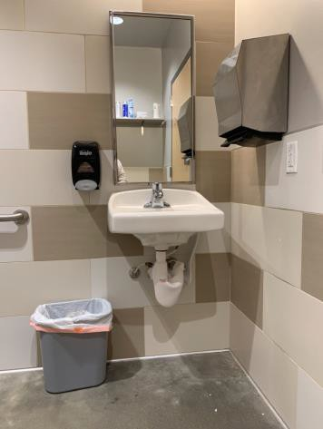

 | ID:  1289 | Facility:  Fire Training/Safety Building

Location: Restroom 4
Schedule: 2021
Estimated Cost: $100.00

Priority Score 8
Quick Fix: Yes
Built before ADA:No

VIOLATIONS
2010 ADA Standards for Accessible Design Codes §308.2.1
The hooks are outside of the unobstructed forward reach range at 64" above the floor.

RECOMMENDATIONS
Lower at least one of the hooks by 16" to meet the accessible reach range of 48" maximum above the floor.

PHOTOGRAPH(S) OF THIS LOCATION

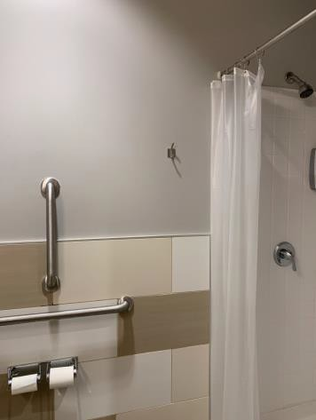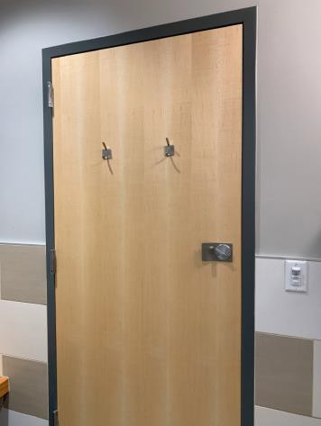

 | ID:  1293 | Facility:  Fire Training/Safety Building

Location: Restroom 4
Schedule: 2022
Estimated Cost: $1,000.00

Priority Score 5
Quick Fix: No
Built before ADA:No

VIOLATIONS
2010 ADA Standards for Accessible Design Codes §606.3
The sink is 34.75" above the floor.

RECOMMENDATIONS
Lower the sink to the maximum height of 34" above the floor.

PHOTOGRAPH(S) OF THIS LOCATION

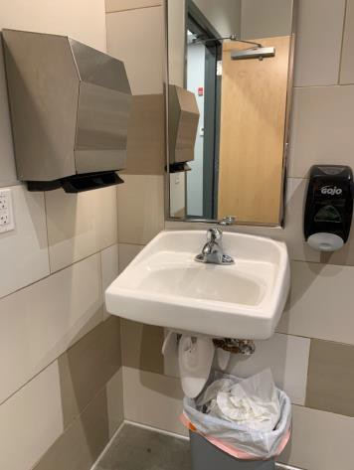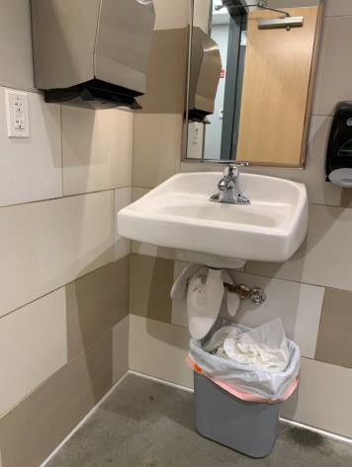

 | ID:  1283 | Facility:  Fire Training CMRCL Tower Burn

Location: Training Building
Schedule: 2021
Estimated Cost: $0.00

Priority Score 0
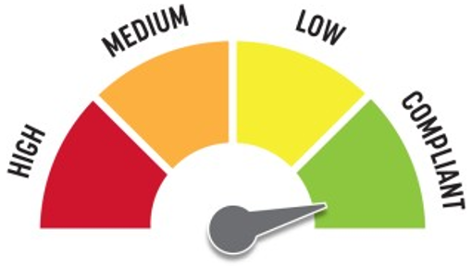
Quick Fix: Yes
Built before ADA:No

VIOLATIONS
2010 ADA Standards for Accessible Design Codes §216.2, §703
There are no tactile signs identifying twelve permanent rooms.

RECOMMENDATIONS
Since the Fire Training CMRCL Tower Burn is used for firefighter training purposes only, there are no recommendations at this time.

PHOTOGRAPH(S) OF THIS LOCATION

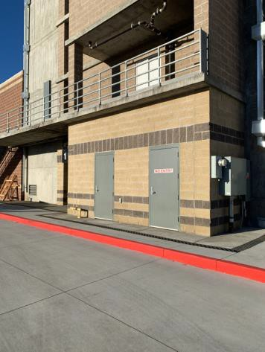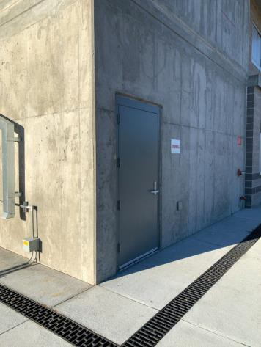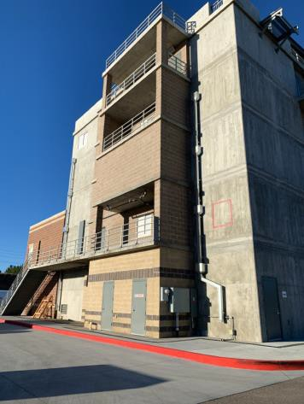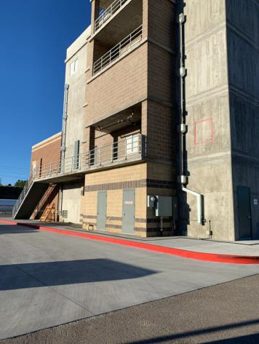

 | ID:  1284 | Facility:  Fire Training CLSS A Burn Building

Location: Training Building
Schedule: 2021
Estimated Cost: $0.00

Priority Score 0
Quick Fix: Yes
Built before ADA:No

VIOLATIONS
2010 ADA Standards for Accessible Design Codes §216.2, §703
There is no tactile sign identifying four permanent rooms.

RECOMMENDATIONS
Since the CLSS A Burn Building is used for firefighter training purposes only, there are no recommendations at this time.

PHOTOGRAPH(S) OF THIS LOCATION

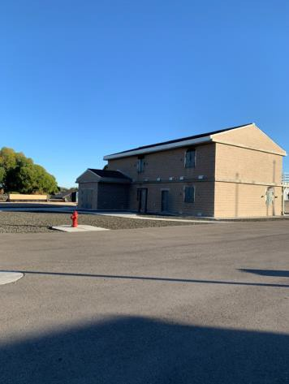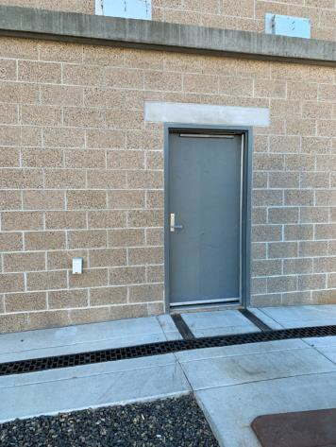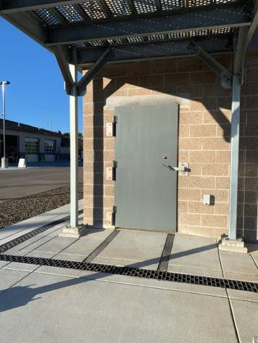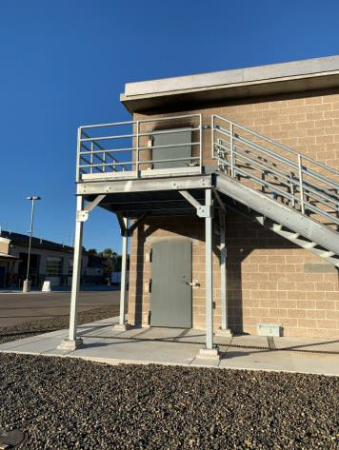

 | ID:  1303 | Facility:  Fire Training Admin Building

Location: Women's Restroom
Schedule: 2021
Estimated Cost: $100.00

Priority Score 5
Quick Fix: Yes
Built before ADA:No

VIOLATIONS
2010 ADA Standards for Accessible Design Codes §604.8.1.2
The door to the accessible water closet is not self closing. Either self-closing hinges are not installed on the door or if installed, they are defective.

RECOMMENDATIONS
Install or reinstall self-closing hinges on the door to ensure that the door is self-closing per the ADA requirements. Ensure that there is adequate maneuvering clearance to operate the door.

PHOTOGRAPH(S) OF THIS LOCATION

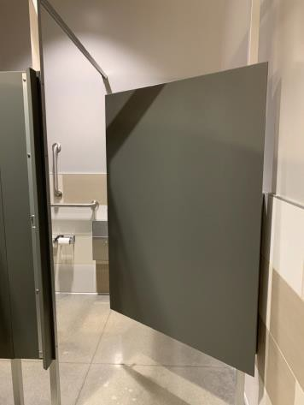

 | ID:  1308 | Facility:  Fire Training Admin Building

Location: Women's Restroom
Schedule: 2021
Estimated Cost: $100.00

Priority Score 5
Quick Fix: Yes
Built before ADA:No

VIOLATIONS
2010 ADA Standards for Accessible Design Codes §403.5.1
There is not a clear 36" width for wheelchairs to pass between the counter and the restroom door.
When the restroom door is closed, the width is 29.5". When the restroom door is open, the width is 27.75".

RECOMMENDATIONS
Remove the counter from the restroom to ensure that there is a minimum clear width of 36".

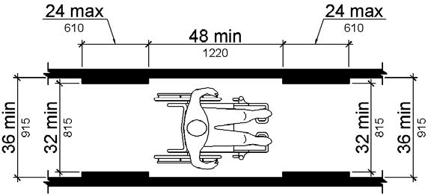

PHOTOGRAPH(S) OF THIS LOCATION

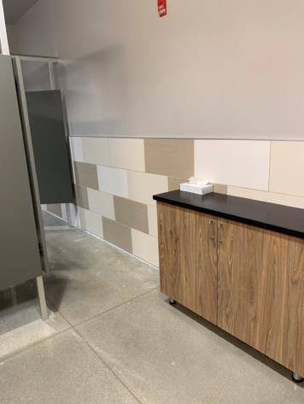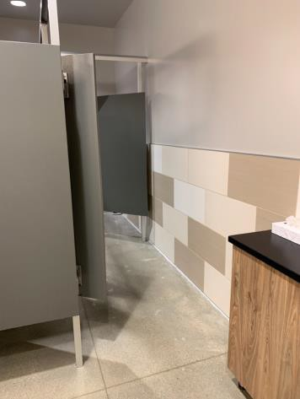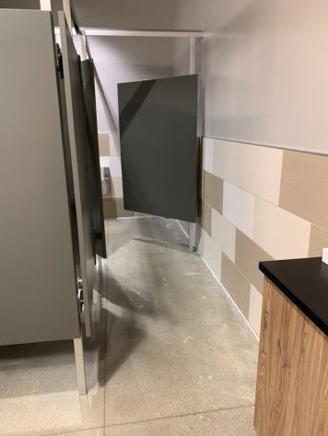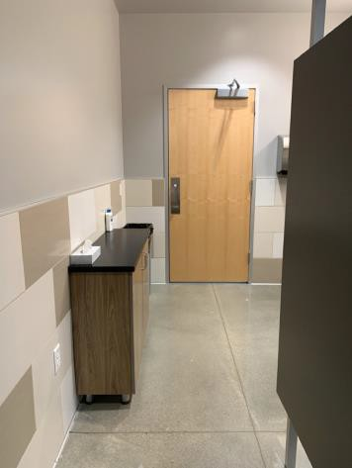

 | ID:  1305 | Facility:  Fire Training Admin Building

Location: Women's Restroom
Schedule: 2022
Estimated Cost: $1,000.00

Priority Score 5
Quick Fix: No
Built before ADA:No

VIOLATIONS
2010 ADA Standards for Accessible Design Codes §604.5.1
The side grab bar is located 11" from the rear wall, is 33" long, and extends 44.5" from the rear wall.

RECOMMENDATIONS
Replace the side grab bar with one that is a minimum of 42" long minimum, located 12" maximum from the rear wall and extending 54" minimum from the rear wall.

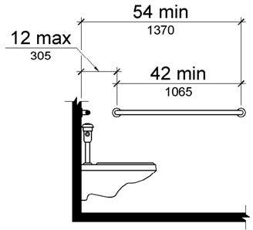

PHOTOGRAPH(S) OF THIS LOCATION

